Year 5 juncture
Planning and auditing template
All key learning areas
Abridged version: conceptual statements only

About this template  This resource is intended to help you plan teaching, learning and assessment of the Essential Learnings across the curriculum. It can be used to:  - audit existing units  - plan new units of work.  The template provides a record of your units of work and their specific teaching, learning and assessment of:  - Ways of working  - Knowledge and understandings (conceptual statements only)  - Assessable elements.  Using the form features  This template is a protected MS Word form document — it allows you to enter unit titles in the shaded areas and check and uncheck boxes by clicking on them.  To make any other changes to the template, turn off the MS Word protection feature:  - Open the document in MS Word.  - Display the Forms toolbar: from the top menu, select View > Toolbars > Forms.  - On the Forms toolbar, click on the Protect forms icon (padlock).  Reactivate protection by clicking on padlock when needed. | Five processes that guide planning  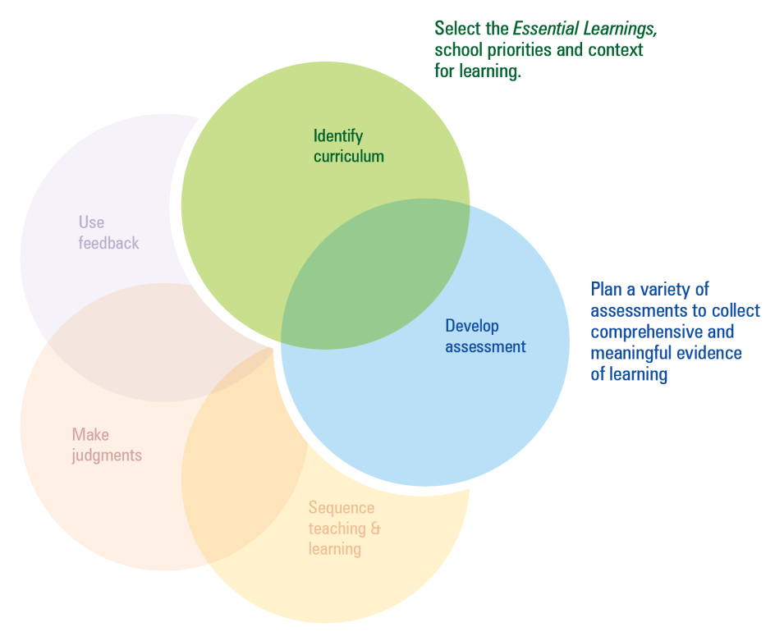  This template can be used to identify curriculum and develop assessment.  Additional planning and auditing resources  APEL is a QSA developed software application to help teachers audit their curriculum and plan units of work using the Essential Learnings. Available from the QSA website <www.qsa.qld.edu.au>.

Year 5 juncture — The Arts
Ways of working |  | Units of work
 |  | Year 4 |  |  |  |  |  |  |  | Year 5
 |  | Semester 1 |  |  |  | Semester 2 |  |  |  | Semester 1 |  |  |  | Semester 2
Key: Teaching and learning  Assessment | Unit title
Students are able to:
- select and develop ideas for arts works, considering different audiences and different purposes, using arts elements and languages
- create and shape arts works by organising arts elements to express personal and community values, beliefs and observations
- rehearse and rework arts works, using interpretive and technical skills
- present arts works to informal and formal audiences, using arts techniques, skills and processes
- identify and apply safe practices
- respond to arts works by identifying and interpreting the influences of social, cultural and historical contexts, using arts elements and languages
- reflect on learning to identify new understandings and future applications.

Year 5 juncture — The Arts
Knowledge and understanding |  | Units of work
 |  | Year 4 |  |  |  |  |  |  |  | Year 5
 |  | Semester 1 |  |  |  | Semester 2 |  |  |  | Semester 1 |  |  |  | Semester 2
Key: Teaching and learning  Assessment | Unit title
Dance: Dance involves using the human body to express ideas, considering different audiences and different purposes, by selecting dance elements in short movement sequences.
Drama: Drama involves selecting dramatic elements and conventions to express ideas, considering different audiences and different purposes, through dramatic action based on real or imagined events.
Media: Media involves selecting media languages and technologies to create representations and construct meaning, considering different audiences and different purposes.
Music: Music involves singing, playing instruments, listening, moving, improvising and composing by selecting the music elements to express ideas, considering different audiences and different purposes, through sound.
Visual Art: Visual Art involves selecting visual arts elements, concepts, processes and forms (both 2D and 3D) to express ideas, considering different audiences and different purposes, through images and objects.

The Arts — Assessable elements
 |  | Units of work
 |  | Year 4 |  |  |  |  |  |  |  | Year 5
 |  | Semester 1 |  |  |  | Semester 2 |  |  |  | Semester 1 |  |  |  | Semester 2
Assessable elements | Unit title
Students demonstrate evidence of their learning over time in relation to the following assessable elements:
Knowledge and understanding
Creating
Presenting
Responding
Reflecting

Year 5 juncture — HPE
Ways of working |  | Units of work
 |  | Year 4 |  |  |  |  |  |  |  | Year 5
 |  | Semester 1 |  |  |  | Semester 2 |  |  |  | Semester 1 |  |  |  | Semester 2
Key: Teaching and learning  Assessment | Unit title
Students are able to:
- pose and refine questions or issues, and plan activities
- collect, organise and evaluate information and evidence
- draw conclusions and make decisions by identifying connections
- propose, justify and implement simple plans or actions to promote health and wellbeing, movement capacities, and personal development
- apply fundamental and simple specialised movement skills when participating in physical activities
- create and perform movement sequences by selecting and combining movement skills
- apply personal development skills and strategies in team and group situations
- identify and apply safe practices
- reflect on and identify how their own and others’ behaviours, skills and actions influence health and wellbeing, movement capacities and personal development
- reflect on learning to identify new understandings and future applications.

Year 5 juncture — HPE
Knowledge and understanding |  | Units of work
 |  | Year 4 |  |  |  |  |  |  |  | Year 5
 |  | Semester 1 |  |  |  | Semester 2 |  |  |  | Semester 1 |  |  |  | Semester 2
Key: Teaching and learning  Assessment | Unit title
Health: Health is multidimensional and influenced by individual and group actions and environments.
Physical activity: Fundamental and simple specialised movement skills are elements of physical activity.
Personal development: Personal identity, relationships and self-management are influenced by beliefs, behaviours and social factors, and shape personal development.

HPE — Assessable elements
 |  | Units of work
 |  | Year 4 |  |  |  |  |  |  |  | Year 5
 |  | Semester 1 |  |  |  | Semester 2 |  |  |  | Semester 1 |  |  |  | Semester 2
Assessable elements | Unit title
Students demonstrate evidence of their learning over time in relation to the following assessable elements:
Knowledge and understanding
Investigating
Planning
Implementing and applying
Reflecting

Year 5 juncture — SOSE
Ways of working |  | Units of work
 |  | Year 4 |  |  |  |  |  |  |  | Year 5
 |  | Semester 1 |  |  |  | Semester 2 |  |  |  | Semester 1 |  |  |  | Semester 2
Key: Teaching and learning  Assessment | Unit title
Students are able to:
- pose and refine questions for investigations
- plan investigations based on questions and inquiry models
- collect and organise information and evidence
- evaluate sources of information and evidence to determine different perspectives, and distinguish facts from opinions
- draw and justify conclusions based on information and evidence
- communicate descriptions, decisions and conclusions, using text types selected to match audience and purpose
- share opinions, identify possibilities and propose actions to respond to findings
- apply strategies to influence decisions or behaviours and to contribute to groups
- reflect on and identify personal actions and those of others to clarify values associated with social justice, the democratic process, sustainability and peace
- reflect on learning to identify new understandings and future applications.

Year 5 juncture — SOSE
Knowledge and understanding |  | Units of work
 |  | Year 4 |  |  |  |  |  |  |  | Year 5
 |  | Semester 1 |  |  |  | Semester 2 |  |  |  | Semester 1 |  |  |  | Semester 2
Key: Teaching and learning  Assessment | Unit title
Time, continuity and change: Changes and continuities are represented by events and people’s contributions, and are viewed differently by different people.
Place and space: Environments are defined and changed by interactions between people and places.
Culture and identity: Communities contain cultures and groups that contribute to diversity and influence cohesion.
Political and economic systems: Communities have developed decision-making systems that include principles and values formed over time.

SOSE — Assessable elements
 |  | Units of work
 |  | Year 4 |  |  |  |  |  |  |  | Year 5
 |  | Semester 1 |  |  |  | Semester 2 |  |  |  | Semester 1 |  |  |  | Semester 2
Assessable elements | Unit title
Students demonstrate evidence of their learning over time in relation to the following assessable elements:
Knowledge and understanding
Investigating
Communicating
Participating
Reflecting

Year 5 juncture — Technology
Ways of working |  | Units of work
 |  | Year 4 |  |  |  |  |  |  |  | Year 5
 |  | Semester 1 |  |  |  | Semester 2 |  |  |  | Semester 1 |  |  |  | Semester 2
Key: Teaching and learning  Assessment | Unit title
Students are able to:
- identify and analyse the purpose and context for design ideas
- generate design ideas that match requirements
- communicate the details of their designs using 2D or 3D visual representations
- select resources, techniques and tools to make products
- plan production procedures by identifying and sequencing steps
- make products to match design ideas by manipulating and processing resources
- identify and apply safe practices
- evaluate products and processes to identify strengths, limitations, effectiveness and improvements
- reflect on and identify the impacts of products and processes on people and their communities
- reflect on learning to identify new understandings and future applications.

Year 5 juncture — Technology
Knowledge and understanding |  | Units of work
 |  | Year 4 |  |  |  |  |  |  |  | Year 5
 |  | Semester 1 |  |  |  | Semester 2 |  |  |  | Semester 1 |  |  |  | Semester 2
Key: Teaching and learning  Assessment | Unit title
Technology as a human endeavour: Technology influences and impacts on people, their communities and environments.
Information, materials and systems (resources):
The characteristics of resources are matched with tools and techniques to make products to meet design challenges.

Technology — Assessable elements
 |  | Units of work
 |  | Year 4 |  |  |  |  |  |  |  | Year 5
 |  | Semester 1 |  |  |  | Semester 2 |  |  |  | Semester 1 |  |  |  | Semester 2
Assessable elements | Unit title
Students demonstrate evidence of their learning over time in relation to the following assessable elements:
Knowledge and understanding
Investigating and designing
Producing
Evaluating
Reflecting

ICT Cross-curriculum priorities
 |  | Units of work
 |  | Year 4 |  |  |  |  |  |  |  | Year 5
 |  | Semester 1 |  |  |  | Semester 2 |  |  |  | Semester 1 |  |  |  | Semester 2
Inquiring with ICTs | Unit title
Students explore and use ICTs in the processes of inquiry across key learning areas. They:
- identify the inquiry focus, data and information requirements and possible digital information sources
- plan, conduct and manage structured searches for data and information
- organise and analyse, experiment with and test data and information from a variety of sources
- evaluate data and information gathered for usefulness, credibility, relevance and accuracy
- reflect on and analyse how ICTs have assisted in meeting the inquiry purposes and in developing new understandings.

Creating with ICTs
Students experiment with and use ICTs to create a range of responses to suit the purpose and audience. They use ICTs to develop understanding,
demonstrate creativity, thinking, learning, collaboration and communication across key learning areas. They:
- develop simple plans to create imaginative responses
- express and represent ideas, information and thinking
- create imaginative responses that demonstrate required features
- reflect on their use of ICTs as creative tools and evaluate their choice of ICTs, their ICT responses, and the effectiveness of the ICT features in meeting requirements.

ICT Cross-curriculum priorities
 |  | Units of work
 |  | Year 4 |  |  |  |  |  |  |  | Year 5
 |  | Semester 1 |  |  |  | Semester 2 |  |  |  | Semester 1 |  |  |  | Semester 2
Communicating with ICTs | Unit title
Students experiment with and use ICTs across key learning areas to collaborate and enhance communication in different contexts for an identified purpose and audience. They:
- collaborate and communicate ideas, understandings, information and responses
- consider how communication with ICTs varies in different social and cultural contexts
- apply appropriate communication conventions
- use a variety of digital media to improve communication
- express a personal image and an identity in communication
- reflect on their use of ICTs and analyse and identify ways to improve the effectiveness of their collaboration and communication.

ICT Cross-curriculum priorities
 |  | Units of work
 |  | Year 4 |  |  |  |  |  |  |  | Year 5
 |  | Semester 1 |  |  |  | Semester 2 |  |  |  | Semester 1 |  |  |  | Semester 2
Ethics, issues and ICTs | Unit title
Students understand the role of some ICTs in society. They develop and apply ethical, safe and responsible practices when working with ICTs in online and stand alone environments. They:
- develop and apply codes of practice that promote safety, security, responsibility and respect
- examine practices in a variety of ICT environments and identify underlying values
- identify owner(s)/creator(s) of digital information sources and apply sound practices to acknowledge them
- apply a range of preventative strategies to address issues relating to health and safety when using ICTs
- develop and apply strategies for the security of personal information when using ICTs
- reflect on and analyse the use of ICTs in the workplace and identify their impact in society.

ICT Cross-curriculum priorities
 |  | Units of work
 |  | Year 4 |  |  |  |  |  |  |  | Year 5
 |  | Semester 1 |  |  |  | Semester 2 |  |  |  | Semester 1 |  |  |  | Semester 2
Operating ICTs | Unit title
Students use a range of ICT functions and applications across key learning areas to inquire, create, collaborate and communicate, and to manage information and data. They:
- experiment with operational processes and use the basic capabilities of a range of ICT devices
- access appropriate network, personal system and device information
- make selections from common input, output and storage devices
- adopt basic recognised ICT conventions and manage personal ICT resources to enhance operational efficiency
- describe common ICT devices and operational processes using ICT-specific terminology
- develop and apply “help” strategies for effective use of ICT
- explain some management processes when working with content in digital environments
- reflect on and analyse their operational skills and identify ways to improve their effectiveness.

Queensland Studies Authority
295 Ann Street, Brisbane
PO Box 307 Spring Hill
QLD 4004 Australia
T +61 7 3864 0299
F +61 7 3221 2553
www.qsa.qld.edu.au

