Year 3 juncture
Planning and auditing template
All key learning areas
Abridged version: conceptual statements only

About this template  This resource is intended to help you plan teaching, learning and assessment of the Essential Learnings across the curriculum. It can be used to:  - audit existing units  - plan new units of work.  The template provides a record of your units of work and their specific teaching, learning and assessment of:  - Ways of working  - Knowledge and understandings (conceptual statements only)  - Assessable elements.  Using the form features  This template is a protected MS Word form document — it allows you to enter unit titles in the shaded areas and check and uncheck boxes by clicking on them.  To make any other changes to the template, turn off the MS Word protection feature:  - Open the document in MS Word.  - Display the Forms toolbar: from the top menu, select View > Toolbars > Forms.  - On the Forms toolbar, click on the Protect forms icon (padlock).  Reactivate protection by clicking on padlock when needed. | Five processes that guide planning  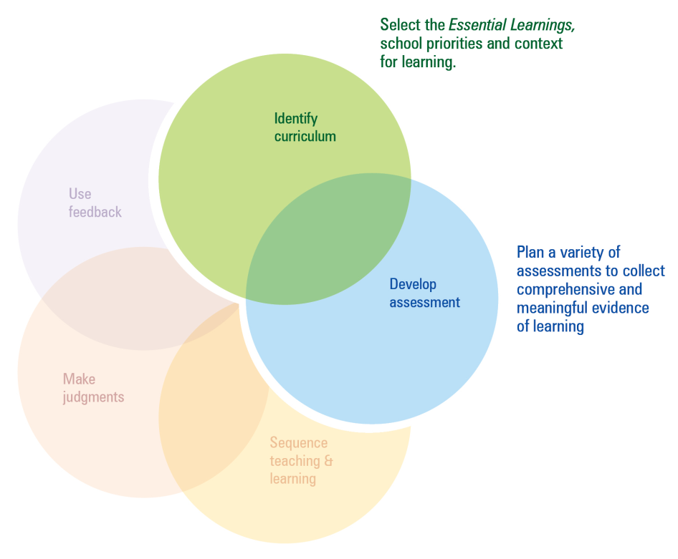  This template can be used to identify curriculum and develop assessment.  Additional planning and auditing resources  APEL is a QSA developed software application to help teachers audit their curriculum and plan units of work using the Essential Learnings. Available from the QSA website <www.qsa.qld.edu.au>.

Year 3 juncture — The Arts
Ways of working |  | Units of work
 |  | Year 2 |  |  |  |  |  |  |  | Year 3
 |  | Semester 1 |  |  |  | Semester 2 |  |  |  | Semester 1 |  |  |  | Semester 2
Key: Teaching and learning  Assessment | Unit title
Students are able to:
- select ideas for arts works, considering particular audiences and particular purposes, using arts elements and languages
- create and shape arts works by combining arts elements to express personal ideas, feelings and experiences
- practise arts works, using interpretive and technical skills
- present arts works to familiar audiences, using arts techniques, skills and processes
- follow guidelines to apply safe practices
- respond to arts works and describe initial impressions and personal interpretations, using arts elements and languages
- reflect on learning to identify new understandings and future applications.

Year 3 juncture — The Arts
Knowledge and understanding |  | Units of work
 |  | Year 2 |  |  |  |  |  |  |  | Year 3
 |  | Semester 1 |  |  |  | Semester 2 |  |  |  | Semester 1 |  |  |  | Semester 2
Key: Teaching and learning  Assessment | Unit title
Dance: Dance involves using the human body to express ideas, considering particular audiences and particular purposes, through dance elements in movement phrases.
Drama: Drama involves using dramatic elements and conventions to express ideas, considering particular audiences and particular purposes, through dramatic action based on real or imagined events.
Media: Media involves constructing meaning by using media languages and technologies to express representations, considering particular audiences and particular purposes.
Music: Music involves singing, playing instruments, listening, moving, improvising and composing by using the music elements to express ideas, considering particular audiences and particular purposes, through sound.
Visual Art: Visual Art involves using visual arts elements, concepts, processes and forms (both 2D and 3D) to express ideas, considering particular audiences and particular purposes, through images and objects.

The Arts — Assessable elements
 |  | Units of work
 |  | Year 2 |  |  |  |  |  |  |  | Year 3
 |  | Semester 1 |  |  |  | Semester 2 |  |  |  | Semester 1 |  |  |  | Semester 2
Assessable elements | Unit title
Students demonstrate evidence of their learning over time in relation to the following assessable elements:
Knowledge and understanding
Creating
Presenting
Responding
Reflecting

Year 3 juncture — HPE
Ways of working |  | Units of work
 |  | Year 2 |  |  |  |  |  |  |  | Year 3
 |  | Semester 1 |  |  |  | Semester 2 |  |  |  | Semester 1 |  |  |  | Semester 2
Key: Teaching and learning  Assessment | Unit title
Students are able to:
- pose questions and plan simple activities and investigations
- identify and collect information and evidence
- draw conclusions and make decisions
- propose and take action to promote health and wellbeing, movement capacities and personal development
- apply fundamental movement skills when participating in physical activities
- create and sequence simple movement patterns in response to stimuli
- apply personal development skills when interacting with others
- follow guidelines to apply safe practices
- reflect on and identify how behaviours, skills and actions influence health and wellbeing, movement capacities and personal development
- reflect on learning to identify new understandings.

Year 3 juncture — HPE
Knowledge and understanding |  | Units of work
 |  | Year 2 |  |  |  |  |  |  |  | Year 3
 |  | Semester 1 |  |  |  | Semester 2 |  |  |  | Semester 1 |  |  |  | Semester 2
Key: Teaching and learning  Assessment | Unit title
Health: Health is multidimensional and influenced by everyday actions and environments.
Physical activity: Fundamental movement skills are foundations of physical activity.
Personal development: Personal identity, self-management and relationships develop through interactions in family and social contexts and shape personal development.

HPE — Assessable elements
 |  | Units of work
 |  | Year 2 |  |  |  |  |  |  |  | Year 3
 |  | Semester 1 |  |  |  | Semester 2 |  |  |  | Semester 1 |  |  |  | Semester 2
Assessable elements | Unit title
Students demonstrate evidence of their learning over time in relation to the following assessable elements:
Knowledge and understanding
Investigating
Planning
Implementing and applying
Reflecting

Year 3 juncture — SOSE
Ways of working |  | Units of work
 |  | Year 2 |  |  |  |  |  |  |  | Year 3
 |  | Semester 1 |  |  |  | Semester 2 |  |  |  | Semester 1 |  |  |  | Semester 2
Key: Teaching and learning  Assessment | Unit title
Students are able to:
- pose questions for investigations
- plan simple investigations based on questions
- identify and collect information and evidence from narratives and familiar sources
- make judgments about the usefulness of the information and evidence
- draw conclusions and give explanations, using information and evidence
- communicate social and environmental ideas, using texts and terminology to match audience and purpose
- share ideas, and plan and enact responses to group or community issues
- participate in group decision making to achieve goals
- reflect on and identify values associated with fairness, protecting the environment and behaving peacefully
- reflect on learning to identify new understandings.

Year 3 juncture — SOSE
Knowledge and understanding |  | Units of work
 |  | Year 2 |  |  |  |  |  |  |  | Year 3
 |  | Semester 1 |  |  |  | Semester 2 |  |  |  | Semester 1 |  |  |  | Semester 2
Key: Teaching and learning  Assessment | Unit title
Time, continuity and change: Changes and continuities are identified through events, people’s contributions and the stories of local communities.
Place and space: Local natural, social and built environments are defined by specific features and can be sustained by certain activities.
Culture and identity: Local communities have different groups with shared values and common interests.
Political and economic systems: Communities have systems to make rules and laws, govern, and manage the production and consumption of goods and services.

SOSE — Assessable elements
 |  | Units of work
 |  | Year 2 |  |  |  |  |  |  |  | Year 3
 |  | Semester 1 |  |  |  | Semester 2 |  |  |  | Semester 1 |  |  |  | Semester 2
Assessable elements | Unit title
Students demonstrate evidence of their learning over time in relation to the following assessable elements:
Knowledge and understanding
Investigating
Communicating
Participating
Reflecting

Year 3 juncture — Technology
Ways of working |  | Units of work
 |  | Year 2 |  |  |  |  |  |  |  | Year 3
 |  | Semester 1 |  |  |  | Semester 2 |  |  |  | Semester 1 |  |  |  | Semester 2
Key: Teaching and learning  Assessment | Unit title
Students are able to:
- identify a purpose for design ideas
- generate simple ideas for designs
- communicate major features of their designs, using 2D or 3D visual representations and words
- select resources, simple techniques and tools to make products
- plan and sequence main steps in production procedures
- make products by following production procedures to manipulate and process resources
- follow guidelines to apply safe practices
- evaluate products and processes by identifying what worked well, what did not and ways to improve
- reflect on the uses of technology and describe the impact in everyday situations
- reflect on learning to identify new understandings.

Year 3 juncture — Technology
Knowledge and understanding |  | Units of work
 |  | Year 2 |  |  |  |  |  |  |  | Year 3
 |  | Semester 1 |  |  |  | Semester 2 |  |  |  | Semester 1 |  |  |  | Semester 2
Key: Teaching and learning  Assessment | Unit title
Technology as a human endeavour: Technology is part of our everyday lives and activities.
Information, materials and systems (resources): Resources are used to make products for particular purposes and contexts.

Technology — Assessable elements
 |  | Units of work
 |  | Year 2 |  |  |  |  |  |  |  | Year 3
 |  | Semester 1 |  |  |  | Semester 2 |  |  |  | Semester 1 |  |  |  | Semester 2
Assessable elements | Unit title
Students demonstrate evidence of their learning over time in relation to the following assessable elements:
Knowledge and understanding
Investigating and designing
Producing
Evaluating
Reflecting

ICT Cross-curriculum priorities
 |  | Units of work
 |  | Year 2 |  |  |  |  |  |  |  | Year 3
 |  | Semester 1 |  |  |  | Semester 2 |  |  |  | Semester 1 |  |  |  | Semester 2
Inquiring with ICTs | Unit title
Students explore and use ICTs in the processes of inquiry across key learning areas. They:
- experiment with different ICTs and select and use ICTs appropriate to the inquiry
- conduct structured searches for data and information from a limited range of sources
- organise data and information
- evaluate the data and information gathered for usefulness and credibility
- reflect on how ICTs have assisted in meeting the inquiry purposes and in developing new understandings.

Creating with ICTs
Students experiment with and use ICTs to create a range of responses to suit the purpose and audience. They use ICTs to develop understanding, demonstrate creativity, thinking, learning, collaboration and communication across key learning areas. They:
- represent ideas, information and thinking
- develop imaginative responses
- record evidence of their learning
- reflect on their use of ICTs as a creative tool and identify how their responses could be improved.

ICT Cross-curriculum priorities
 |  | Units of work
 |  | Year 2 |  |  |  |  |  |  |  |  | Year 3
 |  | Semester 1 |  |  |  | Semester 2 |  |  |  |  | Semester 1 |  |  |  | Semester 2
Communicating with ICTs | Unit title
Students experiment with and use ICTs across key learning areas to collaborate and enhance communication in different contexts for an identified audience. They:
- share and communicate ideas, understandings and responses
- consider how ICTs can be used to communicate different meanings in different situations
- apply basic communication conventions
- apply digital media to communicate
- recognise some elements of image and identify in communication
- reflect on their use of ICTs and identify ways to improve their collaboration and enhance their communication.

Ethics, issues and ICTs
Students understand the role of some ICTs in society. They develop and apply ethical, safe and responsible practices when working with ICTs in online
and stand-alone environments. They:
- develop and apply basic protocols and practices for safe, secure and responsible use of ICTs
- examine values and identify issues and practices for using ICTs in a safe and responsible manner
- identify and acknowledge the owner(s)/creator(s) of digital information sources
- apply basic preventative strategies to address health and safety issues when using ICTs
- follow guidelines for personal safety and information security practices when using ICTs
- reflect on how ICTs are used in the community and identify their impact.

ICT Cross-curriculum priorities
 |  | Units of work
 |  | Year 2 |  |  |  |  |  |  |  | Year 3
 |  | Semester 1 |  |  |  | Semester 2 |  |  |  | Semester 1 |  |  |  | Semester 2
Operating ICTs | Unit title
Students use a range of basic ICT functions and applications across key learning areas to inquire, create collaborate and communicate, and to manage, store and retrieve information and data. They:
- follow guidelines to use ICTs and associated processes
- explore ways to work with and manage personal ICT resources and files
- apply basic formatting features when using ICTs
- describe common ICT devices using familiar ICT terminology
- use strategies to seek help when using ICTs
- reflect on their operation of ICTs and identify what worked well and what did.

Queensland Studies Authority
295 Ann Street, Brisbane
PO Box 307 Spring Hill
QLD 4004 Australia
T +61 7 3864 0299
F +61 7 3221 2553
www.qsa.qld.edu.au

