Languages — Lower intermediate stage
Planning and auditing template

About this template  This resource is intended to help you plan teaching, learning and assessment of the Essential Learnings across the curriculum. It can be used to:  - audit existing units  - plan new units of work.  The purpose of this template is to provide information for Languages — Lower intermediate stage focusing on:  - Ways of working  - Knowledge and understandings (conceptual statements only)  - Assessable elements.  Using the form features  This template is a protected MS Word form document — it allows you to enter unit titles in the shaded areas and check and uncheck boxes by clicking on them.  To make any other changes to the template, turn off the MS Word protection feature:  - Open the document in MS Word.  - Display the Forms toolbar: from the top menu, select View > Toolbars > Forms.  - On the Forms toolbar, click on the Protect forms icon (padlock).  Reactivate protection by clicking on padlock when needed. | Five processes that guide planning  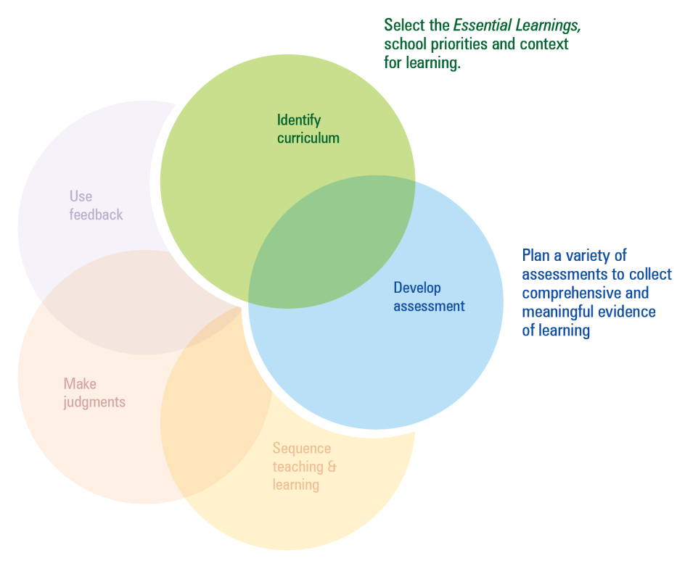  This template can be used to identify curriculum and develop assessment.  Additional planning and auditing resources  APEL is a QSA developed software application to help teachers audit their curriculum and plan units of work using the Essential Learnings. Available from the QSA website <www.qsa.qld.edu.au>.

Time allocation | Unit title | Assessment focus | Assessment techniques | Functions | Grammar | Key vocabulary/topics | Miscellaneous
e.g. 7 weeks | Getting to know you | Comprehending - listening  Composing - speaking  Intercultural competence | Listening to a conversation  Role play - meeting someone  Presentation - cultural protocol | e.g. introducing yourself, greetings, etc. | Konnichiwa mina san (Japanese) | Interest, hobbies, age, family | script

Languages — Lower intermediate stage
Ways of working |  | Units of work
 |  | Semester 1 |  |  |  | Semester 2 |  |  |  | Semester 1 |  |  |  | Semester 2
Key: Teaching and learning  Assessment | Unit title
Students are able to:
- interpret ideas and information in spoken and written texts and make judgments about the ways that people, places, events and things are represented
- locate, analyse and respond in the target language to information on topics and issues of significance to members of the target cultures of a similar age
- plan, monitor and adjust verbal and non-verbal language to suit the role, purpose, context and audience
- construct spoken and written texts that present an argument, perspective or opinion
- recognise that texts are culturally constructed, and analyse embedded cultural information
- notice and compare similarities and differences in text formats, language and style between similar texts in the target language and English, and/or other familiar languages, to inform intercultural communication
- notice and compare beliefs, values and practices in target language texts to identify the author’s purpose and audience
- reflect on and evaluate the appropriateness of their own and others’ language choices in target language texts for purpose, context and audience
- reflect on and evaluate learning to evaluate and apply new understandings and future applications.

Languages — Lower intermediate stage
Knowledge and understanding |  | Units of work
 |  | Semester 1 |  |  |  | Semester 2 |  |  |  |  |  | Semester 1 |  |  |  |  | Semester 2
Key: Teaching and learning  Assessment | Unit title
Comprehending and composing in the target language: Comprehending and composing texts for particular purposes, contexts
and audiences requires knowledge about the interrelations among purpose, text type, audience, mode and medium.
- Verbal language and non-verbal language are adapted, based on role, purpose, context, audience, mode and medium.
- Context, vocabulary and syntax combine to provide cues to the purpose and meaning of texts.
- High-frequency forms and identification of register help when interpreting complex language involving dependent clauses.
- Ideas and information can be expressed through a variety of text types and language adjusted to suit formal and informal contexts
- Language can be manipulated to make original and extended texts that are organised according to sociocultural conventions.
- Common colloquial expressions are used in communication and these can be regional in their use and often meaningless when translated word for word.
Intercultural competence and language awareness: Intercultural competence and knowledge of languages and cultures allow
for differing ways of experiencing, acting in and viewing the world.
- Regional and social diversity exists within and across languages and cultures, and this diversity informs appropriate communication.
- Familiarity with issues and topics of significance to members of the target culture enhances intercultural communication.
- Beliefs, values and attitudes are embedded in languages and cultures; and knowledge of these aspects can facilitate intercultural communication.

Languages — Lower intermediate stage
 |  | Units of work
 |  | Semester 1 |  |  |  | Semester 2 |  |  |  | Semester 1 |  |  |  | Semester 2
Assessable elements | Unit title
Students demonstrate evidence of their learning over time in relation to the following assessable elements:
Knowledge and understanding
Comprehending texts
Composing texts
Intercultural competence
Reflecting

Queensland Studies Authority
295 Ann Street, Brisbane
PO Box 307 Spring Hill
QLD 4004 Australia
T +61 3864 0299
F +61 3221 2553
www.qsa.qld.edu.au

