Languages — Elementary stage
Planning and auditing template

About this template  This resource is intended to help you plan teaching, learning and assessment of the Essential Learnings across the curriculum. It can be used to:  - audit existing units  - plan new units of work.  The purpose of this template is to provide information for Languages — Elementary stage focusing on:  - Ways of working  - Knowledge and understandings (conceptual statements only)  - Assessable elements.  Using the form features  This template is a protected MS Word form document — it allows you to enter unit titles in the shaded areas and check and uncheck boxes by clicking on them.  To make any other changes to the template, turn off the MS Word protection feature:  - Open the document in MS Word.  - Display the Forms toolbar: from the top menu, select View > Toolbars > Forms.  - On the Forms toolbar, click on the Protect forms icon (padlock).  Reactivate protection by clicking on padlock when needed. | Five processes that guide planning  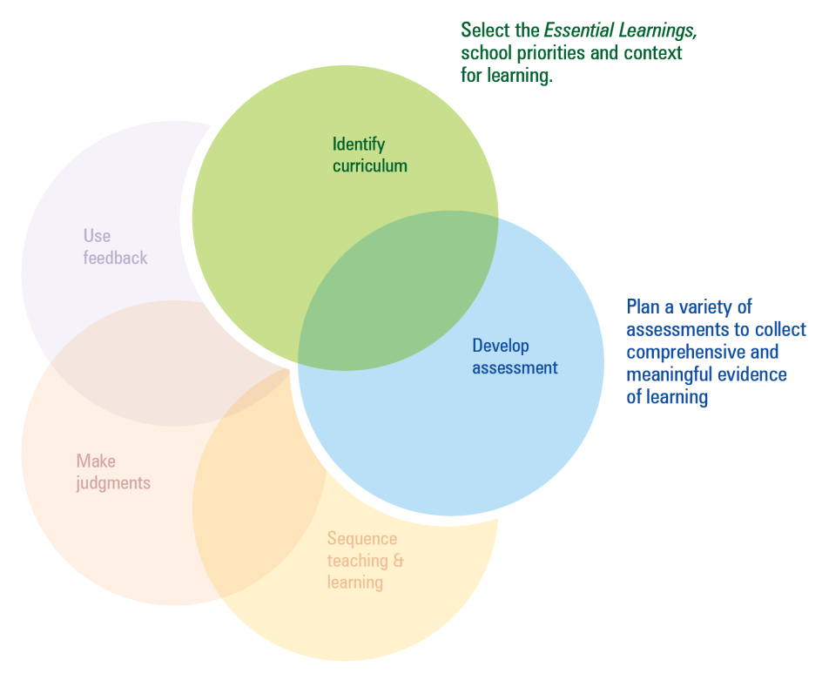  This template can be used to identify curriculum and develop assessment.  Additional planning and auditing resources  APEL is a QSA developed software application to help teachers audit their curriculum and plan units of work using the Essential Learnings. Available from the QSA website <www.qsa.qld.edu.au>.

Time allocation | Unit title | Assessment focus | Assessment techniques | Functions | Grammar | Key vocabulary/topics | Miscellaneous
e.g. 7 weeks | Getting to know you | Comprehending - listening  Composing - speaking  Intercultural competence | Listening to a conversation  Role play - meeting someone  Presentation - cultural protocol | e.g. introducing yourself, greetings, etc. | Konnichiwa mina san (Japanese) | Interest, hobbies, age, family | script

Languages — Elementary stage
Ways of working |  | Units of work
 |  | Semester 1 |  |  |  | Semester 2 |  |  |  | Semester 1 |  |  |  | Semester 2
Key: Teaching and learning  Assessment | Unit title
Students are able to:
- interpret a range of spoken and written texts in different contexts where familiar and some unfamiliar language is used
- interpret and respond by manipulating some elements of language to contribute to conversations for different purposes, contexts and audiences
- recognise and use appropriate verbal and non-verbal language to support the development of communicative competence
- select and apply strategies to adjust verbal and nonverbal language for a variety of purposes, contexts and audiences, and respond appropriately to feedback
- construct simple, cohesive spoken and written texts for different contexts, displaying some concept of register
- notice and compare similarities and differences between the target language and English and/or other familiar languages
- notice and compare their own beliefs, attitudes and practices and those reflected in the target culture
- reflect on and evaluate the suitability of language choices for purpose, context and audience
- reflect on learning, apply new understandings and identify future applications.

Languages — Elementary stage
Knowledge and understanding |  | Units of work
 |  | Semester 1 |  |  |  | Semester 2 |  |  |  |  |  | Semester 1 |  |  |  |  | Semester 2
Key: Teaching and learning  Assessment | Unit title
Comprehending and composing in the target language: Comprehending and composing skills are used to understand language input, to convey
information and express ideas and opinions, and to engage in interactions in the target language for different purposes, contexts and audiences.
- Verbal language and non-verbal language are adapted according to purpose, context and audience.
- Texts, including conversations and narratives, follow patterns and are shaped by conventions that can vary between cultures.
- Familiar language can be used in new contexts to help interpret and convey main ideas and supporting details.
- Familiar linguistic features and structures are manipulated to generate original target language texts and to construct simple, cohesive texts for different purposes, contexts and audiences.
Intercultural competence and language awareness: Intercultural competence and knowledge of languages and cultures allow
for exploration of different ways of experiencing and acting in the world.
- Ideas or information may or may not be transferable from one language to another and can provide cultural insights and information.
- Cultural practices in the target language can be compared with those of other cultures and connections noticed between language use and cultural knowledge and behaviour.
- Investigations into language use and cultural beliefs, attitudes and practices further develop intercultural competence.

Languages — Elementary stage
 |  | Units of work
 |  | Semester 1 |  |  |  | Semester 2 |  |  |  | Semester 1 |  |  |  | Semester 2
Assessable elements | Unit title
Students demonstrate evidence of their learning over time in relation to the following assessable elements:
Knowledge and understanding
Comprehending texts
Composing texts
Intercultural competence
Reflecting

Queensland Studies Authority
295 Ann Street, Brisbane
PO Box 307 Spring Hill
QLD 4004 Australia
T +61 3864 0299
F +61 3221 2553
www.qsa.qld.edu.au

