Templates for curriculum and assessment
The planning templates can be used by schools to:
- identify the Essential Learnings to be targeted in units of work
- identify the assessable elements and suggested assessment evidence
- align curriculum within and across junctures.
The templates could be used in a variety of ways, e.g. to plan curriculum intent for a two-year period, or to record the curriculum that was implemented through negotiation with students. Consider using by KLA, or through an integrated (or connected) approach.
The attached template presents one approach to curriculum and assessment planning. Other templates are available from the QSA website <www.qsa.qld.edu.au>.

Other planning and auditing resources
The QSA website <www.qsa.qld.edu.au> has a range of resources to help schools plan and audit their curriculum.
APEL is a QSA developed software application to help teachers audit their curriculum and plan units of work using the Essential Learnings.
Juncture work plan templates enable detailed auditing of curriculum plans and identification of specific teaching, learning and assessment across a juncture.

Planning resources
The following diagram shows the key processes to consider when planning units of work. The supporting resources noted in the diagram are available from the QSA website <www.qsa.qld.edu.au>.
The five processes can be used in any sequence, but all should be considered.

Five processes that guide planning
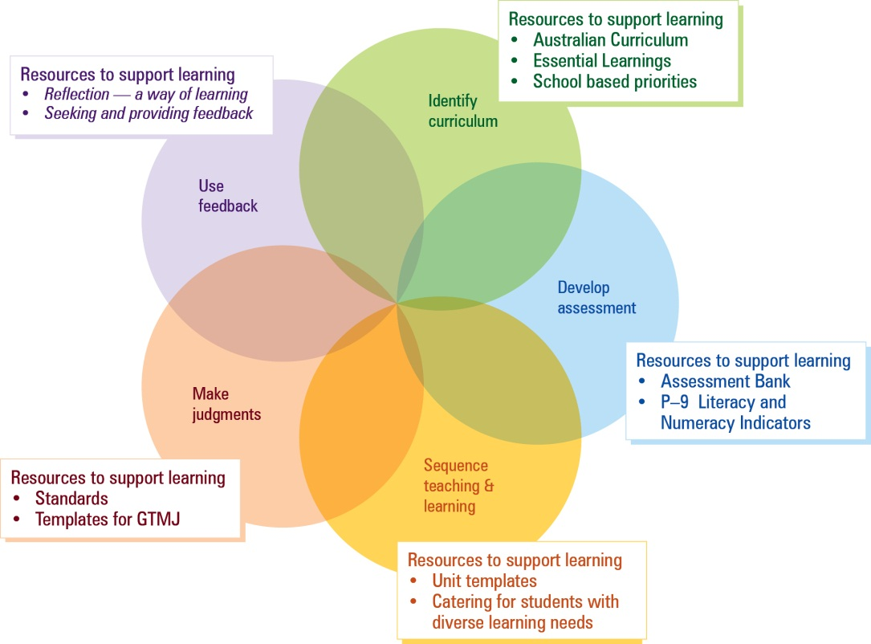
Source: QSA 2008, Building Student Success: A guide to the Queensland Curriculum, Assessment and Reporting Framework.

 |  | Knowledge and understanding | Ways of working | Assessment |  | Knowledge and understanding | Ways of working | Assessment
Term 1 | Year level — Unit title | KLA |  | Assessment evidence  Assessable elements | Year level — Unit title | KLA |  | Assessment evidence  Assessable elements
 |  | KLA |  | Assessment evidence  Assessable elements |  | KLA |  | Assessment evidence  Assessable elements
 |  | KLA |  | Assessment evidence  Assessable elements |  | KLA |  | Assessment evidence  Assessable elements
 |  | KLA |  | Assessment evidence  Assessable elements |  | KLA |  | Assessment evidence  Assessable elements
 |  | KLA |  | Assessment evidence  Assessable elements |  | KLA |  | Assessment evidence  Assessable elements
 |  | KLA |  | Assessment evidence  Assessable elements |  | KLA |  | Assessment evidence  Assessable elements
 |  | KLA |  | Assessment evidence  Assessable elements |  | KLA |  | Assessment evidence  Assessable elements
 |  | Literacy:  Numeracy: |  |  |  | Literacy:  Numeracy:
 |  | ICTs cross-curriculum priorities: |  |  |  | ICTs cross-curriculum priorities:

 |  | Knowledge and understanding | Ways of working | Assessment |  | Knowledge and understanding | Ways of working | Assessment
Term 2 | Year level — Unit title | KLA |  | Assessment evidence  Assessable elements | Year level — Unit title | KLA |  | Assessment evidence  Assessable elements
 |  | KLA |  | Assessment evidence  Assessable elements |  | KLA |  | Assessment evidence  Assessable elements
 |  | KLA |  | Assessment evidence  Assessable elements |  | KLA |  | Assessment evidence  Assessable elements
 |  | KLA |  | Assessment evidence  Assessable elements |  | KLA |  | Assessment evidence  Assessable elements
 |  | KLA |  | Assessment evidence  Assessable elements |  | KLA |  | Assessment evidence  Assessable elements
 |  | KLA |  | Assessment evidence  Assessable elements |  | KLA |  | Assessment evidence  Assessable elements
 |  | KLA |  | Assessment evidence  Assessable elements |  | KLA |  | Assessment evidence  Assessable elements
 |  | Literacy:  Numeracy: |  |  |  | Literacy:  Numeracy:
 |  | ICTs cross-curriculum priorities: |  |  |  | ICTs cross-curriculum priorities:

 |  | Knowledge and understanding | Ways of working | Assessment |  | Knowledge and understanding | Ways of working | Assessment
Term 3 | Year level — Unit title | KLA |  | Assessment evidence  Assessable elements | Year level — Unit title | KLA |  | Assessment evidence  Assessable elements
 |  | KLA |  | Assessment evidence  Assessable elements |  | KLA |  | Assessment evidence  Assessable elements
 |  | KLA |  | Assessment evidence  Assessable elements |  | KLA |  | Assessment evidence  Assessable elements
 |  | KLA |  | Assessment evidence  Assessable elements |  | KLA |  | Assessment evidence  Assessable elements
 |  | KLA |  | Assessment evidence  Assessable elements |  | KLA |  | Assessment evidence  Assessable elements
 |  | KLA |  | Assessment evidence  Assessable elements |  | KLA |  | Assessment evidence  Assessable elements
 |  | KLA |  | Assessment evidence  Assessable elements |  | KLA |  | Assessment evidence  Assessable elements
 |  | Literacy:  Numeracy: |  |  |  | Literacy:  Numeracy:
 |  | ICTs cross-curriculum priorities: |  |  |  | ICTs cross-curriculum priorities:

 |  | Knowledge and understanding | Ways of working | Assessment |  | Knowledge and understanding | Ways of working | Assessment
Term 4 | Year level — Unit title | KLA |  | Assessment evidence  Assessable elements | Year level — Unit title | KLA |  | Assessment evidence  Assessable elements
 |  | KLA |  | Assessment evidence  Assessable elements |  | KLA |  | Assessment evidence  Assessable elements
 |  | KLA |  | Assessment evidence  Assessable elements |  | KLA |  | Assessment evidence  Assessable elements
 |  | KLA |  | Assessment evidence  Assessable elements |  | KLA |  | Assessment evidence  Assessable elements
 |  | KLA |  | Assessment evidence  Assessable elements |  | KLA |  | Assessment evidence  Assessable elements
 |  | KLA |  | Assessment evidence  Assessable elements |  | KLA |  | Assessment evidence  Assessable elements
 |  | KLA |  | Assessment evidence  Assessable elements |  | KLA |  | Assessment evidence  Assessable elements
 |  | Literacy:  Numeracy: |  |  |  | Literacy:  Numeracy:
 |  | ICTs cross-curriculum priorities: |  |  |  | ICTs cross-curriculum priorities:

