Australian Curriculum Year 9 Science sample assessment ׀ Sample response — Sections 1 and 2

Electric kettles

© The State of Queensland (Queensland Curriculum and Assessment Authority) and its licensors 2014. All web links correct at time of publication.

Image: QCAA

To demonstrate understanding of energy transfer in electric circuits and to investigate factors that affect the transfer of energy.
You will:
- Use the particle model and the relationships between energy, power, voltage, current and resistance to demonstrate your understanding of energy transfer in electric circuits.
- Investigate some of the factors that affect energy transfer in electric circuits.
- Plan an investigation to check the power rating of an electric kettle.

Section 1. Explaining how heating elements in electric kettles work
- Electric appliances transform energy from one form to another. Describe the principal energy transformation occurring in an electric kettle.
electrical energy heat energy

- Electric kettles have a power rating measured in watts. Describe the relationship between power and energy.
Power is the rate at which an appliance uses energy.

- Write the formula that shows how power, energy and time relate to each other (include units).
Power (watts) = energy (joules) / time (seconds)

- Write the formula for calculating the electrical power from the voltage applied to a heating element and the current flowing through it (include units).
Power (watts) = voltage (volts) x current (amps)

- Heating elements are made from metals that are electrical resistors. Ohm’s law shows how the current changes when the voltage across a resistor is changed.
- Write the formula for Ohm’s law (include units)
- Describe the relationship between current and voltage.
Ohm’s law states that:
Current (amps) = voltage (volts) / resistance (ohms).
The current flowing increases as the voltage increases.
Also, the smaller the resistance, the larger the current.

- Use the formulas in questions 4 and 5 to give the formula for calculating power from resistance and voltage (include units and show all working).
If: current = voltage / resistance and power = voltage x current
Then: voltage / resistance = power / voltage
Which means power = voltage² (volts²) / resistance (ohms)

- With reference to the particles that make up a resistor, draw a labelled diagram to support an explanation of how electrical energy is transformed into heat when the resistor is connected in an electric circuit.
An electric circuit allows an electric current to flow. As electrons flow through the resistor they collide with the metal atoms in the wire. These collisions convert electrical energy to heat energy.
Atoms in resistor
Path of electron

Section 2. Identifying factors that affect energy transfer in electric circuits
Nichrome wire is commonly used to make heating elements because it is a good electrical resistor. The size of the nichrome wire affects the properties of the electric circuit.

Question to be investigated
What effect does changing the thickness and length of a piece of nichrome wire have on the circuit measurements of voltage, current and resistance?

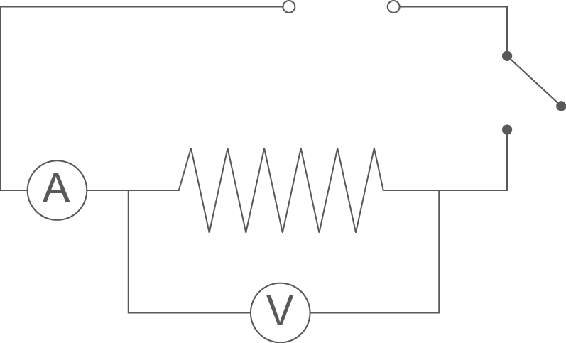
Materials
- variable power supply (power pack)
- ammeter and voltmeter or 2 multimeters
- switch
- 6 connecting wires, with alligator clips
- heatproof mat
- 50 cm and 100 cm lengths of 20 swg (0.91 mm diameter) nichrome wire
- 50 cm and 100 cm lengths of 26 swg (0.46 mm diameter) nichrome wire

Risk assessment
- a. Identify potential safety risks for this investigation.
  - Describe how to manage these safety risks.
Risk | Management strategies
Electric shock | Connect the power pack using DC. Keep water away from the power pack.
Overheating of the nichrome wire | Use 2 volts DC. Only turn the switch in the circuit long enough to take readings on the ammeter and voltmeter. Use a heatproof mat under the wire.
Damaging the ammeter or voltmeter | Connect the voltmeter in parallel and the ammeter in series. Connect the positive terminals. Get the teacher to check your circuit before you turn it on.
Burns | Place the wire on the heat proof mat and keep hands clear of wire.

Method
      - Using the 50 cm coil of 20 swg nichrome wire as a resistor, set up the electric circuit shown in the diagram above. Make sure the ammeter is connected in series with the resistor, and the voltmeter is parallel across it.
      - Place the circuit on the heatproof mat.
      - Set the power pack to 2 volt DC.
      - Close the switch, read the voltmeter and ammeter as quickly as possible, then open the switch.
      - Record the voltage (V) and the current (I) in the results table below.
      - Repeat steps 3–5 for 4 volts DC and 6 volts DC.
      - Repeat the investigation using the 100 cm length of 20 swg nichrome wire as a resistor.
      - Repeat the investigation using the 50 cm length of 26 swg nichrome wire as a resistor.
      - Repeat the investigation using the 100 cm length of 26 swg nichrome wire as a resistor.

Results
- Once you have recorded the values for voltage (V) and current (I) collected during the investigation, complete the results table by:
  - using Ohm’s law to calculate the resistance (R) for each trial
  - calculating the average resistance for each circuit.
Length of wire (cm) | Thickness of wire (swg) | Voltage  (volts) | Current  (amps) | Resistance (ohms) | Average resistance  (ohms)
50 | 20  (0.91 mm) | 1.4 | 1.8 | 0.78 | 0.96
 |  | 2.7 | 3.4 | 0.79
 |  | 4.8 | 3.8 | 1.3
50 | 26  (0.46 mm) | 1.8 | 0.6 | 3.0 | 3.1
 |  | 3.2 | 1.0 | 3.2
 |  | 4.8 | 1.5 | 3.2
100 | 20  (0.91 mm) | 1.6 | 0.5 | 3.2 | 1.7
 |  | 2.5 | 1.9 | 1.3
 |  | 2.7 | 4.4 | 0.6
100 | 26  (0.46 mm) | 2.0 | 0.3 | 6.7 | 5.2
 |  | 3.6 | 0.6 | 6.0
 |  | 5.2 | 1.8 | 2.9

Data analysis
- Use the data in the results table to identify the relationships in the table below.
Circuit measurement | Relationship to wire thickness | Relationship to wire length
Resistance | The resistance increases as the wire thickness decreases. | The resistance increases as the wire length increases.
Current | For a particular voltage, the current decreases as the wire thickness decreases. | For a particular voltage, the current decreases as the wire length increases
Voltage | The voltage is set by the power supply and does not change as the wire thickness changes. | The voltage is set by the power supply and does not change as the wire length changes.

Discussion
- Use the particle model to explain the relationships you identified in the data analysis table above.
If the thickness of the wire decreases, the resistance increases because there is less cross-sectional area for electrons to travel and therefore fewer paths available for the movement of electrons between the atoms of the wire. This means current will decrease because fewer electrons will pass a certain point over time. The voltage does not change because it is set by the power pack and is not affected by the changes in the thickness of the nichrome wire.

If the length of the wire increases, the resistance increases because the electrons have further to go, so there will be more collisions with atoms in the material. This means current will decrease because fewer electrons will pass a certain point over time. The voltage does not change because it is set by the power pack and is not affected by the changes in the length of the nichrome wire.

