|  |  |
| --- | --- |
|  | Australian Curriculum Year 8 Science sample assessment ׀ Sample response  Energy test |

© The State of Queensland (Queensland Curriculum and Assessment Authority) and its licensors 2014. All web links correct at time of publication.

|  |
| --- |
| *C:\Users\dmur\AppData\Local\Microsoft\Windows\Temporary Internet Files\Content.IE5\MYQK62BU\13560967873_d7716a7214_b.jpg* |
| Image: *Potential and Kinetic energy*, Slyavula Education, Creative Commons Attribution 2.0, <https://flic.kr/p/mEmSYE> |

|  |
| --- |
| Solve problems about changes within systems caused by energy transfers and transformations. |
| You will:   * identify types of energy and describe transformations * analyse and calculate the efficiency of energy-transformation devices * solve problems by calculating gravitational potential energy and kinetic energy * link knowledge of thermal energy to change of state * analyse data to draw conclusions and evaluate claims. |

# List of equations

The following equations are required to solve some of the questions in this test

$$GPE=m×g×h$$

$$KE=1/2mv^{2}$$

# Part A: Short-response questions

1. Complete the table below to identify the energy transformation caused by each energy converter.

|  |  |  |
| --- | --- | --- |
| Main energy form used | Energy converter | Main energy form produced |
| electrical | toaster | heat |
| chemical potential | torch | light |
| chemical potential | car | kinetic |
| chemical potential | iPod | sound |

1. This toy car moves when you wind it up and let it go.

**Diagram 1: Wind-up toy car**

WindUpCar

Complete the energy chain below to identify three energy transformations starting with a person, winding the toy, to the toy moving.

|  |  |  |  |  |  |  |
| --- | --- | --- | --- | --- | --- | --- |
| Chemical | 🢡 | Kinetic | 🢡 | Elastic potential | 🢡 | Kinetic |

**Shade the bubble of your chosen response for Questions 3 to 5.**

**In the space provided under each question show all working or provide full explanations to justify your choice of answer.**

1. What is the kinetic energy of a 0.158 kg cricket ball travelling at 28 m/s?

* 61 936 J
* 4.42 J
* 247.74 J
* 61.94 J

KE = ½ mv2

KE = ½ x 0.158 x 282

KE = 61.94 J

1. Janie is at the top of a ski run which is elevated 40 vertical metres above the ground. Her mass (including her equipment) is 60 kg. Calculate her gravitational potential energy at the top of the slope.

**Diagram 2: Ski run**

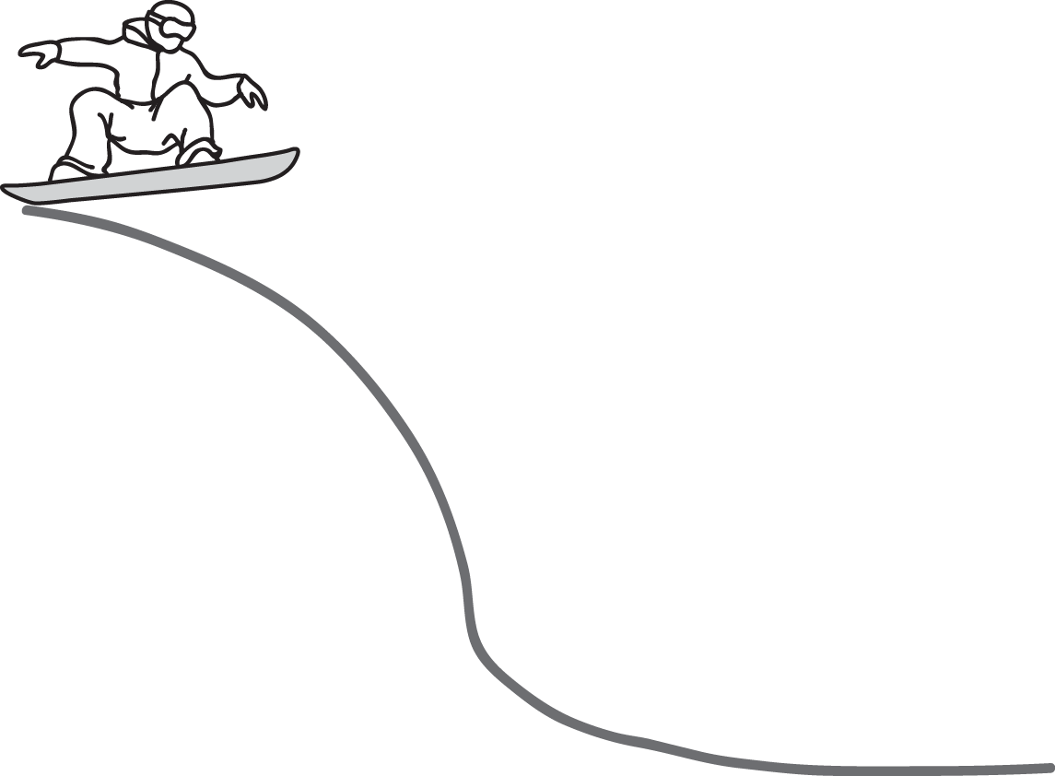

* 23 520J
* 109.8 J
* 940 800 J
* 8 160 J

GPE = mgh

GPE = 60 x 9.8 x 40

GPE = 23 520 J

1. Consider points A, B, C and D on the roller coaster in the diagram below.

**Diagram 3: Roller coaster**

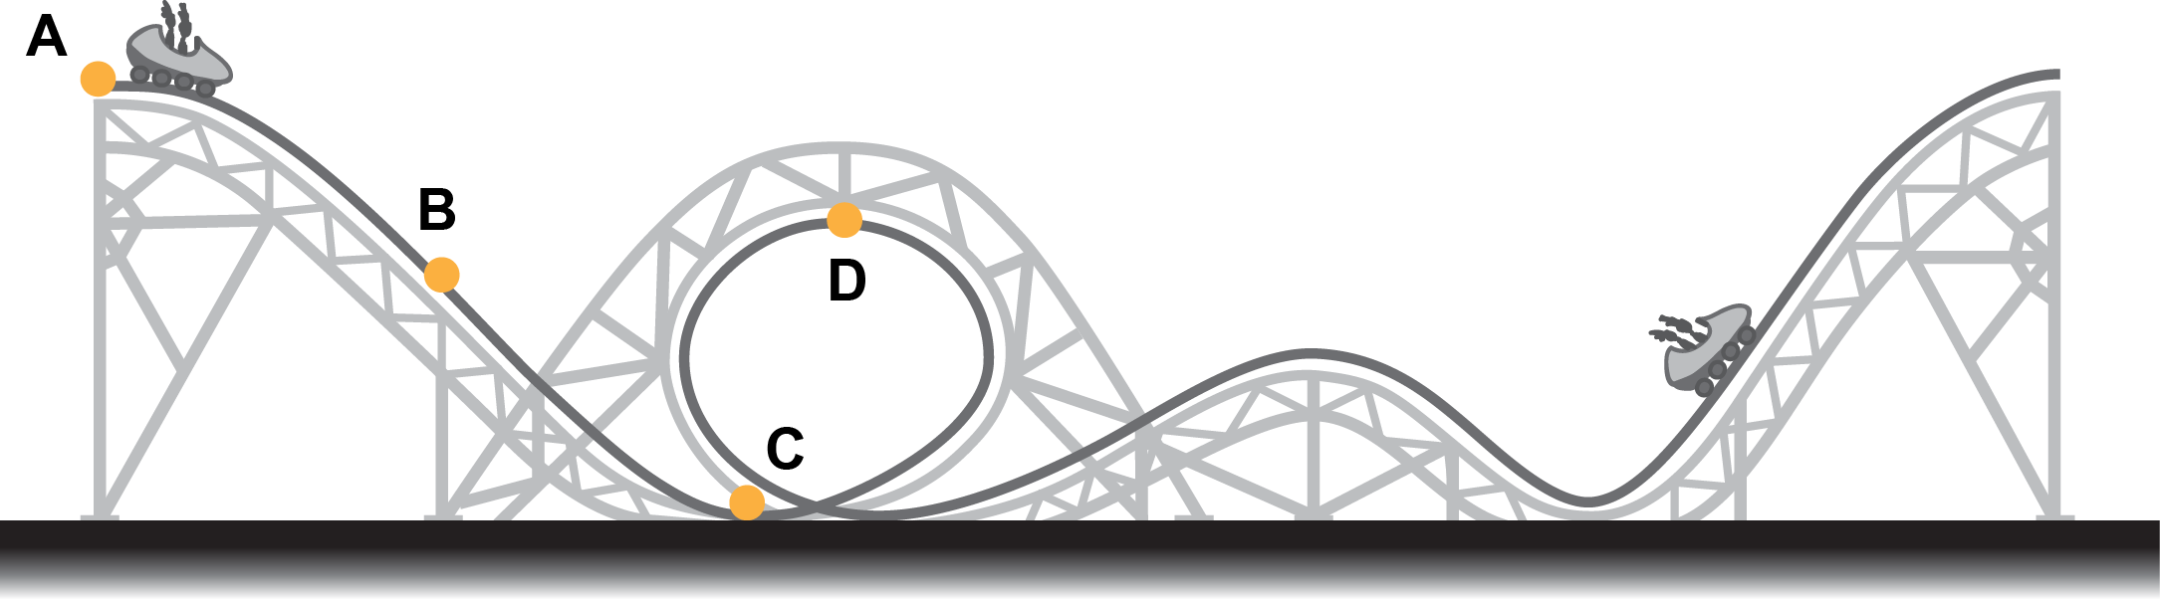

At which point does the roller coaster have the greatest gravitational potential energy?

* A
* B
* C
* D

The roller coast has the greatest gravitational potential energy at point A.

GPE = mgh

Point A is where the roller coaster has the greatest height, hence the greatest GPE.

1. Quantitatively analyse the information in the diagrams below and:
   1. compare the efficiency of the energy transformation in a filament electric light bulb with that of an energy efficient electric light bulb
   2. describe the safety advantages of using energy efficient electric light bulbs in preference to filament light bulbs.

**Diagram 4: Energy transformations of a filament electric light bulb**

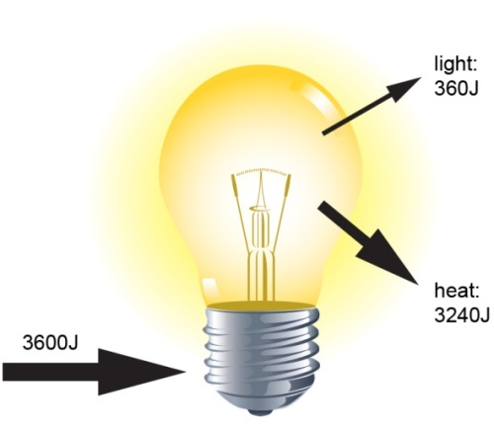

**Diagram 5: Energy transformations of an energy efficient electric light bulb**

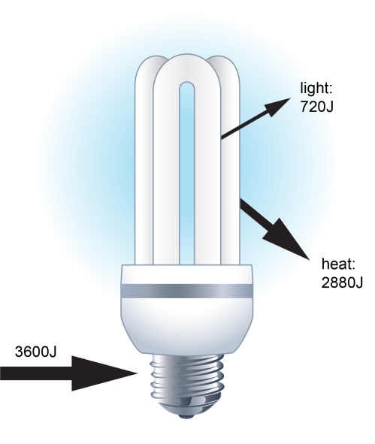

Light bulbs are designed to transform electrical energy into light.

The diagrams show that this is not a very efficient process because a significant amount of the energy is lost as heat, regardless of the type of bulb. However filament electric light bulbs are less efficient than energy efficient electric light bulbs as they lose 90% of electrical energy to heat compared to 80%.

The heat produced is a safety concern as hot bulbs can cause burns. Energy efficient bulbs produce less heat hence are safer than filament bulbs.

1. Diagram 6 shows a skateboard rider performing a trick on a ramp.

**Diagram 6: Path of skateboard rider**

|  |  |
| --- | --- |
| C:\Users\dmur\AppData\Local\Microsoft\Windows\Temporary Internet Files\Content.Outlook\XRDRPMZV\Skateboarder air-123path.png | **----------** Path of the rider |

* 1. Choose the graph in the table below that best represents the potential and kinetic energy of the rider at each of the positions 1, 2 and 3. NOTE: There are two graphs that will not be used when answering this question.
  2. Justify your choices.

|  |  |  |  |  |
| --- | --- | --- | --- | --- |
| **Graph 1** | **Graph 2** | **Graph 3** | **Graph 4** | **Graph 5** |
| C:\Users\dmur\AppData\Local\Microsoft\Windows\Temporary Internet Files\Content.Outlook\XRDRPMZV\A.jpg | C:\Users\dmur\AppData\Local\Microsoft\Windows\Temporary Internet Files\Content.Outlook\XRDRPMZV\B.jpg | C:\Users\dmur\AppData\Local\Microsoft\Windows\Temporary Internet Files\Content.Outlook\XRDRPMZV\14245_C_v2_nv (2).jpg | C:\Users\dmur\AppData\Local\Microsoft\Windows\Temporary Internet Files\Content.Outlook\XRDRPMZV\D.jpg | C:\Users\dmur\AppData\Local\Microsoft\Windows\Temporary Internet Files\Content.Outlook\XRDRPMZV\E.jpg |

Position 1 is best represented by Graph 4 because as the height of the skateboarder is increasing, their kinetic energy is decreasing due to falling velocity (KE = 1/2mv2) and their gravitational potential energy is increasing due to increasing height (GPE = mgh). At this point their gravitational potential energy will be greater than their kinetic energy — though not significantly.

Position 2 is best represented by Graph 3 because at the top of the arc the skateboarder will have no kinetic energy, i.e. will momentarily stop moving   
(KE = 1/2mv2), but will have maximum gravitational potential energy as their height is at a maximum (GPE = mgh).

Position 3 is best represented by Graph 5 because as the height of the skateboarder decreases their gravitational potential energy will fall (GPE = mgh) and their kinetic energy will increase as their velocity increases (KE = 1/2mv2).   
At this point their kinetic energy will be significantly greater than their gravitational potential energy.

1. Cooling milk quickly for storage is an important part of the food safety plan of every dairy farm. Farmers in Australia must cool their milk to 5 °C within 3½ hours from the commencement of milking.

***FOOD SAFETY CERTIFICATE***

🗹 …

🗹 Milk is cooled to 5 °C within 3 ½ hours from the commencement of milking.

🗹 …



A farm is investigating different methods of cooling its milk.

The temperature of the milk is measured regularly after milking a herd of cows.

The graph below shows the drop in temperature of the milk over time using different methods of cooling.

**Diagram 7: The cooling rates of milk using different methods.**

|  |  |
| --- | --- |
| C:\Users\dmur\AppData\Local\Microsoft\Windows\Temporary Internet Files\Content.Outlook\XRDRPMZV\14245_Year8_Science_milk-temp_v2_nv.png | Source: <http://www.dairytechrefrig.com.au/pre-chilling> |

* 1. Would each of these methods allow the farmer to gain a Food Safety Certificate?   
     Justify your answer.

Yes because each method cools the milk below 5 °C in less than 3 ½ hours (210 minutes).

* 1. Evaluate the accuracy of the claim, ‘The Ice bank cools milk to 10 °C, 50% faster than other methods’.

The ice bank took around 45 minutes to cool to 10 °C and the direct expansion method took 100 minutes. This is more than 50% faster, therefore this data supports the claim.

This is because heat transfer in the ice bank method is more efficient. However it is not faster than the Instant cooling method which only took 10 mins. Therefore the claim is true when compared to some methods but not for others, so it is not specific enough in its detail.

1. A steel ball-bearing of mass 0.2 kg is rolled across a frictionless bench top at 2.0 m/s.   
   It rolls off the edge and falls 2.0 m to the ground as shown in Diagram 8.

**Diagram 8: A falling ball-bearing.**

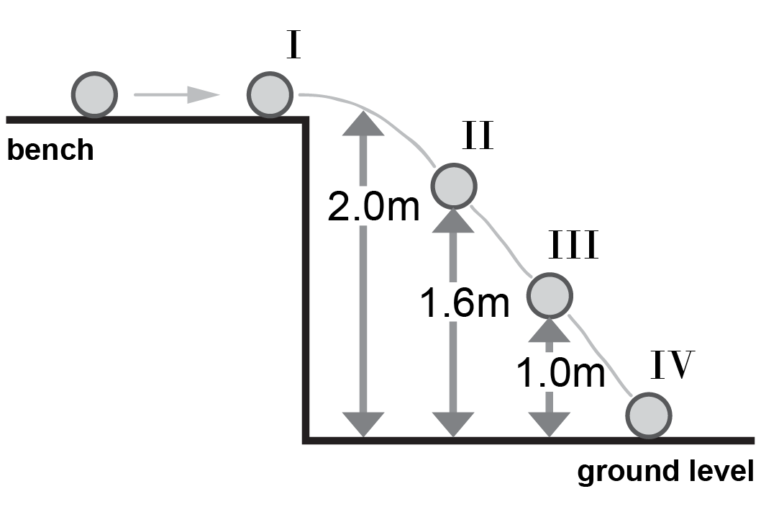

Compare the kinetic energy and the gravitational potential energy of the ball-bearing at position I.

KE = ½ mv2

KE = ½ x 0.2 x 22

KE = 0.4 J

GPE = mgh

GPE = 0.2 x 9.8 x 2

GPE = 3.92 J

The kinetic energy of the ball-bearing at position I is less than the potential energy at the same position.

1. During an experiment, a Year 8 student releases a 500 g cart from rest and accelerates down an inclined plane 1.2 m in length, as shown in Diagram 9.

**Diagram 9: A cart rolling down a ramp**

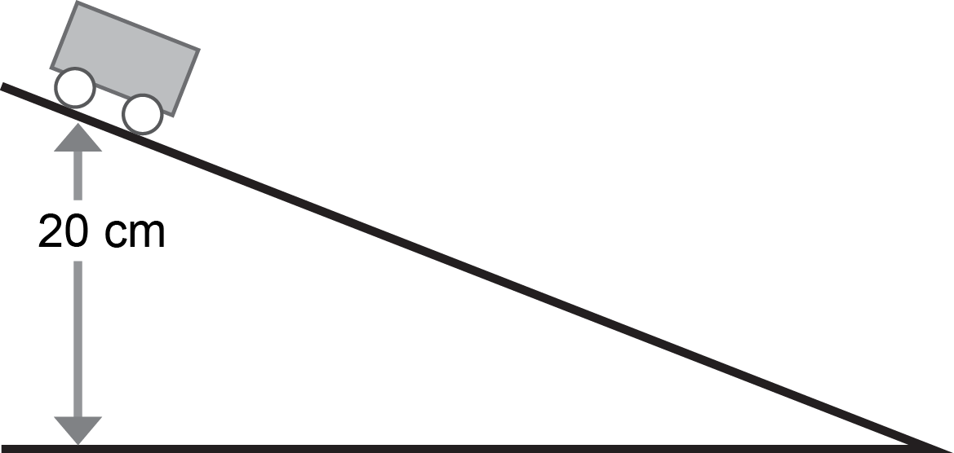

* 1. Given the initial height of the trolley on the inclined plane, calculate the initial gravitational potential energy of the trolley.

500g = 0.5 kg

20 cm = 0.2 m

GPE = mgh

GPE = 0.5 x 9.8 x 0.2

GPE = 0.98 J

* 1. Calculate the kinetic energy of the trolley at the base of the incline if the velocity at the base is 1.7m/s.

KE = ½ mv2

500g = 0.5 kg

KE = ½ x 0.5 x 1.72

KE = 0.72 J

* 1. Calculate the percentage efficiency of the energy transformation.

0.72 J was transformed from gravitational potential energy to kinetic energy.

Hence % efficiency = 0.72/0.98 x 100 = 73.5%

# Part B: Stimulus-response questions

Use the information and data in the stimulus to answer the questions below.

1. Explain what the data indicates about Australia’s total predicted greenhouse gas emissions from transport between 1990–2020.

The data in Figures 1 and 2 indicates that the total greenhouse gas emissions from 1990–2020 in Australia has and will increased.

In 1990 total greenhouse gas emissions was 59 million tonnes which increased to 84 million tonnes in 2007. It is predicted that this total will continue to increase to 104 million tonnes by 2020.

1. On the axes below, sketch graphs that compare the greenhouse gas emissions of cars with trains (rail) from 1990–2020.

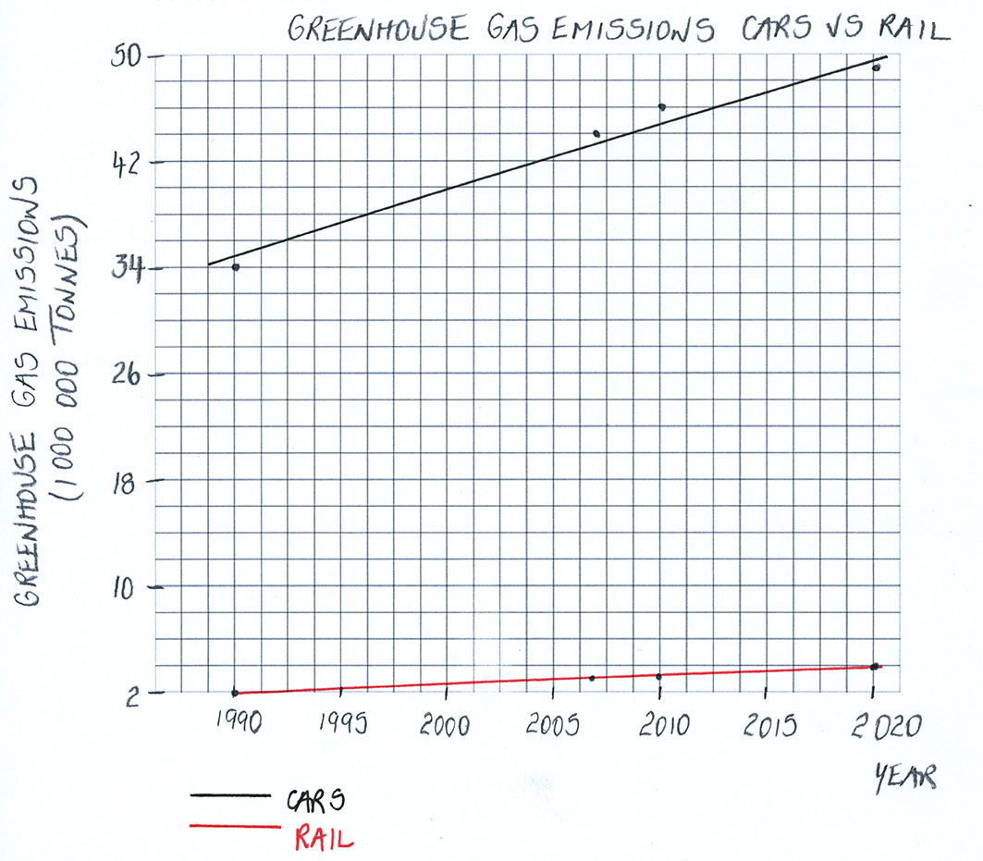

1. Suggest why the UltraBatteryTM was initially targeted at cars rather than trains.

The Australian Government has committed to limiting greenhouse gas emissions.

One of the contributors to greenhouse gas emissions is the burning of fossil fuels for transportation.

The UltraBattery technology provides a storage device for renewable energy such as wind and solar which can be used in hybrid electric vehicles. A hybrid electric vehicle uses both electricity and petrol or diesel which would decrease the volume of gas emissions from the vehicle.

The UltraBattery technology was initially developed to be used in cars rather than trains as the greenhouse gas emissions from cars are significantly more and are predicted to increase significantly more than the emissions from trains.

This is supported by the data in the graph above which shows a steeper graph for greenhouse gas emissions from cars rather than trains. Likewise Figure 1 indicates an increase from 34 million tonnes to 49 million tonnes from 1990–2020 for car emissions and an increase from 2 million tonnes to 4 million tonnes for the same period for trains.