Australian Curriculum Year 4 Science Sample assessment | Sample response
The force of friction
© The State of Queensland (Queensland Studies Authority) and its licensors 2013. All web links correct at time of publication.
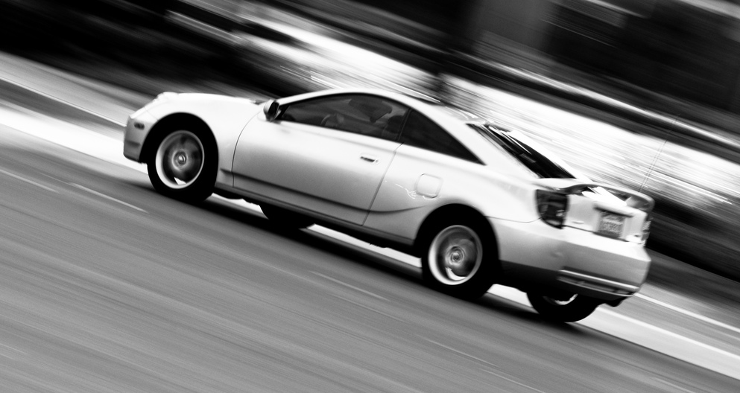
Image: Speed (84/365) by, John Liu, Creative Commons Attribution 2.0, http://flic.kr/p/9tndJN

Students conduct a fair test to establish how friction affects the distance travelled by a toy car.
You will:
- make predictions
- discuss how to make an investigation fair
- conduct an investigation
- record results
- identify patterns in your results
- draw a conclusion
- apply your science knowledge to a real-life situation.

Section 1. Investigating friction
Friction is a force. If something is moving, friction opposes it. Friction is a force that exists whenever two things rub against each other.
You will conduct an investigation about how friction affects the distance a toy car travels.
In your investigation you will roll a toy car down a ramp and on to different surfaces. You will measure how far the car travels along the different surfaces.

Question

What you are trying to find out by doing the investigation?
How does friction affect the distance a toy car will travel?

Prediction

What you think is going to happen in the investigation:
I think the toy car will travel the greatest distance on the laminex surface.
I think this because laminex is very smooth so the friction between the surface and the toy car will be less, which means the car will travel further.
Information for teachers: This response is a sample only to demonstrate the level of reasoning necessary to achieve an A-standard.
Students may predict that the toy car will travel the greatest distance on one of the other surfaces, however, in order to achieve an A-standard they must provide a reasoned justification for their choice.

Materials and equipment

Things you will need to conduct your investigation:
- a toy car
- a ramp from which to launch the toy car
- books (to raise the ramp)
- 3 different surfaces, e.g. concrete, carpet, linoleum, tiles, bench top
- a one-metre measuring tape or ruler

Keeping the investigation fair

Getting the best results you can:
It is important to make sure that this investigation is a fair test.
Have a class discussion with your teacher and class members to complete the table below.
One thing that we will  change each trial | What we will measure | Things that we will keep  the same each trial
the surface the toy car will travel on | how far the toy car will travel | - the toy car used  - the height of the ramp  - the starting point of the car  - the length of the ramp

Method

Follow these steps to conduct your investigation:
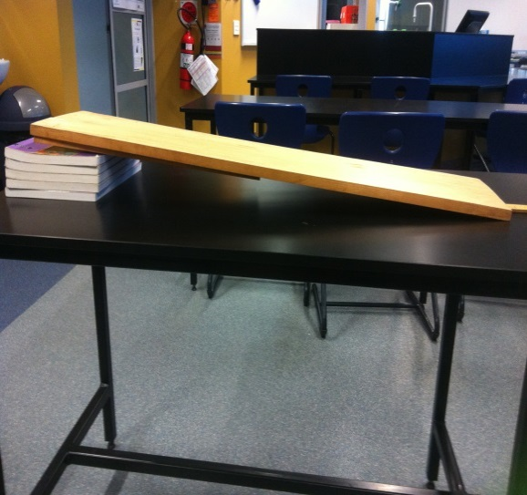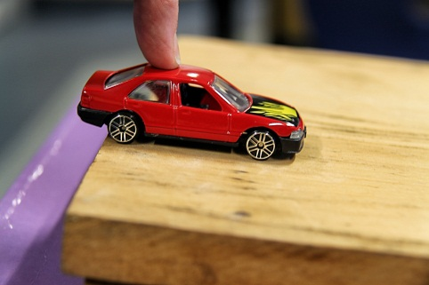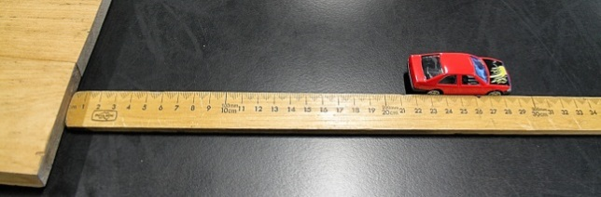
Step 1:
- Set up the equipment using one surface, as shown in the photo below.
- Make sure that there is plenty of room at the end of the ramp for the toy car to roll on to the test surface as it leaves the ramp.
Step 2:
- Place the toy car at the top of the ramp so its back wheels are on the edge of the ramp.
- Hold it in position.
Step 3:
Repeat three times:
- Release the toy car and wait until it stops moving.
- Measure the distance from the end of the ramp to the back wheels of the car.
- Record the distance in centimetres in the results table.
Step 4:
- Repeat steps 1, 2 and 3 for the other two surfaces.

Results

A record of the data you collect during the investigation
- Describe the appearance of each surface, e.g. rough, smooth, bumpy.
- Record the distance the toy car travelled for each trial and each surface.
Table 1: Results data
Surface | Appearance | Distance travelled (cm)
 |  | Test 1 | Test 2 | Test 3
Surface 1: laminex | smooth | 30 | 26 | 28
Surface 2: carpet | textured | 6 | 5 | 7
Surface 3: concrete | rough | 12 | 18 | 19
- Repeating an experiment more than once helps you to be sure that the data you collect is as accurate as possible. No experiment method is perfect so by repeating it a number of times you can recognise any results that may be inaccurate and don’t fit the pattern of the other measurements taken.
In this experiment you repeated the method for each surface three times, but when drawing a column graph from the data you collected you will use only one of the measurements for each surface.
We will assume that the most accurate measurement is the value that sits in the middle of the three measurements you took for each surface.
Complete the table below, using the middle value for each surface from your table of results.
Table 2: Results summary
Surface | Distance travelled (cm)
Surface 1: laminex | 28
Surface 2: carpet | 6
Surface 3: concrete | 18

- Use the values from Table 2 in Question 3 to draw a column graph showing the distance the toy car travelled for each of the three surfaces.
Distance travelled (cm) | Distance travelled over different surfaces
 | 30
 | 29
 | 28
 | 27
 | 26
 | 25
 | 24
 | 23
 | 22
 | 21
 | 20
 | 19
 | 18
 | 17
 | 16
 | 15
 | 14
 | 13
 | 12
 | 11
 | 10
 | 9
 | 8
 | 7
 | 6
 | 5
 | 4
 | 3
 | 2
 | 1
 | 0 | laminex |  |  | carpet |  |  | concrete
 |  | Surface

Discussion

Describe and explain your results using evidence from the investigation and your science knowledge.
- Over which surface did the toy car travel the greatest distance? laminex
Was friction high or low between this surface and the wheels of the toy car? low
Use the evidence from the results table and the column graph and your observation of the surface to explain how you know this.
The surface of the laminex is smooth which means it does not have a lot of friction when the toy car travels over it. My results table shows that the toy car travelled 28 cm over the laminex surface. The laminex column is also the tallest column on my column graph. This means that the toy car travelled the greatest distance over this surface.
- Over which surface did the toy car to travel the smallest distance? carpet
Was friction high or low between this surface and the wheels of the toy car? high
Use the evidence from the results table and the column graph and your observation of the surface to explain how you know this.
The surface of the concrete is rough which means it has a lot of friction when the toy car travels over it. My results table shows that the toy car travelled 6 cm over the concrete surface. The concrete column is also the shortest column on my column graph. This means that the toy car travelled the smallest distance over this surface.
Information for teachers: These responses are samples only to demonstrate the level of explanation and justification necessary to achieve an A-standard.
Students may present an alternative explanation and justification; however, these must be reasonable and based on the data collected in the investigation.

Conclusion

What did you find out?
- Was the investigation question answered? (circle one) Yes / No
- Was your prediction correct? (circle one) Yes / No
- How does friction affect the distance a toy car will travel?
The greater the friction, the smaller distance the toy car travels.

Section 2. Applying your science knowledge
In Section 1, we investigated how friction affects the movement of objects. Sometimes friction can be an advantage, and sometimes it is a disadvantage. It depends on the situation.
Choose one photo, and circle its name.
Slippery slide  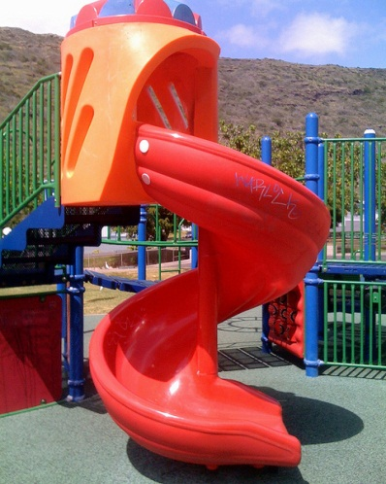  Image: Space savings, kimubert, Creative Commons Attribution 2.0, www.flickr.com/photos/treevillage/8591237012/in/photostream | Running shoes  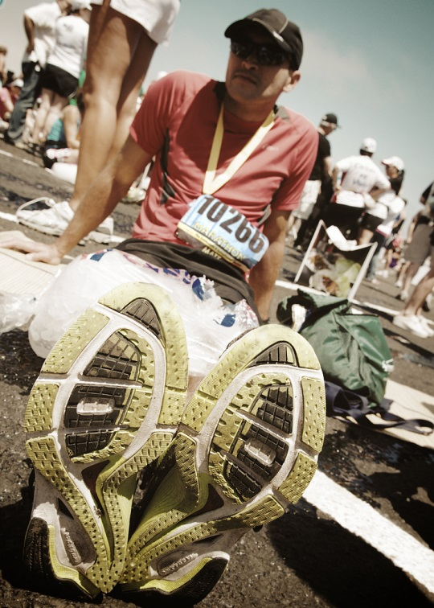  Image: 26 miles of rock and roll, George Ruiz, Creative Commons Attribution 2.0, www.flickr.com/photos/29946035@N08/4735345767/in/photolist-8drTjx-cJMR5y-8EehNW

- Is friction an advantage or disadvantage in this situation? advantage / disadvantage
(circle one)
- Explain why friction is an advantage or disadvantage in this situation.
Friction would be a disadvantage on a slippery slide. When going down a slide, you want to be able to slide easily otherwise it won’t be fun travelling down it. The surface of the slippery slide is smooth so you slide easily, and things that are smooth have low friction when other things move over them.
Information for teachers: This response is a sample only, and demonstrates the level of explanation necessary to achieve an A-standard.
Students may present alternative explanations which are reasonable and based on the science knowledge learned in the investigation.

