Australian Curriculum Year 3 Science sample assessment ׀ Sample response

Cool it!

© The State of Queensland (Queensland Curriculum and Assessment Authority) and its licensors 2014. All web links correct at time of publication.

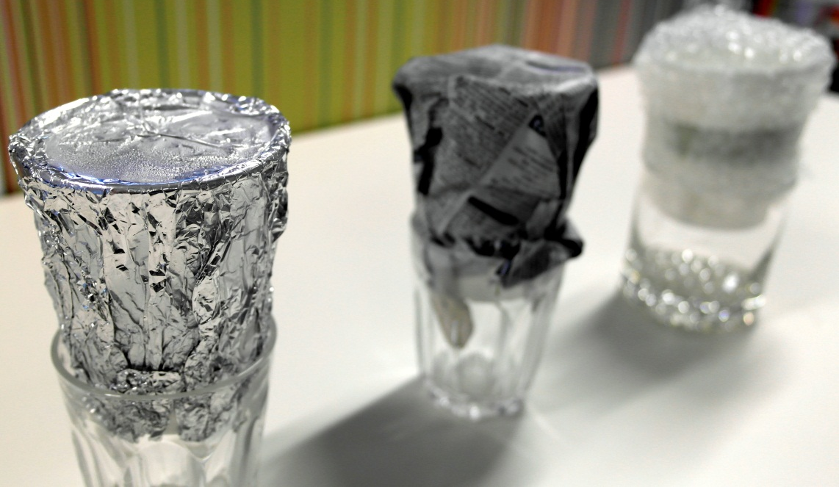
Image: Theo Clark, Creative Commons Attribution 2.0

Conduct an investigation to determine which insulator will keep ice solid for longer.
You will:
- make predictions
- conduct an investigation
- record results
- explain your results
- apply your science knowledge to a real-life situation.

Section 1. Making predictions
Question | What you are trying to find out by doing the investigation.
Which insulator will keep ice solid for longer: bubble wrap, newspaper or aluminium foil?
Prediction | What you think is going to happen in the investigation.
I think the bubble wrap will be the best insulator and will keep the ice solid for longer.
I think this because the bubble wrap is the thickest of the three materials so I think it will take longer for heat to travel through it. This means that the ice inside the plastic bottle will stay solid for longer than the other two insulators.

Information for teachers: This response is a sample only to demonstrate the level of reasoning necessary to achieve an A standard.
Students may predict that one of the other insulators will keep the ice solid for longer; however, in order to achieve an A standard they must provide a reasoned justification for their choice.

Section 2. Conducting the investigation
Materials and equipment | The things you will need to do the investigation.
- three empty 250 mL plastic juice or water bottles
- one sheet each of bubble wrap, newspaper and aluminium foil — enough to cover the bottles
- sticky tape
- three drinking glasses/cups
- a 250 mL measuring cup
- a medicine glass
- water
- a stopwatch
- a freezer

Method | The steps you will follow during the investigation.

Step 1  - Use the measuring cup to measure exactly 150 mL of water.  - Pour into one of the empty plastic juice or water bottles and replace the lid.  - Repeat for the other two bottles.  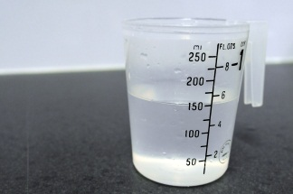 |  | Step 2  - Place the three bottles into the freezer and leave overnight until the water is completely frozen.  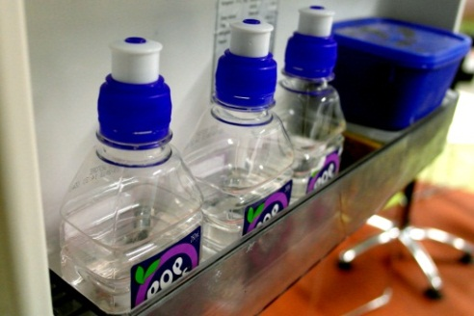
Step 6  - Repeat Step 5 after another 30 minutes (a total of 60 minutes or 1 hour).  - Repeat Step 5 again after a further 30 minutes (a total of 90 minutes or 1 ½ hours). |  | Step 3  - Remove the bottles from the freezer.  - Cover one bottle with bubble wrap, one with newspaper and one with aluminium foil. Do not cover the lid.  - Remove the lid from each bottle.
Step 5  - After 30 minutes, carefully pour any water collected from the bottle wrapped in bubble wrap into the medicine glass.  - Place the bottle upside-down on top of the drinking glass again.  - Record the amount of water collected in the recording table.  - Repeat for the other two bottles.  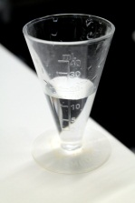 |  | Step 4  - Gently place each bottle upside-down on top of a drinking glass.  - When all three bottles are in place, start the stopwatch.  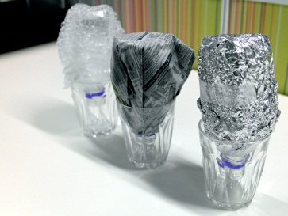

Section 3. Recording results
Results | A record of the data you collect during the investigation.

- Write the volume of water you collect at 30 minutes, 60 minutes and 90 minutes in the table below.
 | 30  minutes | 60  minutes | 90  minutes
Volume of water collected from the bottle wrapped in bubble wrap  (mL) | 0 | 6 | 14
Volume of water collected from the bottle wrapped in newspaper  (mL) | 3 | 9 | 18
Volume of water collected from the bottle wrapped in aluminium foil  (mL) | 7 | 13 | 18

- You need to find out how much water was collected from each bottle in total. To do this, you need to add the three water measurements for each bottle.
Bottle wrapped in bubble wrap: 0 mL + 6 mL + 14 mL = 20 mL in total
Bottle wrapped in newspaper: 3 mL + 9 mL + 18 mL = 30 mL in total
Bottle wrapped in aluminium foil: 7 mL + 13 mL + 18 mL = 38 mL in total

Information for teachers: This is sample data only. Results of the investigation may differ according to temperature variances caused by the time of year (season), time of day and environment in which the investigation is conducted.
Teachers should monitor the data collection process closely in order to determine the outcome of the investigation within their classroom.
- Draw a column graph to show the total volume of water collected from each of the three insulated bottles.

Section 4. Explaining your results
Discussion | Describe and explain your results.
- Which insulator kept the ice solid for longer? The bubble wrap
Use the evidence from the results tables and the column graph to explain how you know this.
My results table shows that we collected the smallest amount of water from the bottle covered with the bubble wrap (20 mL), which means that the ice stayed solid for longer in this bottle. The bubble wrap column is also the shortest column on my column graph. This means that less ice melted than in the bottles covered with the other two insulators.
- Why do you think this insulator was the best at keeping the ice solid?
I think this insulator was the best at keeping the ice solid because it is the thickest of the three materials so it was harder for the heat to travel through it. Also, the bubbles of air in the bubble wrap might have made it harder for the heat to get into the plastic bottle.
- Which insulator caused the ice to melt most quickly? The aluminium foil
Use the evidence from the results tables and the column graph to explain how you know this.
My results table shows that we collected the largest amount of water from the bottle covered with the aluminium foil (38 mL), which means that the ice changed into a liquid more quickly in this bottle. The aluminium foil column is also the longest column on my column graph. This means that more ice melted than in the bottles covered with the other two insulators.
- Why do you think this insulator caused the ice to melt most quickly?
I think this insulator caused the ice to melt most quickly because it is quite thin so it might have been easier for the heat to travel through it.
- Was your prediction correct? (Circle one) Yes / No

Information for teachers: These responses are samples only to demonstrate the level of explanation and justification necessary to achieve an A-standard.
Students may present an alternative explanation and justification; however, these must be reasonable and based on the data collected in the investigation.
Conclusion | Answer the investigation question.
- Choose the correct words from the word bank to complete the passage.
You will not need to use all of the words.
heat | bubble wrap | liquid | less | freeze
newspaper | more | solid | melt | aluminim foil

The bubble wrap was the best insulator because it kept the
ice in a solid state for longer.
This is because it allowed less heat to enter the plastic bottle.

The aluminim foil was the worst insulator because the ice
turned into a liquid state more quickly. This is because
it allowed more heat to enter the plastic bottle which
caused the ice to melt.

Information for teachers: This response is based on the sample data collected.
The correct word choices for the passage will be determined by the results of the investigation as recorded by the student.

Section 5. Applying your science knowledge

In this investigation, we discovered which insulator will keep ice solid for longer.
Insulators can slow down the change of a substance from a solid state to a liquid state.
They can also help to keep things cold.
- Describe how and why (explain) the science knoweldge you have learned in this investigation might be helpful in one of the following real-life situations.
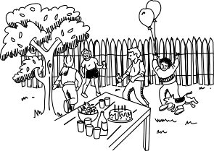 | 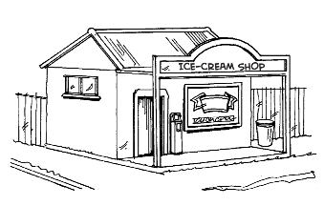 | 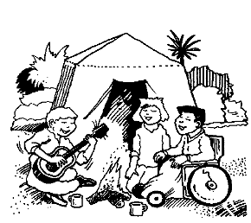
Keeping drinks cool at a party | Stopping an ice-cream from melting | Keeping vegetables fresh on a camping trip

The science knowledge I have learned in this investigation could be helpful to keep drinks cool at a party because you could put them inside an insulator to keep the heat out for longer. You could wrap them in a good insulating material (like the bubble wrap in our investigation) or you could put them inside a bag or a box made out of a good insulating material.

Information for teachers: This response is a sample only to demonstrate the level of explanation necessary to achieve an A standard.
Students may present alternative reasoned explanations; however, these must be reasonable and based on the science knowledge learned in the investigation.

