Australian Curriculum Prep Year Science sample assessment ׀ Assessment resource

Germinate

© The State of Queensland (Queensland Curriculum and Assessment Authority) and its licensors 2014. All web links correct at time of publication.

Sample response
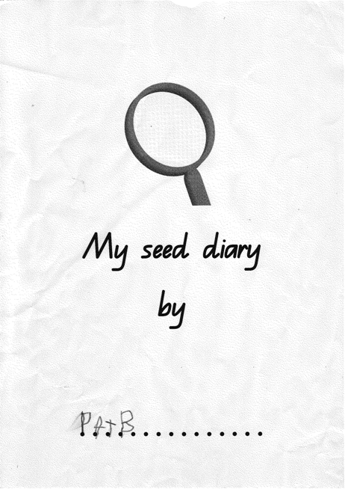

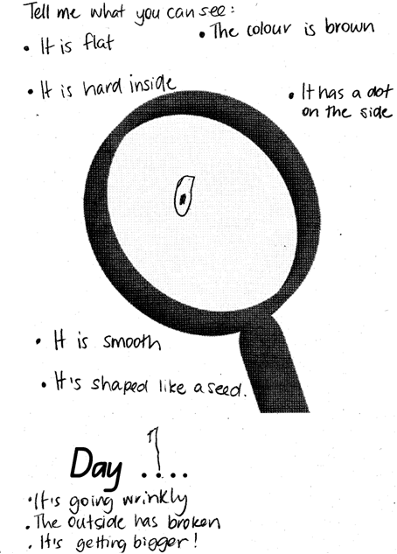 |  | Shares observations and ideas with others.  Talks about what the seed looks and feels like.
Makes observations about changes in seeds, using senses, e.g. 'It smells like … ';
'It is cracking.'
Describes how the seed has changed.
Compares seeds to find out what has changed, e.g. 'It looks bigger.
It feels heavier.'
Compares the size of the wet seed to the dry seed.

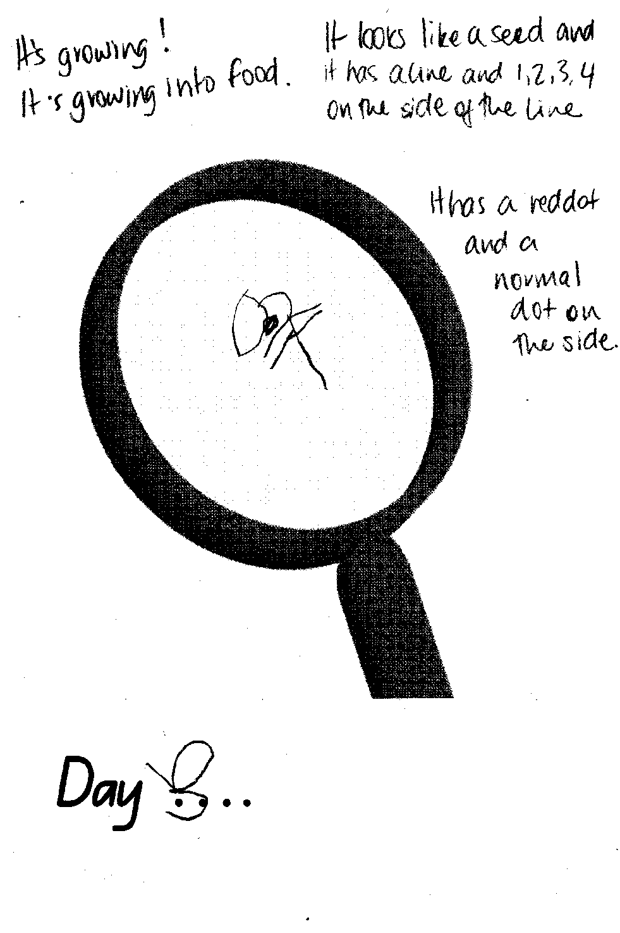 |  | Shares observations and ideas with others.  Tells others about their thinking and the changes they see.
Makes observations about changes in seeds using senses, e.g. 'It’s cracking'; 'It smells like … '
Looks at the seed and describes what they see.
Draws, labels and/or writes to represent observations.
Draws a picture of what they see.

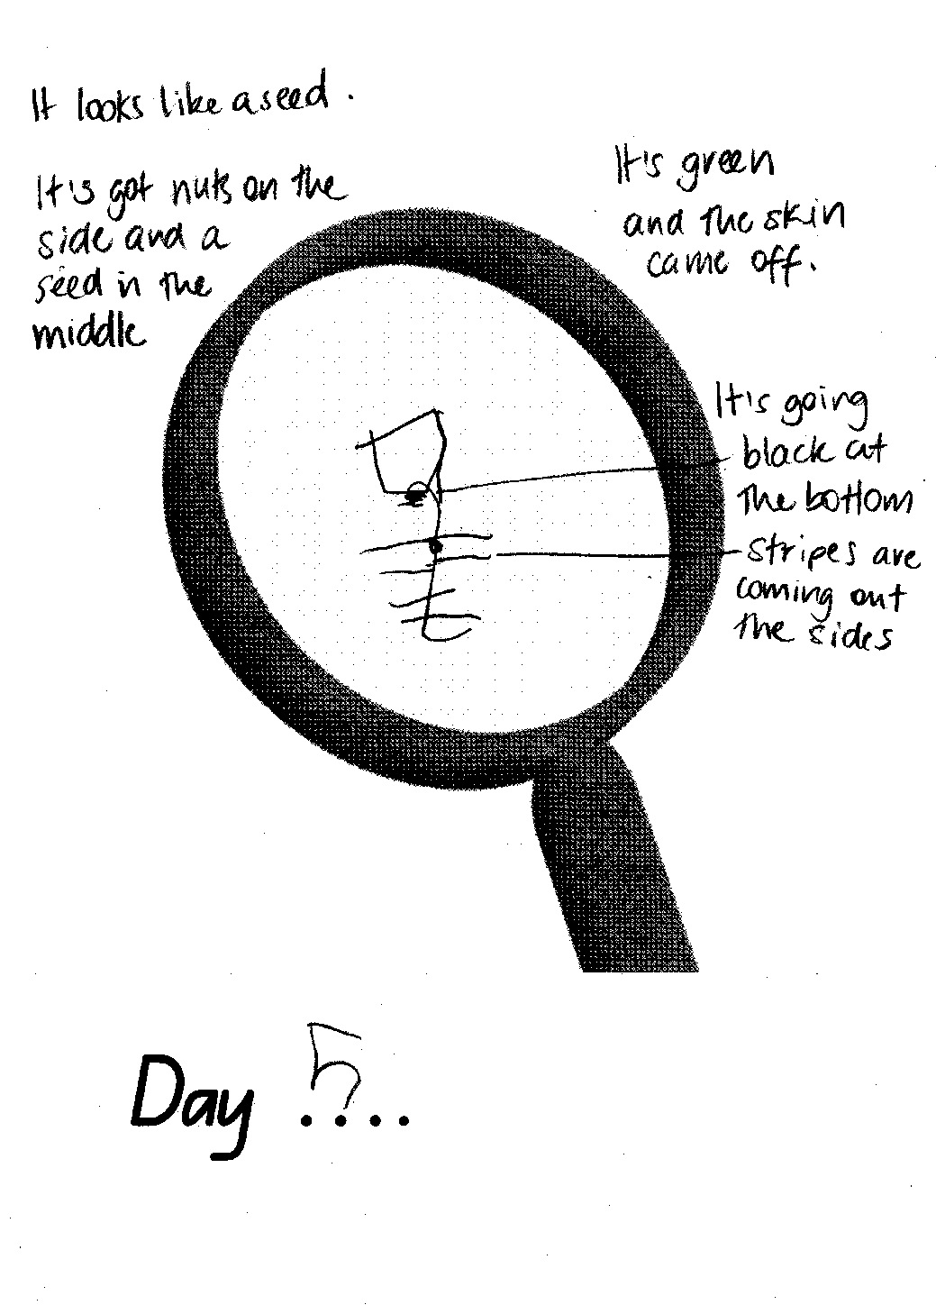 |  | Makes observations about changes in seeds using senses, e.g. 'It’s cracking'; 'It smells like … '  Describes changes in the seeds.
Draws, labels and/or writes to represent observations.
Draws a picture of what they see showing details.

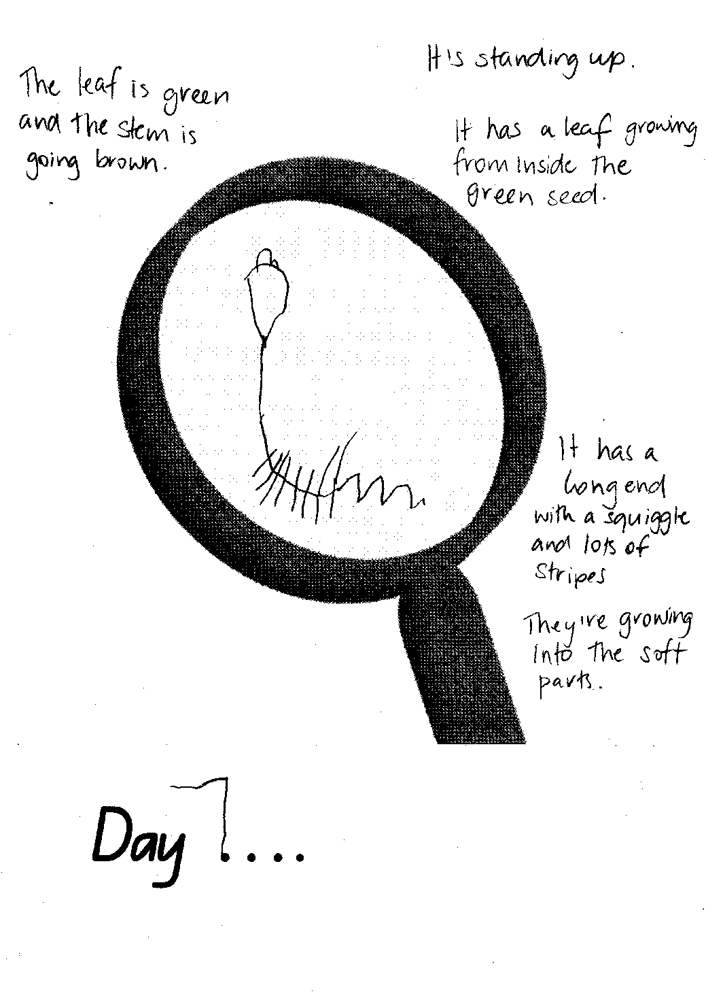 |  | Makes observations about changes in seeds using senses, e.g. 'It’s cracking'; 'It smells like … '  Observes then describes changes.
Draws, labels and/or writes to represent observations.
Draws a picture of what they see showing all the details.
Makes observations about changes in seeds using senses, e.g. 'It’s cracking'; 'It smells like … '
Observes then describes changes.

