Australian Curriculum Year 8 Mathematics Sample assessment | Model response
Pete’s Paving
© The State of Queensland (Queensland Studies Authority) and its licensors 2013. All web links correct at time of publication.

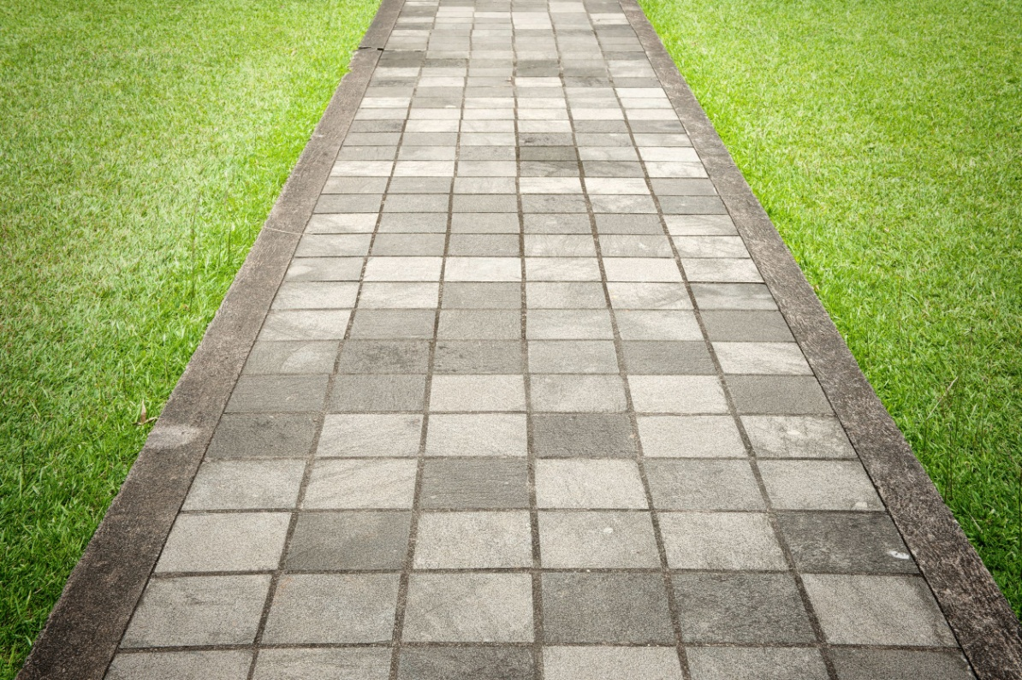

Image: Stock Photo - The walk way surface of concrete blocks, 123RF stock image 9144637, www.123rf.com/photo_9144637_the-walk-way-surface-of-concrete-blocks.html

To use algebraic equations and graphs to simplify paving quotes, and to apply and evaluate the methods used.
You will:
- develop methods to calculate materials and costs quickly and accurately
- compare methods
- prepare a quote for providing an area of paving.

Setting the scene
The owners of Pete’s Paving are updating their manual.
They have decided to develop some reckoners to quickly and accurately calculate the amount of materials and costs for different jobs, such as building a path or outdoor area.
These reckoners will be used when preparing quotes for customers.

Section 1. Material reckoners
A material reckoner is used to calculate quickly and accurately the number of pavers or the length of timber edging needed for different-sized jobs, without drawing a diagram.
- Complete reckoners A and B for Design 1 — Straight path.
Design 1 — Straight path | - 1 m wide, using 500 mm x 500 mm pavers  - pavers held together by timber edging
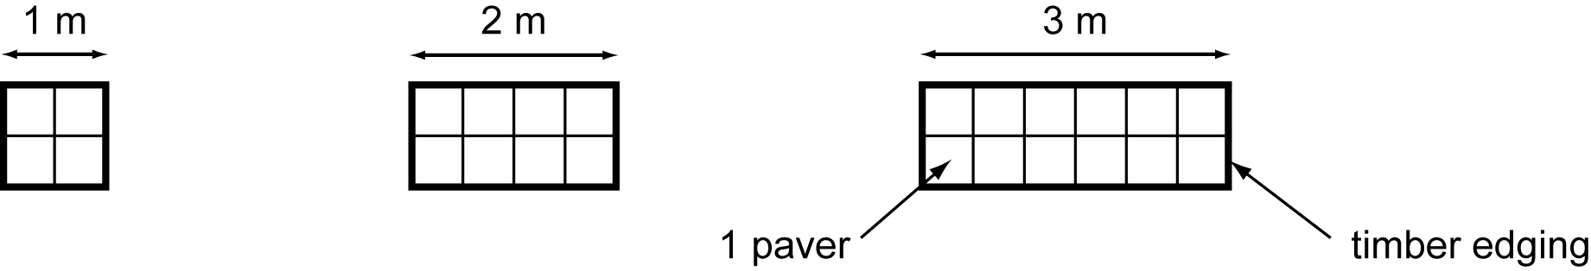

Reckoner A | Number of pavers for Design 1 — Straight path
Length of path in metres (l) | 1 | 2 | 3 | 4 | 5 | 20
Number of pavers (n) | 4 | 8 | 12 | 16 | 20 | 80
To find the number of pavers from the length of the path without drawing a diagram, you can:
multiply the length of the path by 4
Equation:
n = 4l, where l = length of path and n = number of pavers

Reckoner B | Length of timber edging for Design 1 — Straight path
Length of path in metres (l) | 1 | 2 | 3 | 4 | 5 | 20
Length of timber edging in metres (e) | 4 | 6 | 8 | 10 | 12 | 42
To find the length of timber edging from the length of the path without drawing a diagram, you can:
multiply the path length by 2 and then add 2
Equation:
e = 2l + 2, where e = length of timber edging and l = length of path
- Complete reckoners C and D for Design 2 — Square area.
Design 2 — Square area | - square area using 500 mm x 500 mm pavers  - pavers held together by timber edging
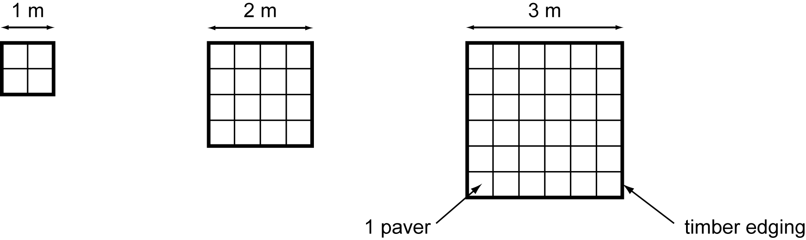

Reckoner C | Number of pavers for Design 2 — Square area
Side length in metres (s) | 1 | 2 | 3 | 4 | 20
Number of pavers (n) | 4 | 16 | 36 | 64 | 1600
To find the number of pavers from the side length of a square area without drawing a diagram, you can:
multiply the side length by itself and then multiply by 4
or
multiply the side length by 2 and then square the answer
Equation:
n = 4l² , where n = number of pavers and l = side length of square
or
n = (2l)²

Reckoner D | Length of timber edging for Design 2 — Square area
Side length in metres (s) | 1 | 2 | 3 | 4 | 20
Length of timber edging in metres (e) | 4 | 8 | 12 | 16 | 80
To find the length of timber edging from the side length of a square area without drawing a diagram, you can:
multiply the side length by 4
Equation:
e = 4l, where e = length of timber edging and l = side length of square

Section 2. Quote reckoners
A quote reckoner is used to calculate quickly and accurately the costs for different jobs.
Pete’s Paving charges the following when costing work:
Item | Description | Cost
Pavers | 500 mm x 500 mm | $12 each
Timber edging | sold per metre | $1.70 per metre
Delivery costs | delivery of materials incurs a fixed charge | $132
Labour | includes preparing the base and timber edging | $10.50 per paver
- Using the equations from Question 1, formulate a single linear equation that describes how to calculate the cost (c) of the work from the length (l) of the straight path.
n = number of pavers
e = metres of edging
c = cost of pavers + cost of edging + delivery cost + labour cost
= (12 x n) + (1.70 x e) + 132 + (10.50 x n)
= 12n + 1.7e + 132 + 10.5n
= 22.5n + 1.7e + 132
n = 4l (from Reckoner A)
e = 2l + 2 (from Reckoner B)
c = (22.5 x 4l) + (1.7 x (2l + 2)) + 132
= 90l + 3.4l + 3.4 + 132
= 90l + 3.4l + 135.4
= 93.4l + 135.4
where c is the cost in dollars and l is the path length in metres.

- Draw a line graph for the cost of a straight path using the linear equation from Question 3.
- Show your working.
- Label your graph “Reckoner E: Cost for Design 1 — Straight path”.

Find points for my graph:
Length of path (m) | 1 | 2 | 3 | 4 | 5 | 20
Cost ($) | 229 | 322 | 416 | 509 | 602 | 2003

Reckoner E | Cost for Design 1 — Straight path
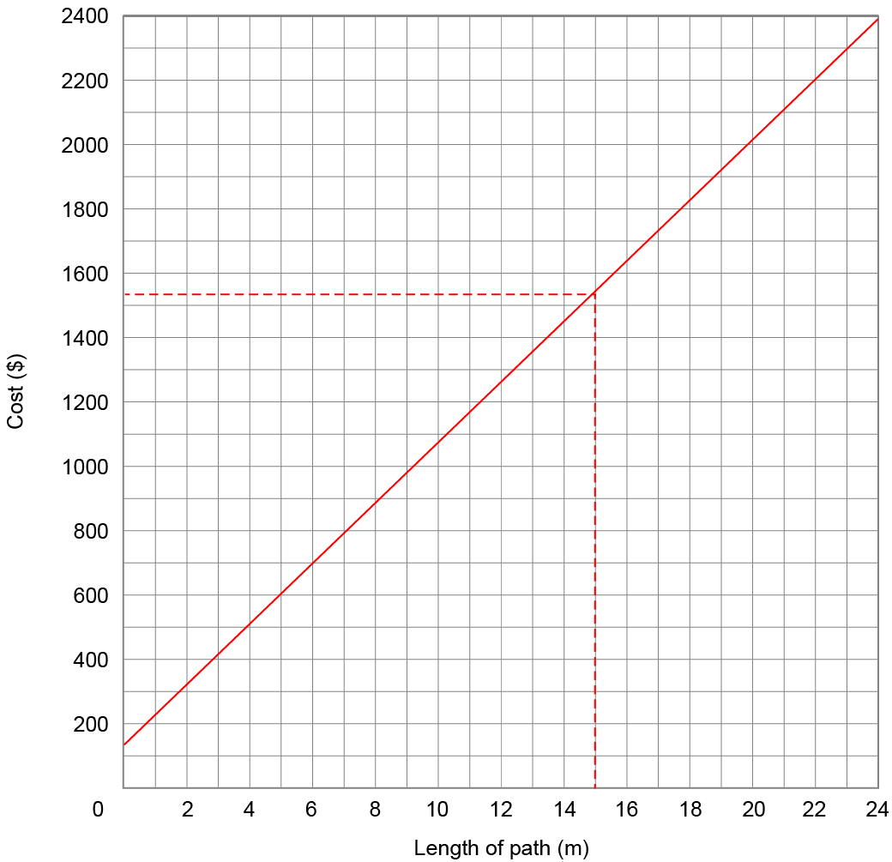
- Rule straight lines on the graph to show how to find the cost of a path 15 metres long.
See dotted line on graph
- Reading from the graph, what is the cost of a 15-metre path?
$1540
- Use a strategy to check your answer to Question 6.
- Hint: Look at your answers to previous questions.
- Show your working.
Using the equation from Question 3,
l = 15 m
c = 93.4l + 135.4
= (93.4 x 15) + 135.4
= $1536.40
- The owners of Pete’s Paving have decided to include just one method for calculating the cost of straight paths in the manual.
  - Which method would you recommend they use?
(Hint: Look at your answers to questions 3 to 6 before answering.)
Reckoner E: Cost for Design 1 — Straight path
  - Give two reasons for recommending this method.
In your answer, suggest ways it is better than the other methods considered.
It is very quick to use because you only have to read off the graph and not do any calculations, so there will be fewer mistakes.
The worker could have the graph already printed in the manual or on the folder where the quotes are written, and just read from it. Otherwise they would need to carry a calculator with them.
  - Describe any disadvantages there could be to using this method.
The graph might not be useful for really long paths that don’t fit on the axis, but an equation could be used for any sized job and could be used if giving a quote from the office.
The graph is not as accurate as the formula. I could only read the graph to the nearest $10, and customers mightn’t like this. Changing the scale of the graph to enlarge it would make it more accurate.
The accuracy of quotes would also depend on how accurately the worker reads the graph.
When using both the graph and the rule, you would need to take away the delivery cost for each extra path that is being quoted for.

Section 3. Mrs Kent’s quote
Mrs Kent wants the following paving work carried out on her property (shown on page 9):
- a square, paved BBQ area in the back corner
- a path from the house to the BBQ area (Path 1)
- a path from the house to Solitude St (Path 2)
- timber edging around the outside of paved areas and paths. (Note that this means there is no timber edging where a path connects to another paved area or to the house.)
A plan for the work required is included in the diagram overleaf.
- Prepare a quote for Mrs Kent, in a format like the one below.
- Use one or more of the reckoners you developed in Sections 1 and 2.
- Show all working.

BBQ area:
l = 4 m
n = 4l²
= 4 x 4 x 4
= 64 pavers
e = 4l
= 4 x 4
= 16 m
Subtract 1 m of timber edging (width of path to house)
= 15 metres edging
Path 1:
l = 3.5 m
n = 4l
n = 4 x 3.5
= 14 pavers
e = 2l + 2
= 2 x 3.5 + 2
= 9 m
Subtract 2 m of timber edging (no ends on the path)
= 7 metres edging
Path 2:
l = 1.7 m, round to 2 m (I can only buy whole pavers)
n = 4l
n = 4 x 2
= 8 pavers
e = 2l + 2
= 2 x 1.7 + 2
= 5.4 m
Subtract 1 m of timber edging (no edging near house)
= 4.4 metres edging
Totals:
n = 64 + 14 + 8
= 86 pavers
e = 15 + 7 + 4.4
= 26.4 metres edging
Cost of pavers = 86 x $12 = $1032
Cost of edging = 26.4 x $1.70 = $44.88
Cost of delivery = $132
Cost of labour = $10.50 x 86 = $892.50
Total cost = pavers + edging + delivery + labour
Total cost = $1032 + $44.88 + $132 + $892.50
= $2101.38
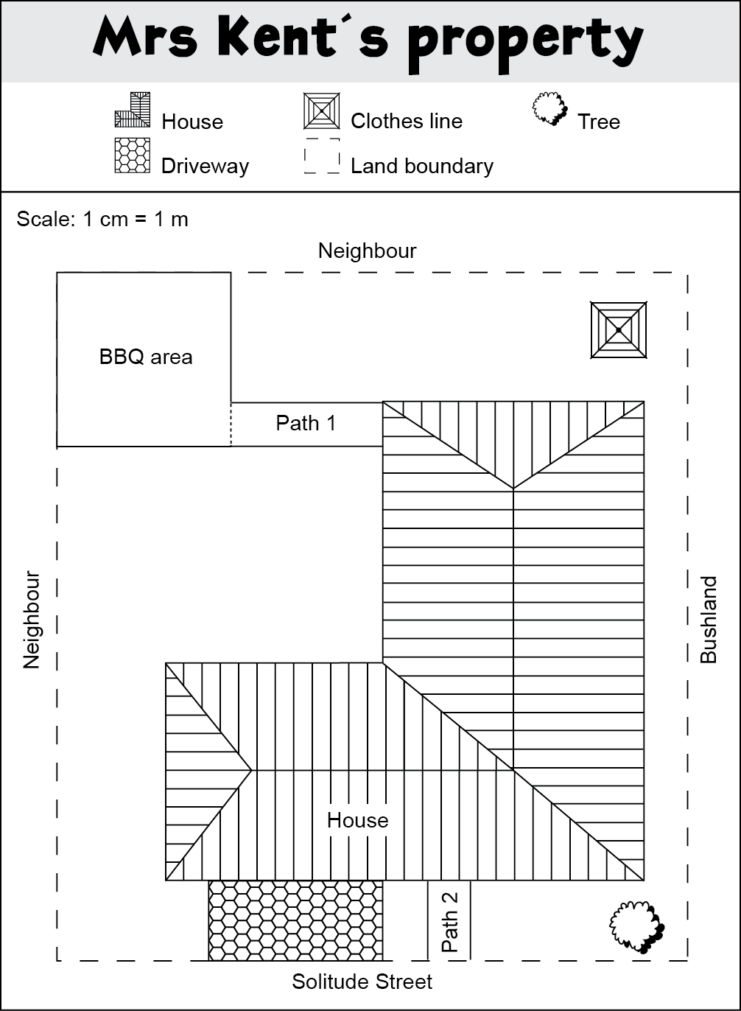
Areas to be paved
No timber edging needed in these places

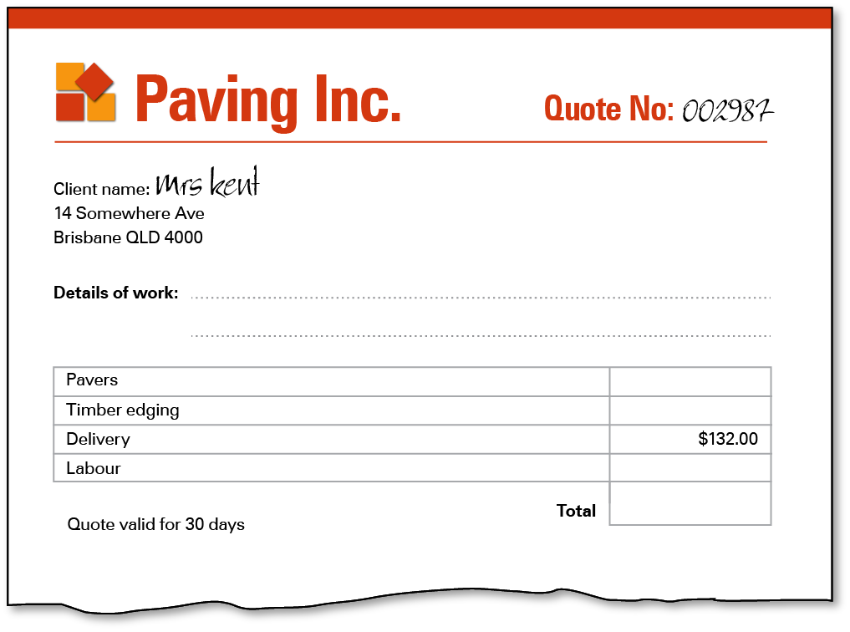
Paving to 4 m x 4 m BBQ area + 2 paths, 3.5 m x 1 m and 1.7 m x 1 m.
44.88
$2101.38
892.50
1032.00
Pete’s Paving
- What modifications did you need to make when using the reckoners to calculate the materials needed for Mrs Kent’s property?
I used paving reckoners A, B, C and D.
Sometimes I needed to subtract the edging where the area met the house or another paved area, and I also needed to round up the number of pavers required as I could only purchase whole pavers.

