Australian Curriculum Year 7 Mathematics Sample assessment | Model response
Refreshing drinks
© The State of Queensland (Queensland Studies Authority) and its licensors 2014. All web links correct at time of publication.

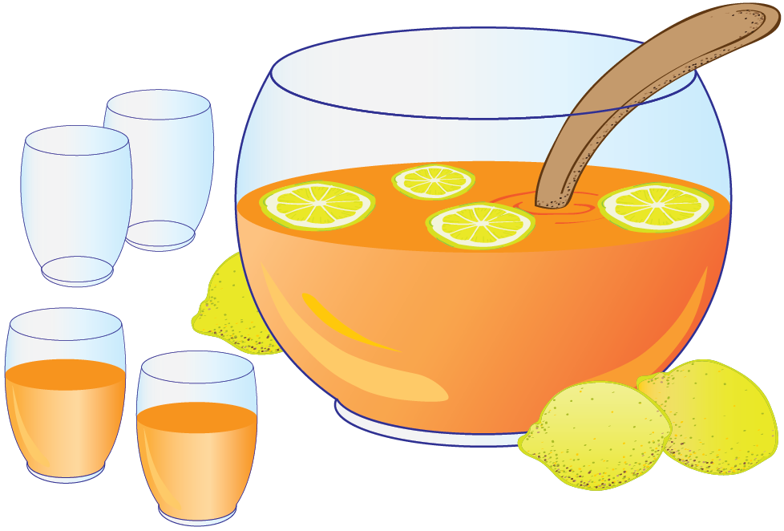
Image: © The State of Queensland (Queensland Studies Authority) 2014

Students apply understanding of ratios, fractions and percentages to solve problems when mixing ingredients for fruity drinks.
You will:
- express the quantities of ingredients in mixed fruity drinks as ratios, fractions and percentages
- solve problems involving mixing and adjusting the ratios of ingredients.

This model response gives one example of a very high quality response for each question.

Section 1. Mei’s orange concentrate

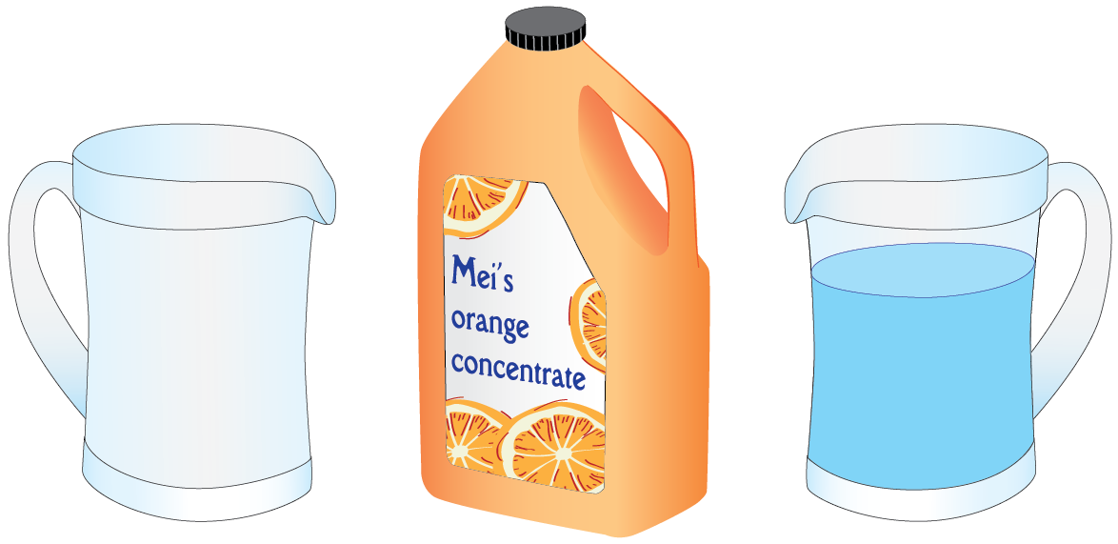
A new brand of fruit juice concentrate called Mei’s orange concentrate is available at your local shop.

This type of fruit juice drink comes in a concentrated form. You need to mix water with it before it is ready to drink.

- A glass contained the ratio shown below:
 | 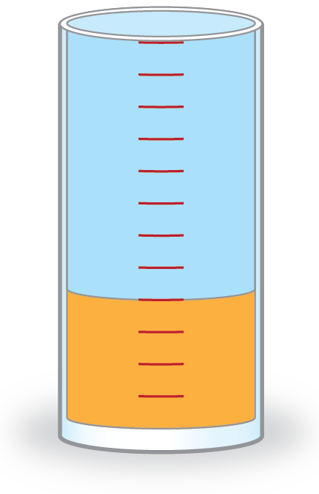 | The ratio of concentrate to water is:  ............. 4:8 or 1:2 ......................
water
concentrate

- The instructions on the bottle say to mix it in the ratio 1:7 (1 part concentrate to 7 parts water).
Draw a picture to illustrate this ratio.
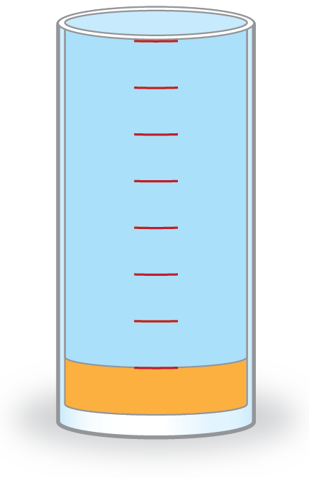

- You decide to try an overly concentrated drink and use 3 parts fruit juice concentrate. It’s too strong and you decide mix it in the ratio 1:7 according to the instructions on the bottle.
  - How many parts of water should you add to the 3 parts fruit juice concentrate?
....... 21
  - Draw a picture to show the quantities of fruit juice concentrate and water used.

  - Write this as a ratio. 3: 21
  - Write this ratio as a fraction. .............$\frac{\text{3}}{\text{21}}$
  - Write an equivalent fraction in its simplest form. ...........$\frac{\text{1}}{\text{7}}$
- When the fruit juice concentrate is mixed with water in the ratio 1:7 …
  - What fraction of the mixture is concentrate?
Show your working.
Total number of parts in mixture  Fraction that is concentrate | = 1 + 7  = 8  = $\frac{\text{1}}{\text{8}}$
  - What percentage (%) of the mixture is concentrate?
Show your working.
% that is concentrate | = $\frac{\text{1}}{\text{8}}$ x 100%  = 12.5%
  - What fraction of the mixture is water?
Show your working.
Total number of parts in mixture  Fraction that is water | = 8  =$\frac{\text{7}}{\text{8}}$
  - What percentage (%) of the mixture is water?
Show working.
% that is water | = $\frac{\text{7}}{\text{8}}$ x 100 %  = 87.5 %

- You like to keep some mixed drink in the fridge.
  - To make a mixture using 400 mL of concentrate, how much water would you add?
Show your working, using answer/s from Question 4.
$\frac{\text{1}}{\text{8}}$ of the mixture is concentrate, $\frac{\text{7}}{\text{8}}$ is water.
There is 7 times as much water as concentrate
Amount of water = 7 x 400 mL
= 2800 mL
  - How much mixed drink would this make?
Show your working.
Total amount = 400 mL + 2800 mL
= 3200 mL
= 3.2 L

- You need to mix 5.6 litres of mixed drink to take to sports training.
  - How much concentrate and water do you need?
Show your working.
5.6 L = 5600 mL
Amount of concentrate = $\frac{\text{7}}{\text{8}}$ of 5600 mL
= 7 x 5600 / 8
= 4900 mL or 4.9 L
Amount of water = $\frac{\text{1}}{\text{8}}$ of 5600 mL
= 700 mL

- One day you wrongly mix up some drink by adding 500 mL of concentrate to 1500 mL of water.
  - What is the ratio of concentrate to water? (Express this ratio in its simplest form)
500:1500 = 1:3

  - Does the drink contain too much concentrate or too much water? Explain how you know.
In the correct mixture, there is 7 times as much water as concentrate, but in this mixture there is only 3 times as much water as concentrate. More water needs to be added as there is too much concentrate.

  - How would you adjust the mixture so it is mixed correctly?
Show your working.
For 500 mL of concentrate,
The total amount of water needed = 7 x 500 mL
= 3500 mL
I have only added 1500 mL of water,
so the extra amount I need to add = 3500 – 1500 mL
= 2000 mL or 2.0 L

Section 2. Paradise punch
You volunteer to make up a fruit punch for a party.

Paradise punch
Mix lemonade,
ginger ale and
fruit juice in the
ratio 2:1:3.

- You decide to test your recipe by making a small amount in a glass, and then plan to make up a large bowl of fruit punch to take to the party.
  - If you add 80 mL of lemonade to a glass, how much ginger ale and fruit juice would you have to you add?
Lemonade : ginger ale : fruit juice = 2:1:3
For 80 mL of lemonade, the ratio is 80:40 :120
So I need 40 mL of ginger ale and 120 mL of fruit juice.
  - How much Paradise punch does this make?
Amount of punch = 80 + 40 + 120 mL
= 240 mL
  - Express the ratio of each ingredient as a percentage of the whole.
% lemonade  % ginger ale  % fruit juice | = $\frac{\text{80}}{\text{240}}$ x 100 = 33.3%  = $\frac{\text{40}}{\text{240}}$ x 100 = 16.7%  = $\frac{\text{120}}{\text{240}}$ x 100 = 50%

- When you arrive at the party, you have left your measuring jug at home so you have to measure the ingredients using a cup.
You put one cup of lemonade in the punch and then add the other ingredients.
  - How many cups of the other ingredients would you add?
Lemonade : ginger ale : fruit juice = 2:1:3
For 1 cup of lemonade, the ratio is 1:$\frac{\text{1}}{\text{2}}$: 1$\frac{\text{1}}{\text{2}}$
So I need $\frac{\text{1}}{\text{2}}$ cup of ginger ale and 1$\frac{\text{1}}{\text{2}}$cups of fruit juice
  - How many cups of punch does this make? Show your working.
Number of cups = 1 + $\frac{\text{1}}{\text{2}}$ + 1$\frac{\text{1}}{\text{2}}$
= 3 cups

You want to make up enough punch so everyone can have 4 cups each. There are 12 people at the party.
- How many cups of each ingredient would you use? Show your working
Punch needed = 4 x 12 = 48 cups
Lemonade : dry ginger ale : fruit juice = 2:1:3
Total parts = 2 + 1 + 3 = 6 parts
For 48 cups
Each part = 48 ÷ 6 = 8 cups
Ingredients needed to make 48 cups:
Lemonade = 2 x 8 = 16 cups
Dry ginger ale = 1 x 8 = 8 cups
Fruit juice = 3 x 8 = 24 cups

