Australian Curriculum Year 6 Mathematics Sample assessment | Model response
Goal difference — the importance of zero
© The State of Queensland (Queensland Studies Authority) and its licensors 2014. All web links correct at time of publication.

Numbers above and below zero can be used to compare the progress of sporting teams in competitions.
You will:
- analyse data in league tables
- use data to judge how teams are performing and to predict future results.

Section 1. League tables
Focus question: How are the teams performing so far?
As a class, explore how a table is used to show how teams progress in a competition.
Look at a results table for a team sport. An example can be found on the English Premier League website, www.premierleague.com/page/LeagueTables.
The table will look something like this.
Table 1: League table example
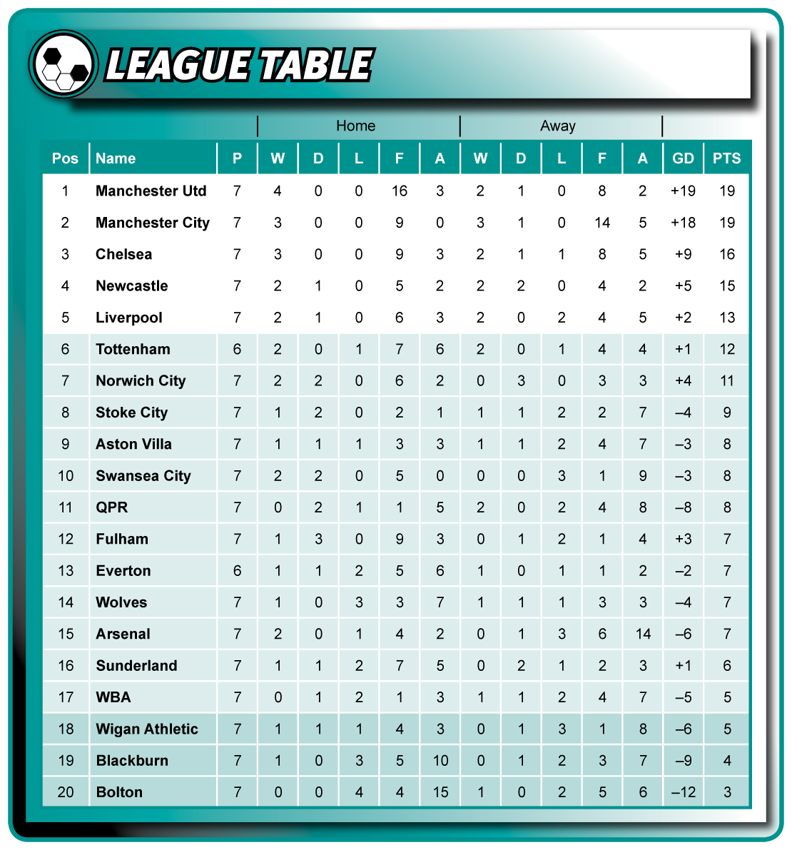
Discuss these questions with your classmates.
- What is the table showing?
- What do the letters stand for at the top of each column?
- What do the terms ‘Home’ and ‘Away’ mean?
Look at the goal difference (GD) column.
- What is ‘goal difference’?
- How is goal difference calculated?
- Use your calculator to test different ideas about how goal difference is calculated.
- Why are there negative numbers in the goal difference column?
Work in a group to check the goal difference results for a number of teams.
Think about a method you could use to check that a team’s goal difference has been calculated correctly. Use calculators to check your method.
Report back to the class on:
- the method you used to check your team’s goal difference
- the accuracy of the results with the method that you used.
Work individually to answer Question 1.
Think about the uses we have for ‘zero’.
- Complete the speech bubble below, giving reasons why you disagree with the person on the left.
I don’t agree! There are lots of reasons that zero is important. First of all, …
zero is a position on the number line — you can't leave out other numbers like 7 or 12 on a number line, so you can’t leave out zero.
Second, zero is a place holder in our number system. If you leave the zeros out of $1000 you’ll only have $1!
Also, zero is a reference point for positive and negative numbers — you can’t talk about temperatures below zero or negative goal differences without it. In a high-rise building, the ground floor is zero and the lift goes up and down from there — you can’t ignore that.
‘Zero’ represents nothing, so I think you can ignore it.

Section 2. Investigating a competition
Focus question: How are the teams performing so far?
Table 2 shows the draw and results for the first four games of an interschool soccer competition.
The Home team is listed first and in bold.
As a class, discuss what the table is showing about how the teams have performed.
Table 2: Interschool soccer competition results
Week 1 |  | Week 2 |  |  | Week 3 |  | Week 4
All Saints  vs  Byfield | 4  1 | All Saints  vs  Cresthill | 5  3 | Dalby  vs  All Saints |  | 0  5 | Dalby  vs  Highfields | 1  2
Cresthill  vs  Dalby | 3  0 | Byfield  vs  Dalby | 2  0 | Byfield  vs  Eastside |  | 1  4 | Eastside  vs  All Saints | 3  4
Eastside  vs  Forestvale | 3  1 | Green Valley  vs  Eastside | 0  2 | Cresthill  vs  Highfields |  | 2  2 | Green Valley  vs  Byfield | 0  3
Highfields  vs  Green Valley | 0  6 | Highfields  vs  Forestvale | 0  1 | Forestvale  vs  Green Valley |  | 2  3 | Forestvale  vs  Cresthill | 1  1
The data in Table 2 can be used to calculate each team’s points for and points against for their home games and their away games.
The calculations for one team have been completed for you below.
Sample calculation: Home and away results for All Saints
All Saints home game points for: 4 + 5 = 9
All Saints home game points against: 1 + 3 = 4
All Saints away game points for: 5 + 4 = 9
All Saints away game points against: 0 + 3 = 3

Work individually to complete Questions 2 and 3.
Table 3 analyses goals scored in the game. Some calculations have been done for you.
You may need notepaper and a number line to work out the missing data.
- Complete Table 3. For each team:
  - calculate for and against points for home and away games
(look at the sample calculation on the previous page to help you)
  - calculate the total goal difference at the end of Week 4 by:
- adding the total number of goals scored for
- then subtracting the total number of goals scored against.
Hint: Some teams will have a goal difference that is a negative number.
Table 3: Interschool soccer competition goal analysis
School | Home games |  | Away games |  | Total goal difference
 | for | against | for | against
All Saints | 9 | 4 | 9 | 3 | 11
Byfield | 3 | 4 | 4 | 4 | –1
Cresthill | 5 | 2 | 4 | 6 | 1
Dalby | 1 | 7 | 0 | 5 | –11
Eastside | 6 | 5 | 6 | 1 | 6
Forestvale | 3 | 4 | 2 | 3 | –2
Green Valley | 0 | 5 | 9 | 2 | 2
Highfields | 0 | 7 | 4 | 3 | –6
On the number line at the right, each line represents 1.
- Complete the number line by following the steps below.
  - Decide on the best place to put zero, and write it on the left side of the number line.
  - Write numerals to show where each school’s goal difference fits on the line.
  - Add a letter (A to H) next to the number that represents each school’s goal difference
on the right side of the number line.

Section 3. Interpreting data
Focus question: How does the table help us to compare teams?
Work individually to complete Section 3.
You can use the data in Table 3 to make judgments about how the teams are performing.
Analyse the data to see which teams have the best attack and defence, considering:
- a good attacking team usually scores a lot of goals
- a good defending team has very few goals scored against them.
- Who is the strongest attacking team?
All Saints
Explain the evidence that supports your opinion. Show any calculations you used.
A: 9 + 9 = 18 B: 3 + 4 = 7 C: 5 + 4 = 9 D: 1 + 0 = 1
E: 6 + 6 = 12 F: 3 + 2 = 5 G: 0 + 9 = 9 H: 0 + 4 = 4
I added both “for” results in the home and away columns and found that All Saints scored the most goals, with 18. The next best school was Eastside with 12.

- Who is the strongest defending team?
Eastside
Explain the evidence that supports your opinion. Show any calculations you used.
A: 4 + 3 = 7 B: 4 + 4 = 8 C: 2 + 6 = 8 D: 7 + 5 = 12
E: 5 + 1 = 6 F: 4 + 3 = 7 G: 5 + 2 = 7 H: 7 + 3 = 10
I added both “against” results in the home and away columns and found that Eastside had the least goals scored against them (6 goals).
- Think about whether there is an advantage in playing games at home in this competition.
  - Complete Table 4 below to analyse the data.
Table 4: Home and away results
School | Wins at home | Wins away | Difference  ( + or – )
All Saints | 2 | 2 | 0
Byfield | 1 | 1 | 0
Cresthill | 1 | 0 | 1
Dalby | 0 | 0 | 0
Eastside | 1 | 2 | –1
Forestvale | 0 | 1 | –1
Green Valley | 0 | 2 | –2
Highfields | 0 | 1 | –1
Total | 5 | 9 | –4
  - Use your data to explain whether it was an advantage to play at home.
Overall there were 5 games won at home and 9 won away, so the total home and away difference is –4.
This data shows that there was no advantage in playing at home.

Another way to analyse the data is to find out which teams are improving as the season progresses.
Think about how the data could help you to judge whether a team is performing better now than at the beginning of the season.
- Which team has improved the most throughout the competition?
  - Use Table 5 to help analyse the data. Decide what headings and columns you will use.
Table 5: Most improved teams
School | GD #1:  Week 1 & 2  goal difference | GD #2:  Week 3 & 4  goal difference | Improvement  (GD #2 – GD #1)
All Saints | 9 – 4 = 5 | 9 – 3 = 6 | 6 – 5 = 1
Byfield | 3 – 4 = –1 | 4 – 4 = 0 | 0 – (–1) = 1
Cresthill | 6 – 5 = 1 | 3 – 3 = 0 | 0 – 1 = –1
Dalby | 0 – 5 = –5 | 1 – 7 = –6 | (–6) – (–5) = –1
Eastside | 5 – 1 = 4 | 7 – 5 = 2 | 2 – 4 = –2
Forestvale | 2 – 3 = –1 | 3 – 4 = –1 | (–1) – (–1) = 0
Green Valley | 6 – 2 = 4 | 3 – 5 = –2 | (–2) – 4 = –6
Highfields | 0 – 7 = –7 | 4 – 3 = 1 | 1 – (–7) = 8
  - Use your data to explain which team has improved the most.
I worked out the goal difference for each team in weeks 1 and 2 (GD #1), and for weeks 3 and 4 (GD #2). Then I subtracted the results to find each team’s goal difference between the first two and last two games.
Highfields was way ahead with a goal difference improvement of 8.
Next best were All Saints and Byfield, with an improvement of 1.
The data shows that Highfields improved the most through the season.
Information for teachers: There is no preferred strategy for solving this problem, and different strategies may support different opinions. Comparing just the first and last games would be a reasonable strategy; using a simple line graph to track each team would be an interesting analysis. Assessment is based on whether the student has presented and justified a logical solution.
Data can’t predict the future, but it can help us to judge the most likely outcome.
- Analyse the data to predict who is most likely to win the games in Week 5.
For each prediction, use your data to explain why you have chosen that team.
Table 6: Predictions
Week 5 | Prediction  Who is most likely to win? | Evidence  How does your data support your prediction?  Explain why.
All Saints  vs  Forestvale | All Saints | All Saints are undefeated and have an overall goal difference of 11, while Forestvale’s is –2.  Also, Forestvale are at 0 goal difference on their last two games compared to the first two, so they’re not improving.
Byfield  vs  Highfields | Byfield | Byfield have a better overall goal difference (–1 vs –6).  Byfield have lost two games but these were to the top teams. They also won their last game 3–0.
Cresthill  vs  Green Valley | Cresthill | Cresthill have been more consistent than Green Valley.  Green Valley have a slightly higher overall goal difference (2 vs 1) but they have one of the worst scores when their first two games are compared with their last two.
Dalby  vs  Eastside | Eastside | Dalby have an overall goal difference of –11 and have only scored one goal in their four games.  Eastside have scored 12 goals and their goal difference is 6.  Dalby have 0 wins while Eastside have 3.

Information for teachers: Again there is no preferred solution. Consider how well a strategy is explained by analysing the data.

