Australian Curriculum Year 3 Mathematics Sample assessment | Sample response
Exploring 3D objects, angles and symmetry
© The State of Queensland (Queensland Studies Authority) and its licensors 2014. All web links correct at time of publication.

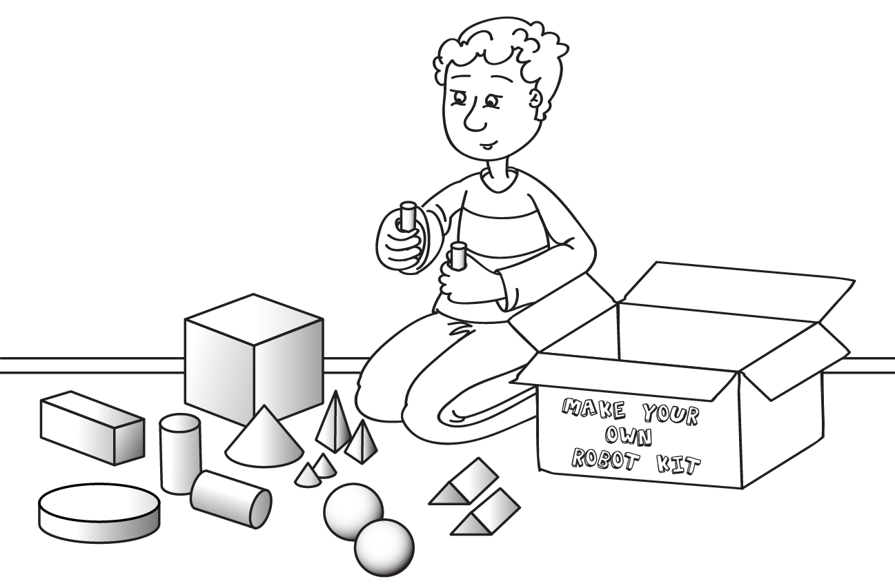

Exploring 3D objects, angles and symmetry are all around us.
You will:
- describe 3D objects
- compare and identify angles
- find symmetry
- find angles and symmetry in letters.

Section 1. Describing 3D objects

- Look at models of the 3D objects in the table below.
Complete the table to identify the features.
3D object | How many?
 | square faces | rectangular  faces | circular faces | triangular faces | curved surfaces | vertices | edges
cone |  |  | 1 |  | 1 | 1 | 1
cube | 6 |  |  |  |  | 8 | 12
cylinder |  |  | 2 |  | 1 |  | 2
rectangular prism |  | 6 |  |  |  | 8 | 12
sphere |  |  |  |  | 1
square-based pyramid | 1 |  |  | 4 |  | 5 | 8
triangular prism |  | 3 |  | 2 |  | 6 | 9

Dale built this robot from 3D objects, including one with a clock.
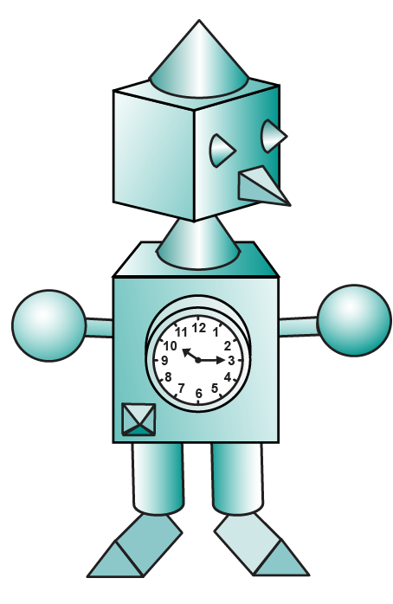
triangular prism
sphere
cube
cylinder
cone
square-based pyramid
- Use the shape names from the box below to label the 3D objects that Dale used to build his robot.
(Not all shapes were used).
3D objects
square-based pyramid | cone | rectangular  prism | sphere
cube | triangular  prism | cylinder | triangular  pyramid

Dale decided to use the same 3D objects to build a robot dog for his robot.
3D objects
square-based pyramid | cone | rectangular  prism | sphere
cube | triangular  prism | cylinder | triangular  pyramid
- What 3D object would you choose for the dog’s head? Why?
I would choose a sphere as it is the roundest object and dog’s heads are usually round.
- What 3D object would you use for the dog’s tail? Why?
I would choose a cylinder as cylinders can be long and thin which makes them look like a dog’s tail.
- Would square-based pyramids be a good choice for the dog’s ears? Why or why not?
Yes, a square-based pyramid would be a good choice for the dog’s ears because they are wide at the bottom and pointy at the top. Square-based pyramids look like triangles and dog’s ears can sometimes look like triangles too.
Information for teachers: These responses are a sample only. Accept other responses where the description of mathematical thinking demonstrates a connection of mathematical understandings of the 3D object selected to its purpose.

Section 2. Comparing and identifying angles
Dale and the robot left to go to the park at quarter past ten.
When they arrived, the robot’s clock showed half past ten.
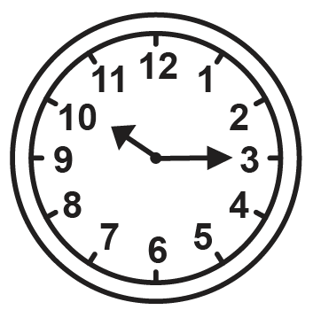 |  | 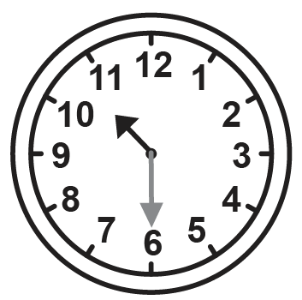
- What size turn did the minute hand have to make to show half past ten?
Circle the answer.
a half turn a quarter turn
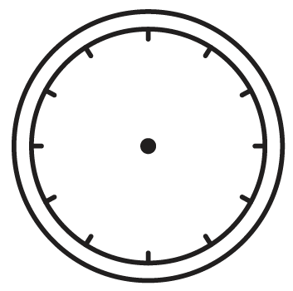
- Draw this hand when it has moved another quarter turn.
- Draw this hand when it has moved another quarter turn.
Dale sees a fort at the park.
- Find 5 angles on the fort that are right angles.
Mark the angles using one colour.
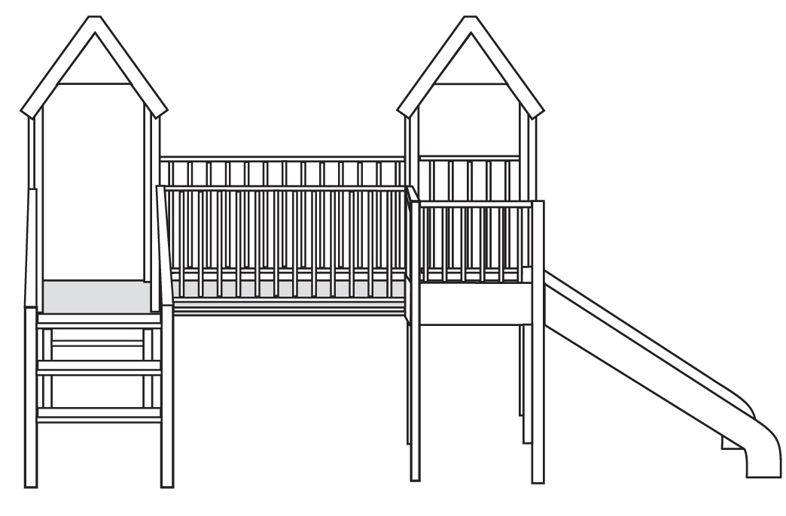
- Find 3 angles on the fort that are different from a right angle.
Mark the angles using a different colour.
- Circle any letter that has two or more different sized angles.
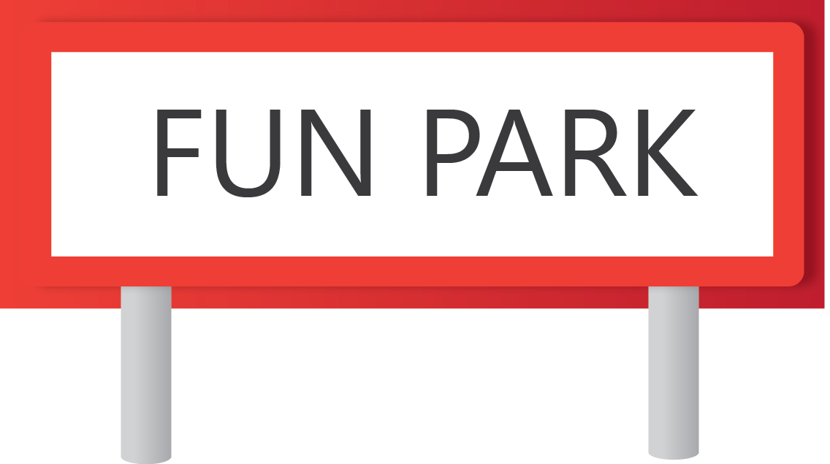

Section 3. Finding symmetry
Dale is looking for shapes with symmetry at the park.
- Draw one line of symmetry on the arrow.

- Circle a part of the fort that has symmetry.
Draw the line of symmetry on that part.

At the park, Dale drew some designs for robot faces.
- Draw a circle around the robot faces that have symmetry.
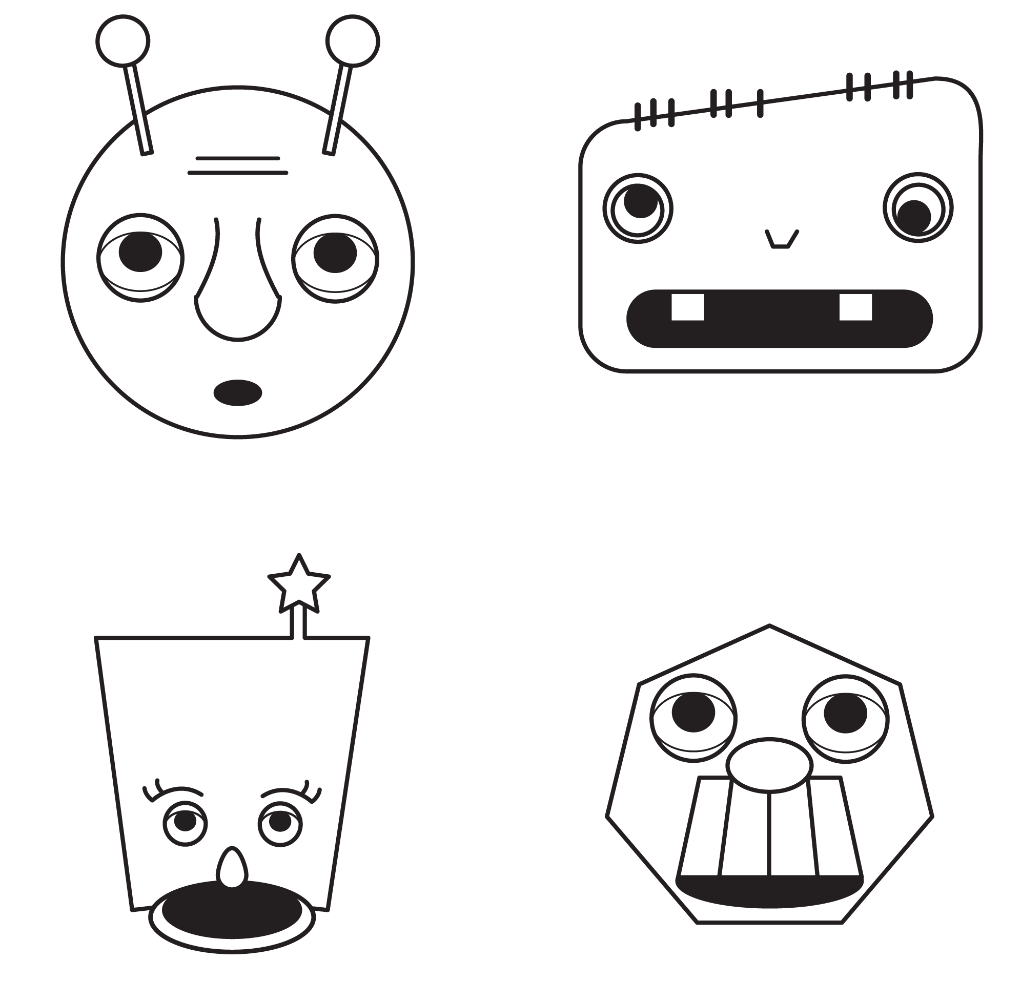

Section 4. Finding angles and symmetry in letters
Dale uses a puzzle to give the robot a name.

- Look at the symmetry and the right angles in these letters.
E | D | A | P | S | H | L
- Read the clues in the table.
- Choose from the letters above to solve the puzzle.
(Not all the letters are used.)
- Write the missing letters in the table.
Letter clues | 1st  letter | 2nd  letter | 3rd  letter | 4th  letter | 5th  letter | 6th  letter
Number of lines of symmetry | 0 | 0 | 0 | 1 | 0 | 2
Number of right angles | 0 | 3 | 1 | 0 | 0 | 4
Robot’s name | S | P | L | A | S | H
Dale wants to make a puzzle for her dog’s name.

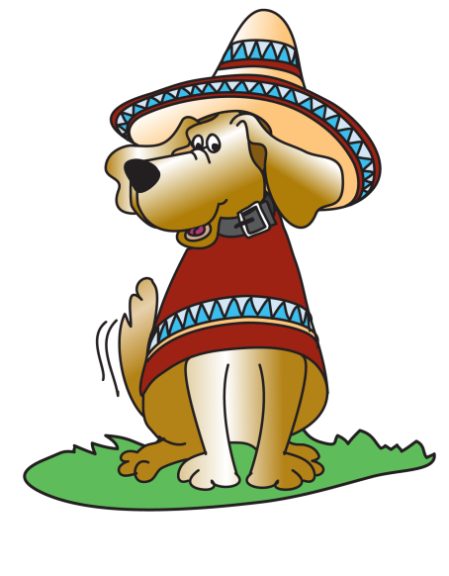
Hi, my name is MEX.
- Look at the letters of the dog’s name.
Write clues for the letters in the table.
Letter  clues | 1st  letter | 2nd  letter | 3rd  letter
Number of lines of symmetry | 1 | 1 | 2
Number of right angles | 0 | 4 | 0
Dog’s name | M | E | X

