Australian Curriculum Year 2 Mathematics Sample assessment | Model response
Feet
© The State of Queensland (Queensland Studies Authority) and its licensors 2014. All web links correct at time of publication.

Image: Perfect circle of legs, Jasmin Merdan, © 123RF.com

Children compare and order class foot lengths, then create graphs to display and interpret the data.
You will:
- measure the length of your foot
- collect data from the rest of the class to create a graph
- compare lengths.

Section 1. Collecting, comparing and ordering data
Class foot lengths  measured in 5 cent pieces |  | Children in order of foot sizes  (shortest to longest)
Girls | Foot length | Natalie
Nikole | 9 | Kaye
Aime | 8 | Aime
Jodie | 9 and some more | Kim
Courtney | 8 and some more | Courtney
Kirsti | 9 and some more | Lisa
Kaye | 8 | Susan
Natalie | 8 | Rachel
Kirsten | 10 | Nikole
Rachel | 9 | Brian
Tracy | 9 and some more | Brett
Kim | 8 and some more | Liz
Liz | 9 and some more | Tracy
Susan | 9 | Kirsti
Lisa | 9 | Jodie
Boys | Foot length | Peter
Martin | 10 and some more | Nathan
Mike | 9 and some more | Mike
Greg | 10 | David M
David M | 10 | Kirsten
Michael | 10 | David F
Brett | 9 | Michael
Andy | 10 and some more | Greg
Nathan | 9 and some more | Andy
David F | 10 | Martin
Peter | 9 and some more
Brian | 9
Checking my list:
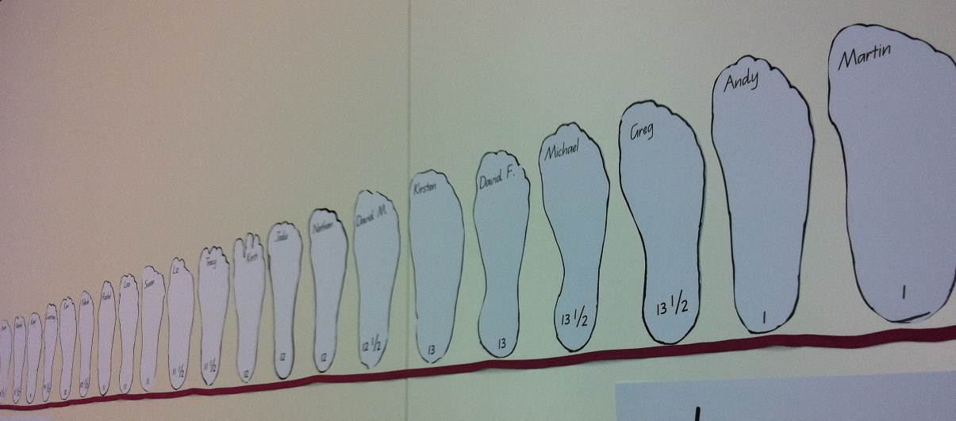

Section 2. Displaying data
Graph 1: Class shoe sizes
Number of children | 15
 | 14
 | 13
 | 12
 | 11
 | 10
 | 9
 | 8
 | 7
 | 6
 | 5
 | 4
 | 3
 | 2
 | 1
 |  | 8 | 8½ | 9 | 9½ | 10 | 10½ | 11 | 11½ | 12 | 12½ | 13 | 13½ | A1 | A1½
 |  | Shoe size
Graph 2: Class foot lengths
Number of children | 15
 | 14
 | 13
 | 12
 | 11
 | 10
 | 9
 | 8
 | 7
 | 6
 | 5
 | 4
 | 3
 | 2
 | 1
 |  | 8 | 8 and some more | 9 | 9 and some more | 10 | 10 and some more
Unit: Number of 5 cent pieces

Section 3. Analysing data

What uniform informal unit did you choose?
I chose 5 cent pieces.
Why did you choose it?
Because it was the smallest unit, so it will be easier to separate the foot outlines into different sizes. If I used something like the pegs, most of our foot outlines would only be two or three pegs long and so it would be hard to get them in order without using the shoe sizes.
Did you have to change the order of your foot outlines when you checked your work?
Yes
Explain what you would do to make your answers more accurate.
I could use a smaller object like single LEGO bricks as my measure. Smaller objects will give me larger numbers when I measure. There will be more LEGO bricks to make up the distance than with 5 cent pieces. It would also give me more groups on the foot length graph to order, which will spread the foot outlines out better, and I can order them more accurately.
Which shoe size has the most crosses for the class?
12
What is the longest shoe size for the boys? For the girls?
Boys: A1, girls: 13
Which shoe size has the most crosses for the boys? For the girls?
Boys: 12½, girls: 11
What is something the data tell us about our Year 2 shoe sizes?
Year 2 have shoe sizes between 8½ and A1.
How can we be sure that is the case?
We could check for the other Year 2 class.
If we measured the feet at a different time of the year, what could we expect to see?
The data would change. Earlier in the year our feet were smaller.
Later in the year our feet will be bigger.
Will the measurements be the same for next year’s Year 2 class? Why do you think that?
No, because their feet aren’t the same as ours. They might have more in the class. They might not have the same number of boys and girls that we have. If they have more boys in the class then their class would probably have more of the longer feet.
Would the measurements be the same if we changed the uniform informal unit? Why do you think that?
No, because if I changed the size of the unit, it would change how many it takes to measure each foot outline. If the unit is bigger, the numbers would be smaller. If the unit is smaller, the numbers would be bigger.
What is something the data doesn’t tell us about our Year 2 shoe sizes?
It doesn’t show how wide the feet are. It doesn’t show us if the oldest children have the biggest feet. It doesn’t show us the teacher’s shoe size.
Make up your own question about your data. Tell me your answer.
Q: Who has the biggest feet — boys or girls?
A: Boys usually have bigger feet than girls.

