Australian Curriculum Year 10 Mathematics Sample assessment | Model response
A future world record
© The State of Queensland (Queensland Studies Authority) and its licensors 2013. All web links correct at time of publication.

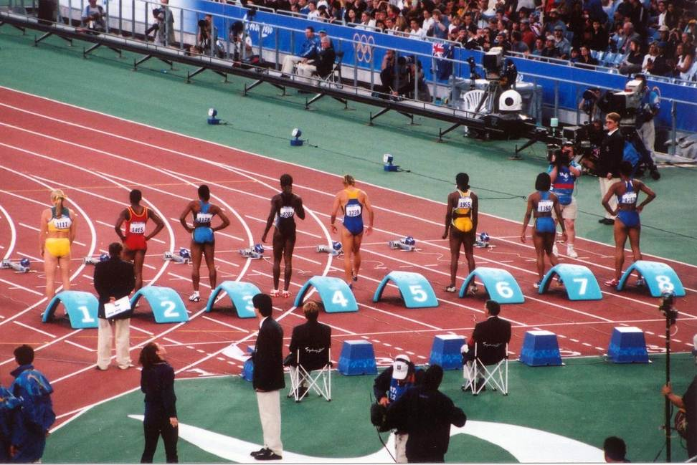
Image: Womens 100m final, jimmyharris, Creative Commons Attribution2.0, www.flickr.com/photos/jimmyharris/23519766

Analyse data for world record times to predict record times in forty years.
You will:
- Analyse and interpret data to determine how world records have changed over time and to predict a future world record
- Evaluate the reasonableness of you prediction and the limitations of your strategy
- Present your findings as a mathematical report.

Mathematical report:
A prediction of the men’s 1500 metres world record time in 2053.
This report involves the mathematical interpretation of world record data from 1912 to 2013 in order to predict the world record time for the men’s 1500-metre event in 2053. The report will also discuss the reasonableness of the prediction and the limitations of the strategy used.
Variables
The variables being investigated are:
- time elapsed since 1912 (years)
- world record times (minutes).

World record times: men’s 1500 metre event
Date record set | Years since 1912 | Time  (mm:ss.0) | Time (minutes) | Date record set | Years since 1912 | Time  (mm:ss.0) | Time (minutes)
8/06/1912 | 0 | 03:55.8 | 3.9300 | 6/09/1955 | 43 | 03:40.8 | 3.6800
5/08/1917 | 5 | 03:54.7 | 3.9117 | 3/08/1956 | 44 | 03:40.6 | 3.6767
19/06/1924 | 12 | 03:52.6 | 3.8767 | 11/07/1957 | 45 | 03:40.2 | 3.6700
11/09/1926 | 14 | 03:51.0 | 3.8500 | 11/07/1957 | 45 | 03:40.2 | 3.6700
5/10/1930 | 18 | 03:49.2 | 3.8200 | 12/07/1957 | 45 | 03:38.1 | 3.6350
9/09/1933 | 21 | 03:49.2 | 3.8200 | 28/08/1958 | 46 | 03:36.0 | 3.6000
17/10/1933 | 21 | 03:49.0 | 3.8167 | 6/09/1960 | 48 | 03:35.6 | 3.5933
30/06/1934 | 22 | 03:48.8 | 3.8133 | 8/07/1967 | 55 | 03:33.1 | 3.5517
6/08/1936 | 24 | 03:47.8 | 3.7967 | 2/02/1974 | 62 | 03:32.2 | 3.5367
10/08/1941 | 29 | 03:47.6 | 3.7933 | 15/08/1979 | 67 | 03:32.1 | 3.5350
17/07/1942 | 30 | 03:45.8 | 3.7633 | 15/07/1980 | 68 | 03:32.1 | 3.5350
17/08/1943 | 31 | 03:45.0 | 3.7500 | 27/08/1980 | 68 | 03:31.4 | 3.5233
7/07/1944 | 32 | 03:43.0 | 3.7167 | 28/08/1983 | 71 | 03:31.2 | 3.5200
15/07/1947 | 35 | 03:43.0 | 3.7167 | 4/09/1983 | 71 | 03:30.8 | 3.5133
29/06/1952 | 40 | 03:43.0 | 3.7167 | 16/07/1985 | 73 | 03:29.7 | 3.4950
4/06/1954 | 42 | 03:42.8 | 3.7133 | 23/08/1985 | 73 | 03:29.5 | 3.4917
21/06/1954 | 42 | 03:41.8 | 3.6967 | 6/09/1992 | 80 | 03:28.9 | 3.4817
28/07/1955 | 43 | 03:40.8 | 3.6800 | 12/07/1995 | 83 | 03:27.4 | 3.4567
6/09/1955 | 43 | 03:40.8 | 3.6800 | 14/07/1998 | 86 | 03:26.0 | 3.4333

Scatter plot and line of best fit

Description of trend
The scatter plot shows a linear decrease in record times over the 86 year period. Most of the individual records are close to the trend line, i.e. there are no obvious anomalies. Therefore this is a strong trend and should be a good predictor of future records.
Equation of line of best fit
Gradient = (3.5 – 3.9)/(72 – 7)
= –0.006
y intercept = 3.94

Equation: y = –0.006x + 3.94,
where y is the world record time and x is the number of years since 1912.
Prediction of world record time in 2053
The year 2053 is 141 years from 1912.
Substituting into the equation for the line of best fit
y = –0.006 x 141 + 3.94
= 3.094
My prediction of the world record time for the men’s 1500-metre event in 2053 is:
3.094 minutes or 3:05.6 (m:ss.0)

Discussion
Based on the information I have at this point in time, I consider that my prediction is reasonable as it is based on sound mathematical analysis of the current trend in world record times.
My strategy has limitations however; as it involves extrapolation over a forty year period, and assumes that the current trend will continue over this time.
It is reasonable to assume that the human body has limitations and that there may be an absolute minimum time for the 1500 metres. As that time is approached we would expect the record to be broken by ever decreasing increments. Data for the 100-metre world records (below) indicate that the limit for that event is not being approached yet. As the 1500-metre event is a much longer duration, there is a much greater margin for reducing the record time, so I think it is less likely that a limit is being approached.
Data source: https://en.wikipedia.org/wiki/Men's_100_metres_world_record_progression
Even though the world record for 1500 metres has not been broken for 15 years, that does not conflict with my prediction as there was no obvious decrease in record-breaking increments up to that time.
Conclusion
In consideration of the points discussed above, my prediction of a time of 3 minutes 5.6 seconds for the 1500-metre men’s world record in 2053 is mathematically justified based on current information.

