Activity 3: Examining the Geography achievement standard
Highlight the aspects of the achievement standard that are evident in the student work below.

Year 3 Australian Curriculum: Geography achievement standard
By the end of Year 3, students describe the characteristics of different places at the local scale and identify and describe similarities and differences between the characteristics of these places. They identify interconnections between people and places. They describe the location of selected countries and the distribution of features of places. Students recognise that people have different perceptions of places and how this influences views on the protection of places.
Students pose simple geographical questions and collect information from different sources to answer these questions. They represent data in tables and simple graphs and the location of places and their characteristics on labelled maps that use the cartographic conventions of legend, title, and north point. They describe the location of places and their features using simple grid references and cardinal compass points. Students interpret geographical data to describe distributions and draw conclusions. They present findings using simple geographical terminology in a range of texts. They suggest action in response to a geographical challenge.
Source: www.australiancurriculum.edu.au/humanities-and-social-sciences/geography/curriculum/f-10?layout=1#level3

- Example of student work
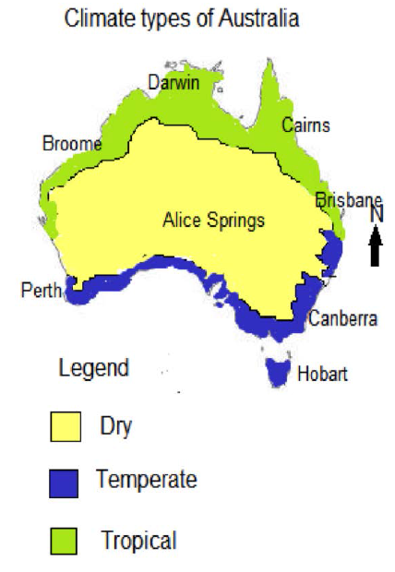 | 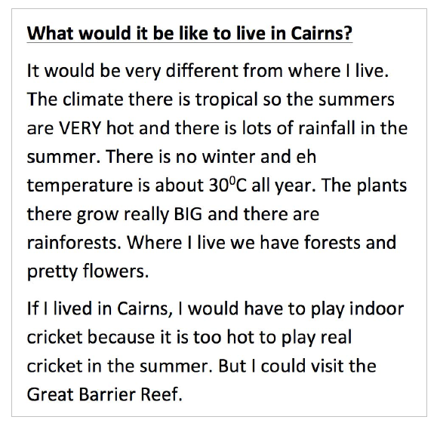
Source: ACARA, Work samples portfolio, www.acara.edu.au/curriculum/worksamples/Year_3_Geography_Portfolio.pdf

