Activity 3: Examining the Geography achievement standard
Highlight the aspects of the achievement standard that are evident in the student work below.

Year 9 Australian Curriculum: Geography achievement standard
By the end of Year 9, students explain how geographical processes change the characteristics of places. They predict changes in the characteristics of places over time and identify the possible implications of change for the future. They analyse interconnections between people, places and environments and explain how these interconnections influence people, and change places and environments. Students propose explanations for distributions and patterns over time and across space and describe associations between distribution patterns. They analyse alternative strategies to a geographical challenge using environmental, social and economic criteria and propose and justify a response.
Students use initial research to identify geographically significant questions to frame an inquiry. They collect and evaluate a range of primary and secondary sources and select relevant geographical data and information to answer inquiry questions. They represent multi-variable data in a range of appropriate graphic forms, including special purpose maps that comply with cartographic conventions. They analyse data to propose explanations for patterns, trends, relationships and anomalies and to predict outcomes. Students synthesise data and information to draw reasoned conclusions. They present findings and explanations using relevant geographical terminology and graphic representations in a range of appropriate communication forms. Students propose action in response to a geographical challenge taking account of environmental, economic and social considerations and predict the outcomes and consequences of their proposal.
Source: www.australiancurriculum.edu.au/humanities-and-social-sciences/geography/curriculum/f-10?layout=1#level3

Example of student work
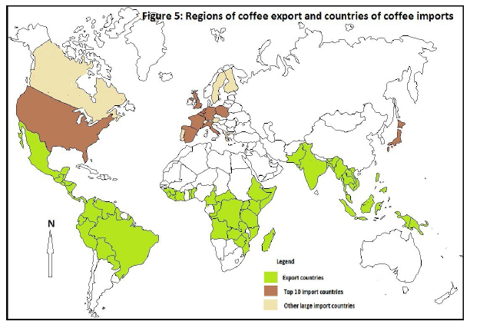
All of the world’s coffee is produced in the regions of Central and South America, Africa and countries of the East and South East Asia region (see Figure 5). These places are involved in the primary production of green coffee beans. The countries that import most of the coffee are in the regions of North America, Europe and in Japan. Countries in these regions are involved in the manufacturing, packaging, distribution and consumption of coffee. All countries that produce coffee are located between the Tropic of Cancer and the Tropic of Capricorn in contrast to the importing countries which are located in the northern hemisphere (mostly above the Tropic of Cancer).
Source: www.acara.edu.au/curriculum/worksamples/Year_9_Geography_Portfolio.pdf

