Video reflection: Making long-, medium- and short-term planning decisions in kindergarten
  - Queensland kindergarten learning guideline 2024

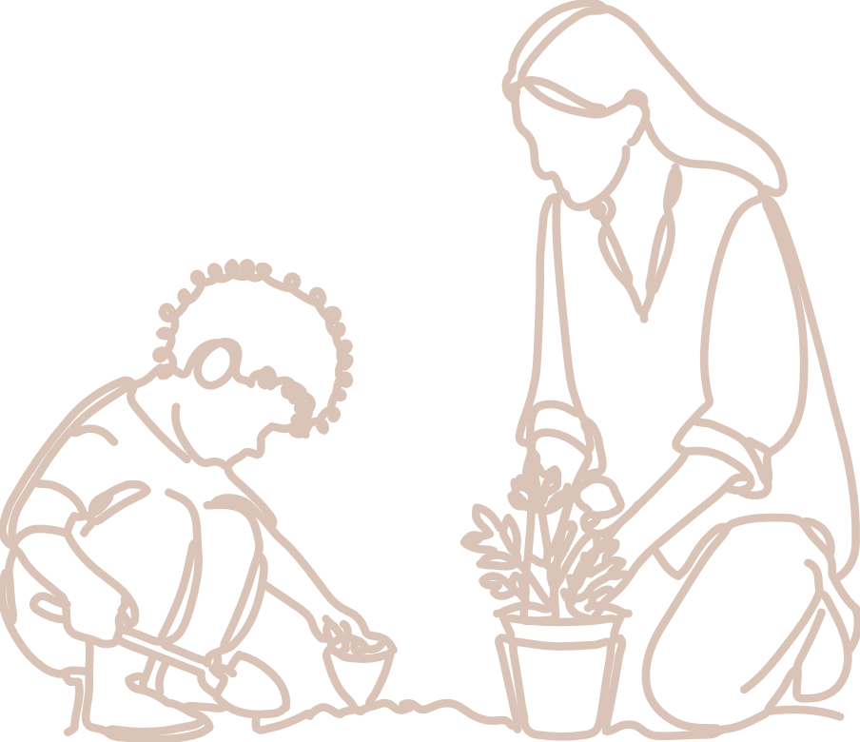  Practices | The video, Making long-, medium- and short-term planning decisions in kindergarten, illustrates the approach of one teacher for the practice: Engaging in responsive planning and decision making.  It shows one teacher’s approach to planning for kindergarten learning and development across the year through the eKindy program.  eKindy offers an at-home kindergarten program for children who are living in rural and remote areas, travelling or medically unable to attend a local early childhood service in the year before Prep. This program is delivered through the Brisbane School of Distance Education.  eKindy implements their program through:  - kindy packs for each unit (2 units per term) sent to families to support learning  - 1 weekly group webinar  - 1 weekly individual webinar  - weekly reflection sheets provided by families  - 3 consecutive face-to-face term play days for children with their eKindy teacher (facilitated in the child’s nearest school of distance education). QKLG p.13

About this resource
This resource allows you to record your own reflections from watching the video, Making long-, medium- and short-term planning decisions in kindergarten. Throughout your reflection, you will have the opportunity to consider:
- the practice that informs decision-making in the video
- next steps for your own practice.

Reflecting on: Engaging in responsive planning and decision-making
Read the practice: Engaging in responsive planning and decision-making (QKLG p.13). A key consideration for planning for this practice is that teacher-initiated planning decisions build on children’s knowledge, perspectives, capabilities and interests in the long-, medium- and short-term. This can be seen in Figure 1.
Figure 1

In the context of the video, planning was undertaken in the following way:
Long-term planning
- significant learnings from the QKLG mapped across the year, allowing children multiple opportunities to engage with learning priorities
Medium-term planning
- two open-ended units per term
Short-term planning
- implementation of the learning priorities using the children’s interests and following spontaneous learning opportunities.

Reflection
How does long- and medium-term planning support this teacher to be responsive and pivot towards children’s interests in the short term, while maintaining the integrity of learning priorities?

Next steps
The teacher identifies that planning is critical to ensure there is a balance of learning and development across the year, and that children have multiple opportunities to show what they know, understand and can do in kindergarten.
How do you ensure children have had the opportunity to engage with the range of learning and development from the QKLG across the kindergarten year?
How do you ensure children have multiple opportunities to engage with learning priorities throughout the year?
How do you maintain the integrity of planned learning priorities when responding to children’s interests and spontaneous moments?
How do you support next steps for learning in short-term planning?

Links to the National Quality Standard
This professional learning can be linked to the following concepts under the National Quality Standard, Quality Area 1 (QA1) — Educational program and practice:
- QA 1.1: Program — as it involves thinking about the kindergarten educational program
- QA 1.2: Practice — as it involves analysing practice to identify where teachers could make improvements for children and families
- QA 1.3: Assessment and planning — as it involves questioning how well the learning needs of all children are being planned for.

References
Australian Children’s Education and Care Quality Authority. (2024). National Quality Standard. Australian Children’s Education and Care Quality Authority. www.acecqa.gov.au/nqf/national-quality-standard
 © State of Queensland (QCAA) 2025
Licence: https://creativecommons.org/licenses/by/4.0 | Copyright notice: www.qcaa.qld.edu.au/copyright —
lists the full terms and conditions, which specify certain exceptions to the licence.
Attribution (include the link): © State of Queensland (QCAA) 2025 www.qcaa.qld.edu.au/copyright.

