Video reflection: Reviewing evidence to make judgments at the time of transition
  - Queensland kindergarten learning guideline 2024

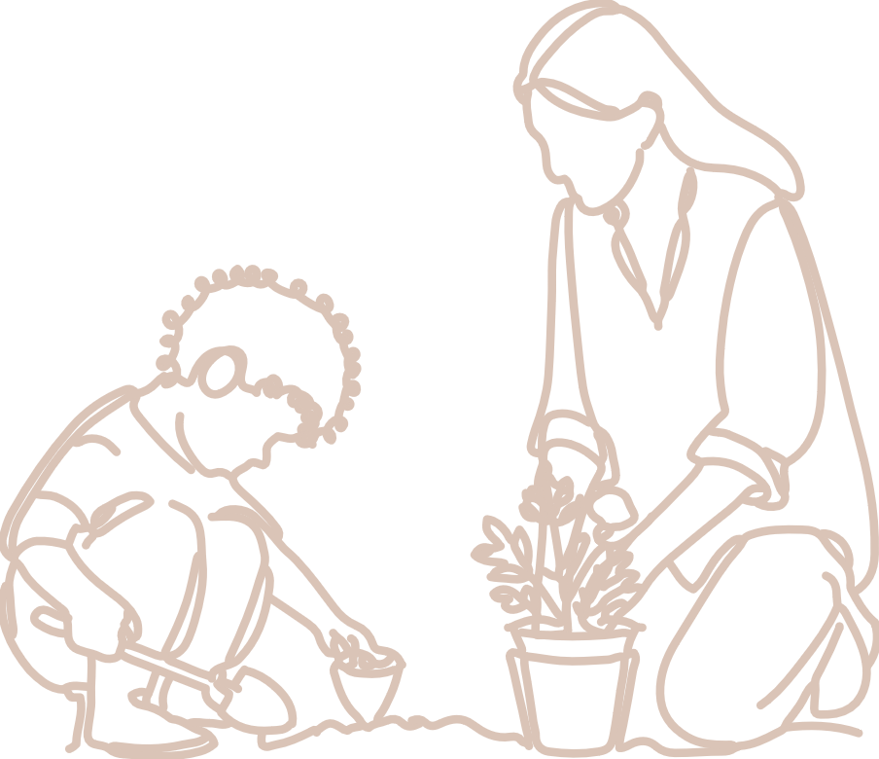Practices | The video, Reviewing evidence to make judgments at the time of transition, provides an illustration of Assessment of learning at the point of transition. In this video, a kindergarten teacher discusses the process of reviewing a collection of evidence to make a ‘more like’ judgment of learning and development using the continua.  QKLG p. 16

About this resource
This resource allows you to record your reflections after watching the video, Reviewing evidence to make judgments at the time of transition. Throughout your reflection, you will have the opportunity to consider:
- QKLG practices that inform decision-making for assessing children’s learning
- making judgments on the continua of learning and development, and next steps for your own practice.

Reflecting on practices
Read Assessing children’s learning (QKLG p.16) and reflect on the video in relation to your own practice.

Assessing children’s learning
Teachers and educators review evidence as part of assessment of learning practices. They make ‘more like’ judgments using the continua at a point in time to describe the phase of a child’s learning and development.
The teacher in the video uses an assessment profile as the mechanism for monitoring and reviewing a collection of evidence.
What are the advantages of an assessment profile?

Reflecting on the continua of learning and development
Read the information on the continua of learning and development (QKLG p. 18–19) and reflect on the process for making ‘more like’ judgments.

Reflection
At a point in time, teachers review a collection of evidence and draw conclusions from their analysis to make judgments about which phase a child’s learning is ‘more like’. These judgments are used in a transition statement to describe and share information about children’s learning, development and wellbeing.
How can collaboration deepen understanding of observable learning on the continua when reviewing a collection of evidence?

Next steps
Considering your context individually or collaboratively reflect on how you review collections of evidence to make judgments at the time of transition.
How do you make decisions about the evidence you need to be able to make a judgment?
In what ways can you use the support of others in your context when reflecting on evidence of learning?
What would you like to continue doing, stop doing or start doing to support making consistent judgments?

Links to the National Quality Standard
This professional learning can be linked to the following concepts under the National Quality Standard, Quality Area 1 (QA1) — Educational program and practice:
- QA 1.1: Program — as it involves thinking about the kindergarten educational program
- QA 1.2: Practice — as it involves analysing practice to identify where teachers could make improvements for children and families
- QA 1.3: Assessment and planning — as it involves questioning how well the learning needs of all children are being planned for.

Reference
Australian Children’s Education and Care Quality Authority. (2024). National Quality Standard. Australian Children’s Education and Care Quality Authority. www.acecqa.gov.au/nqf/national-quality-standard
 © State of Queensland (QCAA) 2026
Licence: https://creativecommons.org/licenses/by/4.0 | Copyright notice: www.qcaa.qld.edu.au/copyright —
lists the full terms and conditions, which specify certain exceptions to the licence. | Attribution: © State of Queensland (QCAA) 2026 — please include the link to our copyright notice.

