Video reflection: Reviewing learning priorities in kindergarten
  - Queensland kindergarten learning guideline 2024

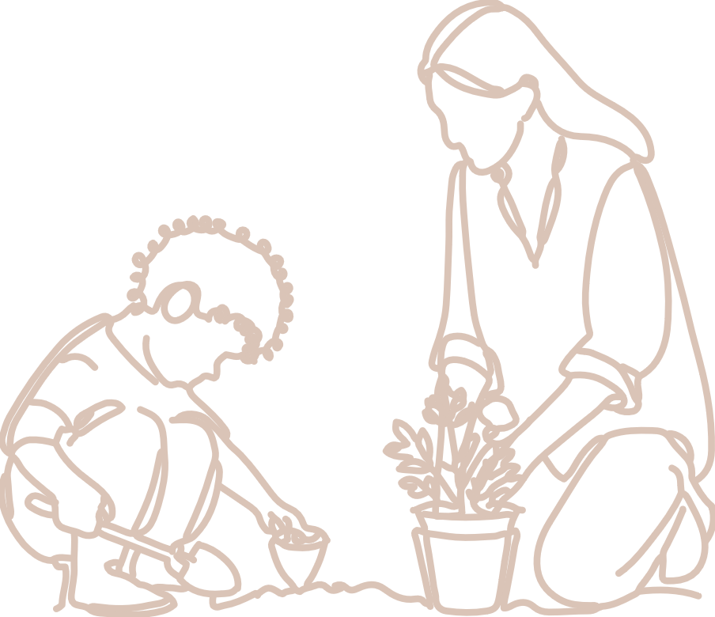  Practices | The video, Reviewing learning priorities in kindergarten, provides an illustration of responsive planning and decision-making focusing on learning priorities for individuals, small groups and the whole group. In this video, two early childhood professionals share their perspectives and practice.  QKLG p. 13

About this resource
This resource allows you to record your own reflections after watching the video, Reviewing learning priorities in kindergarten. Throughout your reflection, you will have the opportunity to consider:
- the QKLG practice of engaging in responsive planning and decision-making
- the learning priorities discussed in the video, in relation to significant learnings
- next steps for your own practice.

Reflecting on engaging in responsive planning and decision-making
Teacher-initiated planning for long-, medium- and short-term decision-making plays a role in how teachers develop learning priorities for small groups, whole groups and individuals.
How does developing and reviewing learning priorities, as described in the video, enable children’s participation and progress to be seen over time?
How does including the perspectives of colleagues, parents/carers or professional partners contribute to the process of reviewing learning priorities?

Reflecting on learning and development
In the video, the teacher shares how goals for individual children connected to the group goal of building numeracy in personally meaningful ways.
Read the following significant learnings and observable learnings from the QKLG 2024 which were mentioned as priority learning in the video.
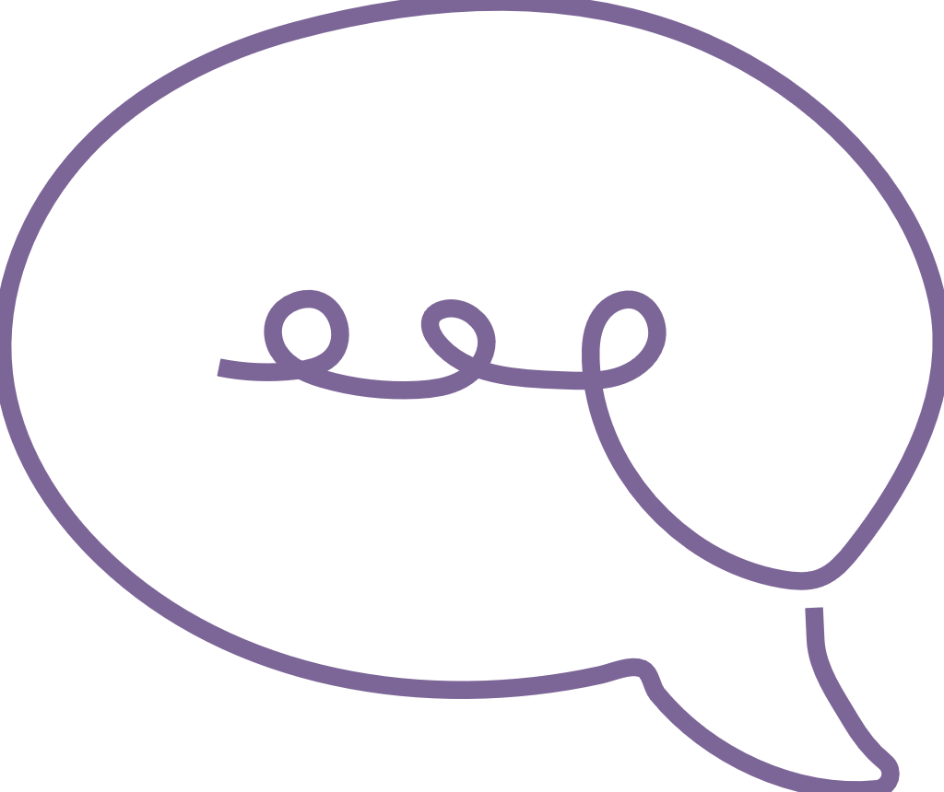  Communicating | Key focus | Significant learnings | Emerging phase  in familiar situations  with explicit support | Exploring phase  in familiar situations  with occasional support | Extending phase  in new situations  with occasional prompting
 | Building numeracy in personally meaningful ways | uses everyday language to describe shapes and spatial relationships | - understands the language of shapes, positions and directions  - e.g. locates objects when features of shapes such as round or pointy are described by an adult | - describes shapes, positions and directions  - e.g. uses everyday language such as round or pointy to describe features of shapes in the environment, with scaffolding | - describes and identifies shapes, positions and directions in a range of contexts  - e.g. recognises shapes in the environment and uses everyday language such as round, circle or pointy to describe the features with infrequent prompting

Reflection
Consider how the group learning priority ‘uses everyday language to describe shapes’ supports the teacher to identify learning priorities for individual children. Using the continua example (above) and the video, reflect on:
How does play-based formative assessment assist the teacher to make decisions about teaching and learning to support individuals?
What information in the continua assists teachers to tailor group learning priorities for individuals?

Next steps
Consider your context and how you develop and review learning priorities. What is something you would like to start, stop and/or continue in your current practice based on your reflections?
Start
Stop
Continue

Links to the National Quality Standard
This professional learning can be linked to the following concepts under the National Quality Standard, Quality Area 1 (QA1) — Educational program and practice:
- QA 1.1: Program — as it involves thinking about the kindergarten educational program
- QA 1.2: Practice — as it involves analysing practice to identify where teachers could make improvements for children and families
- QA 1.3: Assessment and planning — as it involves questioning how well the learning needs of all children are being planned for.

Reference
Australian Children’s Education and Care Quality Authority. (2024). National Quality Standard. Australian Children’s Education and Care Quality Authority. www.acecqa.gov.au/nqf/national-quality-standard
 © State of Queensland (QCAA) 2026
Licence: https://creativecommons.org/licenses/by/4.0 | Copyright notice: www.qcaa.qld.edu.au/copyright —
lists the full terms and conditions, which specify certain exceptions to the licence.
Attribution: © State of Queensland (QCAA) 2026 www.qcaa.qld.edu.au/copyright.

