Video reflection: Responsive decision-making in kindergarten
Queensland kindergarten learning guideline 2024

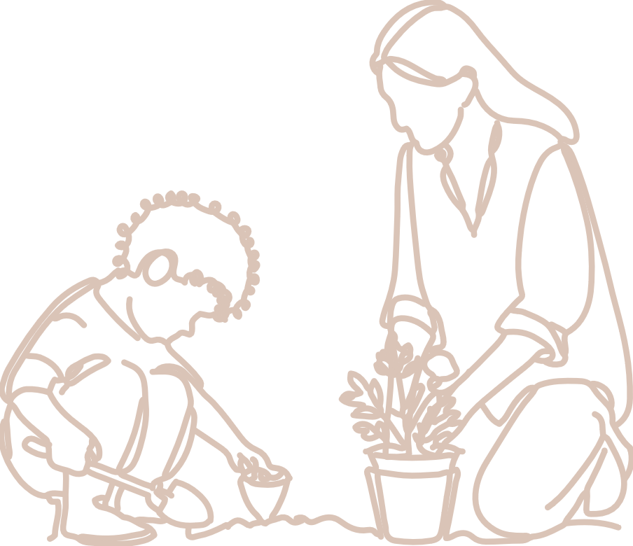  Practices | The video, Responsive decision-making in kindergarten, provides an illustration of learning priorities informing planning and decision-making in teacher-initiated and spontaneous learning moments. In this video, two early childhood professionals share their perspectives and practice.  QKLG p. 13

About this resource
This resource allows you to record your own reflections after watching the video, Responsive decision-making in kindergarten. Throughout your reflection, you will have the opportunity to consider:
- the learning and development areas discussed in the video, in relation to significant learnings
- QKLG practices that inform discussion of practice in the video
- next steps for your own practice.

Reflecting on learning and development
In the video, intentional teaching is described as the purposeful and planful way teachers initiate play-based learning and respond to spontaneous learning focusing on learning priorities. The teacher uses children’s interest in board games to respond to and support learning priorities for individuals in Communicating and Connectedness through intentional teaching strategies.
The video relates to the following significant learnings from the QKLG 2024.
  Communicating | Key focus | Significant learnings | Emerging phase  in familiar situations  with explicit support | Exploring phase  in familiar situations  with occasional support | Extending phase  in new situations  with occasional prompting
 | Building numeracy in personally meaningful ways | develops awareness of number and counting | - uses number names that are personally familiar and attempts counting  - e.g. recalls numbers from familiar stories or rhymes in play | - uses counting in play and is beginning to count in  - e.g. uses numbers and counting in dramatic play with support to count in sequence | - assesses sizes of sets, using one-to-one correspondence to count in sequence  - e.g. estimates how may items are in a collection then counts each item in sequence to check the total, with prompting

  Connectedness | Key focus | Significant learnings | Emerging phase  in familiar situations  with explicit support | Exploring phase  in familiar situations  with occasional support | Extending phase  in new situations  with occasional prompting
 | Building positive relationships | develops skills in cooperating, sharing and turn-taking | - follows directions and cues to share and take turns  - e.g. follows adult direction and copies modelling to share and take turns | - attempts to share and take turns to work with others  - e.g. uses an adult suggested strategy such as ‘first and then’ to negotiate sharing | - cooperates, shares and takes turns in interactions  - e.g. recalls and uses modelled strategies to alternate turns in a group situation with unfamiliar people, with a reminder

Reflection
Reflect on the significant learnings and observable learnings (above) which are mentioned as priority learning in the video. Consider how the structure of the learning and development areas of the QKLG guide responsive decision-making.
What decisions can the continua support you make about teaching and learning?
How can knowledge of individual priorities and the continua support decision-making in spontaneous learning moments?

Reflecting on using intentional teaching strategies
Teachers and educators use and adapt teaching strategies in planned and spontaneous learning to suit individuals. Read the practice using intentional teaching strategies (QKLG p.15) and reflect on your own practice.
How do you monitor the range and balance of intentional teaching strategies you use and consider their effectiveness?
How do you communicate your plans for differentiating teaching, learning and environments for individual learners?

Next steps
What goal/s do you have for your responsive planning and decision-making practice and how can you achieve them?

Links to the National Quality Standard
This professional learning can be linked to the following concepts under the National Quality Standard, Quality Area 1 (QA1) — Educational program and practice:
- QA 1.1: Program — as it involves thinking about the kindergarten educational program
- QA 1.2: Practice — as it involves analysing practice to identify where teachers could make improvements for children and families
- QA 1.3: Assessment and planning — as it involves questioning how well the learning needs of all children are being planned for.

Reference
Australian Children’s Education and Care Quality Authority. (2024). National Quality Standard. Australian Children’s Education and Care Quality Authority. www.acecqa.gov.au/nqf/national-quality-standard
 © State of Queensland (QCAA) 2026
Licence: https://creativecommons.org/licenses/by/4.0 | Copyright notice: www.qcaa.qld.edu.au/copyright —
lists the full terms and conditions, which specify certain exceptions to the licence.
Attribution: © State of Queensland (QCAA) 2026 www.qcaa.qld.edu.au/copyright.

