Video reflection: Monitoring, a planned approach to transition — an experience from eKindy
  - Queensland kindergarten learning guideline 2024

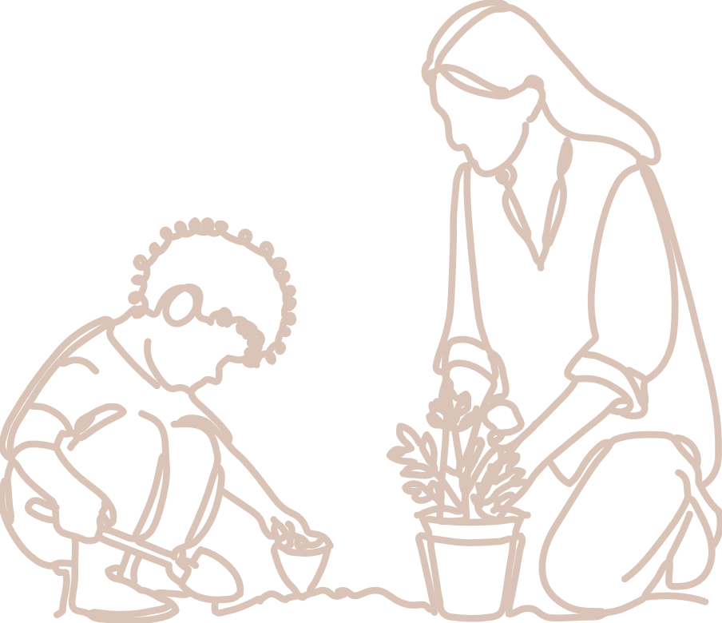  Practices | The video, Monitoring: a planned approach to transition — an experience from e-Kindy illustrates the approach of one teacher to the practice: Assessing children’s learning.  It shows a teacher’s planned approach to gathering and monitoring evidence across the kindergarten year through the eKindy program. eKindy offers an at-home kindergarten program for children who are living in rural and remote areas, travelling or medically unable to attend a local early childhood service, in the year before Prep. This no-cost program is delivered through the Brisbane School of Distance Education.  QKLG p. 16

About this resource
This resource allows you to record your own reflections after watching the video, Monitoring: a planned approach to transition — an experience from eKindy. Throughout your reflection, you will have the opportunity to consider:
- the practice that informs teaching and learning in the video
- next steps for your own practice.

Reflecting on: Assessing children’s learning
The teacher in the video gathers evidence of what children know, understand and can do using a range of strategies across the year. These strategies include:
- weekly feedback sheets from families
- learning records
- learning stories
- anecdotal notes
- a data wall (reviewed each term).

Reflection
Consider the paragraph Assessment of learning from the QKLG p. 16.
How does a planned approach support this teacher to collect evidence effectively and sustainably?
The teacher refers to the use of a data wall that provides a point-in-time snapshot of learning. How does this assist her to monitor a child’s participation in the program and progress towards the identified learning priorities over time?
The data wall is an example of monitoring evidence of learning. How does this support her to make ‘more-like’ judgments at a point in time?

Next steps
Individually, or with your team, reflect on your approach to monitoring and collecting evidence to ensure you plan for learning priorities, use evidence for next steps and have evidence to support decision making using the continua.
How does your planning support you to gather evidence of what children know, understand and can do across the range of learning and development in the QKLG?
At what points in time do you review gathered evidence to reflect on learning?
In what ways do you engage with colleagues for support when making ‘more like’ judgments of learning and creating transition statements? Elaborate here.

Links to the National Quality Standard
This professional learning can be linked to the following concepts under the National Quality Standard, Quality Area 1 (QA1) — Educational program and practice:
- QA 1.1: Program — as it involves thinking about the kindergarten educational program
- QA 1.2: Practice — as it involves analysing practice to identify where teachers could make improvements for children and families
- QA 1.3: Assessment and planning — as it involves questioning how well the learning needs of all children are being planned for.

References
Australian Children’s Education and Care Quality Authority. (2024). National Quality Standard. Australian Children’s Education and Care Quality Authority. www.acecqa.gov.au/nqf/national-quality-standard
 © State of Queensland (QCAA) 2025
Licence: https://creativecommons.org/licenses/by/4.0 | Copyright notice: www.qcaa.qld.edu.au/copyright —
lists the full terms and conditions, which specify certain exceptions to the licence.
Attribution (include the link): © State of Queensland (QCAA) 2025 www.qcaa.qld.edu.au/copyright.

