Video reflection: Documenting Liam’s learning
  - Queensland kindergarten learning guideline 2024

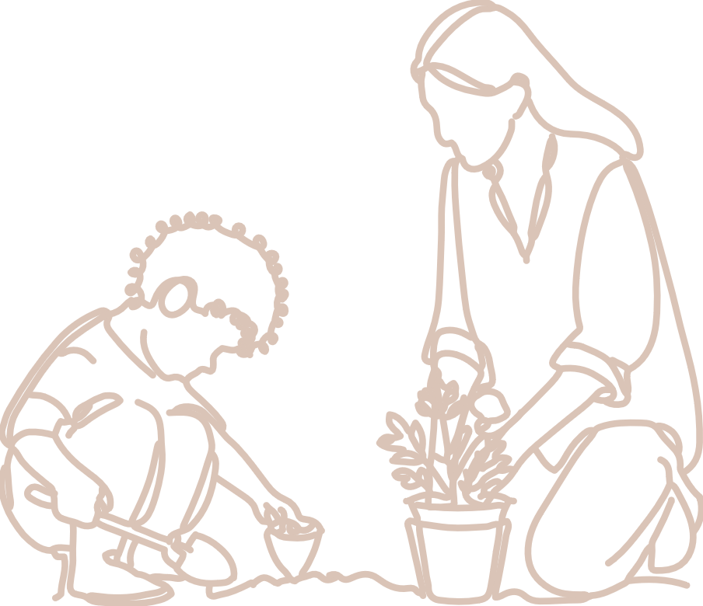  Practices | The video, Documenting Liam’s learning, follows on from the Planning with small groups of children video. It shows Liam carrying out the learning plan that he developed and captures Liam’s learning and his developing ability to engage with others and plan and carry out learning projects.  QKLG p. 13

About this resource
This resource allows you to record your own reflections after watching the video, Documenting Liam’s learning. Throughout your reflection, you will have the opportunity to consider the:
- learning and development demonstrated in the video in relation to a significant learning
- next steps for your own practice.

Teacher reflection
Liam and Ciara had both planned to work in the block studio this morning and their common interest became apparent at our planning meeting. Recognising that they both wanted to work in the same area, I invited them to share their plans and consider how they might be able to work together.
Through this discussion, Liam showed great pride in the knowledge that he had already gained in working with the blocks. He was more than willing to share this knowledge with Ciara in supporting her to build her work, claiming, ‘Well I know how to make a block man, did you know how? I’ll help you; it’s easy!’
This mentoring continued as they moved into the block studio and began their work. Liam generously offered to support Ciara in her work, as well as work on his own construction.

Reflecting on learning and development
The video relates to the following significant learning from the QKLG 2024.
  Connectedness | Key focus | Significant learnings | Emerging phase  in familiar situations  with explicit support | Exploring phase  in familiar situations  with occasional support | Extending phase  in new situations  with occasional prompting
 | Building positive relationships | engages with others | - comfortably plays alongside others | - interacts with others | - engages in interactions for a shared purpose

  Active Learning | Key focus | Significant learnings | Emerging phase  in familiar situations  with explicit support | Exploring phase  in familiar situations  with occasional support | Extending phase  in new situations  with occasional prompting
 | Building positive dispositions towards learning | plans and carries out learning projects | - engages with familiar spaces, materials and play | - attempts to plan and organise resources to carry out projects of interest | - plans, organises resources to carry out projects

Reflection
How does the teacher support Liam to play/interact/engage with others?
How does the teacher support Liam to carry out projects that develop his learning?
What do you think Liam knows, understands and can do? Record your observations.
The teacher identified that: Planning to follow this current interest could encourage opportunities for Liam and Ciara to connect their ideas for block play in the planning phase to extend their collaborative skills.
How does this identified next step allow for Liam and Ciara to progress, enrich or consolidate their learning?
Give a reason for your response.
What other next steps could consolidate their learning?

Links to the National Quality Standard
This professional learning can be linked to the following concepts under the National Quality Standard, Quality Area 1 (QA1) — Educational program and practice:
- QA 1.1: Program — as it involves thinking about the kindergarten educational program
- QA 1.2: Practice — as it involves analysing practice to identify where teachers could make improvements for children and families
- QA 1.3: Assessment and planning — as it involves questioning how well the learning needs of all children are being planned for.

Reference
Australian Children’s Education and Care Quality Authority. (2024). National Quality Standard. Australian Children’s Education and Care Quality Authority. www.acecqa.gov.au/nqf/national-quality-standard
 © State of Queensland (QCAA) 2025
Licence: https://creativecommons.org/licenses/by/4.0 | Copyright notice: www.qcaa.qld.edu.au/copyright —
lists the full terms and conditions, which specify certain exceptions to the licence.
Attribution (include the link): © State of Queensland (QCAA) 2025 www.qcaa.qld.edu.au/copyright.

