Video reflection: Inclusive practice in Communicating
  - Queensland kindergarten learning guideline 2024

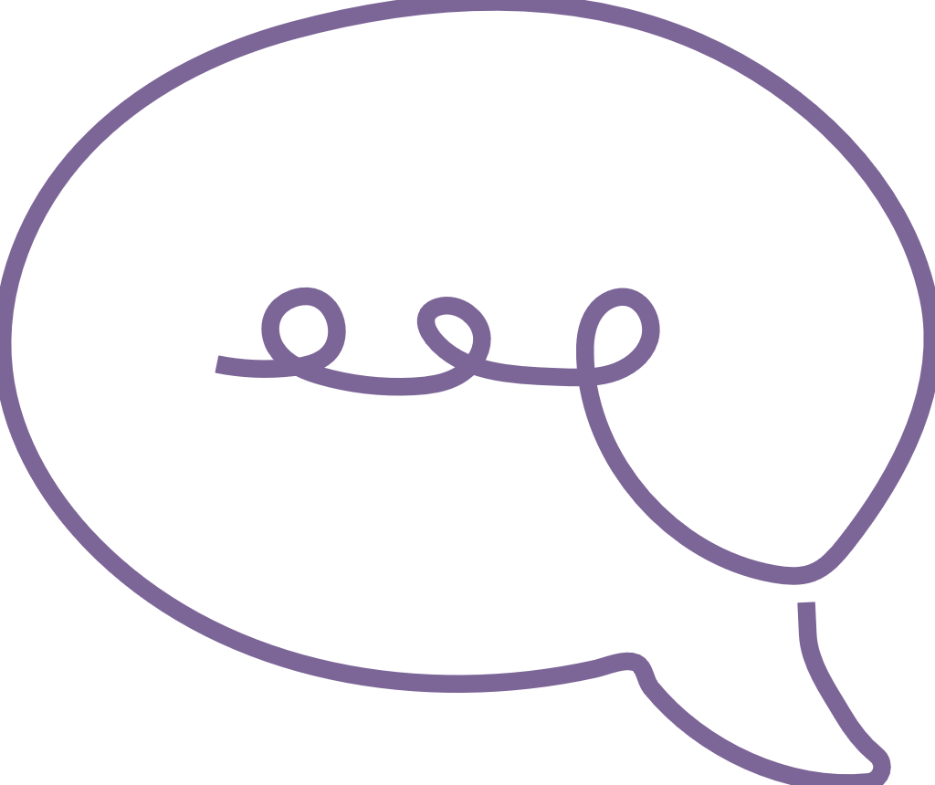  Communicating | The video, Inclusive practice in Communicating, illustrates the approach one service has taken to support the diversity of their learners. This reflects high expectations, equity and respect for diversity when creating an inclusive learning environment in their service.  This example of practice relates to the key focus: Engaging with and expanding language and the significant learnings:  - communicates verbally and nonverbally with others  - expands vocabulary.  QKLG p 49

About this resource
This resource allows you to record your own reflections after watching the video, Inclusive practice in Communicating. Throughout your reflection, you will have the opportunity to consider:
- the learning and development demonstrated in the video
- the principles that underpin the illustration of practice in the video
- the practices that inform teaching and learning in the video
- next steps for your own practice.

Reflecting on learning and development
The video relates to the following significant learning from the QKLG 2024.
Communicating | Key focus | Significant learnings | Emerging phase  in familiar situations  with explicit support | Exploring phase  in familiar situations  with occasional support | Extending phase  in new  situations  with occasional prompting
 | Engaging with and expanding language | communicates verbally and nonverbally with others | - begins to use nonverbal strategies, spoken/signed language/s or AAC to communicate  - e.g. uses modelled gestures or vocalisations to communicate wants or needs | - communicates using nonverbal strategies, spoken/signed language/s or AAC  - e.g. uses gestures and vocalisations to make requests and express themselves | - communicates confidently using nonverbal strategies, spoken/signed language/s or AAC to make meaning  - e.g. initiates an interaction to communicate interests, wants or requests using gestures and vocalisations that convey their meaning effectively
 | Engaging with and expanding language | expands vocabulary | - uses a small range of familiar words to express themselves  - e.g. uses single words to label familiar objects or people with adult modelling | - uses an increasing range of words to express themselves  - e.g. uses familiar words to express their thoughts and experiments with using new modelled vocabulary in play and interactions with adult support | - uses phrases to express themselves  - e.g. connects increasingly complex ideas drawing on a wider vocabulary modelled in texts and interactions

Reflection
Children may demonstrate their knowledge, skills and dispositions in multiple ways in a range of situations. Inclusive language in the observable learnings of the five learning and development areas supports teachers to recognise and value diverse ways children may communicate their learning.
Reflect on examples of observable learning using inclusive language in the table below.
In the space below, record examples of diverse ways children may respond, recognise, share and communicate what they know, understand and can do. For example, a child may point to an image to communicate what they are feeling.
respond
recognise
share
communicate
In your context, what are some familiar situations in which you might observe children communicating with others? What might be new situations that could challenge children to confidently use their communication skills?
List ways you may expand vocabulary to strengthen communication in play.

Reflecting on principles
Consider the identified principles of the QKLG (pp. 7–10) and complete the table below.
QKLG principle | How is the principle evident in the video?
Principle | Question | Response
Collaborative leadership and teamwork | What teamwork and collaboration supports teacher practice and enhances children’s communication outcomes?
High expectations, equity and respect for diversity | How does embedding inclusive communication practice benefit the individual and the group?

Reflecting on practices
Consider the identified practices of the QKLG (pp. 11–16) and complete the table below.
QKLG practice | How is the practice evident in the video?
Practice | Question | Response
Interacting with and responding to children | How are quality interactions supported through the practice in the video?
Facilitating play-based learning | How is the child’s participation in play-based learning enhanced?
Assessing children’s learning | How is evidence of learning used to inform ongoing planning and assessment?

Next steps
Consider the video and individually or collaboratively reflect on how you support all children in your service to access and participate in the range of learning in kindergarten.
How can each child be supported in personally meaningful ways to progress in their communicating knowledge, skills and understandings?
How can you foster shared understandings and collaborative approaches toward observing and assessing learning?
Why is it important to recognise and value home language/s, signed language/s and visual communication as well as Standard Australian English when gathering evidence of what children know, understand and can do?
What would you like to start, stop or continue in your own planning and assessment practice?

Links to the National Quality Standard
This professional learning can be linked to the following concepts under the National Quality Standard, Quality Area 1 (QA1) — Educational program and practice:
- QA 1.1: Program — as it involves thinking about the kindergarten educational program
- QA 1.2: Practice — as it involves analysing practice to identify where teachers could make improvements for children and families
- QA 1.3: Assessment and planning — as it involves questioning how well the learning needs of all children are being planned for.

References
Australian Children’s Education and Care Quality Authority. (2024). National Quality Standard. Australian Children’s Education and Care Quality Authority. www.acecqa.gov.au/nqf/national-quality-standard
 © State of Queensland (QCAA) 2026
Licence: https://creativecommons.org/licenses/by/4.0 | Copyright notice: www.qcaa.qld.edu.au/copyright —
lists the full terms and conditions, which specify certain exceptions to the licence.
Attribution: © State of Queensland (QCAA) 2026 www.qcaa.qld.edu.au/copyright.

