Video reflection: Exploring writing behaviours in kindergarten
  - Queensland kindergarten learning guideline 2024

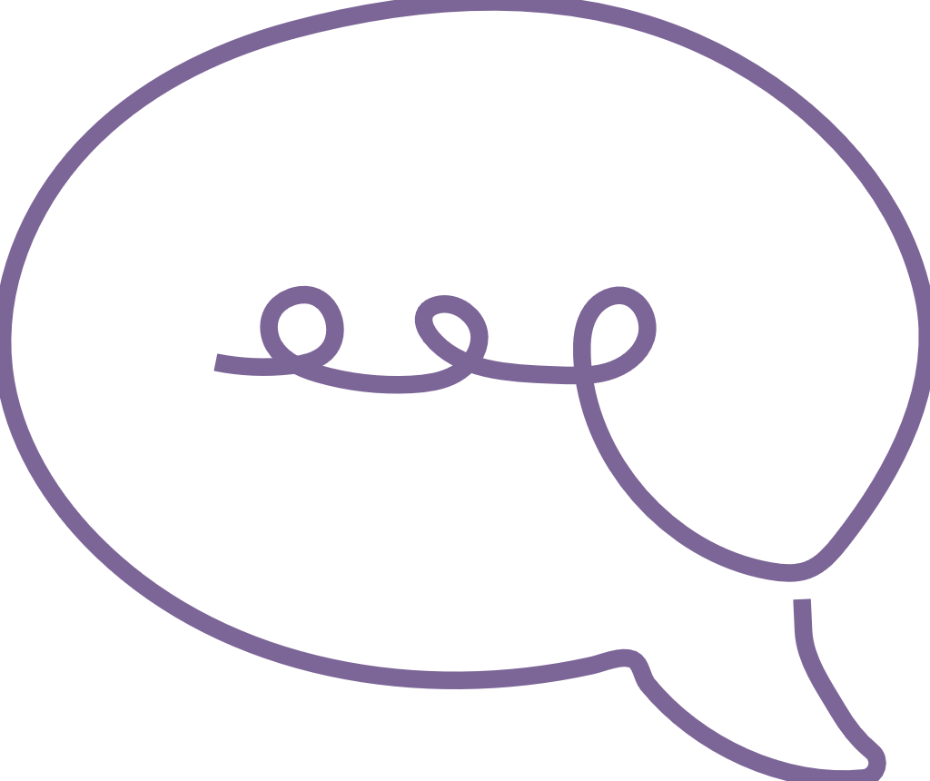  Communicating | The video, Developing writing behaviours in kindergarten, provides an illustration of intentional teaching practice and decision-making for the learning and development area: Communicating and the key focus: Building literacy in personally meaningful ways. The discussion focuses on the importance of intentionally planning and teaching mark-making and early writing for the significant learning:  - develops writing behaviours.  QKLG pp. 47–54

About this resource
This resource allows you to record your own reflections after watching the video, Developing writing behaviours in kindergarten. Throughout your reflection, you will have the opportunity to consider:
- the principles that underpin the illustration of practice in the video
- the practices that inform teaching and learning in the video
- the learning and development demonstrated in the video, in relation to a significant learning
- next steps for your own practice.

Reflecting on learning and development
The video relates to the following significant learning from the QKLG 2024.
Communicating | Key focus | Significant learnings | Emerging phase  in familiar situations with explicit support | Exploring phase  in familiar situations with occasional support | Extending phase  in new situations with occasional prompting
 | Building numeracy in personally meaningful ways | develops writing behaviours | - experiments with writing implements and begins to make marks  - e.g. begins to show an interest in making marks with an adult to create props for play experiences | - explores using writing implements to make marks and convey meaning  - e.g. experiments with mark-making and ways to ‘write’ using lines, shapes and symbols. May attempt to copy some familiar letters from environmental print to create signs for dramatic play, with encouragement | - uses mark-making and writing to convey meaning  - e.g. to support dramatic play, uses a combination of marks and familiar letters or words copied from environmental print, with prompting

Reflection
Consider your current group/s and print-rich environment. How do you use your environment to support mark-making and early writing outside of your dedicated literacy or writing space, e.g. other spaces or activities?
How do the observable learnings from this significant learning help you to plan experiences to consolidate, enrich or extend on children’s development of writing behaviours?
Consider the range of learning and development evidence that could be gathered for mark-making and to document what children know, understand and can do for this significant learning.
What types of evidence could you gather to assess children’s development of mark-making and early writing?

Reflecting on practices
Consider the identified practices of the QKLG (pp. 11–16) and complete the table below.
Practice | How is the practice evident in the video?
Practice | Question | Response
Using intentional teaching strategies | What strategies were discussed and/or demonstrated that support children’s development of writing behaviours?
Facilitating play-based learning | What opportunities did you notice for children to be active learners through mark-making in indoor and outdoor environments?
Assessing children’s learning | What strategies can teachers and educators use to ensure inclusive mark-making practices reflecting children’s diverse cultures, languages and capabilities?

Next steps
Over time, collaboratively reflect on how your service builds mark-making and early writing capabilities for all children in your kindergarten group.
Consider what you might need to know or actions you could take to intentionally plan for and assess mark-making and early writing for all kindergarten learners.
What are some ways you can share mark-making and early writing in your kindergarten context with families and the community?
How do you plan for learning priorities that leverage children’s interest in mark-making and early writing in personally meaningful ways?

Links to the National Quality Standard
This professional learning can be linked to the following concepts under the National Quality Standard, Quality Area 1 (QA1) — Educational program and practice:
- QA 1.1: Program — as it involves thinking about the kindergarten educational program
- QA 1.2: Practice — as it involves analysing practice to identify where teachers could make improvements for children and families
- QA 1.3: Assessment and planning — as it involves questioning how well the learning needs of all children are being planned for.

Reference
Australian Children’s Education and Care Quality Authority. (2024). National Quality Standard. Australian Children’s Education and Care Quality Authority. www.acecqa.gov.au/nqf/national-quality-standard
 © State of Queensland (QCAA) 2025
Licence: https://creativecommons.org/licenses/by/4.0 | Copyright notice: www.qcaa.qld.edu.au/copyright —
lists the full terms and conditions, which specify certain exceptions to the licence.
Attribution (include the link): © State of Queensland (QCAA) 2025 www.qcaa.qld.edu.au/copyright.

