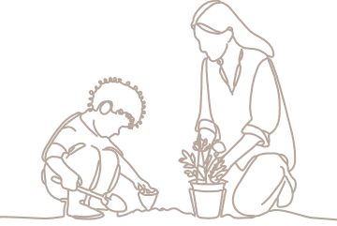
Evidence of learning
  - [Enter child’s name]

You may use this template as one way to document children’s learning and development in kindergarten.
How to use this template: Type information into the fields (yellow shading). When completed, delete the highlighted instructions (blue shading). To do so, select the instruction text, click the Home tab > Styles dropdown > Clear All/Clear Formatting > text will revert to Normal style and you can delete the text.

Teacher/educator name: | [Enter name] | Date: | [Enter a date]
Observed learning
Record the learning you observed, which may include:
  - the learning situation, e.g. the experience, the environment, who was involved, degree of familiarity
  - support provided in this situation by peers or adults
  - the child’s ideas, actions, interactions and/or language/s.
You may insert/attach samples of work or images to support your observation.
[Enter text]

Analysis and evaluation
Reflect on the Queensland kindergarten learning guideline (QKLG) and your professional knowledge to make meaning of the learning observed. You may consider:
  - significant learning/s focused on in this situation
  - what the child demonstrated they know, understand and can do in this situation
  - degree and effectiveness of the support provided
  - progress toward learning priorities
  - how strengths and capabilities may have changed or developed over time
  - the perspectives of the child, parent/carer or colleagues.
[Enter text]

Next steps
Use your analysis and evaluation to make decisions about future learning and teaching. You may consider:
  - knowledge, skills and dispositions to prioritise for future learning
  - learning situations, and levels of support, suited to the individual and the learning
  - experiences and opportunities promoting the prioritised learning
  - intentional teaching strategies to support intended next steps in learning for the child
  - further information you may need to make informed decisions about future learning.
[Enter text]

