Fractions reflection
  - Numeracy: Improving thinking about fractions in Years 2–6
April 2026

© State of Queensland (QCAA) 2026
Licence: https://creativecommons.org/licenses/by/4.0 | Copyright notice: www.qcaa.qld.edu.au/copyright —
lists the full terms and conditions, which specify certain exceptions to the licence. |
Attribution: © State of Queensland (QCAA) 2026 www.qcaa.qld.edu.au/copyright.
Other copyright material in this publication is listed below.
1. Unless otherwise indicated NAPLAN Proficiency level descriptions and material from the Australian Curriculum
is © ACARA 2010–present, licensed under CC BY 4.0. For the latest information and additional terms of use, please check the Australian Curriculum website and its copyright notice.
2. The ACARA National Numeracy Learning Progressions are licensed under a creative commons Attribution-NonCommercial 4.0 International (CC BY-NC 4.0) licence .

Queensland Curriculum & Assessment Authority
PO Box 307 Spring Hill QLD 4004 Australia
Phone: (07) 3864 0299
Email: office@qcaa.qld.edu.au
Website: www.qcaa.qld.edu.au

Contents
Notes and reflections 1
Introduction 1
The five fraction constructs 2
Representations 6
Final reflection 6
The five key constructs 7
Fractions in the Australian Curriculum 8
Achievement standard aspects and related content descriptions 8
General capability: Numeracy learning progression 10
Element: Number sense and algebra 10
Fractions in NAPLAN proficiency levels 12
Activities — overview 13
QCAA Numeracy resource 16
References 16

Notes and reflections

Introduction
List where you and your students encounter fractions in daily life.

What misconceptions do your students have about fractions?

In your classroom, what does:
- Numeracy look like?

- Mathematics look like?

- How do they look different?

Review the Numeracy learning progression. Choose a Year level. Consider:
What does the Numeracy learning progression tell you about the new fraction learning for that year level?

The five fraction constructs
Comparing quarters
- How would you adapt the activity to your classroom?
- What would you want your students to notice when participating in the activity?
- Which misconceptions might the activity help address?

What is the whole?
- How would you adapt the activity to your classroom?
- What would you want your students to notice when participating in the activity?
- Which misconceptions might the activity help address?

What fraction time?
- How would you adapt the activity to your classroom?
- What would you want your students to notice when participating in the activity?
- Which misconceptions might the activity help address?

Walk the line
- How would you adapt the activity to your classroom?
- What would you want your students to notice when participating in the activity?
- Which misconceptions might the activity help address?

Money, money, money
- How would you adapt the activity to your classroom?
- What would you want your students to notice when participating in the activity?
- Which misconceptions might the activity help address?

Multiplication squares
- How would you adapt the activity to your classroom?
- What would you want your students to notice when participating in the activity?
- Which misconceptions might the activity help address?

Dividing pancakes
- How would you adapt the activity to your classroom?
- What would you want your students to notice when participating in the activity?
- Which misconceptions might the activity help address?

Sharing snakes
- How would you adapt the activity to your classroom?
- What would you want your students to notice when participating in the activity?
- Which misconceptions might the activity help address?

Fraction wall
- How would you adapt the activity to your classroom?
- What would you want your students to notice when participating in the activity?
- Which misconceptions might the activity help address?

Creating and naming ratios
- How would you adapt the activity to your classroom?
- What would you want your students to notice when participating in the activity?
- Which misconceptions might the activity help address?

Interpreting fractions sub-element
- Is this progression reflected in our current program?
- What are the strengths of our current program?
- Are there gaps we could fill?
- How might changes to our program support student learning?

Representations
All the ways we represent a fraction
- How would you adapt the activity to your classroom?
- What would you want your students to notice when participating in the activity?
- Which misconceptions might the activity help address?

Final reflection
Identify one thing that you will share with a colleague or incorporate into your classroom practice.

The five key constructs

- Fractions as a part-whole | 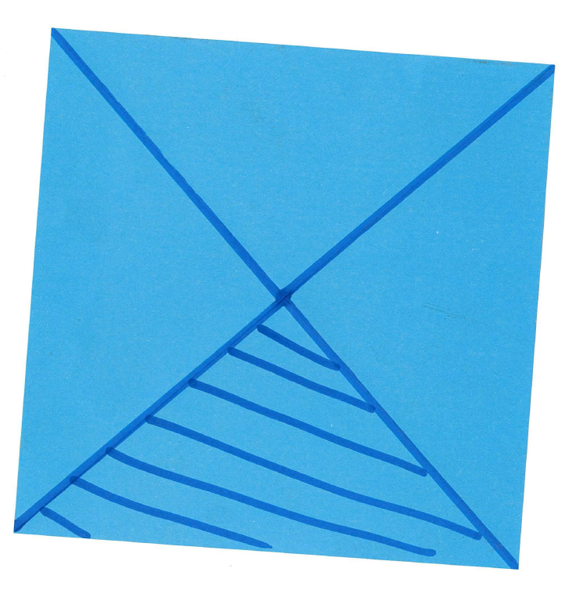
- Fractions as a measure | 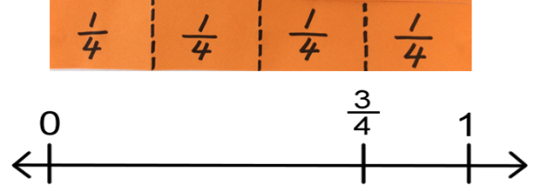
- Fractions as division | $\frac{7}{4}$ = 7 ÷ 4 = 1 $\frac{3}{4}$
- Fractions as operators | 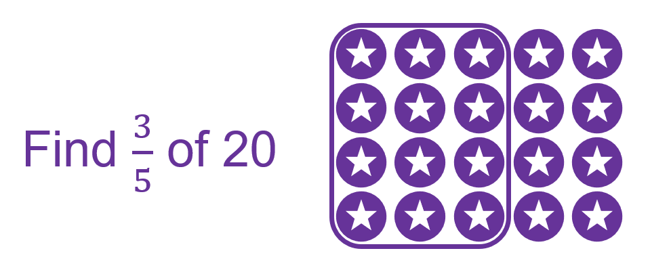
- Fractions as ratios | 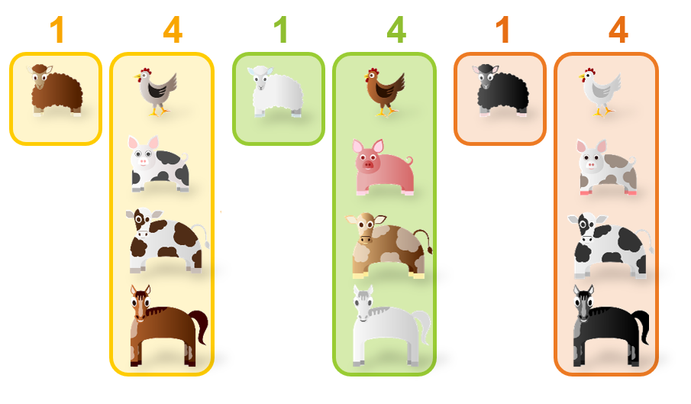

Fractions in the Australian Curriculum

Achievement standard aspects and related content descriptions
Year | Achievement standard | Related content descriptions
2 | identify and represent part-whole relationships of halves, quarters and eighths in measurement contexts | - recognise and describe one-half as one of 2 equal parts of a whole and connect halves, quarters and eighths through repeated halving (AC9M2N03)  - identify common uses and represent halves, quarters and eighths in relation to shapes, objects and events (AC9M2M02)  - recognise and read the time represented on an analog clock to the hour, half-hour and quarter-hour (AC9M2M04)  - identify, describe and demonstrate quarter, half, three-quarter and full measures of turn in everyday situations (AC9M2M05)
2 | determine the number of days between events using a calendar and read time on an analogue clock to the hour, half hour and quarter hour | - identify the date and determine the number of days between events using calendars (AC9M2M03)  - recognise and read the time represented on an analog clock to the hour, half-hour and quarter-hour (AC9M2M04)
3 | represent unit fractions and their multiples in different ways | - recognise and represent unit fractions including $\frac{1}{2}, \frac{1}{ 3}, \frac{1}{4}, \frac{1}{5}$and $\frac{1}{10},$and their multiples in different ways; combine fractions with the same denominator to complete the whole (AC9M3N02)
4 | recognise equivalent fractions and make connections between fraction and decimal notations | - recognise and extend the application of place value to tenths and hundredths and use the conventions of decimal notation to name and represent decimals (AC9M4N01)  - find equivalent representations of fractions using related denominators and make connections between fractions and decimal notation (AC9M4N03)
4 | count and represent fractions on a number line | - count by fractions including mixed numerals; locate and represent these fractions as numbers on number lines (AC9M4N04)
5 | order and represent, add and subtract fractions with the same or related denominators | - compare and order fractions with the same and related denominators including mixed numerals, applying knowledge of factors and multiples; represent these fractions on a number line (AC9M5N03)  - solve problems involving addition and subtraction of fractions with the same or related denominators, using different strategies (AC9M5N05)
5 | represent common percentages and connect them to their fraction and decimal equivalents | - recognise that 100% represents the complete whole and use percentages to describe, represent and compare relative size; connect familiar percentages to their decimal and fraction equivalents (AC9M5N04)
6 | order common fractions, giving reasons, and add and subtract fractions with related denominators | - apply knowledge of equivalence to compare, order and represent common fractions including halves, thirds and quarters on the same number line and justify their order (AC9M6N03)  - solve problems involving addition and subtraction of fractions using knowledge of equivalent fractions (AC9M6N05)
6 | solve problems involving finding a fraction, decimal or percentage of a quantity and use estimation to find approximate solutions to problems involving rational numbers and percentages | - apply knowledge of place value to add and subtract decimals, using digital tools where appropriate; use estimation and rounding to check the reasonableness of answers (AC9M6N04)  - multiply and divide decimals by multiples of powers of 10 without a calculator, applying knowledge of place value and proficiency with multiplication facts; using estimation and rounding to check the reasonableness of answers (AC9M6N06)  - solve problems that require finding a familiar fraction, decimal or percentage of a quantity, including percentage discounts, choosing efficient calculation strategies and using digital tools where appropriate (AC9M6N07)  - approximate numerical solutions to problems involving rational numbers and percentages, including financial contexts, using appropriate estimation strategies (AC9M6N08)

General capability: Numeracy learning progression

Element: Number sense and algebra
 | Sub-element: Interpreting fractions | Year
Progression level 1 | Creating halves  - demonstrates that dividing a whole into 2 parts can create equal or unequal parts  - identifies the part and the whole in representations of one-half (e.g. joins 2 equal pieces back together to form the whole shape and can identify the pieces as equal parts of the whole shape)  - creates equal halves of collections and physical and virtual materials using all of the whole (e.g. folds a paper strip in half to make equal pieces by aligning the edges; cuts a sandwich in half diagonally; partitions a collection into 2 equal groups to represent halving) | 3  2
Progression level 2 | Repeated halving  - makes quarters and eighths by repeated halving (e.g. locates halfway on a strip of paper then halves each half; finds a quarter of an orange by halving and then halving again; 8 counters halved and then halved again into 4 groups of 2)  - identifies the part and the whole in representations of halves, quarters and eighths (e.g. identifies the fractional parts that make up the whole using fraction puzzles)  - represents known fractions using various fraction models (e.g. discrete collections, continuous linear and continuous area) | 3  2
Progression level 3 | Repeating fractional parts  - accumulates fractional parts (e.g. knows that two-quarters is inclusive of one-quarter and twice one-quarter, not just the second quarter)  - checks the equality of parts by iterating one part to form the whole (e.g. when given a representation of one-quarter of a length and asked, “what fraction is this of the whole length?”, uses the length as a counting unit to make the whole)  - identifies fractions in measurement situations and solves problems using halves, quarters and eighths (e.g. quarters in an AFL match; uses 2 $\frac{1}{2}$-cup measures in place of a single one-cup measure)  - demonstrates that fractions can be written symbolically and interprets using part-whole knowledge (e.g. interprets $\frac{3}{4}$ to mean 3 one-quarters or 3 lots of $\frac{1}{4}$) | 3  2
Progression level 4 | Re-imagining the whole  - creates thirds by visualising or approximating and adjusting (e.g. imagines a strip of paper in 3 parts, then adjusts and folds)  - identifies examples and non-examples of partitioned representations of fractions  - divides a whole into different fractional parts for different purposes (e.g. explores the problem of sharing a cake equally between different numbers of guests)  - demonstrates that the more parts into which a whole is divided, the smaller the parts become | 3  2
Progression level 5 | Equivalence of fractions  - identifies the need to have equal wholes to compare fractional parts (e.g. compares the pieces of pizza when 2 identical pizzas are cut into 6 and 8 and describes how one-sixth is greater than one-eighth)  - creates fractions greater than one by recreating the whole (e.g. when creating four-thirds, demonstrates that three-thirds corresponds to the whole and the fourth third is part of an additional whole)  - creates equivalent fractions by dividing the same-sized whole into different parts (e.g. shows two-sixths is the same as one-third of the same whole; creates a fraction wall)  - uses partitioning to establish relationships between fractions (e.g. creates one-sixth as one-third of one-half)  4 | 3  2
Progression level 6 | Fractions as numbers  - connects the concepts of fractions and division: a fraction is a quotient, or a division statement (e.g. two-sixths is the same as 2 ÷ 6 or 2 partitioned into 6 equal parts or to solve “how to share 2 chocolate bars equally between 3 people”, understands that it is 2 divided by 3, therefore each person gets two-thirds of a chocolate bar)  - justifies where to place fractions on a number line (e.g. to show two-thirds on a number line, divides the space between zero and one into 3 equal parts and indicates the correct location)  - uses and explains the equivalence of decimals to benchmark fractions (e.g. $\frac{1}{4}$= 0.25, $\frac{1}{2}$ = 0.5, $\frac{3}{4}$= 0.75, $\frac{1}{10}$ = 0.1, $\frac{1}{100},$= 0.01; converts cup measures to millilitres)  5 | 3  2
Progression level 7 | Comparing fractions  - understands the equivalence relationship between a fraction, decimal and percentage as different representations of the same quantity (e.g. $\frac{1}{2}$ = 0.5 = 50% because 5 is half of 10 and 50 is half of 100)  - identifies a fraction as a rational number that has relative size (e.g. describes a position as $\frac{2}{ 3}$ of the way up a ladder or varies a movement by performing it at half speed; understands “a quarter turn” as turning 90˚ rather than turning once every four steps)  - reasons and uses knowledge of equivalence to compare and order fractions of the same whole (e.g. compares two-thirds and three-quarters of the same collection or whole, by converting them into equivalent fractions of eight-twelfths and nine-twelfths; explains that three-fifths must be greater than four-ninths because three-fifths is greater than a half, and four-ninths is less than a half)  6 | 3  2
Progression level 8 | Operating with fractions  - adds or subtracts fractions with the same denominators and justifies the need for a common denominator  - uses strategies to calculate a fraction of a quantity (e.g. to find a time-point two-thirds of the way through a music video or animation, determines one-third then doubles; locates a position a third of the way across the stage by measuring the width of the stage and dividing by 3)  - explains the difference between multiplying and dividing fractions (e.g. recognises $\frac{1}{2}$ × $\frac{1}{4}$as one-half of a quarter and $\frac{1}{2}$ ÷ $\frac{1}{4}$as how many quarters are in one half)  - expresses one quantity as a fraction of another (e.g. 12 defective items from the 96 that were produced represents one-eighth of all items produced) demonstrates why dividing by a fraction can result in a larger number | 3  2

Fractions in NAPLAN proficiency levels
Year | Needs additional support | Developing | Strong | Exceeding
Year 3 | identify halves and quarters of a shape, object or small collection | determine halves, quarters and eighths of a whole  read time on a digital and analog clock to the hour and half hour | interpret common fractions as equal parts of a whole and determine a fraction of a shape, object or collection | solve problems involving common fractions
Year 5 | determine a simple fraction of a collection | compare fractions and identify the fraction to complete a whole | identify equivalent fractions  represent hundredths as decimals  solve problems using unit fractions  continue number patterns using addition and multiplication with whole numbers, simple fractions and decimals | add and subtract decimals and fractions with the same denominator
Year 7 | calculate a simple fraction of a quantity  describe the probability of an event, using likelihood and familiar fractions | compare unit fractions  identify equivalent fractions  calculate a fraction of a quantity and the fraction to complete a whole  convert between fractions, decimals and percentages  solve single- and multi-step problems involving integers, decimals and fractions with related denominators  continue number patterns using addition or subtraction with fractions | calculate fractions and percentages of a quantity  solve single- and multi-step problems involving integers, decimals and fractions | connect equivalent fractions, decimals and percentages  solve multi-step problems including with integers, fractions, decimals and the combination of operations

Activities — overview
Detailed instructions can be found on the relevant strategy factsheets.
Activity | Resources needed |  | Description
Comparing quarters  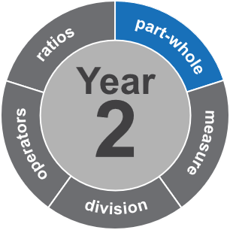 | Continuous models, e.g.  - playdough  - paper shapes.  Discrete models, e.g.  - 12 counters  - 8 buttons  - 22 matchsticks. |  | Work in pairs or groups.  - Use the resource you have been given to create and label one quarter.  - Compare your one quarter to other representations in the class and discuss.
What is the whole?  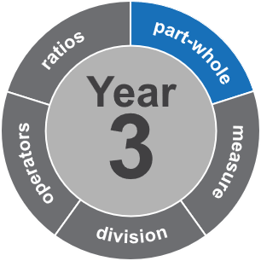 | - Dice:  - one standard six-sided die  - one die labelled with $\frac{1}{2}, \frac{1}{3}, \frac{1}{4}, \frac{1}{5}, \frac{1}{8}, \frac{1}{10}$  - 60 paperclips or other counters |  | Work in groups of three to four.  - Place 60 paperclips in the middle of the table. Each student takes a turn.  - Roll the pair of dice and use the paperclips to complete this sentence:  ‘(fraction roll) of my collection is (whole number roll), so altogether, I have … ’  - Take the amount of paperclips that completes the sentence from the centre of the table.  - The person with the most paperclips when the pile runs out wins.
What fraction time?  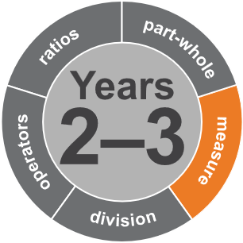 |  | What fraction time? Circular number line cards  Printed and cut out | Work in groups of three to four.  - Take the rope and make a circle for a clock or a full turn.  - First, add the fractions on the pegs to show 0, $\frac{1}{4}$, $\frac{1}{2}$, $\frac{2}{4}$, $\frac{3}{4}$ and 1.  - Use the additional cards to add the other fractions.  - Leave your completed clockface and compare to other groups in the class.
- 1.5 metre rope
- At least 8 pegs
Walk the line  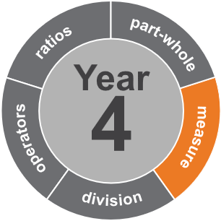 |  | Walk the line cards  Printed and cut out | Work as a whole group.  - Hang a rope across the classroom low enough for students to reach.  - Start by having students place the fraction cards for 0, $\frac{1}{2}$ and 1.  - Call students forward one by one to place the other fractions. Allow students to provide feedback or corrections to their peers.
- Rope to fit across the space, and fixed so cards can be hung below
- At least 40 pegs
Money, money, money  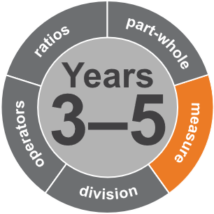 |  | Money, money, money cards  Printed and cut out | Work in pairs or groups of three to four.  - Take the paper strip on your table and fold it to make fifths.  - Label 0 at one end and 1 at the other end to make a fraction measure.  - Take turns to place cards at the right place on the paper strip. The cards include common fractions, their decimal and percentage equivalents, and Australian coins up to $1.
- Paper strip, string or rope
- Pen or paper clip to mark $\frac{1}{5}$intervals
Multiplication squares  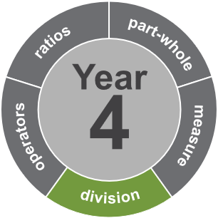 |  | Multiplication square template  Printed and cut out | Work in pairs.  - Students first explore the use of a multiplication square.  - Demonstrate how you can use any two rows to find equivalent fractions.  - Call out fractions and have students identify and record equivalent fractions.
 | - Writing materials
Dividing pancakes  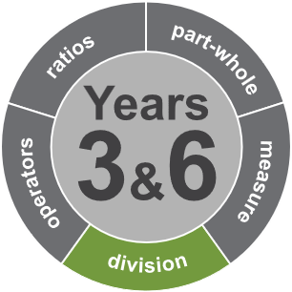 | - Playdough  - Knives for cutting  - Plates or suitable surface |  | Work in pairs.  - Give each pair one ball of playdough, and instruct them to partition it in the following ways  - three pancakes to share between four people  - four pancakes to share between three people  - nine pancakes to share between 12 people.  - Have students determine three more ways to divide pancakes.
Sharing snakes  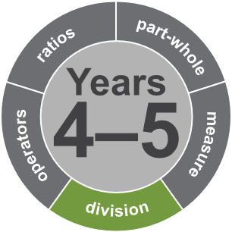 |  | Sharing snakes template  Printable version of the below resources | Work as a whole group.  - Begin with three chairs at the front of the room, one with one lolly snake, one with two snakes and one with three snakes.  - Explain to students that when it is their turn, they need to stand behind the chair that will give them the largest amount of lolly snake, given they are sharing with everyone else also standing behind that chair.  - Call students up one by one, and have them say what amount of lolly snake each person at their chair group will now get.
- 3 chairs or tables
- At least 6 lolly snakes or other snacks to share
Fraction wall  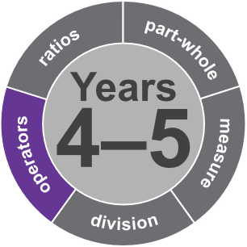 |  | Fraction wall template  Print and cut out | Work in small groups.  - All students require a fraction wall template and something to colour it in with.  - Students take turns to roll the two dice to create a fraction then colour it in on their fraction wall, if possible. (No ‘part’ bricks can be coloured so students may have to ‘pass’ on their turn.)  - Repeat until one group member has their whole wall coloured.
- One fraction die and one normal die per group
- Pens or pencils for each student
Creating and naming ratios  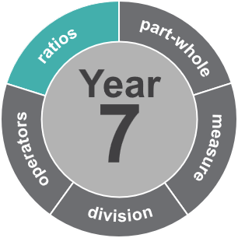 |  | Ratio scenario cards  Print and cut out all or some of Sets A–D | Work in pairs.  - Students, in their pair, select a ratio card and use their blocks to represent it.  - Students record their representations for later discussion.  - Sets get progressively more challenging so can be used for differentiating.
 | - Blocks or counters in various colours
All the ways we represent a fraction  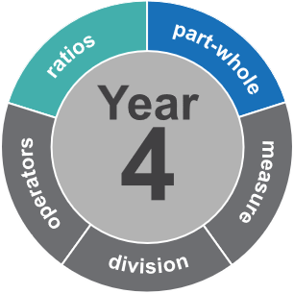 | - Sticky notes |  | Work individually, in pairs, groups or whole class.  - Students find as many ways as possible to represent $\frac{3}{5}$ (name a fraction) and write each representation on a sticky note.  - Students sort sticky notes into representation types and label the types.  - Compare all the representations.

QCAA Numeracy resources
- Advice and resources www.qcaa.qld.edu.au/p-10/aciq/general-capabilities/numeracy
- Sequence of numeracy progressions www.qcaa.qld.edu.au/downloads/aciqv9/general-resources/ac9_gc_progressions_numeracy.pdf
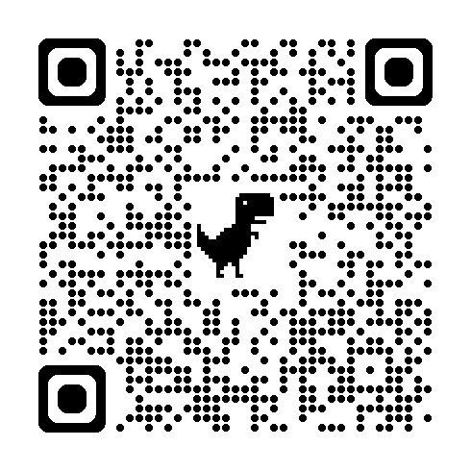
Sequence of numeracy progressions

References
Clarke, D. (2011). Fractions as division: The forgotten notation? In J. Way & J. Bobis. Fractions: Teaching for understanding (pp. 33–41). Australian Association of Mathematics Teachers.
Way, J. (2011.) Activities. Top drawer teachers: Resources for teachers of mathematics. The Australian Association of Mathematics Teachers . https://topdrawer.aamt.edu.au/Fractions/Activities.

