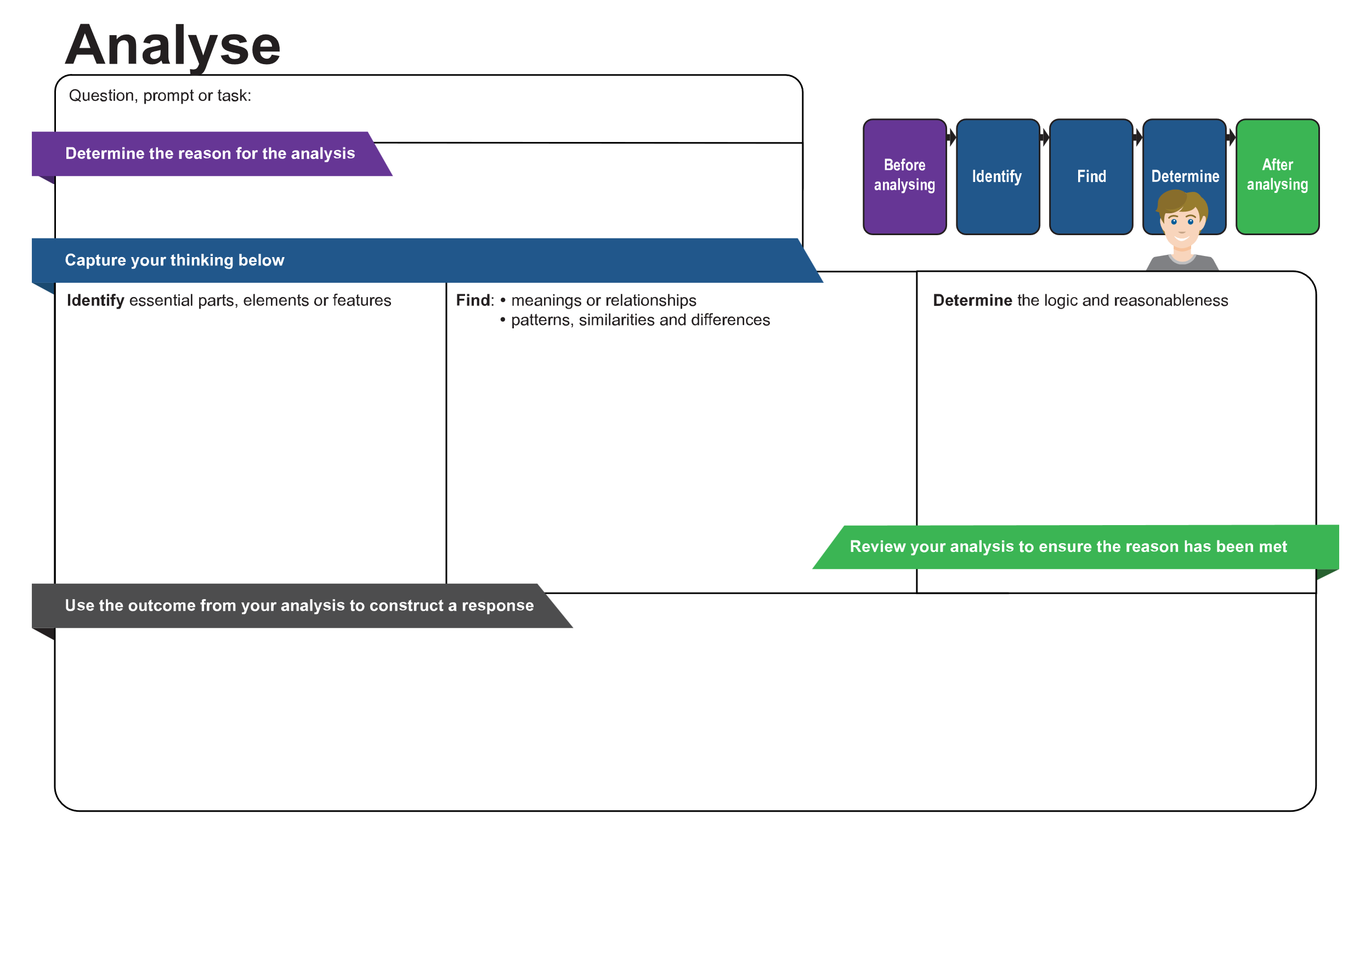
[Enter content]
[Enter content]
[Enter content]
[Enter content]
[Enter content]
[Enter content]
© State of Queensland (QCAA) 2026
Licence: https://creativecommons.org/licenses/by/4.0 | Copyright notice: www.qcaa.qld.edu.au/copyright — lists the full terms and conditions, which specify certain exceptions to the licence. |
Attribution: © State of Queensland (QCAA) 2026 www.qcaa.qld.edu.au/copyright.
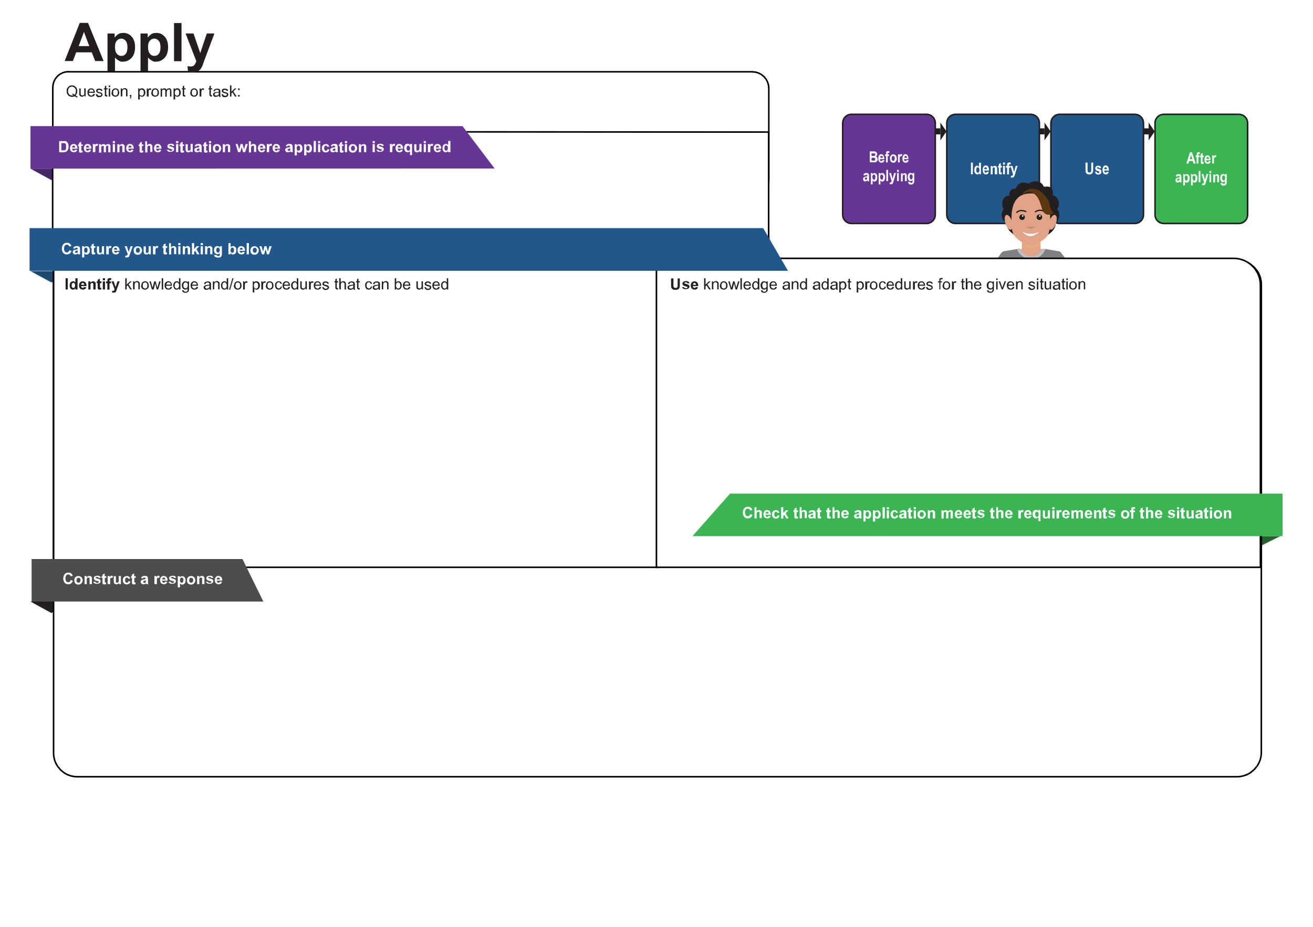
[Enter content]
[Enter content]
[Enter content]
[Enter content]
[Enter content]
© State of Queensland (QCAA) 2026
Licence: https://creativecommons.org/licenses/by/4.0 | Copyright notice: www.qcaa.qld.edu.au/copyright — lists the full terms and conditions, which specify certain exceptions to the licence. |
Attribution: © State of Queensland (QCAA) 2026 www.qcaa.qld.edu.au/copyright.
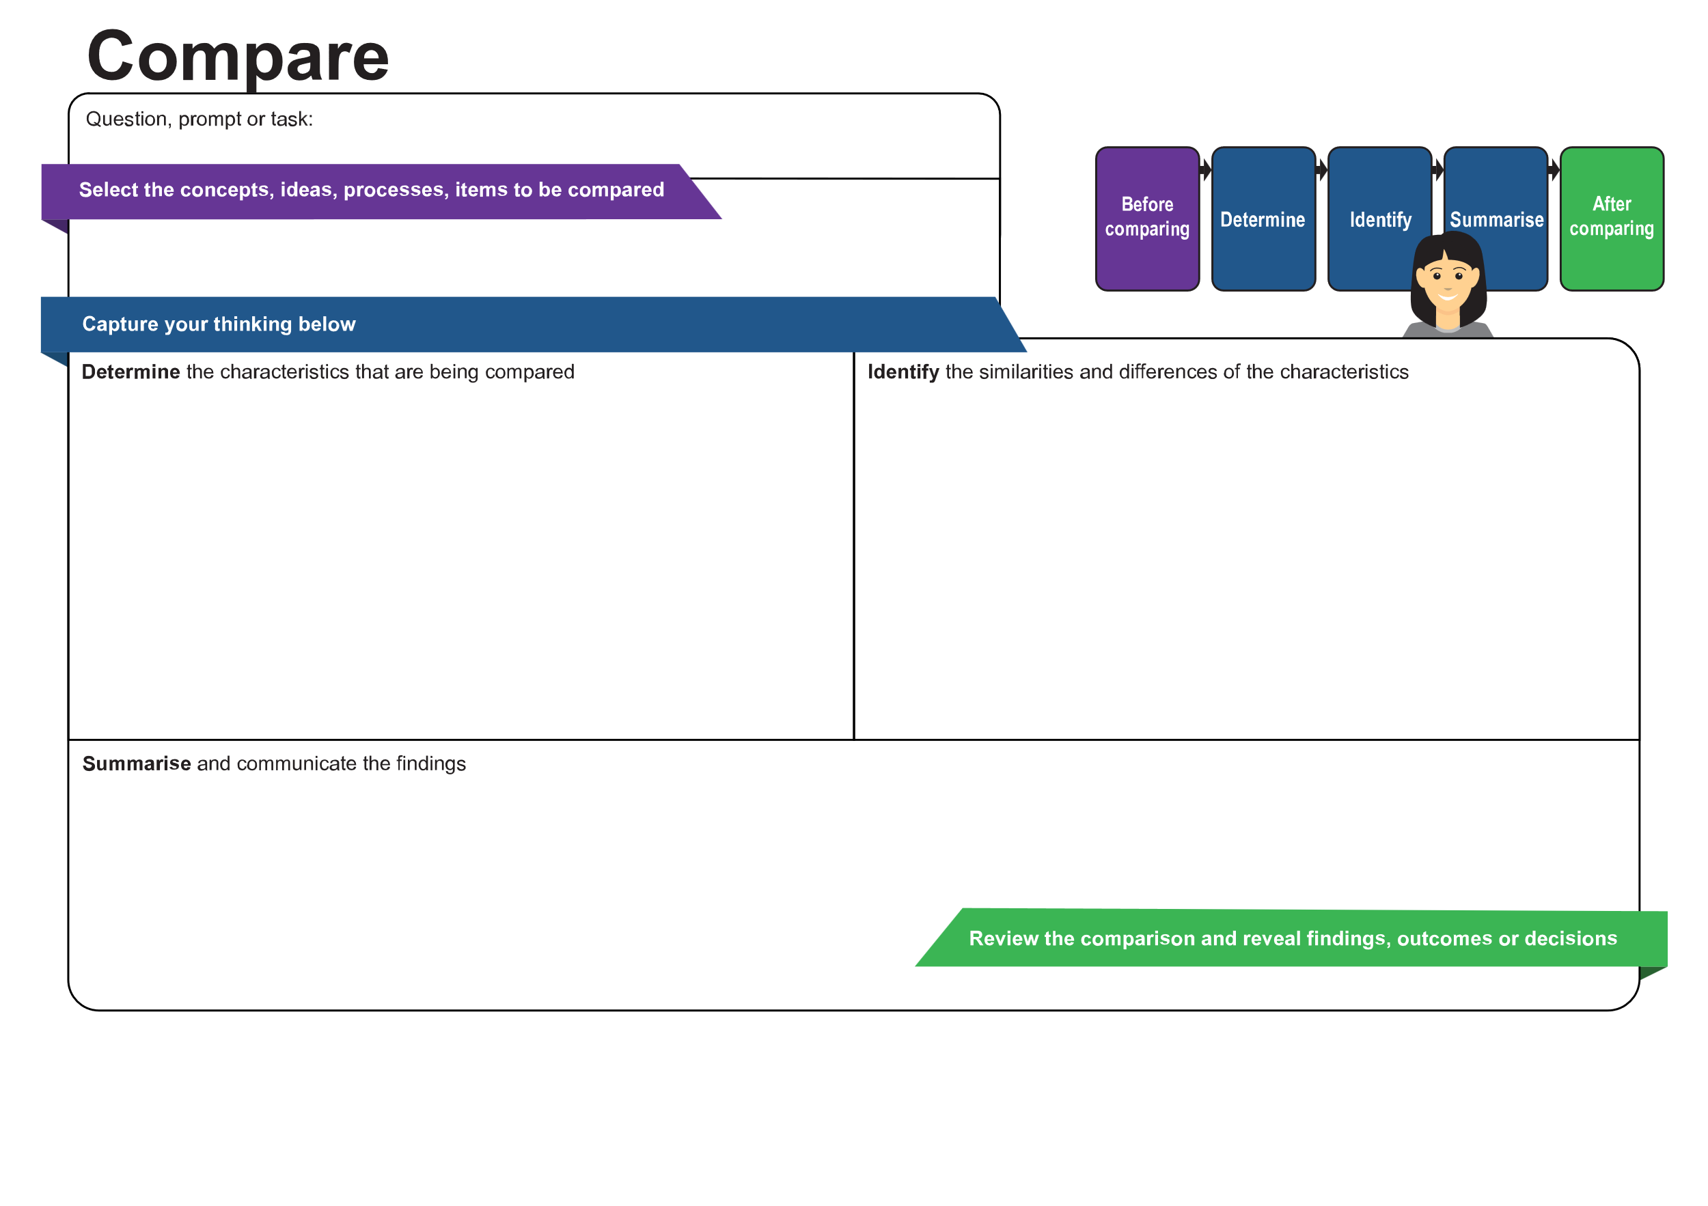
[Enter content]
[Enter content]
[Enter content]
[Enter content]
[Enter content]
© State of Queensland (QCAA) 2026
Licence: https://creativecommons.org/licenses/by/4.0 | Copyright notice: www.qcaa.qld.edu.au/copyright — lists the full terms and conditions, which specify certain exceptions to the licence. |
Attribution: © State of Queensland (QCAA) 2026 www.qcaa.qld.edu.au/copyright.
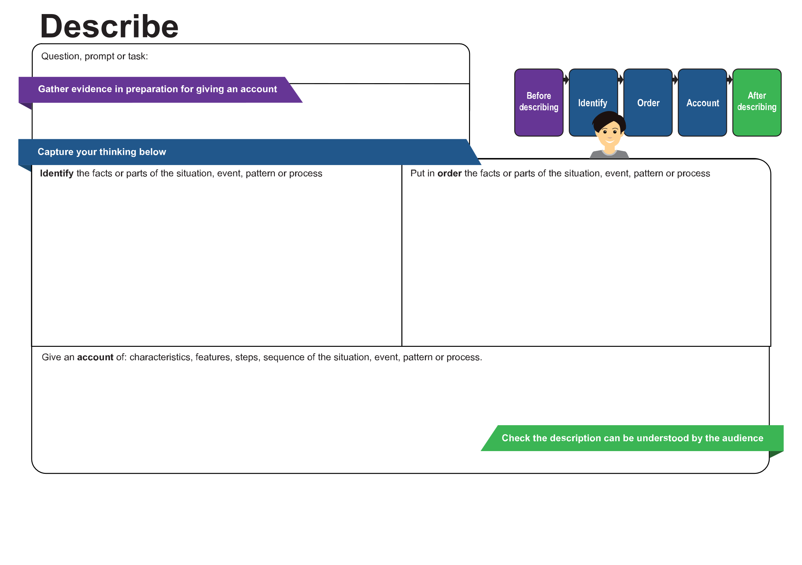
[Enter content]
[Enter content]
[Enter content]
[Enter content]
[Enter content]
© State of Queensland (QCAA) 2026
Licence: https://creativecommons.org/licenses/by/4.0 | Copyright notice: www.qcaa.qld.edu.au/copyright — lists the full terms and conditions, which specify certain exceptions to the licence. |
Attribution: © State of Queensland (QCAA) 2026 www.qcaa.qld.edu.au/copyright.
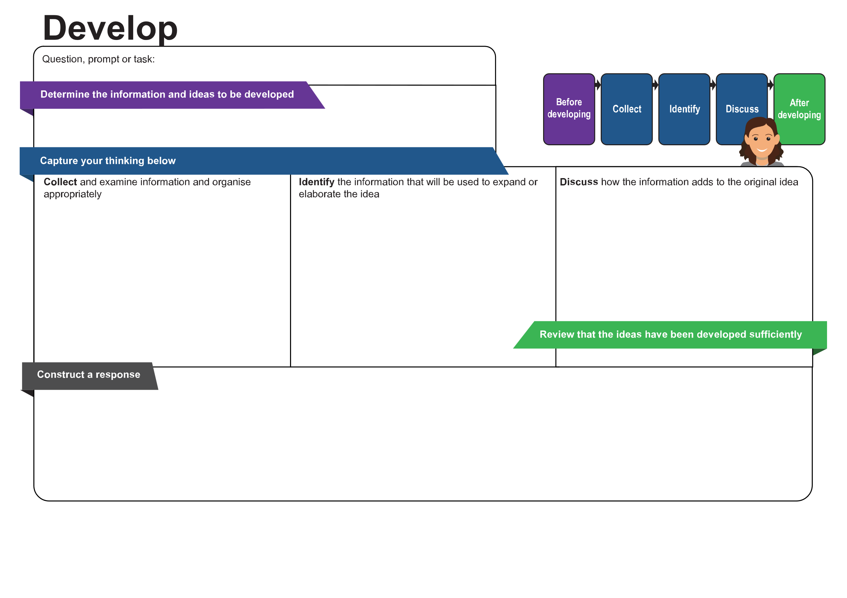
[Enter content]
[Enter content]
[Enter content]
[Enter content]
[Enter content]
[Enter content]
© State of Queensland (QCAA) 2026
Licence: https://creativecommons.org/licenses/by/4.0 | Copyright notice: www.qcaa.qld.edu.au/copyright — lists the full terms and conditions, which specify certain exceptions to the licence. |
Attribution: © State of Queensland (QCAA) 2026 www.qcaa.qld.edu.au/copyright.
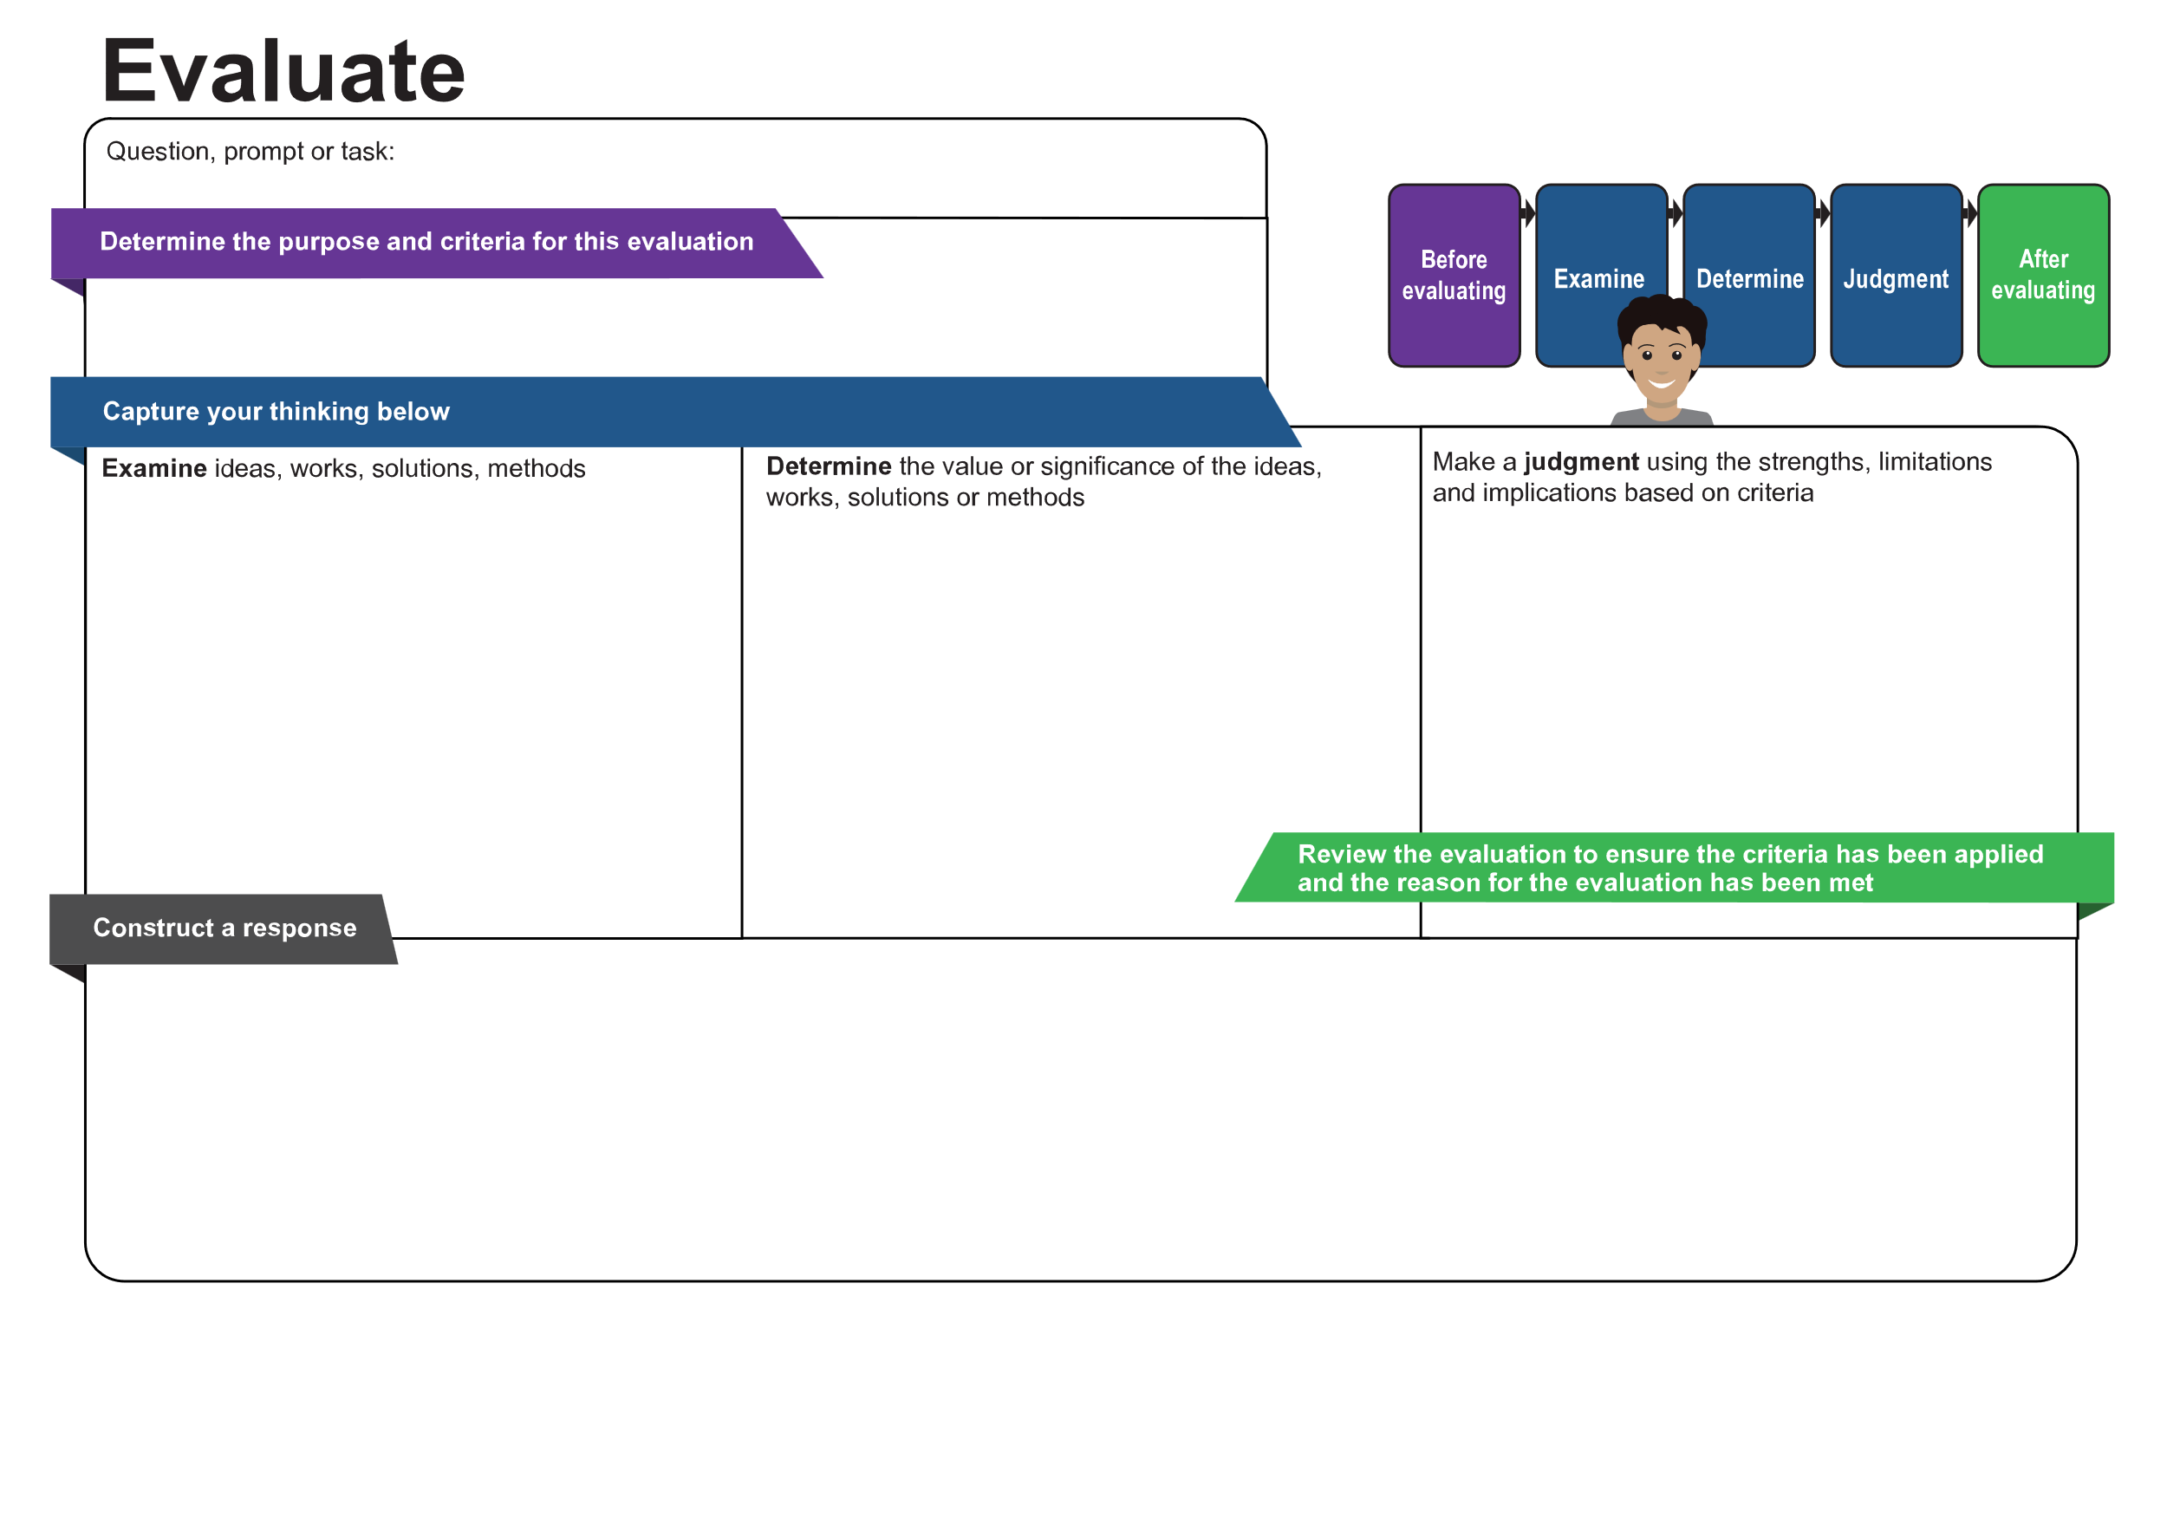
[Enter content]
[Enter content]
[Enter content]
[Enter content]
[Enter content]
[Enter content]
© State of Queensland (QCAA) 2026
Licence: https://creativecommons.org/licenses/by/4.0 | Copyright notice: www.qcaa.qld.edu.au/copyright — lists the full terms and conditions, which specify certain exceptions to the licence. |
Attribution: © State of Queensland (QCAA) 2026 www.qcaa.qld.edu.au/copyright.
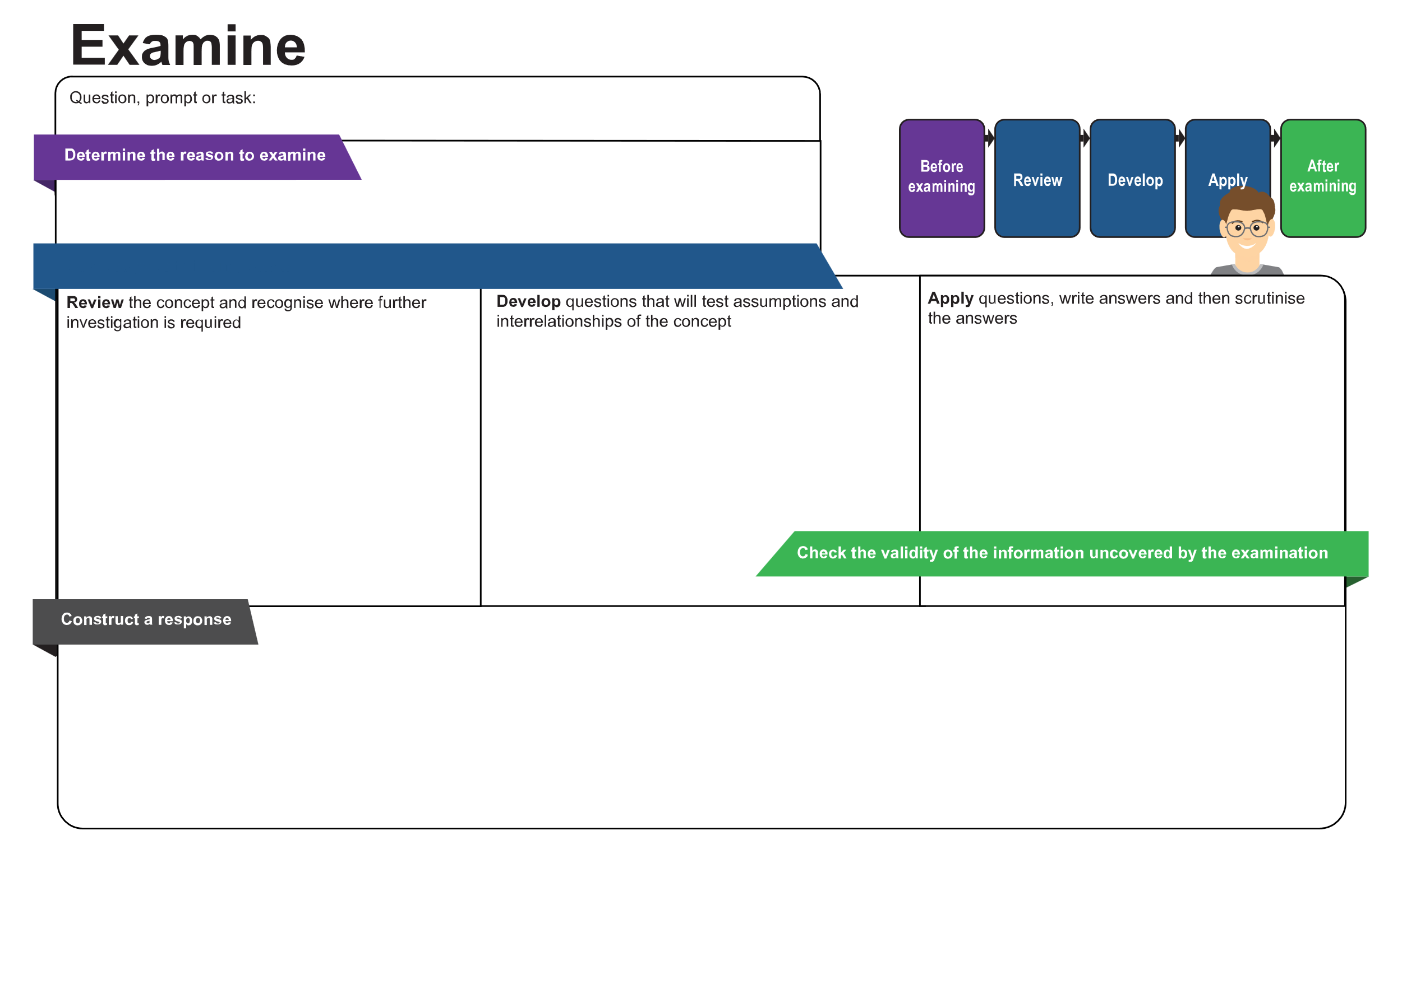
[Enter content]
[Enter content]
[Enter content]
[Enter content]
[Enter content]
[Enter content]
© State of Queensland (QCAA) 2026
Licence: https://creativecommons.org/licenses/by/4.0 | Copyright notice: www.qcaa.qld.edu.au/copyright — lists the full terms and conditions, which specify certain exceptions to the licence. |
Attribution: © State of Queensland (QCAA) 2026 www.qcaa.qld.edu.au/copyright.
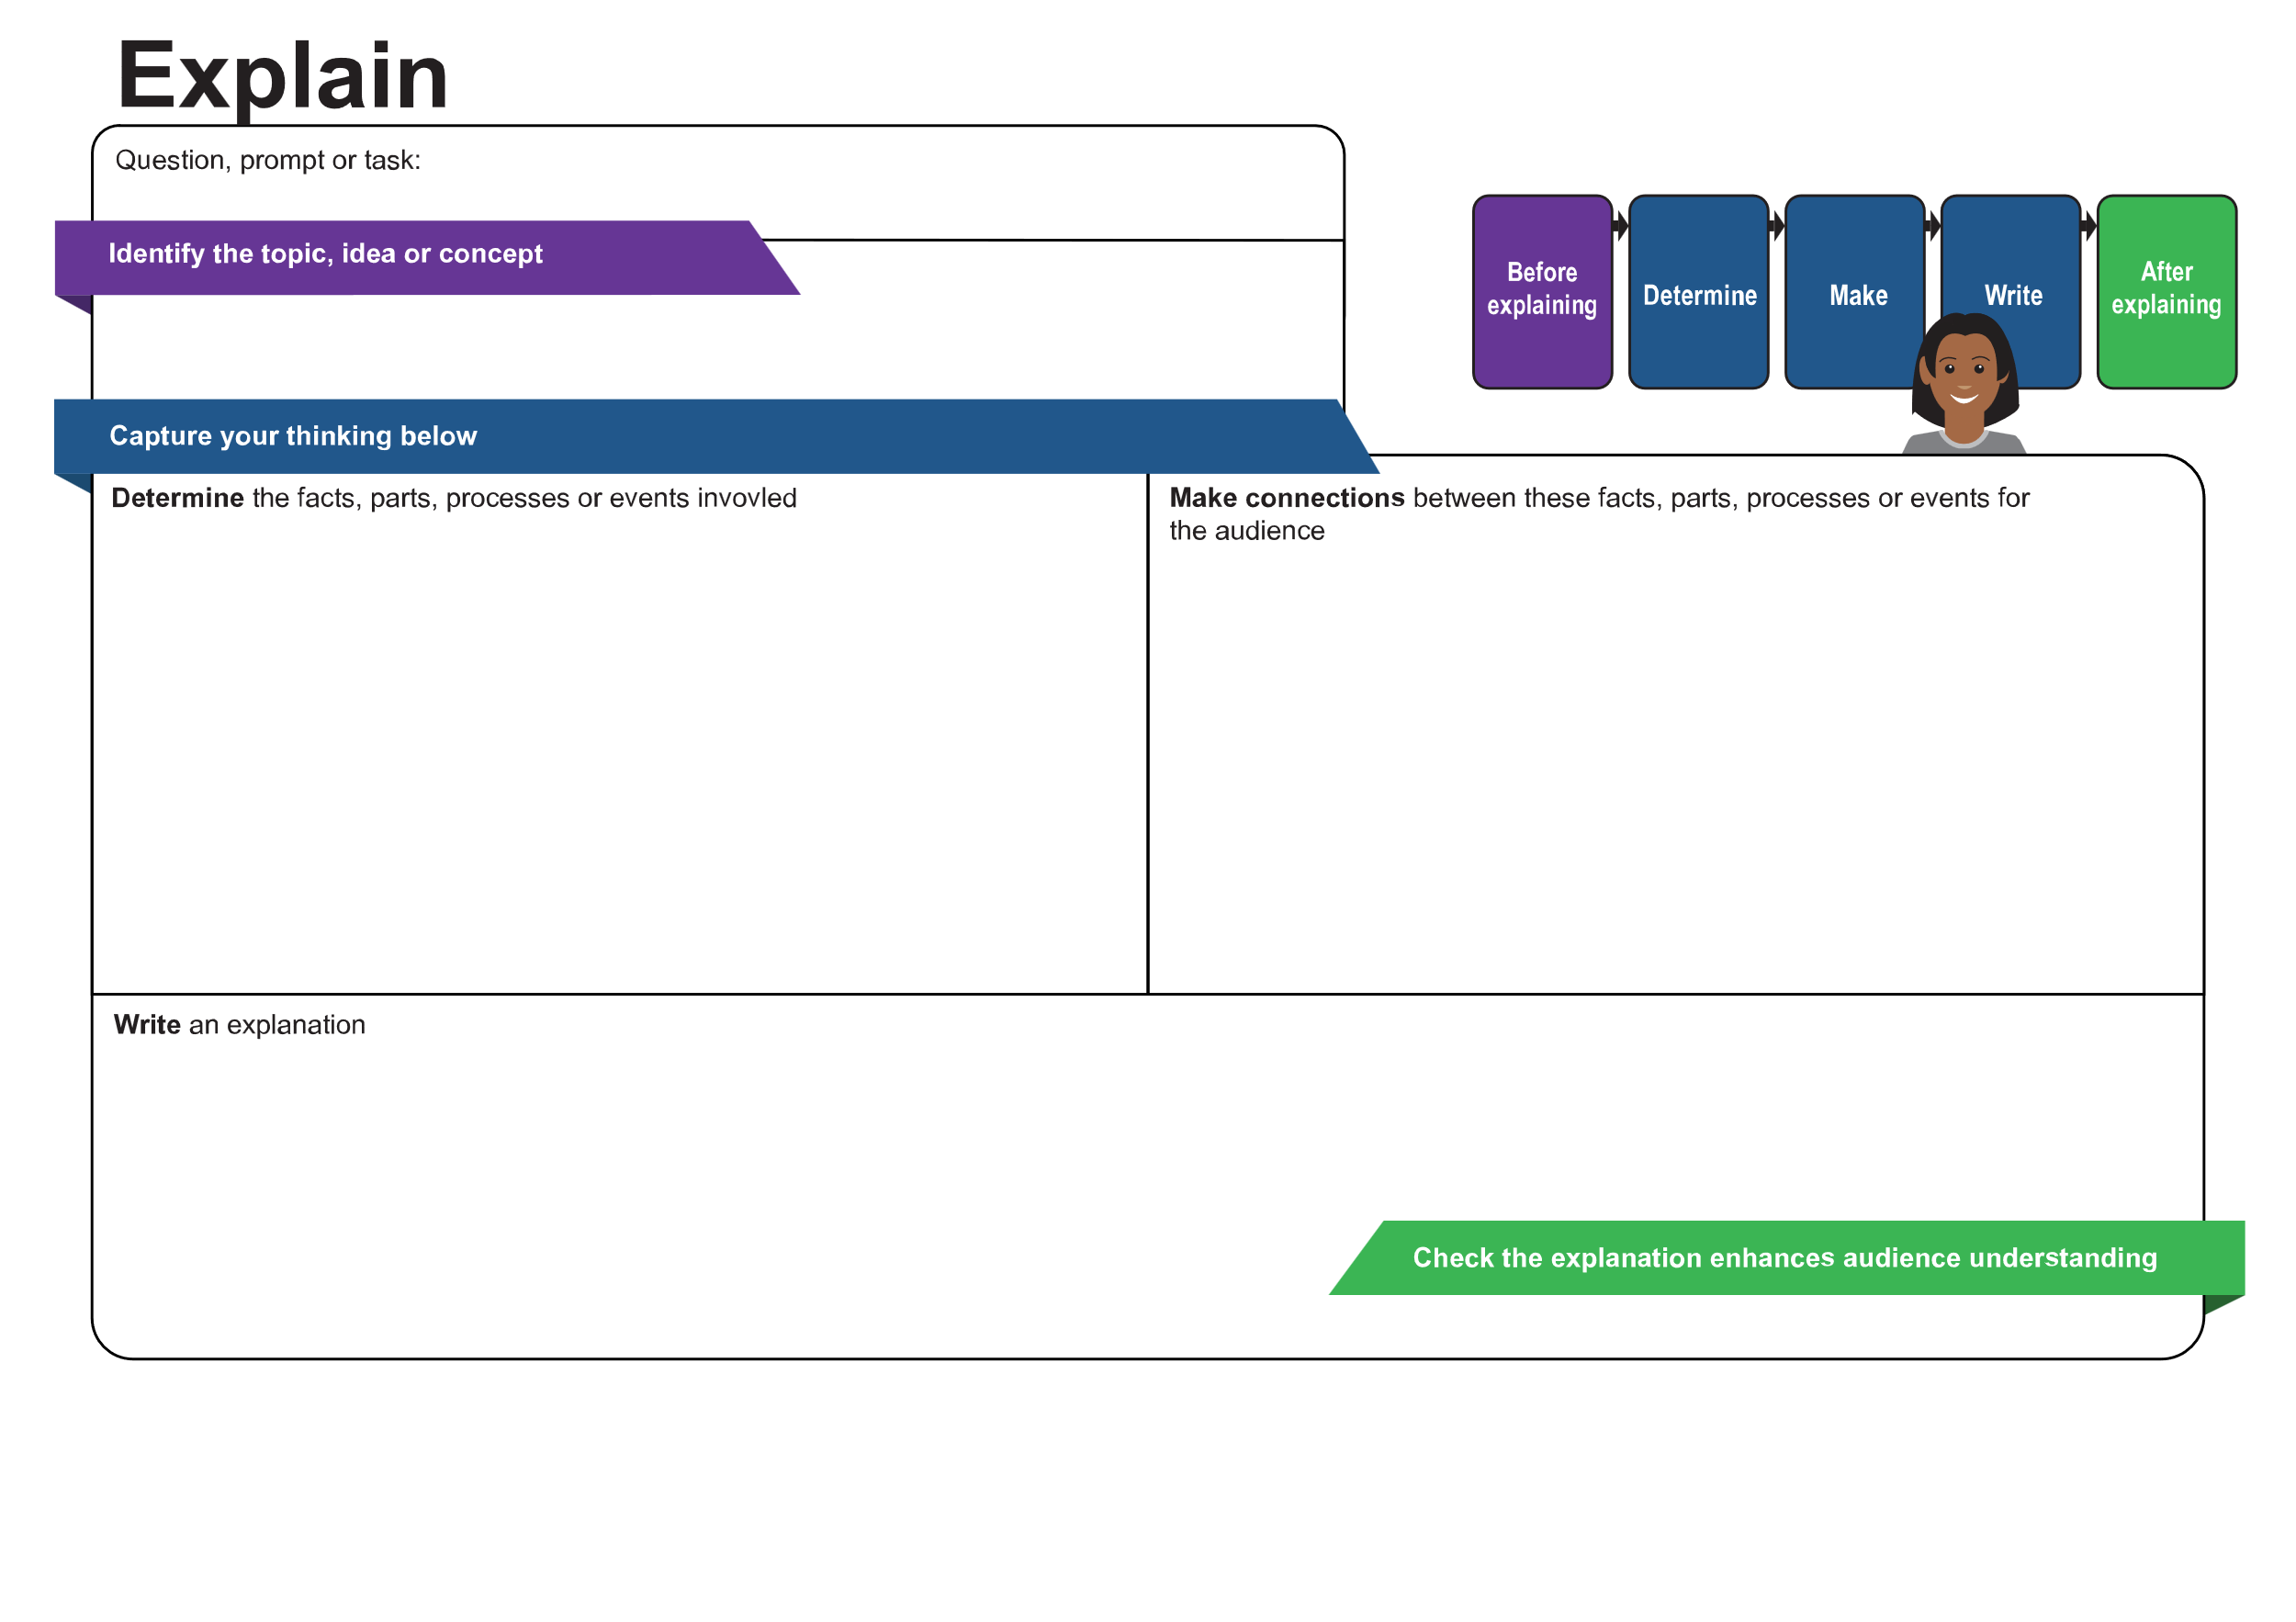
[Enter content]
[Enter content]
[Enter content]
[Enter content]
[Enter content]
© State of Queensland (QCAA) 2026
Licence: https://creativecommons.org/licenses/by/4.0 | Copyright notice: www.qcaa.qld.edu.au/copyright — lists the full terms and conditions, which specify certain exceptions to the licence. |
Attribution: © State of Queensland (QCAA) 2026 www.qcaa.qld.edu.au/copyright.
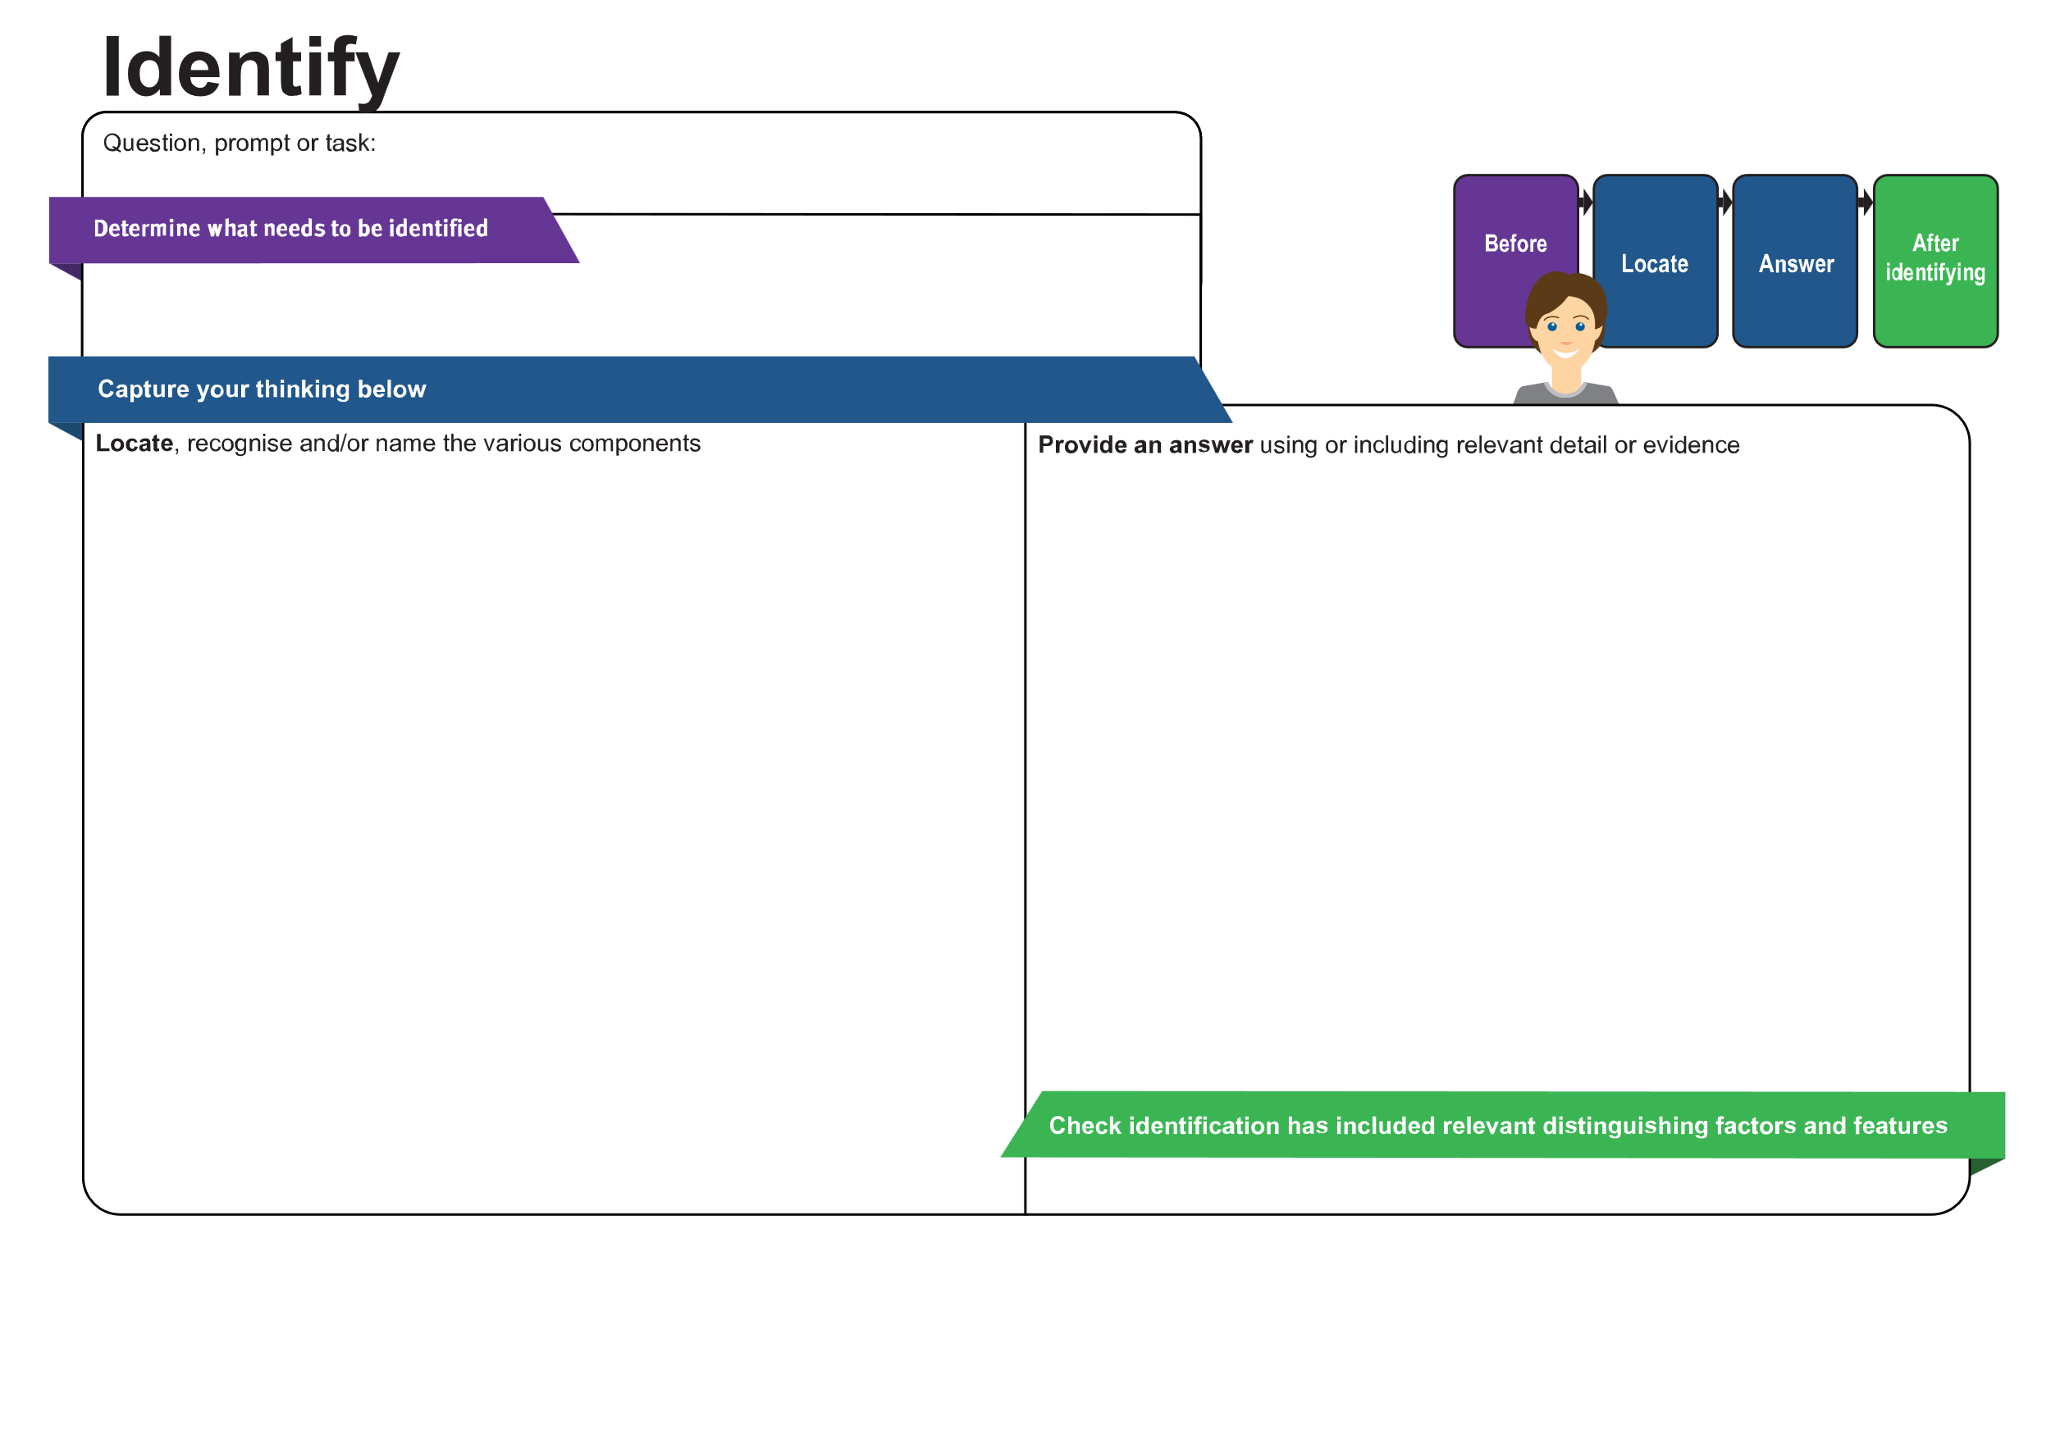
[Enter content]
[Enter content]
[Enter content]
[Enter content]
© State of Queensland (QCAA) 2026
Licence: https://creativecommons.org/licenses/by/4.0 | Copyright notice: www.qcaa.qld.edu.au/copyright — lists the full terms and conditions, which specify certain exceptions to the licence. |
Attribution: © State of Queensland (QCAA) 2026 www.qcaa.qld.edu.au/copyright.
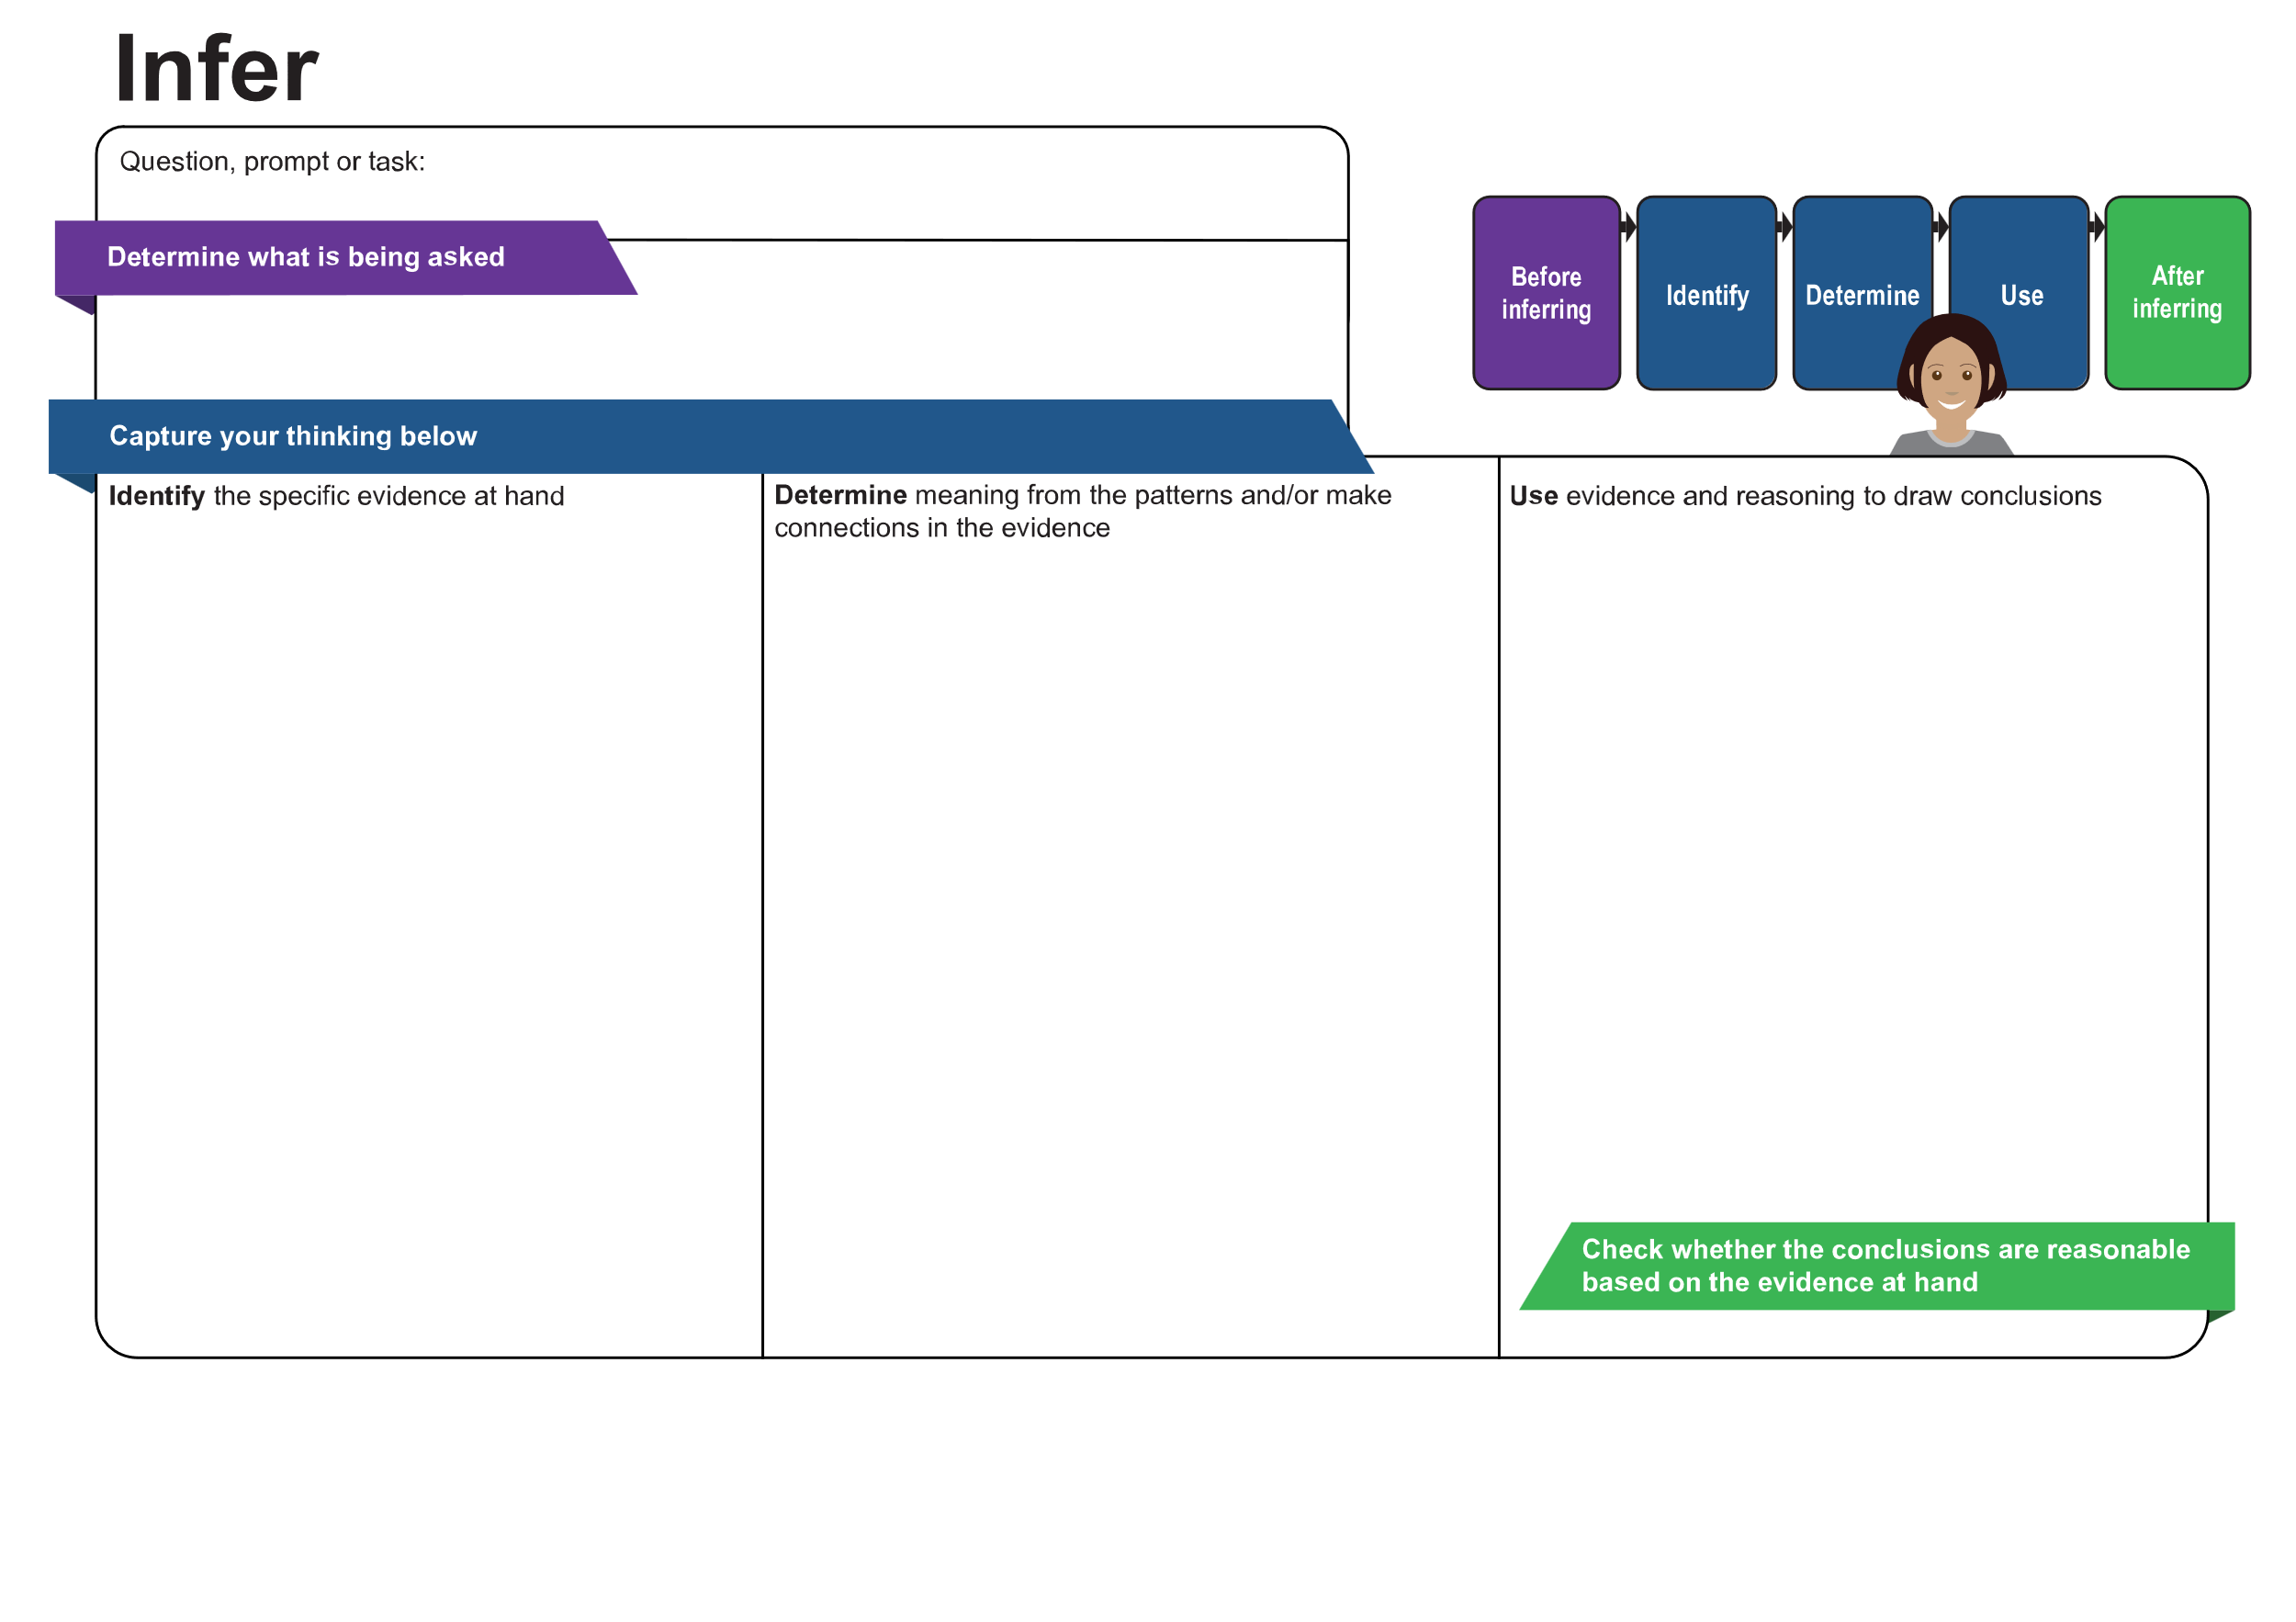
[Enter content]
[Enter content]
[Enter content]
[Enter content]
[Enter content]
© State of Queensland (QCAA) 2026
Licence: https://creativecommons.org/licenses/by/4.0 | Copyright notice: www.qcaa.qld.edu.au/copyright — lists the full terms and conditions, which specify certain exceptions to the licence. |
Attribution: © State of Queensland (QCAA) 2026 www.qcaa.qld.edu.au/copyright.
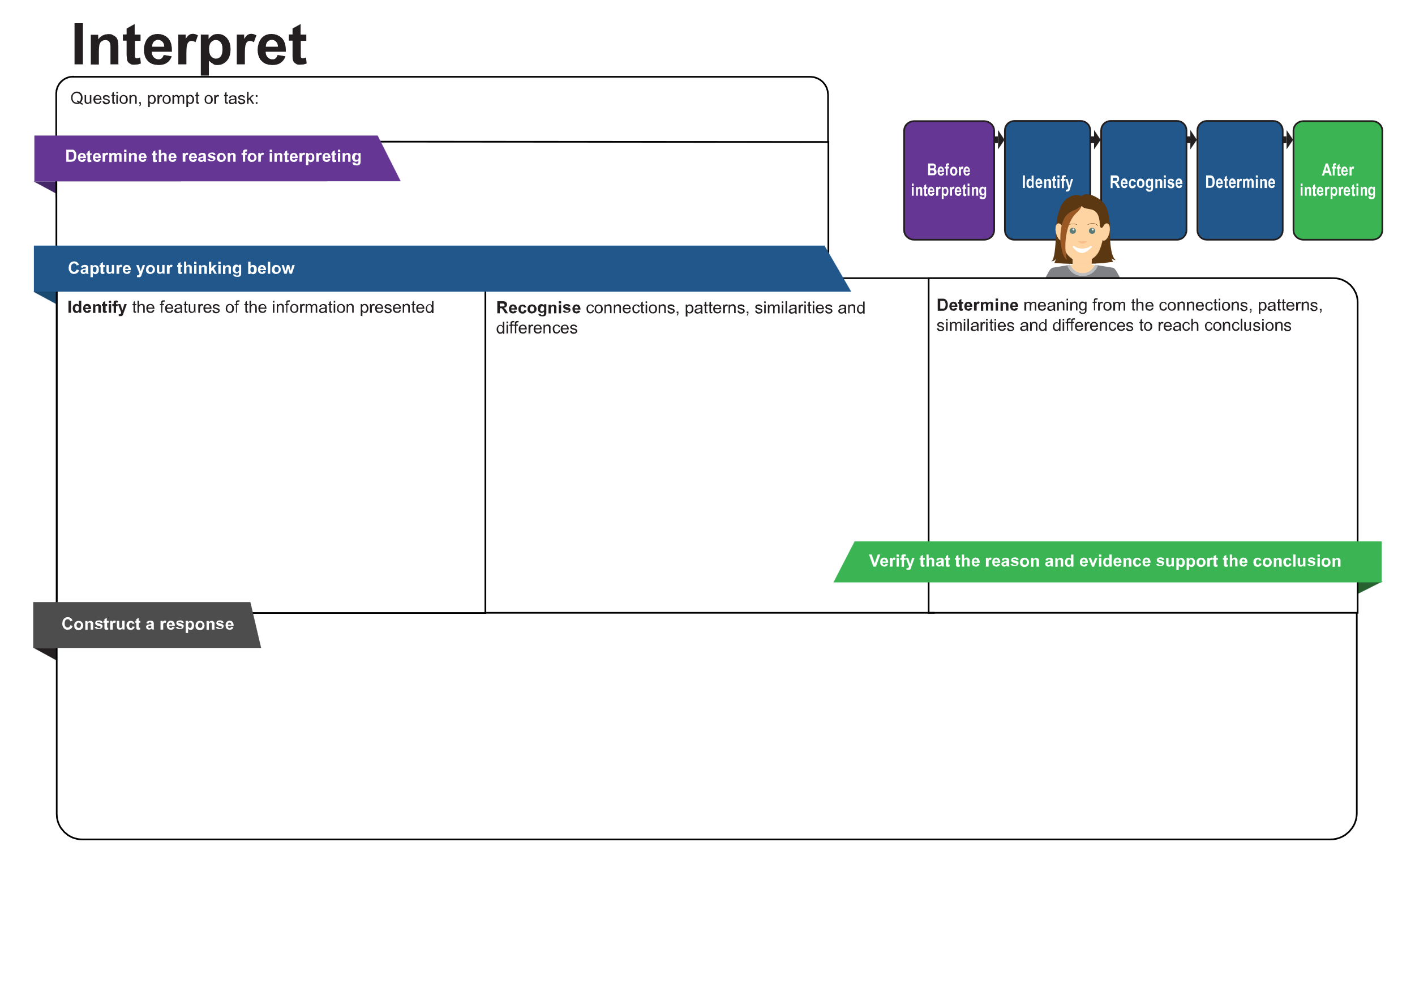
[Enter content]
[Enter content]
[Enter content]
[Enter content]
[Enter content]
[Enter content]
© State of Queensland (QCAA) 2026
Licence: https://creativecommons.org/licenses/by/4.0 | Copyright notice: www.qcaa.qld.edu.au/copyright — lists the full terms and conditions, which specify certain exceptions to the licence. |
Attribution: © State of Queensland (QCAA) 2026 www.qcaa.qld.edu.au/copyright.
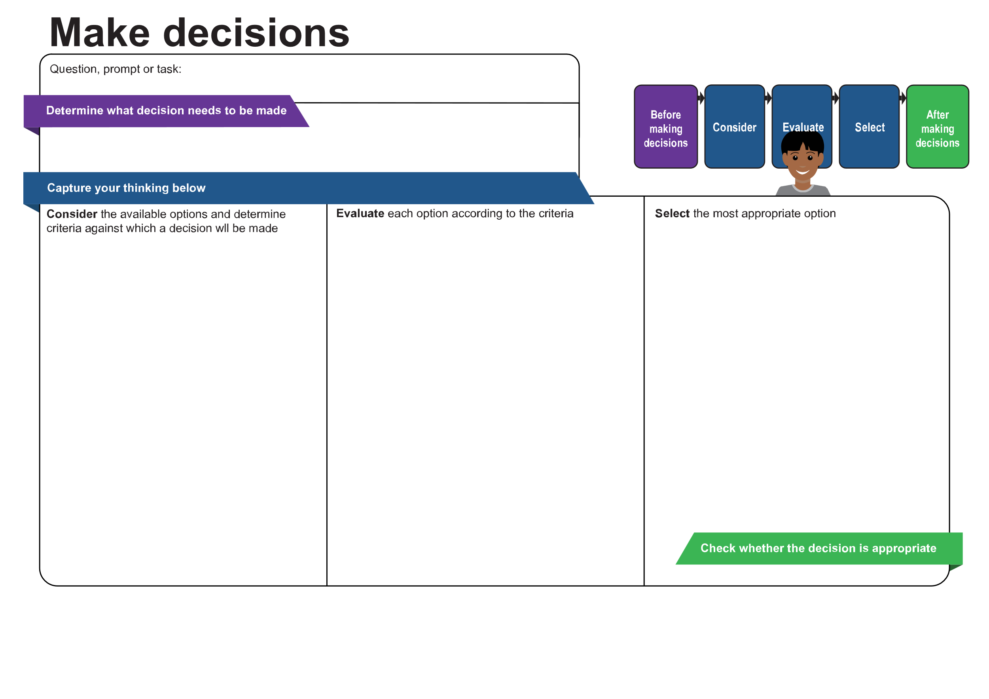
[Enter content]
[Enter content]
[Enter content]
[Enter content]
[Enter content]
© State of Queensland (QCAA) 2026
Licence: https://creativecommons.org/licenses/by/4.0 | Copyright notice: www.qcaa.qld.edu.au/copyright — lists the full terms and conditions, which specify certain exceptions to the licence. |
Attribution: © State of Queensland (QCAA) 2026 www.qcaa.qld.edu.au/copyright.
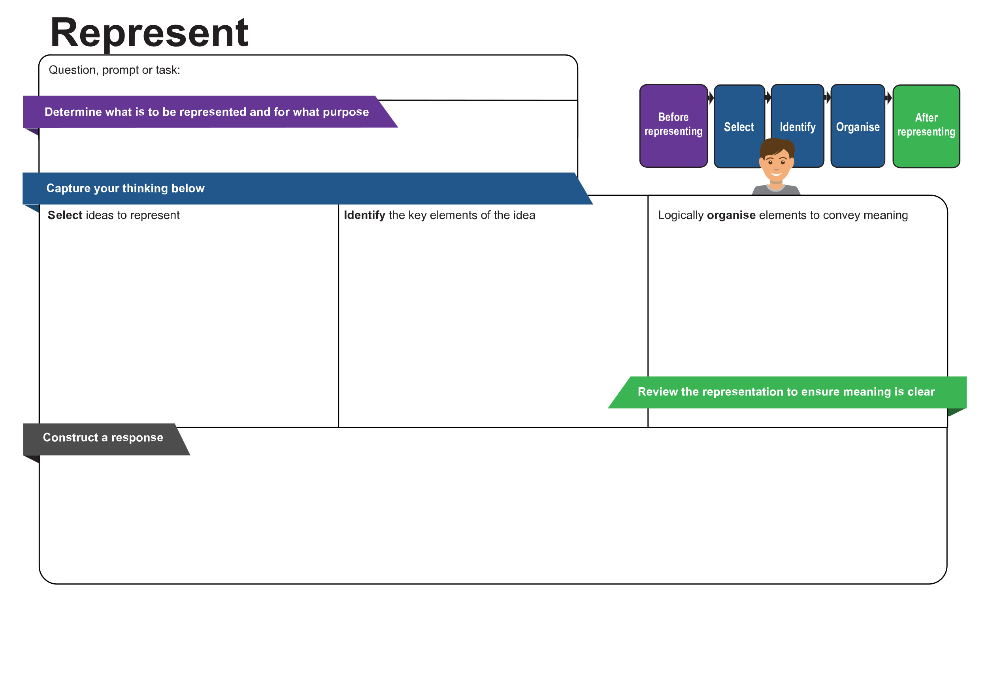
[Enter content]
[Enter content]
[Enter content]
[Enter content]
[Enter content]
[Enter content]
© State of Queensland (QCAA) 2026
Licence: https://creativecommons.org/licenses/by/4.0 | Copyright notice: www.qcaa.qld.edu.au/copyright — lists the full terms and conditions, which specify certain exceptions to the licence. |
Attribution: © State of Queensland (QCAA) 2026 www.qcaa.qld.edu.au/copyright.
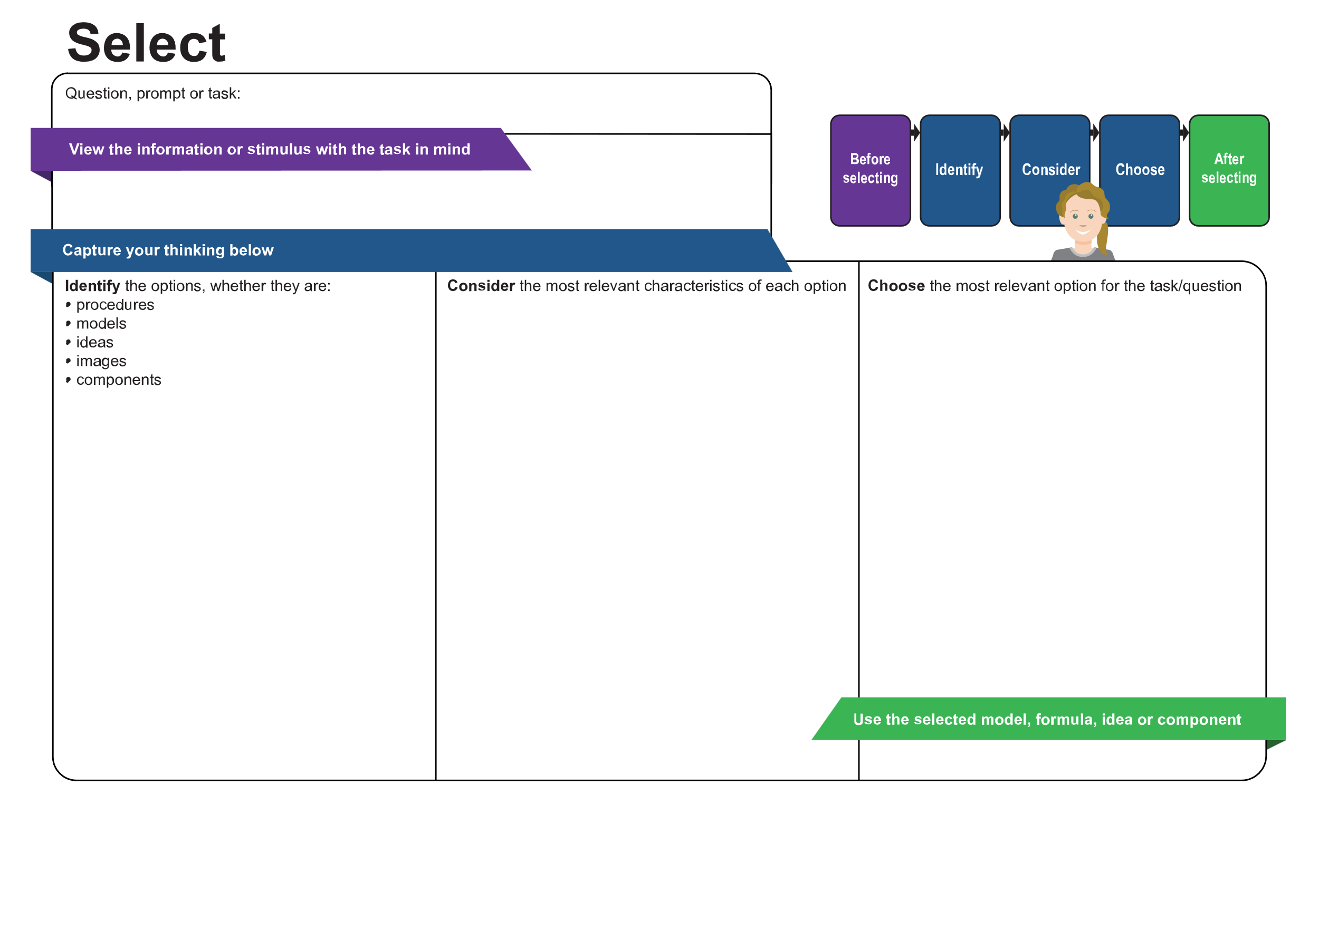
[Enter content]
[Enter content]
[Enter content]
[Enter content]
[Enter content]
© State of Queensland (QCAA) 2026
Licence: https://creativecommons.org/licenses/by/4.0 | Copyright notice: www.qcaa.qld.edu.au/copyright — lists the full terms and conditions, which specify certain exceptions to the licence. |
Attribution: © State of Queensland (QCAA) 2026 www.qcaa.qld.edu.au/copyright.
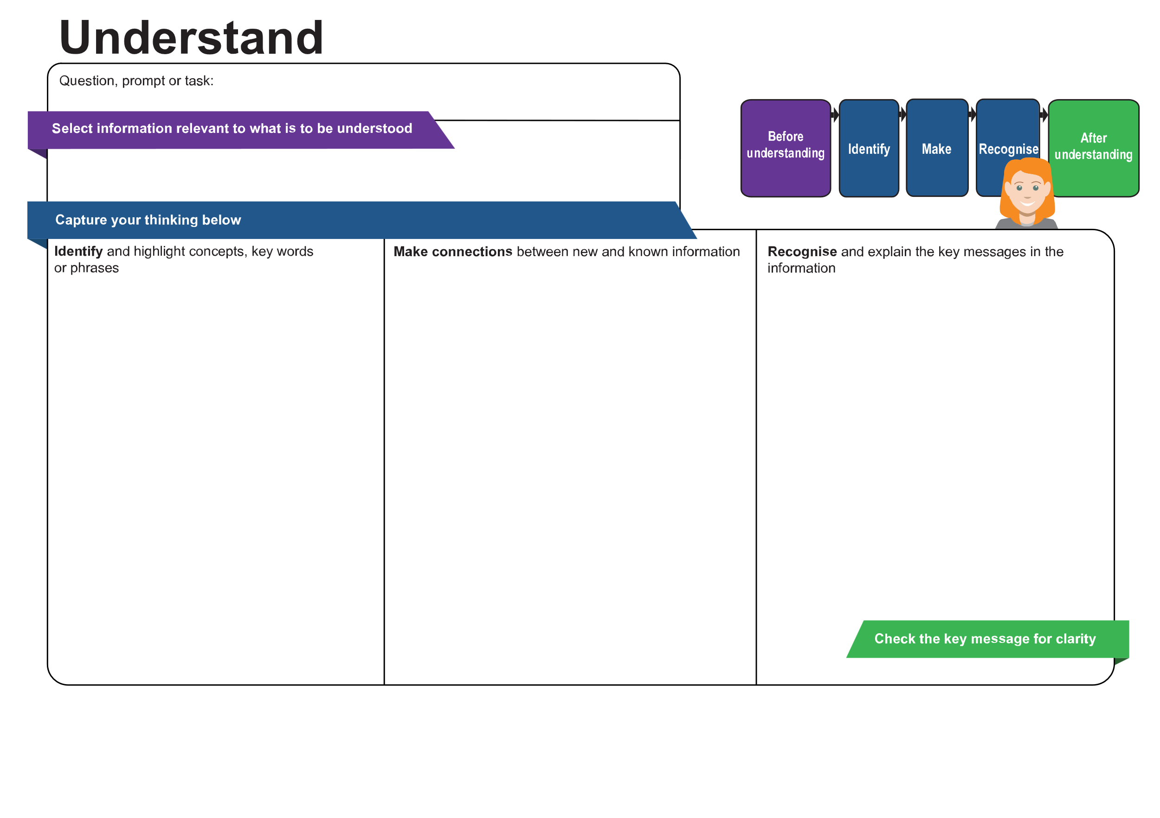
[Enter content]
[Enter content]
[Enter content]
[Enter content]
[Enter content]
© State of Queensland (QCAA) 2026
Licence: https://creativecommons.org/licenses/by/4.0 | Copyright notice: www.qcaa.qld.edu.au/copyright — lists the full terms and conditions, which specify certain exceptions to the licence. |
Attribution: © State of Queensland (QCAA) 2026 www.qcaa.qld.edu.au/copyright.

