Let it grow!
Australian Curriculum Year 6 STEM sample assessment

Children often eat processed snacks that are high in sodium, sugar, fat, and artificial colours and flavours. These snacks are unhealthy and lead to a lack of concentration. To physically and mentally thrive at school, children should eat healthy snacks.
We could grow nutritious food at school for students to eat. To grow fresh produce, we need to investigate suitable plants, soil conditions and sustainable processes to ensure water and nutrients are conserved.
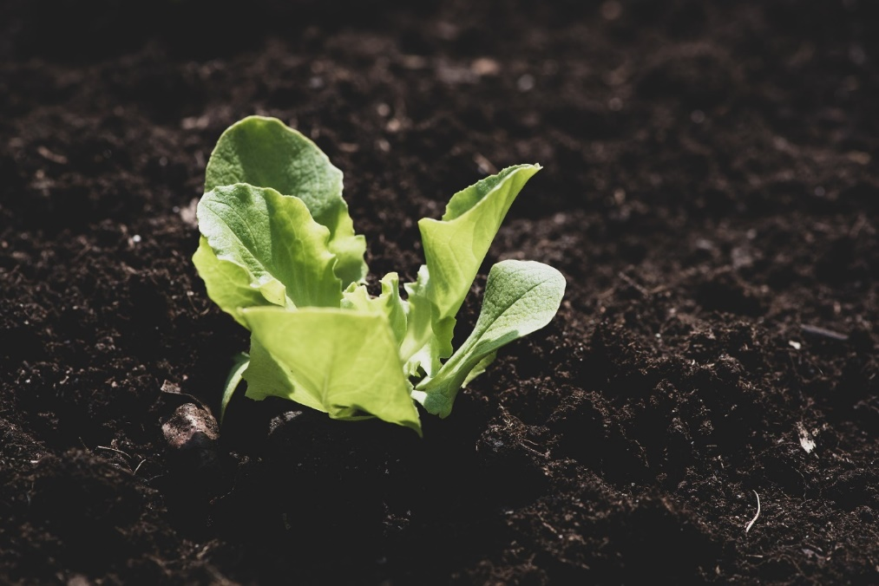
Image: Lettuce seedling, by Pezibear, Pixabay licence,
https://pixabay.com/photos/lettuce-seedling-seedling-small-4134145, accessed 27 May 2019
Design brief
Students need healthy food throughout the school day to maintain their energy levels and stay alert.
They would benefit from fresh, healthy snacks available to eat during a school day. How might we design a garden space in our school environment so that students can grow nutritious food?
Criteria for success  As a class, negotiate a garden design that:  - supports optimal conditions for growing plants  - includes sustainable design ideas  - fulfils the needs of students. | Constraints  The design will need to be:  - located within the school grounds  - enjoyable to visit  - maintained by students.
User needs
The users of the garden will be students. Consider:
- why students need fresh, healthy food
- how the physical characteristics of students (e.g. height, disability) should influence the design so students of all ages can enjoy and maintain the garden (e.g. safety, access for students with disability)
- what design elements could increase the appeal of the garden space (e.g. colours, layout, seating and how students like to use outdoor spaces).

Section 1: Design brief needs and opportunities
- Why do students need fresh, healthy snacks?

- Label the physical characteristics of the users that will influence the design, so students of all ages can enjoy and maintain the garden. Think about student height, safety and access for students with disabilities.
- What design elements could increase the appeal of the garden space for students?
Think about colours, layout, seating and how students like to use outdoor spaces.

Note: In class, negotiate the criteria for success and complete the table in section 4.

Section 2: Scientific knowledge
- Complete the table below by applying the scientific discoveries you have made throughout this unit to decide which techniques will help plants grow and thrive in your garden.
Based on the scientific discoveries you have made, predict the best techniques to grow and maintain plants at school. | How could you incorporate each of these scientific discoveries into your garden design?
Technique 1
Technique 2
Technique 3
- Explain why incorporating the above scientific discoveries will provide the best conditions for the plants to grow.
Technique 1:

Technique 2:

Technique 3:

Section 3: Graphical representation
- Use the design ideas generated in the brainstorming activity in class to draw two views of your designed solution for the garden. Show the view from the front (front view) and the view from above (aerial view). Label and annotate your drawings.
Front view
Aerial view

Section 4: Evaluating the designed solution
- Complete the following table.
Criteria for success | Evaluation
Record the criteria for success below. | Explain how the design features of your garden fulfil each of the criteria for success.
- Describe two changes or additions that could improve the garden space.
a.
b.
- Why would these changes or additions improve the garden space? Refer to the criteria for success in your answer.

Let it grow! Year 6 STEM unit task-specific standards
 |  |  | A | B | C | D | E
 |  |  | The folio of student work has the following characteristics:
Science | Understanding | Biological sciences | application of science knowledge to generate reasoned predictions and comprehensive solutions for growing and maintaining plants in our local area | application of science knowledge to generate predictions and informed solutions for growing and maintaining plants in our local area | application of science knowledge to generate predictions and solutions for growing and maintaining plants in our local area | application of science knowledge to generate predictions and partial solutions for growing and maintaining plants in our local area | recall of science facts
Design and Technologies | Knowledge and understanding | Food and fibre production/  Food specialisation | comprehensive explanation of how gardening techniques have informed the designed solution (a garden to grow healthy food) | detailed explanation of how gardening techniques have informed the designed solution (a garden to grow healthy food) | explanation of how gardening techniques have informed the designed solution (a garden to grow healthy food) | partial explanation of how sustainable gardening techniques have informed the designed solution (a garden to grow healthy food) | statements about features of the designed solution
 | Processes and production skills | Investigating and defining | identification and explanation of student needs for growing healthy food within the school environment | identification and description of student needs for growing healthy food within the school environment | identification of student needs for growing healthy food within the school environment | identification of aspects of needs for growing healthy food | statements about needs or for growing healthy food
 |  | Generating  and designing | considered combination of design ideas, and comprehensive and effective communication of design ideas, to audiences using:  - graphical representation techniques  - technical terms | informed combination of design ideas and effective communication of design ideas to audiences using:  - graphical representation techniques  - technical terms | combination of design ideas and communication of these design ideas to audiences using:  - graphical representation techniques  - technical terms | partial combination of design ideas and partial communication of design ideas to audiences using aspects of:  - graphical representation techniques  - technical terms | fragmented combination of design ideas and fragmented communication of design ideas to audiences using aspects of:  - representation techniques  - everyday language
 |  | Evaluating | considered evaluation of ideas and designed solutions using the suggested criteria for success, including sustainability considerations and improvements | informed evaluation of ideas and designed solutions using the suggested criteria for success, including sustainability considerations and improvements | evaluation of ideas and designed solutions using the suggested criteria for success, including sustainability considerations | explanation of ideas and designed solutions using the suggested criteria for success, including aspects of sustainability considerations | statements about their ideas and designed solutions using their suggested criteria for success

