Annual report 2012–13
Queensland Studies Authority

Published September 2013
© The State of Queensland (Queensland Studies Authority) 2013
ISSN 2201-0580
154 Melbourne Street, South Brisbane
PO Box 307 Spring Hill
QLD 4004 Australia
T +61 7 3864 0299
F +61 7 3221 2553
E office@qsa.qld.edu.au
www.qsa.qld.edu.au

Contents
Letter of compliance 1
Communication objectives 2
Highlights of 2012–13 3
Chair’s introduction 4
Financial snapshot 2012–13 5
Constitution, functions & powers 6
Corporate profile 6
Authority members 6
Executive committee 7
Authority committee functions 7
Authority committees 8
Organisational structure 9
Strategic Plan 2012–16 10
Planning and objectives 10
Performance against objectives 10
Challenges and future priorities 10
Program review 11
Syllabus development and implementation 11
Testing and assessment 15
Certification and tertiary entrance 18
Corporate support and communication 20
Financial report 2012–13 23
Statement of comprehensive income 24
Statement of financial position 25
Statement of changes in equity 26
Statement of cash flows 27
Notes to and forming part of the financial statements 28
Certificate of the Queensland Studies Authority 46
Independent auditor’s report 47
Appendixes 49
1. Committees of the Authority 49
2. Fees paid to Board members 52
3. Early retirement, redundancy and retrenchment 52
4. Key corporate governance committee of the QSA 52
5. QSA district offices 53
6. Reader evaluation of the Annual Report 2012–13 55
Abbreviations and acronyms inside back cover

Letter of compliance
6 September 2013
The Honourable John-Paul Langbroek MP
Minister for Education, Training and Employment
PO Box 15033
CITY EAST QLD 4002
Dear Minister
I am pleased to present the 2012–13 Annual Report and financial statements for the Queensland Studies Authority.
I certify that this Annual Report complies with:
- the prescribed requirements of the Financial Accountability Act 2009 and the Financial and Performance Management Standard 2009, and
- the detailed requirements set out in the Annual report requirements for Queensland Government agencies.
A checklist outlining the annual reporting requirements can be accessed at www.qsa.qld.edu.au/624.html.
Yours sincerely
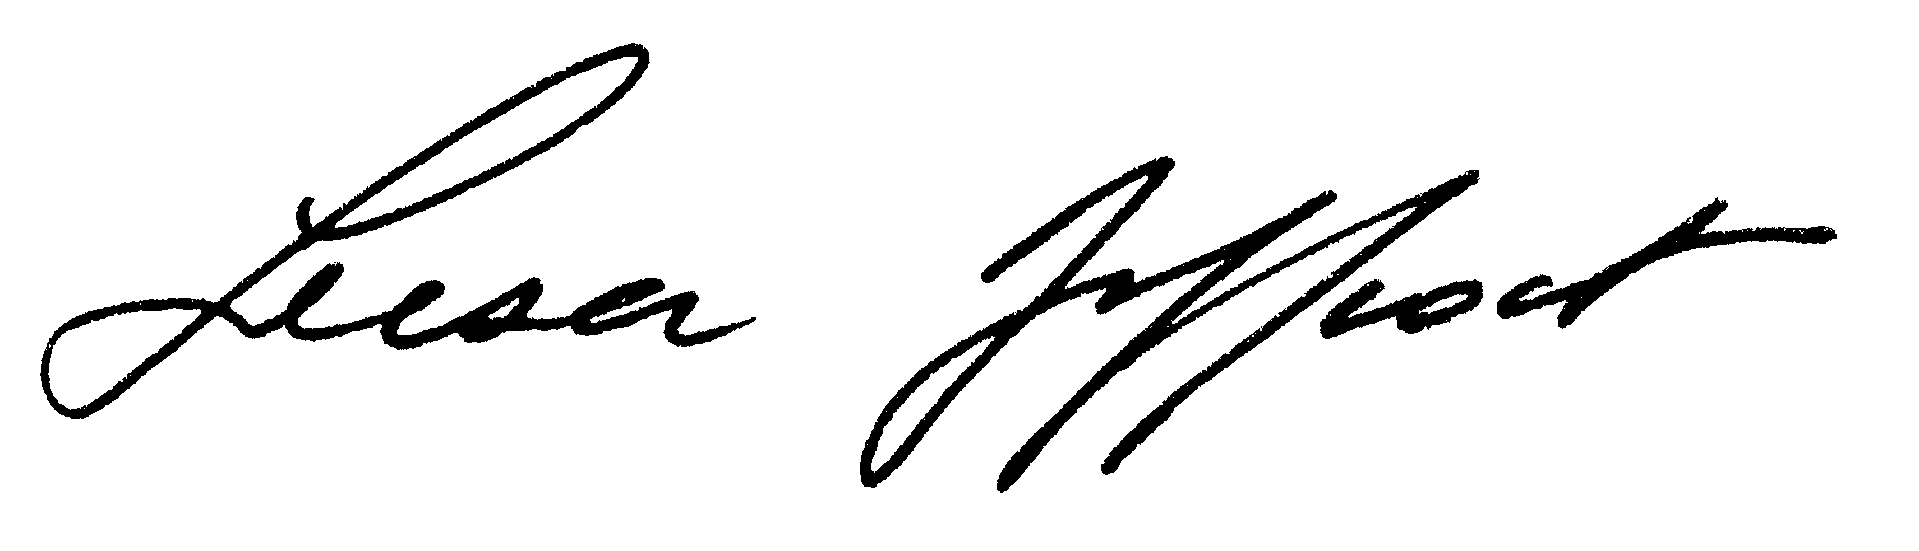
Leesa Jeffcoat
Acting Chair
Queensland Studies Authority

Communication objectives
The Queensland Studies Authority (QSA) was established in 2002 and is responsible for a range of functions including developing and accrediting Kindergarten to Year 12 syllabuses and guidelines, testing, assessment, moderation, certification, vocational education and training, and tertiary entrance.
This annual report shows the ways in which the QSA is fulfilling its role as prescribed by the Education (Queensland Studies Authority) Act 2002. The report is aimed, in particular, at:
- school staff
- parents
- tertiary institutions
- unions
- employers
- the Queensland Government.

Report access
Access to this report is provided through the QSA’s website: www.qsa.qld.edu.au/624.html, or by contacting the QSA.

Interpreter Service Statement
The Queensland Government is committed to providing accessible services to Queenslanders from all culturally and linguistically diverse backgrounds. If you have difficulty in understanding the annual report, you can contact the QSA on (07) 3864 0299 and we will arrange an interpreter to effectively communicate the report to you.

Highlights of 2012–13
Senior Education Profiles  issued to 48 205  Year 12 students | Exploring what’s new in K–2 conferences | Tailored professional development for schools implementing the  Australian Curriculum
Queensland Certificates of Education awarded to  41 330 students | Administration of  2013 NAPLAN | Moderation of 110 000 senior student assessment folios
Public release of 2012  NAPLAN and  Year 12 outcomes reports | Administration of 2012 and development of 2013  QCS Test | Revisions completed for eight senior syllabuses

Chair’s introduction
Change is a constant in education, and principals and school staff continue to do a magnificent job in making meaning of change at the school level. The QSA works to support all schools in Queensland. It must be proactive to the emerging policy changes formulated by both Federal and State Governments, and to the needs of schools.
In recent times, Queensland’s progressive transition to the Australian Curriculum, the broadening of the QSA’s remit to include the kindergarten year, and the changing profile of the Year 11 and 12 student cohort and their needs have all involved realigning QSA’s focus.
In addition, the outcomes of important reviews may have a significant impact on QSA’s structure, function and work in the future. We await with interest the outcomes of the Queensland Parliament’s Education and Innovation Committee review of assessment approaches in senior mathematics and science subjects; the independent review of senior assessment, reporting and tertiary entrance processes; and the Department of Education, Training and Employment’s review of QSA’s legislation and functions.
Over the past year, the QSA has made a significant contribution in supporting schools to implement Australian Curriculum learning areas from Prep to Year 10 (P–10). We have developed a comprehensive range of high quality curriculum and assessment resources for schools implementing English, Mathematics, Science and History. Online materials and professional development workshops have been made available to schools preparing to introduce Geography as a stand-alone subject in P–10 from 2014.
To assist the Australian Curriculum, Assessment and Reporting Authority in finalising the P–10 curriculum content and achievement standards, the QSA coordinated Queensland education stakeholders’ feedback on the remaining learning areas of The Arts, Civics and Citizenship, Economics and Business, Health and Physical Education, Languages and Technology. Consultation and partnerships like these with our education colleagues have remained central to the way the QSA conducts its business.
With funding support from the Australian and Queensland Governments, we have continued to develop resources to assist kindergarten teachers implementing the Queensland kindergarten learning guideline.
At the other end of the schooling spectrum, QSA has been working with Queensland’s universities to ensure the alignment of senior mathematics syllabuses with first-year university mathematics courses. We intend this to be an ongoing project that will branch out to include further learning areas.
Against this backdrop, the QSA has continued to deliver its core functions of providing Kindergarten to Year 12 syllabuses, guidelines, assessment, reporting, testing, accreditation and certification services for Queensland schools.
This work is facilitated by the dedicated members of our representative committees and Governing Body who give of their expertise in the interests of all schools and all students. As I conclude my four years as Chair of the QSA, I would like to express my appreciation for their support, policy direction, guidance and advice. I believe the QSA is in a sound position to embrace any new challenges with confidence.
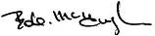
Bob McHugh
Chair
Queensland Studies Authority

Financial snapshot 2012–13
In 2012–13, the QSA received $38.473 million in grant revenue from the Department of Education, Training and Employment (DETE) and raised $2.067 million from the curriculum and professional development products and services it delivered to approximately 1800 state and non-state schools.
Table 1: Summary of QSA finances 2012–13
 | 2012–13 | 2011–12 | 2010–11 | 2009–10 | 2008–09
 | $(000) | $(000) | $(000) | $(000) | $(000)
Revenue
Grant revenue | 38 527 | 41 223 | 41 423 | 38 276 | 37 425
Other revenue | 2 760 | 3 259 | 3 963 | 3 653 | 3 707
Expenses
Employee expenses | 26 906 | 29 033 | 28 804 | 26 636 | 24 786
Other expenses | 14 108 | 14 924 | 16 579 | 16 182 | 15 003
Operating surplus/(deficit) | 273 | 525 | 3 | (889) | 1 343
Capital outlays
Plant and equipment | 65 | 107 | 297 | 211 | 445
Software | 89 | 182 | 0 | 839 | 2 227
Total assets | 18 125 | 17 919 | 17 068 | 17 823 | 18 215
Total liabilities | 5 788 | 5 855 | 5 529 | 6 287 | 5 790
Net assets/(liabilities) | 12 337 | 12 064 | 11 539 | 11 536 | 12 425
Table 2: QSA employees 2012–13
 | 2012–13 | 2011–12 | 2010–11 | 2009–10 | 2008–09
Number of employees  at 30 June 2013  (full-time equivalent) | 217 | 247.2 | 248.5 | 239.8 | 235.5
A comprehensive set of financial statements covering all aspects of the QSA’s activities starts at page 23 of this report.

Constitution, functions & powers

The QSA is a statutory body established under the provisions of the Education (Queensland Studies Authority) Act 2002.
The main functions of the QSA are to:
- develop and implement syllabuses and guidelines from Kindergarten to Year 12, and accredit syllabuses and guidelines prepared outside of the QSA
- undertake assessment and testing programs that help students demonstrate and improve their learning achievements and plan for their future, and that benchmark Queensland students against national standards and support school improvement processes
- determine procedures for and quality assure Queensland's system of continuous school-based assessment in the senior phase of learning
- manage certification and reporting processes that reflect student learning across the range of their school experiences, capture student achievement in their various endeavours, and provide personalised, up-to-date information to students and parents
- register schools as registered training organisations (RTOs), and accredit and recognise vocational education and training courses
- develop tertiary entrance procedures, issue tertiary entrance statements and provide information to the public about tertiary entrance procedures and requirements
- undertake research in relation to the aforementioned functions.
In performing its functions, the QSA also provides the three schooling sectors with a range of professional development activities to support:
- implementation of syllabuses, associated materials and processes
- QSA business processes of assessment, moderation, certification and accreditation.

Corporate profile

Authority members
The constitution of the Authority is specified in Section 25 of the Act. It comprises representatives of primary and secondary schools, special and tertiary education sectors (including practising teachers), the vocational education sector, parent groups, unions and industry.
The Authority held eight meetings during the 2012–13 financial year. Its membership over the period is outlined below:
- one nominee of the Minister for Education, Training and Employment (chair)
Bob McHugh (appointed until June 2013)
- the chief executive (Director-General) of the education department, whose nominee is
Dr Suzanne Innes (appointed until October 2012)
Lyn McKenzie (appointed until 7 June 2013)
Patrea Walton (appointed until 30 June 2013)
- the chief executive (Director-General) of the vocational education and training department, whose nominee is
Trevor Schwenke (appointed until June 2013)
- one nominee of Independent Schools Queensland (ISQ)
David Robertson (appointed until June 2013)
- one nominee of the Queensland Catholic Education Commission (QCEC)
Leesa Jeffcoat (appointed until June 2013)
- two nominees of the Higher Education Forum
(at least one of whom must have expertise relating to tertiary entrance)
Professor Bob Lingard (appointed until June 2013)
Alan Finch (appointed until June 2013)
- two persons who, at the time of appointment, are parents or guardians of students enrolled at a school, of whom
  - one is to be nominated jointly by the Federation of Parents and Friends Associations of Catholic Schools, Qld, and the Queensland Independent Schools Parents Council
  - one is to be nominated by the Queensland Council of Parents’ and Citizens’ Associations Incorporated
Machus de Ponte (appointed until June 2013)
Margaret Leary (appointed until June 2013)
- one primary school principal and one secondary school principal, of whom
  - one is to be nominated by the chief executive
  - one is to be nominated jointly by ISQ and QCEC
Patricia Neate (appointed until June 2013)
Daryl Hanly (appointed until June 2013)
- one teacher of primary education and one teacher of secondary education, neither of whom is a school principal, of whom
  - one is to be nominated by the chief executive
  - one is to be nominated jointly by ISQ and QCEC
Gail Young (appointed until June 2013)
Tsae Wong (appointed until June 2013)
- one nominee of the Queensland Teachers’ Union
Samantha Pidgeon (appointed until June 2013)
- one nominee of the Independent Education Union of Australia — Queensland and Northern Territory Branch (IEUA–QNT)
Dr Paul Giles (appointed until June 2013)
- one nominee of the Minister administering the vocational education and training department
Deidre Stein (appointed until June 2013)
- three nominees of the Minister for Education, Training and Employment, of whom
  - one is to have expertise in the provision of special education
  - one is to have expertise in the education of Aboriginal peoples or Torres Strait Islander peoples
  - one is to be representative of industry
David Rogers (appointed until June 2013)
Elizabeth King (appointed until June 2013)
Alan Waldron (appointed until June 2013)
- one other person who may be nominated by the Minister for Education, Training and Employment
Professor Claire Wyatt-Smith
(appointed until June 2013).

Executive committee
In accordance with Section 45 of the Act, an executive committee meets before each Authority meeting to set the agenda. The executive committee comprises:
- chair of the Authority
- one nominee of the chief executive (Director-General) of education
- one nominee of the chief executive (Director-General) of vocational education and training
- one nominee of the Queensland Catholic Education Commission
- one nominee of Independent Schools Queensland.
The Director of the QSA also participates in executive committee meetings as outlined in Section 46 of the Act, but has no voting rights.
The executive committee also performs any other functions conferred on it by the Authority and reports to the Authority as required.

Authority committee functions
A number of committees of the Authority have been established, as set out in Section 47 of the Act, to:
- develop policy proposals (for referral to the Authority)
- identify issues that require policy development by the committee
- provide advice to the Authority on matters referred to the committee by the Authority
- provide advice to the Authority on matters identified by the committee as warranting such advice
- keep the Authority informed about current and expected issues requiring its attention
- consider and approve plans and procedures that provide mechanisms for the implementation and endorsement of Authority policy
- establish (or recommend establishment of) subcommittees and task groups to provide specialist advice and develop policy proposals
- consider specialist advice and policy proposals from subcommittees and task groups
- advise and assist the Office of the Authority in policy implementation
- consider advice from the Office of the Authority on relevant issues
- maintain and strengthen communication links between the Authority and its stakeholders.
Details of the functions and membership of each committee are given in Appendix 1.

Authority committees
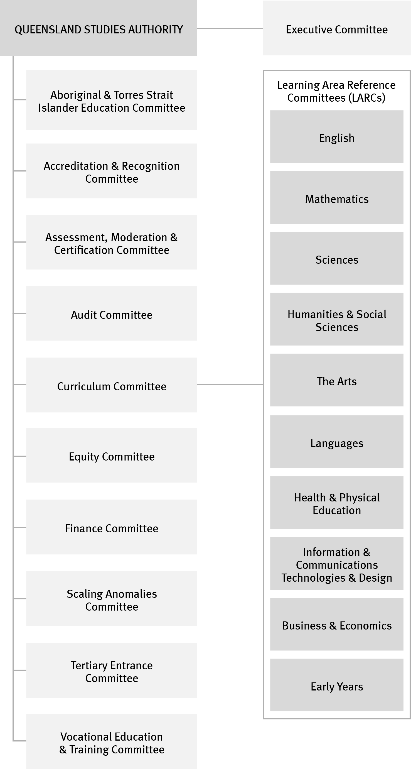

Organisational structure
The organisational structure of the QSA, as at June 2013, is shown below. Members of the key corporate governance committee of the QSA are listed in Appendix 4.
QSA’s central office is located at 154 Melbourne Street, South Brisbane. The QSA had 217 full-time equivalent staff as at June 2013, based mostly at the central office. The remainder work in 13 district offices across Queensland (district office contact details are listed in Appendix 5). Positions are filled through a mix of permanent and temporary appointments, and secondments. Staff are employed directly by the Authority as part of the Education, Training and Employment portfolio.
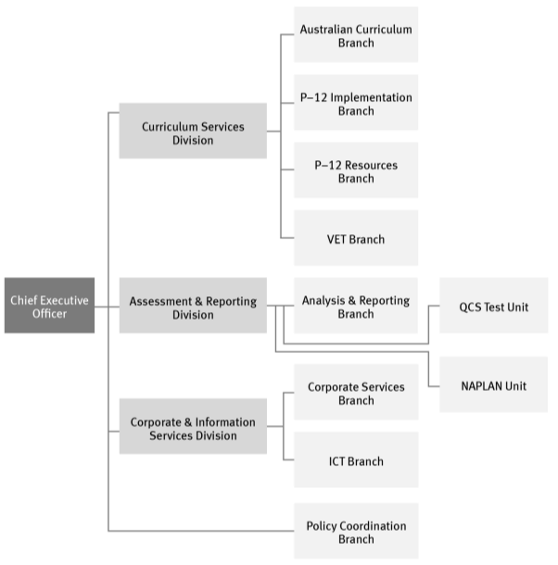

Strategic Plan 2012–16

Planning and objectives
The Strategic Plan 2012–16 refined the objectives and strategies of the Strategic Plan 2011–15, taking into account the strategic direction and policy focus of the government and progress achieved against current strategies. The plan will guide the work of the QSA and provide the framework for its operational planning in a context of significant state and national developments in education.
QSA’s work supports the Queensland Government’s objective to revitalise front-line services for families by assisting teachers to develop high quality curriculum for the classroom. To support this, our strategic objectives focus on providing:
- innovative syllabuses and supporting products that assist schools to prepare young people for life and work in the 21st century
- assessments and other resources that enable students to demonstrate achievement and provide useful information for teachers, parents and other stakeholders
- efficient and effective delivery of our products and services.

Performance against objectives
A summary of achievements is presented on page 3. Performance against the following indicators identified in the plan is detailed throughout the report:
- Queensland schools provided with adequate products and services to enable successful integration of the new Australian Curriculum with the Queensland curriculum
- percentage of stakeholders surveyed who consider the syllabuses and support materials developed by the QSA to be satisfactory
- average cost per syllabus revision
- external audit of QSA VET management processes demonstrates compliance with Australian Quality Training Framework standards
- distribution of test materials and reports for NAPLAN within designated time frames
- average cost per student of developing and issuing the NAPLAN student report
- distribution of QCS Test and senior education profile reports within designated time frames
- proportion of students who become QCE eligible
- the percentage of all learners whose QCE eligibility status changed following a request for verification or review of information
- the percentage of all OP-eligible Year 12 students whose OP changed following a request for verification or review of information
- VET data supplied in agreed time frames
- Governing Body’s satisfaction with support and advice
- satisfaction with QSA professional development activities
- increase in subscribers to QSA newsletters
- QSA projects delivered effectively, on time and within budget.
- outcomes of the external audit of QSA financial statements
- number of requests from external parties for our data and/or expertise
- staff satisfaction and retention data.

Challenges and future priorities
A major challenge for the QSA will be to respond effectively to the outcomes of the current reviews related to its legislation, operations and functions. The QSA will take this opportunity to enhance its products and services and realign them to the needs of education stakeholders and the community.
Other priorities include:
- delivering our core business to a high standard while reducing red tape
- providing schools with resources and support to implement the Australian Curriculum in collaboration with our education partners
- providing resources and support to assist implementation of the Queensland kindergarten learning guideline in childcare centres
- supporting schools to improve student performance in the National Assessment Program — Literacy and Numeracy (NAPLAN)
- assisting more students to become eligible for a Queensland Certificate of Education
- incorporating new technologies in the delivery and development of our products and services.

Program review

Syllabus development and implementation
During 2012–13, the QSA continued to develop its vision of an innovative and future focused Kindergarten–Year 12 (K–12) education framework based on:
- syllabus design principles and elements that create the conditions for teachers to shape a curriculum that meets the needs of their students
- phases of learning with a specific developmental focus
- syllabus and guideline content that focuses on the expected learning and sets the parameters for the intended curriculum
- assessment, standards and consistency that show how standards based, school-based assessment is integral to the teaching and learning process.
A survey of education stakeholders showed that 90% were satisfied with the syllabuses and support materials that the QSA developed in 2012–13. This is 3% less than in 2011–12 but a 4% increase on 2010–11.

Transition to the Australian Curriculum
The QSA is working with its education partners to ensure a smooth transition to the Australian Curriculum and promote the best interests of Queensland schools.
QSA’s partnership with the school sectors is coordinated through the Transition to Australian Curriculum Steering Committee, which provides a structure for ensuring Queensland schools receive consistent and timely information about the new curriculum. As an activity of the committee, the QSA developed an agreed implementation plan and
Prep–Year 12 (P–12) work plan that addresses:
- guidelines and advice
- resource development
- professional development
- communication
- ICT infrastructure.

Curriculum development
QSA’s key curriculum development activities have included:
- providing advice about P–12 curriculum content, achievement standards, assessment and implementation strategies to inform Queensland’s position at national and state meetings
- developing coordinated Queensland responses to
  - draft initial and final shape papers for the Aboriginal and Torres Strait Islander Languages Framework, Civics and Citizenship, Languages, National Trade Cadetships, Technologies and Work Studies
  - draft P–10 curriculum materials for the revised general capabilities, students with disability and eight subjects: The Arts, Civics and Citizenship, Economics and Business, Geography, Health and Physical Education, Languages (Chinese and Italian), Technologies
  - draft curriculum materials for the 15 senior secondary subjects: Ancient History, Biology, Chemistry, Earth and Environmental Science, English, English as an Additional Language or Dialect, Essential English, Essential Mathematics, General Mathematics, Geography, Literature, Mathematical Methods, Modern History, Physics, Specialist Mathematics
- coordinating participation of Queensland teachers and curriculum specialists in national forums, national panels and Australian Curriculum, Assessment and Reporting Authority (ACARA) advisory committees
- coordinating Queensland participation in ACARA projects including
  - the national work samples project
  - the intensive engagement with senior secondary Australian Curriculum
  - trial school engagement with P–10 curriculum for seven subjects: The Arts, Economics and Business, Geography, Health and Physical Education, Languages (Chinese and Italian), Technologies and Work Studies
  - curriculum materials for students with disability.

Guidelines and advice
Guidelines and advice have been developed to give an agreed Queensland position on Australian Curriculum implementation including validation of the draft learning area standards descriptors (LASDs) to support assessment and reporting in English, Mathematics, Science and History. The LASDs were revised as draft Standards Elaborations for further validation.

Resource development
Resources previously developed with the school sectors and classroom teachers for the Australian Curriculum English, History, Mathematics and Science have been redeveloped as a comprehensive, fully searchable online resource organised as:
- curriculum that directly links to the Australian Curriculum
- assessment and reporting advice
- resources including
  - year level and unit overview planning templates
  - exemplars to demonstrate the application of the templates
  - exemplars for multiple year level planning for P–7
  - sample assessments
  - detailed mapping of the Australian and Queensland curriculums
  - P–10 Literacy and Numeracy indicators aligned to the revised Australian Curriculum general capabilities
  - Year 1 Checkpoints assessments and associated resources
  - example literacy and numeracy short assessments for Years 2–7
  - Agricultural Education Course Advice
  - Elaborations for Year 7–10 Science
  - information statements and templates to support student diversity.

Professional development
Professional development activities included:
- delivering 106 workshops for more than 2500 teachers
- providing sessions by invitation from professional associations, school clusters, school sectors and administrator’s groups
- delivering eight statewide training sessions for Education Queensland regional office staff
- developing online modules
- facilitating Queensland forums and workshops with stakeholders to support ACARA consultation.

Communication
Communication activities included participating in stakeholder forums and contributing regular articles in the QSA’s e-newsletter.

OUTLOOK FOR 2013–14:
Transition to the Australian Curriculum
The QSA will:
- continue to provide strategic advice to inform Queensland’s position on the development and finalisation of the P–12 Australian Curriculum content and achievement standards
- develop and revise guidelines and advice to reflect Australian Curriculum materials and learning areas as they are approved including
  - assessment advice and guidelines in P–10
  - The Arts
  - Civics and Citizenship
  - cross-curriculum priorities
  - Economics and Business
  - Geography
  - Health and Physical Education
  - Languages
  - P–2 planning for teaching and learning, assessment and reporting for 2014
  - reporting student achievement and progress
in P–10
  - Work Studies
  - integrated programs
- develop resources including
  - exemplars for other Australian Curriculum learning areas as they are approved
  - multiple year level exemplars for learning areas as they are approved
  - integrated programs exemplars
  - mapping Australian Curriculum to Queensland curriculum in learning areas as they are approved
  - revising assessment resources that support the application of the Australian Curriculum achievement standards in classroom practice following the validation process
- provide professional development including
  - workshops for teachers focusing on disciplinary learning and assessment
  - online modules
- provide timely, consistent and accurate information to stakeholders.

Aboriginal and Torres Strait Islander perspectives
The QSA is working to increase awareness of Indigenous perspectives and improve outcomes for Indigenous students in Queensland schools and kindergarten services. Embedding Indigenous perspectives into our organisational environment, products and services is the key to achieving these aims.
The QSA has published:
- a range of resources for kindergarten teachers to support the learning of Aboriginal children and Torres Strait Islander children
- a suite of resources to support the implementation of the P–10 Aboriginal and Torres Strait Islander Languages Syllabus — resources that support teachers and community members in the maintenance, revival and development of Aboriginal and Torres Strait Islander languages and build respect for local histories and culture
- resources to support the cross-curriculum priority of Aboriginal and Torres Strait Islander histories and cultures in Australian Curriculum learning areas.
The QSA has sought expressions of interest from schools wishing to trial the Aboriginal and Torres Strait Islander Languages Senior Syllabus from 2013. However, to date, there have been insufficient applications for a trial to proceed. The syllabus would enable students to study the languages associated with their own communities and locations.

OUTLOOK FOR 2013–14: Aboriginal and Torres Strait Islander perspectives
The QSA will:
- embed Aboriginal and Torres Strait Islander perspectives in QSA products and services
- continue to support school communities wishing to implement the P–10 Aboriginal and Torres Strait Islander Languages syllabus
- work with stakeholders to support them to embed Aboriginal and Torres Strait Islander perspectives in their work with schools and kindergarten services.

Kindergarten — Year 10 resources

Queensland kindergarten learning guideline (QKLG)
The QSA has continued to develop online professional development resources and delivered 30 workshops to support implementation of the QKLG in kindergartens and long day care services. Successful conferences on the theme Exploring what’s new in K–2 were attended by approximately 350 early years’ educators in Cairns, the Sunshine Coast and Townsville.

OUTLOOK FOR 2013–14:
Kindergarten — Year 10 resources
The QSA will:
- continue to develop resources to assist schools implementing the Australian Curriculum
- continue to develop online professional development resources and deliver workshops supporting implementation of the QKLG.

Senior curriculum resources

Senior syllabuses
The QSA has revised its quality plans for the development of new senior syllabuses and the revision of existing syllabuses. These processes provide schools with quality senior syllabuses and support resources, and improve consistency across syllabuses.

Completed syllabus revisions
Queensland’s senior syllabuses are revised on a six-year cycle to ensure currency and relevance.
Eight syllabuses for Authority subjects were revised during the past year:
- Agricultural Science
- Business Organisation and Management
- Drama
- Graphics
- Legal Studies
- Marine Studies
- Music
- Technology Studies.
Two syllabuses were renamed to better reflect their content and focus:
- Business Organisation and Management was renamed Business Management
- Marine Studies was renamed Marine Science.
These syllabuses were published online together with a suite of support resources including sample units of work. Professional development workshops were also provided to support implementation.
The average cost of each syllabus revision in 2012–13 was $113 833.

Redevelopment of Study Area Specifications
The QSA consulted with a range of stakeholders to inform the revision of Study Area Specifications.
The revisions concern:
- updating the subject matter
- removing references to embedded vocational education and training (VET)
- providing clearer and more specific advice about teaching, learning and assessment.

Senior External Examination syllabuses
A Punjabi syllabus was developed for use with students taking the Senior External Examination in this subject.

Trial syllabuses
The English for ESL Learners Senior Syllabus continues in extended trial, as a similar course is being developed as part of the Australian Curriculum.

OUTLOOK FOR 2013–14:
Senior curriculum resources
The QSA will:
- plan the redevelopment of the suite of Study Area Specifications
- commence the revisions of Study Area Specifications.

Testing and assessment
The QSA works in partnership with school communities to support assessment practices across Prep to Year 12.
QSA also works with students, principals, teachers and parents to build greater understanding of test results and their use in improving student performance.

Prep–Year 10

Literacy and Numeracy Indicators
Literacy and Numeracy Indicators describe expected learning in literacy and numeracy for students from Prep to Year 10. They support planning for teaching, learning, assessment and monitoring across all key learning areas.
The indicators have been aligned to the Australian Curriculum and a range of short literacy and numeracy assessment resources for Prep to Year 10 have been developed.
The short assessments focus on specific literacy and numeracy skills within Australian Curriculum learning areas and Queensland curriculum, and provide practical examples of ways to embed the monitoring and assessment of literacy and numeracy skills across the curriculum.

National Assessment Program — Literacy and Numeracy (NAPLAN)
The NAPLAN tests are designed to assess the skills of Australian students in literacy and numeracy by:
- collecting data from the population of Years 3, 5, 7 and 9 students for reporting to parents/carers and schools and for systemic reporting
- assessing students against national minimum standards.
The 2013 NAPLAN tests were held in May for all students in Australia in Years 3, 5, 7 and 9.
The QSA successfully coordinated the administration, marking and reporting of NAPLAN for approximately 236 550 students in Queensland within the agreed time frames.
This is 18 550 more students than last year, as the initial half-cohort Prep Year students from 2007 were in Year 5 in 2012.
In a survey of school principals, 88% rated QSA’s test preparation and communication material for NAPLAN as ‘good’ or ‘very good’.
The average cost of developing and issuing the NAPLAN report was $35 per student.

Queensland Comparable Assessment Tasks (QCATs)
The QCATs were developed by the QSA to provide evidence of what students know, understand and can do in relation to a selection of Australian Curriculum content and achievement standards for English, Mathematics and Science in Years 4, 6 and 9. They were available for implementation by schools for the final time in Term 3, 2012.
QCATs were administered by the QSA under a Memorandum of Understanding with the Department of Education, Training and Employment, which ceased on 30 June 2012.

Assessment Bank
The Assessment Bank operated from 2008 as an online collection of assessments and resources linked to the current curriculum. It was developed under the Queensland Curriculum, Assessment and Reporting Framework project. By 2013 the Assessment Bank contained over 1200 items and had approximately 39 000 registered users.
These assessments and resources have now been incorporated into the QSA website with the relevant Years 1–9 Essential Learnings and Standards and Australian Curriculum learning areas. This means:
- a login is no longer required — teachers have easier access to assessments as they can search using search engines such as Google
- QSA’s curriculum and assessment resources are now available in the same location.
The Assessment Bank was decommissioned on 21 June 2013.

Years 11–12

Queensland Core Skills (QCS) Test
The QCS Test assesses candidates in the common curriculum elements of Authority subjects and contributes scaling data for the calculation of Overall Positions (OPs) and Field Positions (FPs) for tertiary entrance.
Table 3 shows a breakdown of candidates who sat the 2012 QCS Test. Table 4 shows the distribution of grades awarded, both by gender and overall.
Table 3: 2012 QCS Test candidates
Total | 29 210*
OP-eligible | 25 759
OP-ineligible | 2 606
Equivalent eligible | 784
Equivalent ineligible | 35
Sat but not certificated  (i.e. left before completing Year 12) | 26
Table 4: 2012 QCS Test grades
Grade | Overall | Female | Male
Total # | 29 189* | 16 281 | 12 908
A | 15.54% | 12.97% | 18.78%
B | 27.74% | 27.03% | 28.63%
C | 34.66% | 36.83% | 31.93%
D | 20.80% | 22.10% | 19.16%
E | 1.26% | 1.07% | 1.50%
Total % | 100.00% | 55.78% | 44.22%
*21 students who sat the test did not receive a grade

Senior External Examination
The QSA conducts a series of senior subject examinations at locations across Queensland in October and November each year. These examinations are for people who are not senior students in Queensland secondary schools or for Year 12 students unable to access particular subjects at their school.
Twenty-one subjects were offered at the 2012 Senior External Examination, with seven language subject examinations borrowed from interstate curriculum authorities under the Collaborative Curriculum and Assessment Framework for Languages (CCAFL) arrangements. There were 1205 subject registrations by 845 candidates. Ultimately, 793 candidates sat 1030 subject examinations.

Externally moderated school-based assessment
The QSA works in partnership with schools to implement Queensland’s system of externally moderated school-based assessment, quality assure the accuracy of data collected, and report student results.
The continued engagement of classroom teachers and commitment of district and state review moderation panellists enables the system to work effectively.

State and district review panels
To support the senior assessment system, QSA developed and delivered:
- the Senior moderation hub — a link to advice documents, resources, professional development materials and administration forms
- over 200 training sessions across districts
- the annual moderation conference for approximately 750 review panel chairs, state panellists and Queensland Certificate of Individual Achievement (QCIA) district advisers
- training to review panel chairs through half-day training sessions.

School implementation of courses and assessment
QSA’s actions in supporting schools to implement syllabuses and assess students included:
- providing over 240 assessment instruments and approximately 150 samples of student responses
- providing advice documents and resources for schools
- developing work program requirements, checklists and samples for eight new syllabuses
- conducting assessment workshops statewide in twelve subjects
- meeting with school administrators across districts
- advising schools on assessment for over 110 000 student folios
- externally reviewing the implementation of Authority-registered subjects and short courses at 150 schools
- providing advice to schools about the QCIA, including reviewing over 600 curriculum plans and peer-reviewing certificate statements and evidence from 190 schools
- gathering data through comparability and random sampling to evaluate year-to-year processes and to determine priorities for assessment support and panel training
- providing advice to schools, students, employers and community groups about learning projects
- reviewing student learning projects and evidence of achievement.

Innovation
The QSA has responded to international demand for quality education by delivering the Queensland senior assessment system to:
- two schools in Suzhou and Hangzhou in China
- the Australian International School (AIS) in Sharjah, United Arab Emirates
- Nauru Secondary School in the Republic of Nauru.
We have also enhanced service delivery through:
- the electronic transfer of Forms R12 after moderation meetings for Authority-registered subjects
- submissions for AIS Sharjah using an e-Form R6.
OUTLOOK FOR 2013–14:
Testing and assessment
The QSA will:
- work with DETE to provide feedback to the national testing authority about potential test items, test protocols and test administration issues relating to NAPLAN tests
- administer NAPLAN tests to all Queensland students in Years 3, 5, 7 and 9
- provide an in-depth analysis of NAPLAN test items to assist teachers to interpret data from NAPLAN results
- develop and administer the QCS Test for Year 12 students
- continue to implement recommendations of the Review of the QCS Test conducted in 2011–12
- develop and administer senior external examinations for non-school candidates and school students who are unable to access those subjects in their school
- continue to develop assessment items aligned with the content descriptors and achievement standards in the Australian Curriculum
- continue to provide a facility for data analysis of NAPLAN, the QCS Test, OPs and FPs and Year 12 outcomes
- evaluate and refine all processes involved in NAPLAN tests and the QCS Test
- check Subject Achievement Indicators allocated by schools for Authority subjects in Year 12
- develop and deliver training packages and information for moderation panels
- develop professional development and resources to support the implementation of externally moderated school-based assessment
- ensure the validity and reliability of assessment and achievement decisions of schools for senior students
- deliver the system of externally moderated school-based assessment to international schools
- enhance delivery of senior assessment services to schools through the exploration of digital and electronic technology.

Certification and tertiary entrance

Senior Education Profile
In 2012, the QSA issued Senior Education Profiles and Senior Statements to 48 205 students who completed Year 12. Queensland Certificates of Education (QCEs) were awarded to 41 330 students —1748 more than in 2011. Of these students, 27 023 received a Tertiary Entrance Statement. Certification was achieved within the agreed government time frames, as has been the case each year since the QSA assumed responsibility for certification in Queensland in 2002.
The quality of the QSA’s certification processes is evident from these statistics:
- the QCE-eligibility status of only 0.42% of all learners changed following requests for verification or review of results
- only three OPs (or 0.01%) were required to be changed following official appeals by students — the same number as in 2011.
The average cost of developing and issuing Senior Education Profiles was $269 per student.
The average cost of providing tertiary entrance and pathways information programs (which included the Queensland Core Skills Test, calculation of Subject Achievement Indicators and career advice) was $9 per student.

Queensland Certificate of Education (QCE)
The QCE is Queensland’s senior schooling certificate. It is awarded to eligible students when they complete the senior phase of learning, usually at the end of Year 12.
The QCE provides pathways to work, further education and training by recognising a broad range of learning options and offering flexibility in what is learnt, as well as where and when that learning occurs. Learning options can include senior school subjects, vocational education and training, workplace and community learning, and university subjects undertaken while at school.

Learning accounts
The QSA continues to work with learning providers to promote the online student learning account as a useful tool for students to personally monitor their progress towards the QCE. The learning account records what, where and when a student learns, and the results achieved.

Student Connect
www.studentconnect.qsa.qld.edu.au
The Student Connect website gives senior students access to their learning account and results, as well as information and links for exploring post-school education, training and career pathways.

Queensland Certificate of Individual Achievement (QCIA)
The QCIA recognises and reports the individualised learning achievements of students with special needs who have completed at least 12 years of schooling. The QCIA ensures that the educational achievement of all students can be recorded.
In 2012, the QSA awarded 599 QCIAs to students from 179 schools.

Equivalency of non-Queensland qualifications
The QSA provides Education Statements for school qualifications that have been awarded by recognised interstate or overseas institutions. The statements give the Queensland secondary school level equivalent of submitted qualifications.
In 2012–13, the QSA received and processed 140 equivalency applications for qualifications from 40 countries. Equivalency assessments are provided for employment and recruitment purposes.

2012 Year 12 outcomes report
On behalf of the Queensland Government, the QSA publicly reported a range of Year 12 student outcomes data. For each school, the report includes:
- information on the number of students awarded certificates and qualifications
- the proportion of Queensland Tertiary Admissions Centre applicants receiving a tertiary offer
- the number of students who received OPs in bands 1–5, 6–10, 11–15, 16–20 and 21–25
- the number of students receiving VET certificates at various levels.
The QSA worked closely with schools to ensure the accuracy of the data, and to communicate the implications of the data to school communities.
OUTLOOK FOR 2013–14:
Senior Education Profile
The QSA will:
- continue to promote the QCE and work with stakeholders to maximise learning opportunities for students
- develop resources to support schools to make optimum use of Student Connect
- evaluate all processes involved in providing Tertiary Entrance Statements
- provide ongoing support for the implementation of the QCIA by training QCIA advisors in policies and protocols
- continue to provide a facility for data analysis of Year 12 outcomes.

Vocational education and training (VET)
The QSA registers schools as registered training organisations (RTOs) to Australian Qualifications Framework Certificate IV level (except declared Apprenticeship Certificates III). This registration function is performed under a delegation from the Australian Skills Quality Authority (ASQA).
An external audit of QSA’s VET management processes demonstrated QSA’s compliance with the Australian Quality Training Framework standards and national benchmarks.
The QSA also provides advice to schools on becoming an RTO and implementing selected qualifications from National Training Packages. This advice is provided through a range of modes, including workshops, memos, newsletters and telephone calls.
Strong VET participation by schools is contributing to the achievement of the Queensland Government’s 2012 target to reduce unemployment in Queensland to 4% over the next six years.

School audits
As part of the registration process, schools are audited by the QSA for compliance with the National VET Quality Framework.
In the past year, the QSA has conducted 81 site audits and 29 desk audits.
The average cost per school of external audit as an RTO was $13 200.

Registration activity
In the past year, the QSA processed 998 registration activities for the 366 schools registered as RTOs. There were 712 registration applications and 286 registration removals.

VET and the QCE
The QSA continued to work with the State Training Agency Clearinghouse to ensure accurate banking of VET achievements from non-school RTOs. The QSA also banked student VET achievements gained at schools in other states.

VET data quality
The QSA implemented new reports for school RTOs to assist them in improving their reporting of student VET achievement.

National collaboration
The QSA and fellow members of the Australasian Curriculum, Assessment and Certification Authorities (ACACA) continued working together on a range of common issues relating to VET in schools.

National VET regulator
In April 2011, the National Vocational Education and Training Regulator Act 2011 established the Australian Skills Quality Authority (ASQA).
ASQA assumed certain state and territory VET registration and accreditation functions from those states and territories that refer their powers to the Commonwealth.
Legislation was passed by the Queensland Government on 29 June 2012 referring its VET registration powers to ASQA from 1 July 2012.
ASQA granted the QSA a delegation on 3 August 2012 for the period until 30 June 2013. ASQA has since extended all delegations until 31 December 2013.

OUTLOOK FOR 2012–13: VET
The QSA will:
- continue to guide schools that are RTOs or seeking to become RTOs in complying with the VET Quality Framework
- work according to the VET Quality Framework to
  - register schools as RTOs, including those seeking to add to their scope of registration
  - renew registration of schools that are RTOs
- work with DETE staff to improve the quality of VET data reported by RTOs
- work with school RTOs to improve the quality of their VET data
- work with other states and territories through ACACA on issues of common interest
- work with school sectors on the implementation of National Trade Cadetships.

Corporate support and communication
Corporate support functions have a key role in developing the governance framework of the QSA and leading the development and implementation of effective resource management and capability development strategies.
Effective communication and partnerships with schools, industry, academia and the wider community ensure that the QSA’s products and services meet the needs of stakeholders.
The QSA continues to develop its consultative structures and uses a range of approaches to build partnerships and share information with these groups.

Consultation mechanisms
Ten committees provide advice to the QSA Governing Body to ensure its decision making is well informed. These committees are an important part of the consultation framework that assists the QSA to develop high quality products and services for all Queensland teachers and students.
The QSA continued to consult with principals on key education issues and obtain their perspectives on QSA’s activities, products and services.
Early in 2013, the Chief Executive Officer conducted a series of stakeholder consultation meetings to seek feedback on:
- QSA’s products and services, including externally moderated school-based assessment,
- QSA’s professional development programs and communications
- interactions with QSA staff.
The QSA committed to responding to a range of issues raised during these sessions.
The QSA is currently working with its stakeholders to improve its products and services and to help schools improve learning outcomes.

Professional development activities
During 2012–13, the QSA delivered more than 300 workshops to approximately 8000 educators to support the introduction and implementation of curriculum, assessment and reporting initiatives across Kindergarten–Year 12. Participants received certification appropriate for teacher registration renewal based on the Australian Professional Standards for Teachers and the Queensland College of Teachers’ Continuing Professional Development Framework.

The QSA organised 39 presentations in response to requests for professional development services from schools, higher education institutions and professional associations. Topics included the Australian Curriculum, assessment, the QCS Test, tertiary pathways, senior syllabuses and the QKLG.
More than 95% of participants expressed satisfaction with QSA’s workshop program.

Briefing for education academics
The QSA hosted its annual briefing for approximately 50 academics involved in teaching pre-service education students. The briefing encouraged professional conversations and information sharing about the implementation of the Australian Curriculum, senior assessment and the QKLG.

Careers markets
The QSA provided advice for students, parents, and prospective tertiary applicants at the Tertiary Studies Expo (TSXPO) in Brisbane.

Enquiry service
The QSA maintained its toll-free Student Connect hotline service for students, parents/carers and school staff.
During the 2012 release of the Senior Education Profile, hotline staff assisted with approximately 700 student certification-related queries.

Publications
Regular publications produced by the QSA for stakeholders include:
- QSA Connect, a fortnightly email newsletter that updates more than 12 500 subscribers about QSA initiatives, professional development activities and events
- NAPLAN, a monthly online bulletin keeping schools informed about processes and procedures for the National Assessment Program — Literacy and Numeracy tests
- Student Connect, a magazine published twice a year, providing Year 12 students with news, study tips and information about their studies and further education, training and career pathways
- VET Update, a quarterly update about practical aspects of VET in schools for VET coordinators
and principals
- memos — timely online advice to schools about important QSA information.

Information and communications technology (ICT)
Efficient ICT systems are essential to ensure the delivery of the QSA’s strategic initiatives and to support the delivery of accurate and timely data to schools, teachers, students and other stakeholders, particularly for testing and senior certification programs.

Senior Learning Information Management System (SLIMS)
Ageing hardware for the SLIMS application, which registers young people working towards the QCE and records information about their enrolments and results, will be replaced during 2013.

Student Data Capture System (SDCS)
Redevelopment has commenced on the SDCS application, which is used by all secondary schools across Queensland for the purposes of capturing data on student achievements and results. Rollout of the new SDCS to schools is planned to commence in 2014 and be completed during 2015.

ICT governance
The QSA’s ICT Strategic Plan guides development, investment and maintenance decisions relating to QSA’s ICT systems.

OUTLOOK FOR 2013–14: ICT
The QSA will:
- support and advise schools about student enrolment rules and regulations for senior certification
- proceed with redevelopment of the SDCS
- develop and implement enhancements to SLIMS
- replace ageing computer hardware associated with the delivery of the QCE
- support and maintain all QSA corporate application systems
- assist QSA business units to identify, scope and implement system improvements
- support the development and maintenance of the QSA website.

Workforce planning, attraction and retention
In 2012–13, the QSA was staffed by 217 full-time equivalent staff. The permanent retention rate during this period was 86.6% and the permanent separation rate was 13.4%.
The QSA has focused on initiatives to attract and retain high performing staff. Key activities included:
- revising attendance management policies to promote work–life balance
- providing targeted professional development opportunities where appropriate
- continuing to promote a culture of ongoing performance monitoring and management
- providing development opportunities to strengthen the leadership and management skills of senior staff.
The QSA’s Consultative Committee underpins QSA’s industrial and employee relations framework. It consists of an equal number of management and union representatives. The committee meets as required to ensure relevant industrial and employment information is shared and provide representatives with a forum to raise relevant issues.

Governance achievements
The QSA has undertaken a range of initiatives aimed at ensuring its sustainability and compliance with legislative requirements. These include:
- updating the QSA’s Corporate Governance Framework to support the effectiveness of the QSA’s corporate governance activities
- engaging the Department of Education, Training and Employment (DETE) to provide internal audit services (financial compliance and performance audits)
- continuing to review the strategic risk assessment and ensuring risk minimisation or mitigation actions are in place
- developing the 2012–13 operating and capital budgets to support strategic priorities and accountabilities
- continuing to improve internal reporting systems
- continuing to promote the requirements of the State Procurement Policy and strengthen purchasing through targeted training
- monitoring and reviewing the Financial Management Improvement Framework to articulate explicit links between improvement initiatives and operational activities
- providing records management training to managers to support understanding of policies and procedures
- continuing to review business processes to identify opportunities for improvements and innovation
- monitoring QSA corporate and management performance against branch operational plans and performance accountabilities for managers and branch budgets.

Advice and compliance
During 2012–13, the QSA provided advice on administrative, financial, human resource, service improvement and publishing issues that influenced the performance of the organisation. This included reviewing, developing, improving and implementing policies and procedures to ensure that the QSA’s corporate service-related activities complied with whole-of-government legislation, policies and directives.
Every year the QSA is audited internally and externally. The internal audit was performed by DETE’s Internal Audit Unit, and the external audit was performed by Prosperity Advisers Pty Ltd, a contractor of the Queensland Audit Office. There were no significant issues arising from either the internal or external audits in 2012–13.
The QSA also engaged DETE’s Internal Audit Unit to undertake an independent examination of all activity associated with the calculation and reconciliation of costs involved in the QSA’s administration of the NAPLAN tests. Internal Audit found QSA’s processes to be sound.

Audit and risk management
The QSA has an Audit Committee, whose charter is consistent with the Queensland Treasury Audit Committee Guidelines. Its membership, duties and responsibilities are listed in Appendix 1.
The QSA’s internal audit plan was informed by its strategic plan, operational plan, and strategic risk assessment.

Delegations
During 2012–13, the QSA reviewed and endorsed all financial, procurement, and human resource management activities in accordance with their delegations. These were subject to the Financial Accountability Act 2009 and Financial and Performance Management Standard 2009.

Workplace ethics
The QSA’s Code of Conduct is informed by the Public Sector Ethics Act 2004 and published on the QSA website. All QSA employees undertake education and training about the Code of Conduct — which includes the application of ethics principles and obligations of public officials — at induction and regularly throughout their employment.

Information
Information provision is undertaken by the QSA in accordance with Sections 13–15 and 17 of the Education (Queensland Studies Authority) Act 2002.

Copies of certificates
As outlined in Part 7 of the Education (Queensland Studies Authority) Regulation 2002, certified copies of certificates issued by the QSA were provided on request to those who had previously been awarded a Junior Certificate, Senior Certificate, Queensland Certificate of Individual Achievement, Queensland Certificate of Education and/or Tertiary Entrance Statement.

Right to Information
The QSA received no applications under the Information Privacy Act 2009 or the Right to Information provisions.

OUTLOOK FOR 2013–14:
Corporate support and communication
The QSA will:
- continue to communicate and consult with key stakeholders through a range of media and mechanisms
- review and improve approaches to project, risk and performance management
- improve the quality management systems that support delivery of core products and services, and coordinate the development of quality plans for new products and services
- implement financial resources for strategic and operational products and services
- monitor the Financial Management Practice Manual to support consistent business practice and ensure compliance with the Financial Accountability Act 2009 and subordinate legislation
- continue to review and implement the Financial Management Improvement Framework
- build on the success of the Engaged Workplaces initiative to strengthen performance management processes
- review the Professional Development Strategy to align staff development with organisational and employee performance initiatives
- provide regular ethics training for staff
- continue to refine recruitment and selection processes
- conduct ongoing monitoring of corporate services policies to support quality corporate governance
- continue to review corporate services policies to support quality corporate governance
- continue to seek opportunities to streamline business processes and promote innovative approaches
- continue to conduct Corporate Information Sharing Sessions to targeted staff to ensure understanding of and compliance with corporate policies and guidelines.

Financial report 2012–13
Contents
Statement of comprehensive income 24
Statement of financial position 25
Statement of changes in equity 26
Statement of cash flows 27
Notes to and forming part of the financial statements 28
Certificate of the Queensland Studies Authority 46
Independent auditor’s report 47

General information
This financial report covers the Queensland Studies Authority.
The Queensland Studies Authority is a statutory body established under the Education (Queensland Studies Authority) Act 2002.
The Authority is controlled by the State of Queensland, which is the ultimate parent.
The head office and principal place of business of the Authority is:
154 Melbourne Street
South Brisbane QLD 4101
A description of the nature of the Authority’s operations and its principal activities is included in the notes to the financial statements.
For information in relation to the Authority’s financial report, please call (07) 3864 0222, email finance@qsa.qld.edu.au or visit the Authority’s website: www.qsa.qld.edu.au.
Amounts shown in this financial report may not add to the correct subtotals or totals due to rounding.

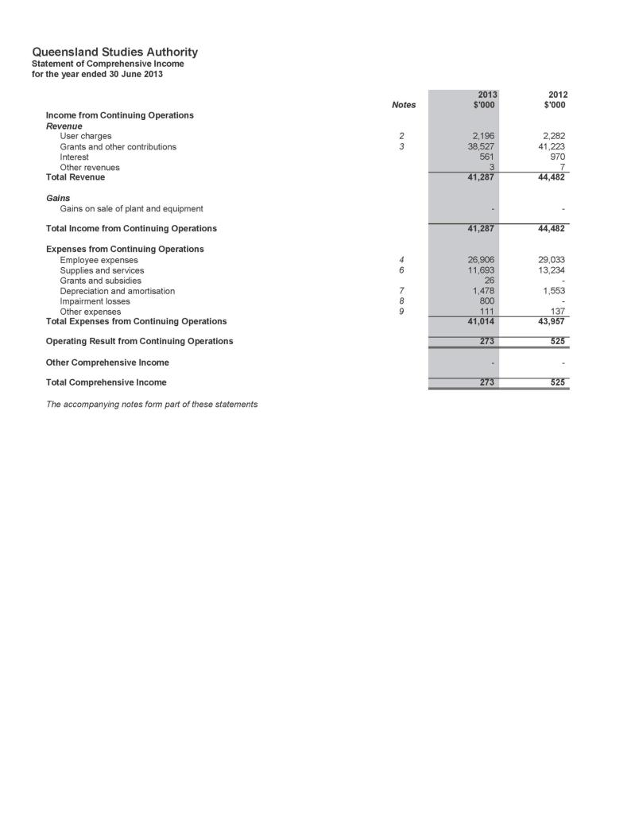
Statement of comprehensive income

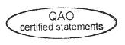

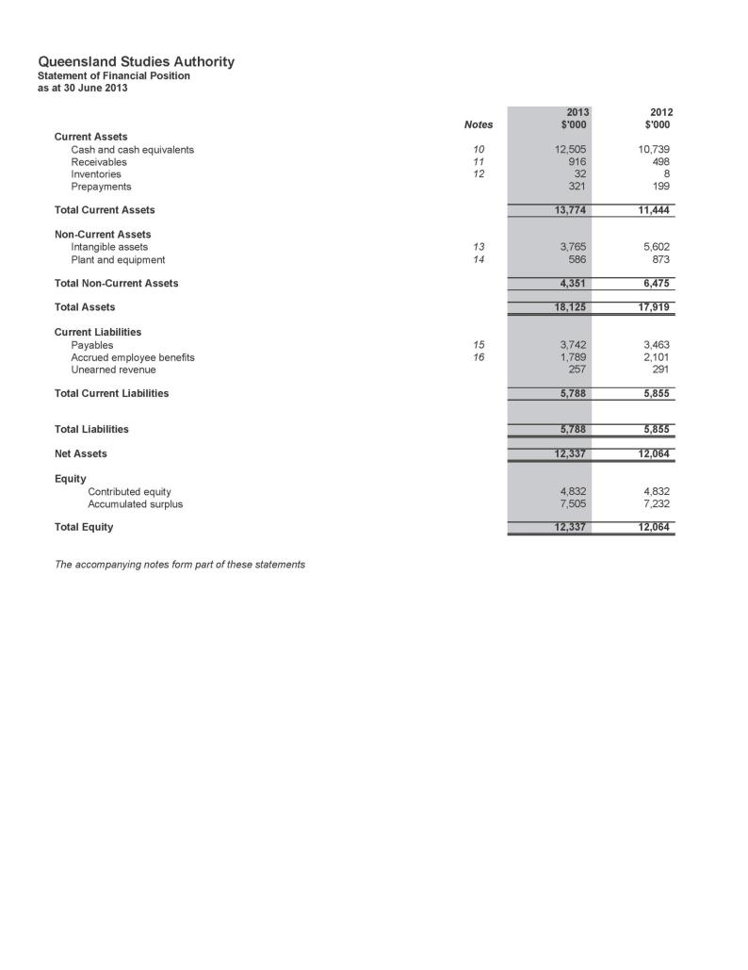
Statement of financial position

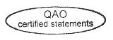

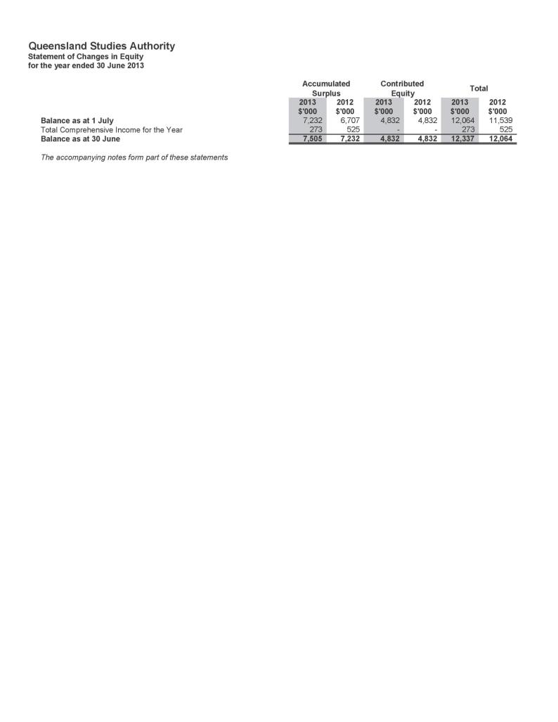
Statement of changes in equity

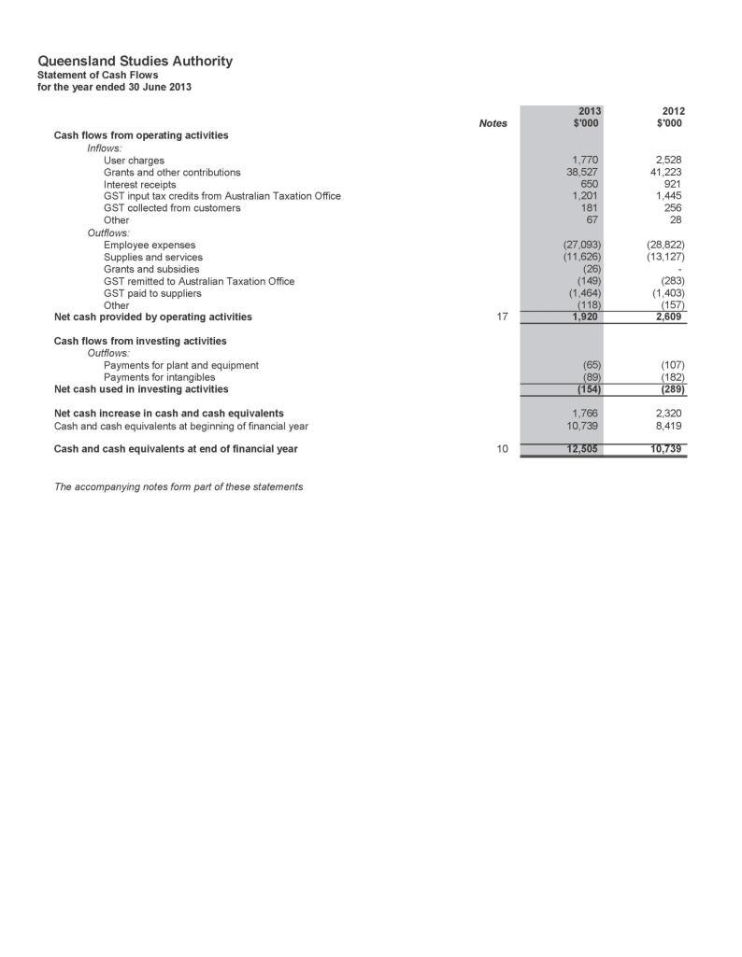
Statement of cash flows

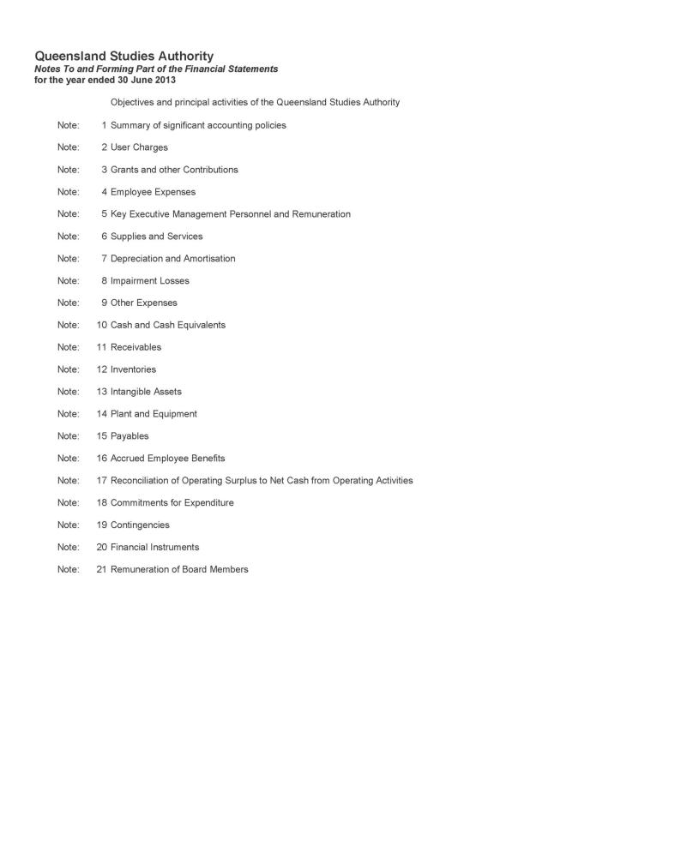
Notes to and forming part of the financial statements

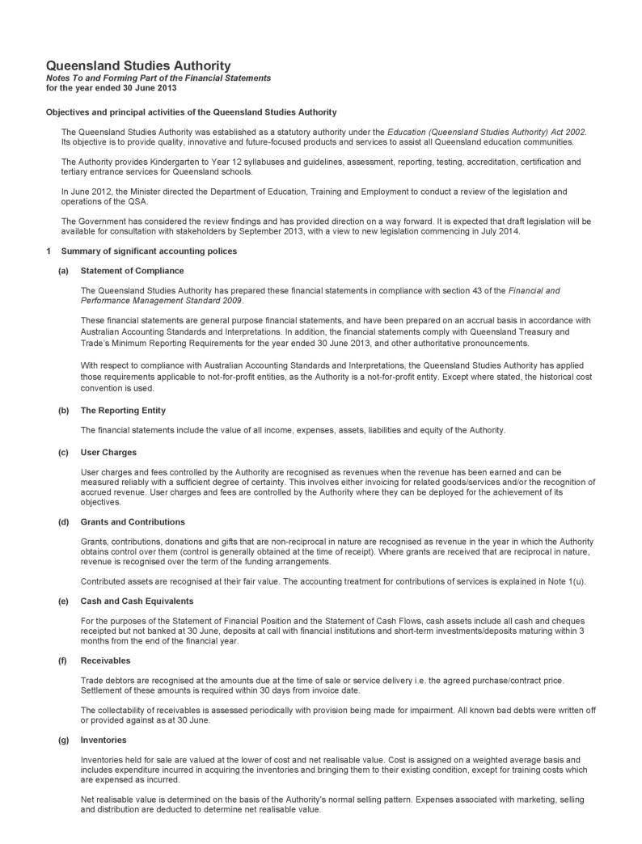
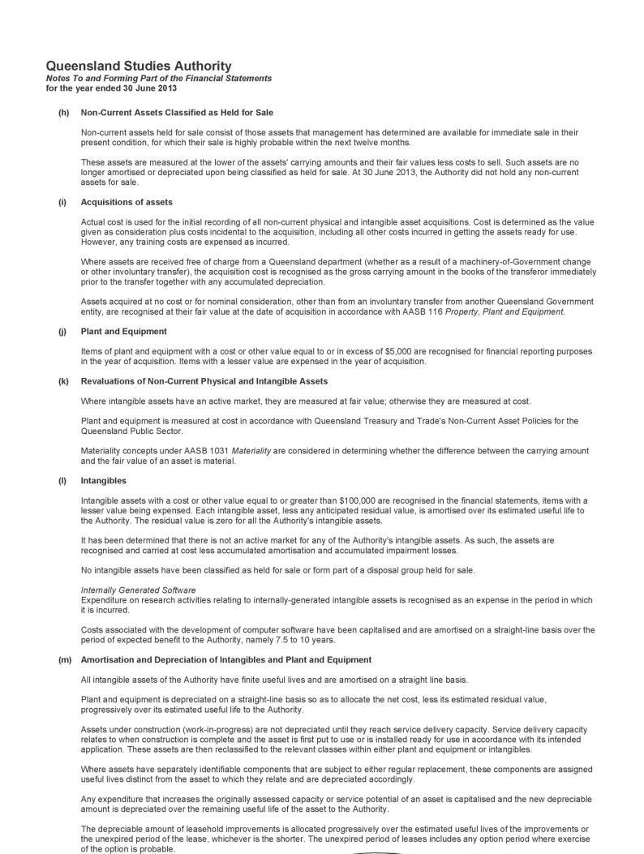
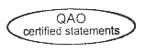
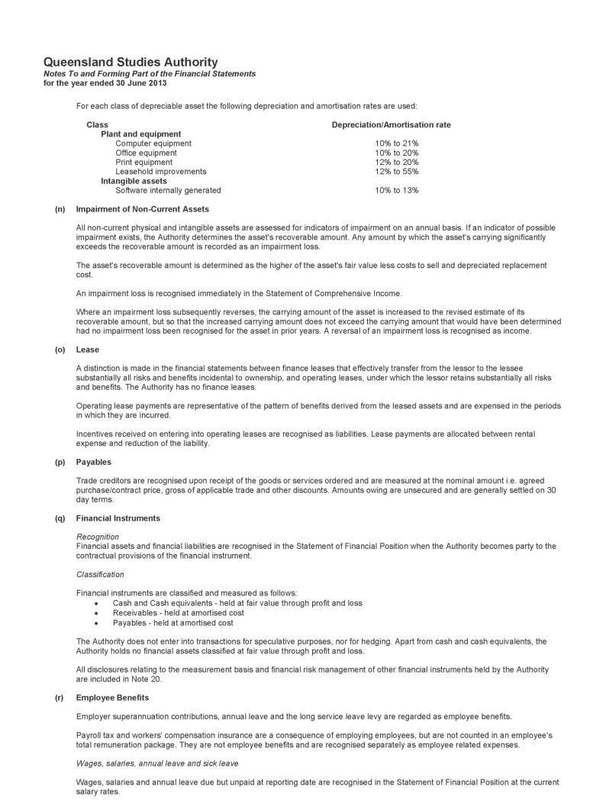
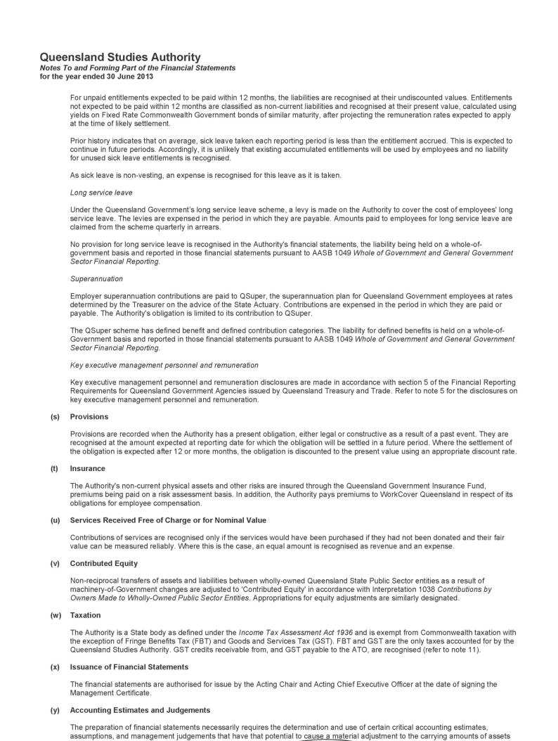
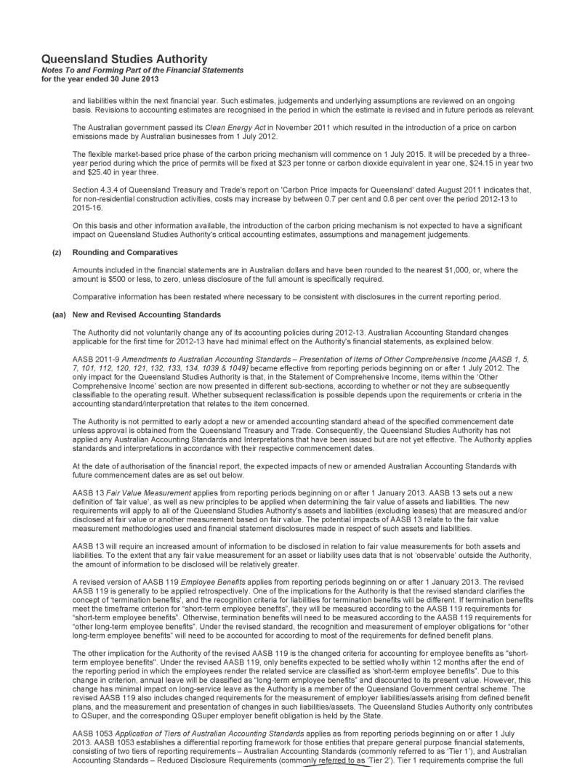
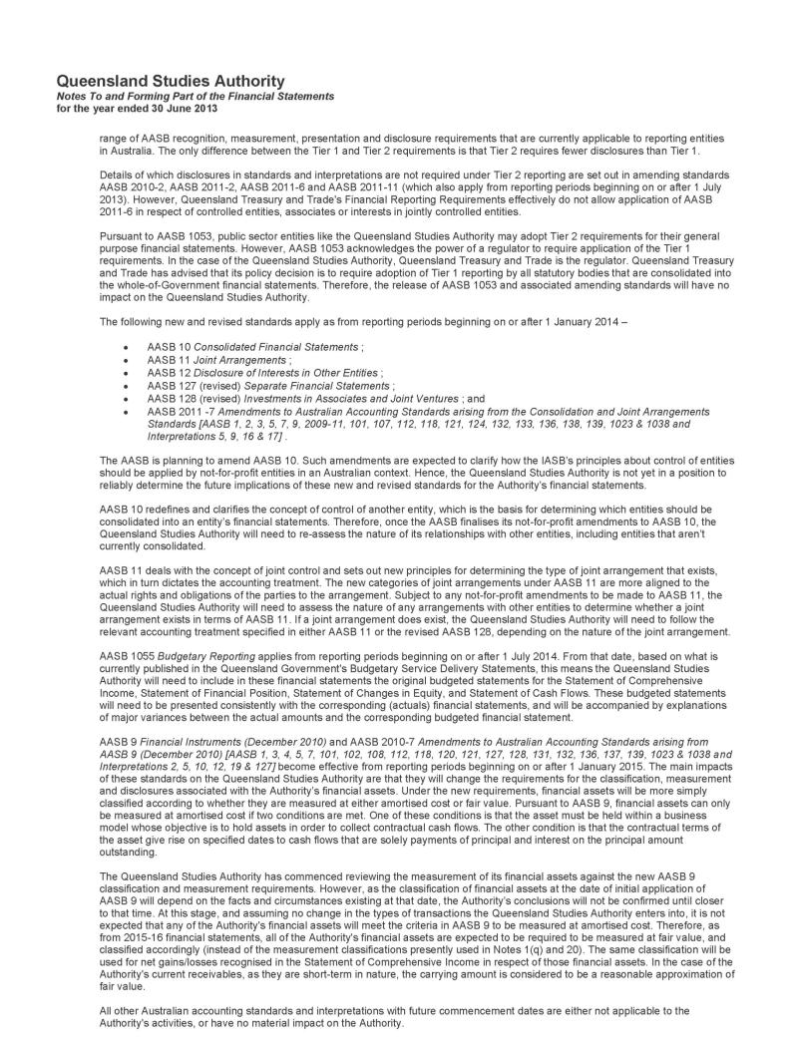
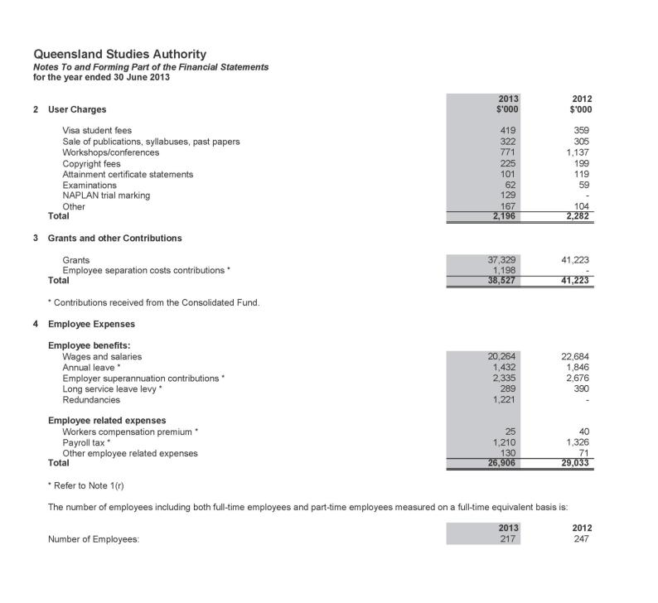
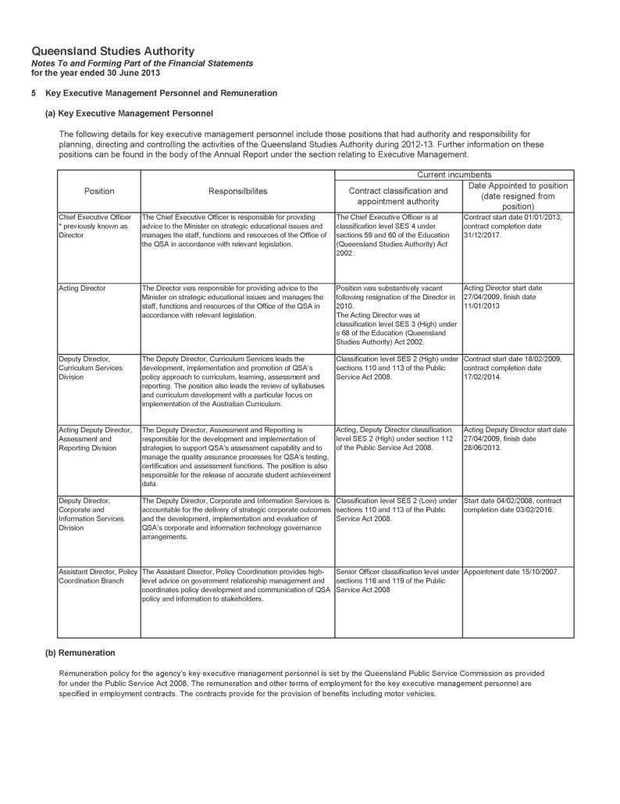
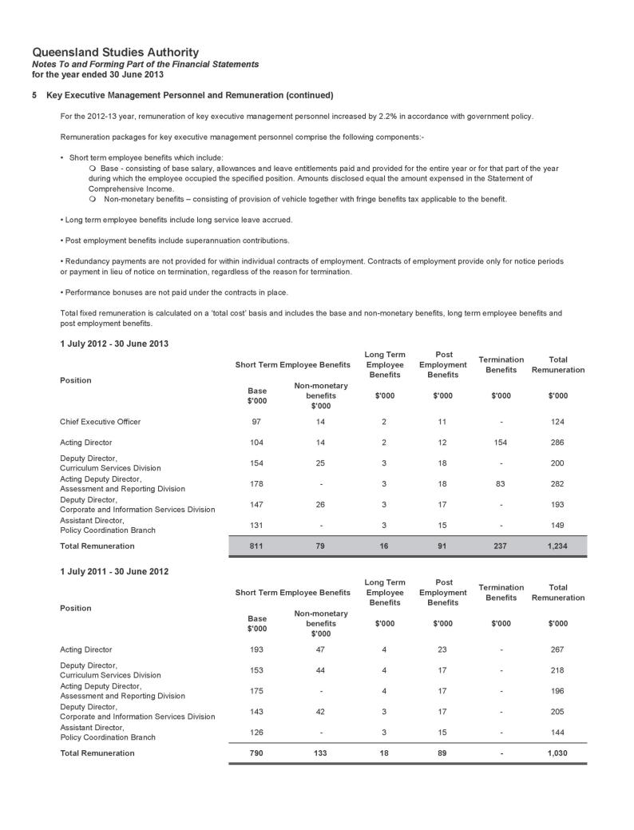
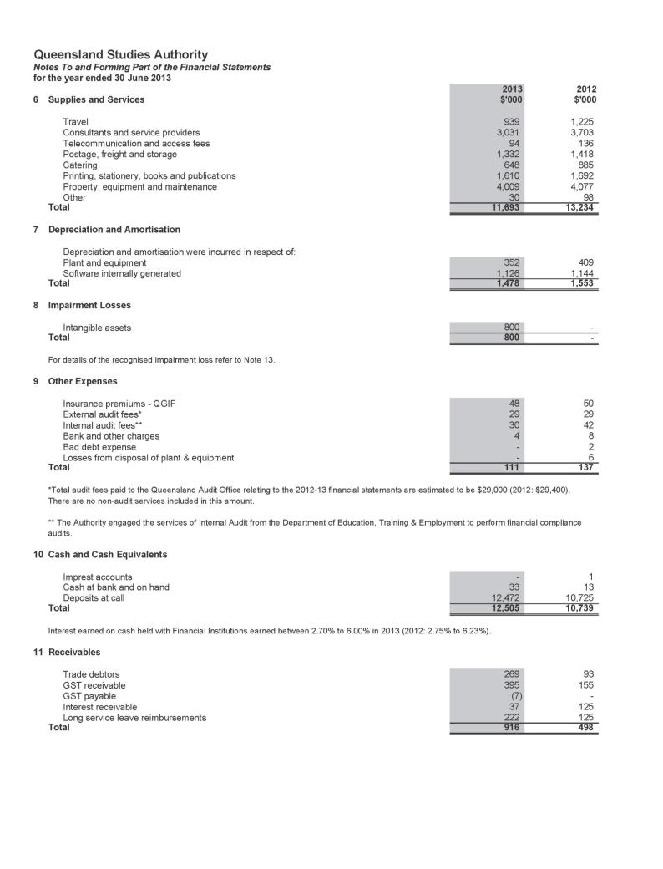
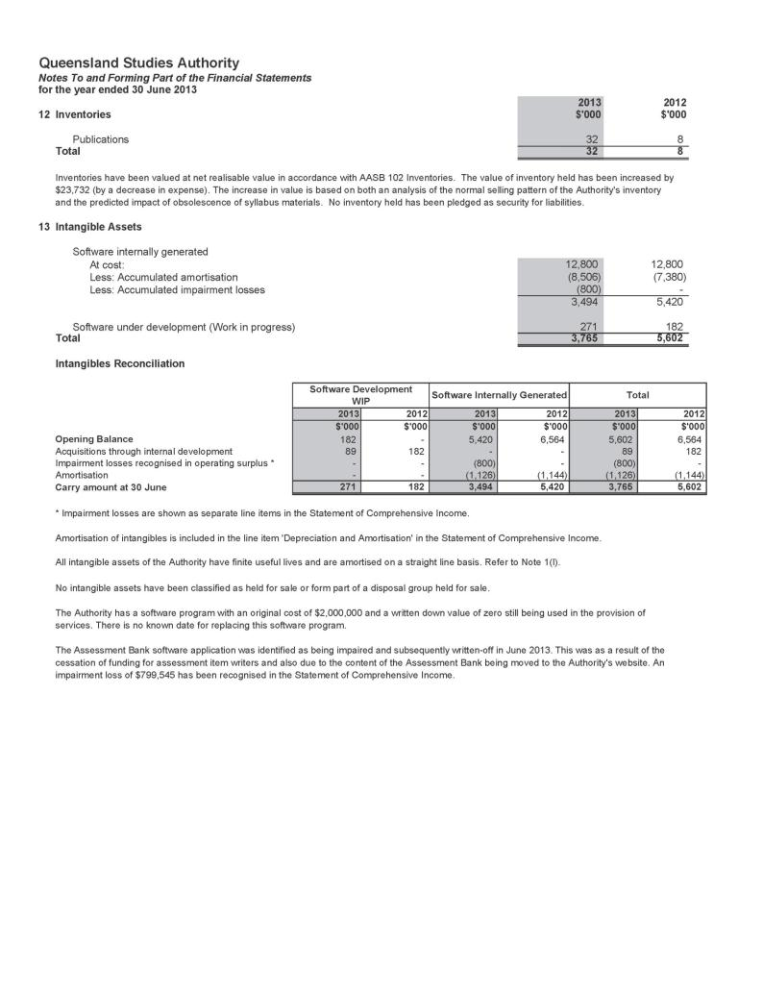
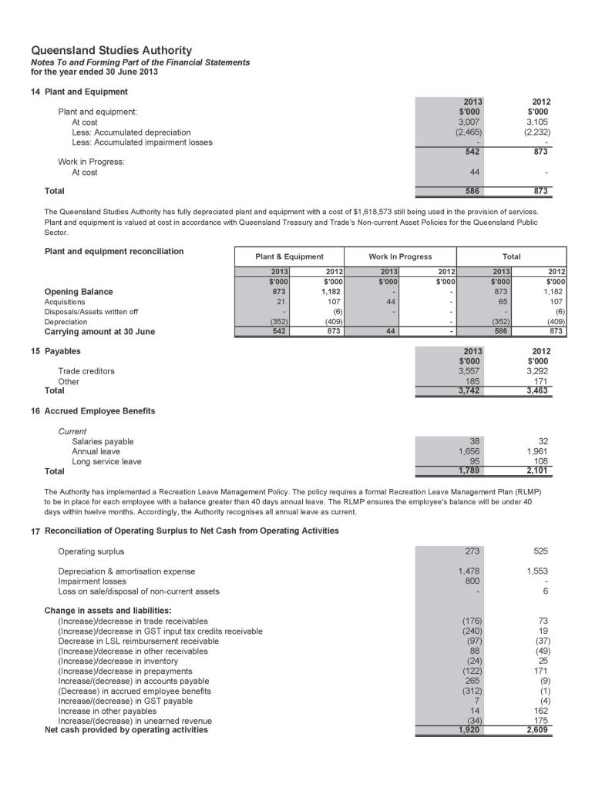
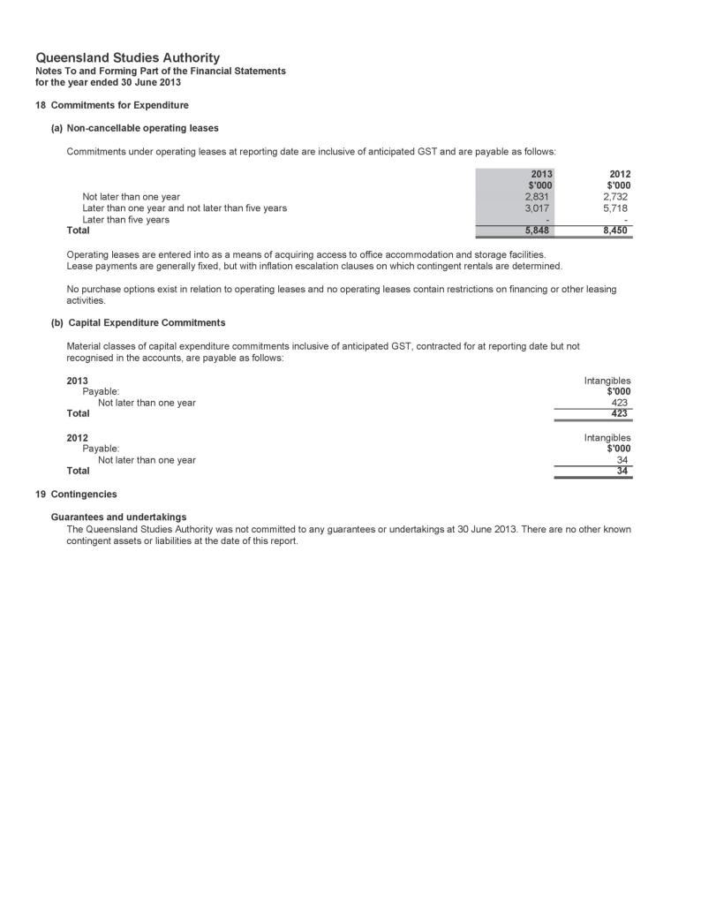
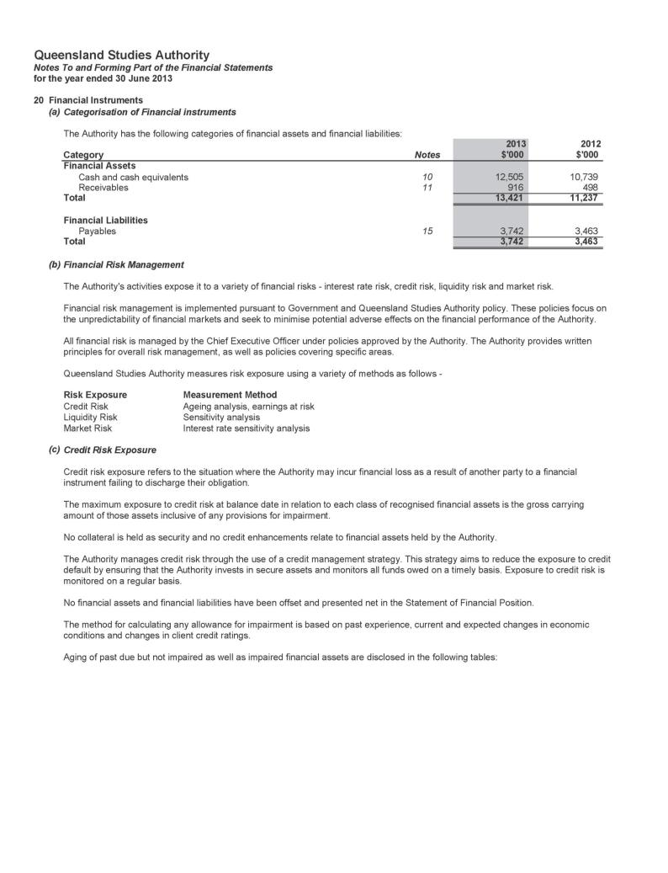
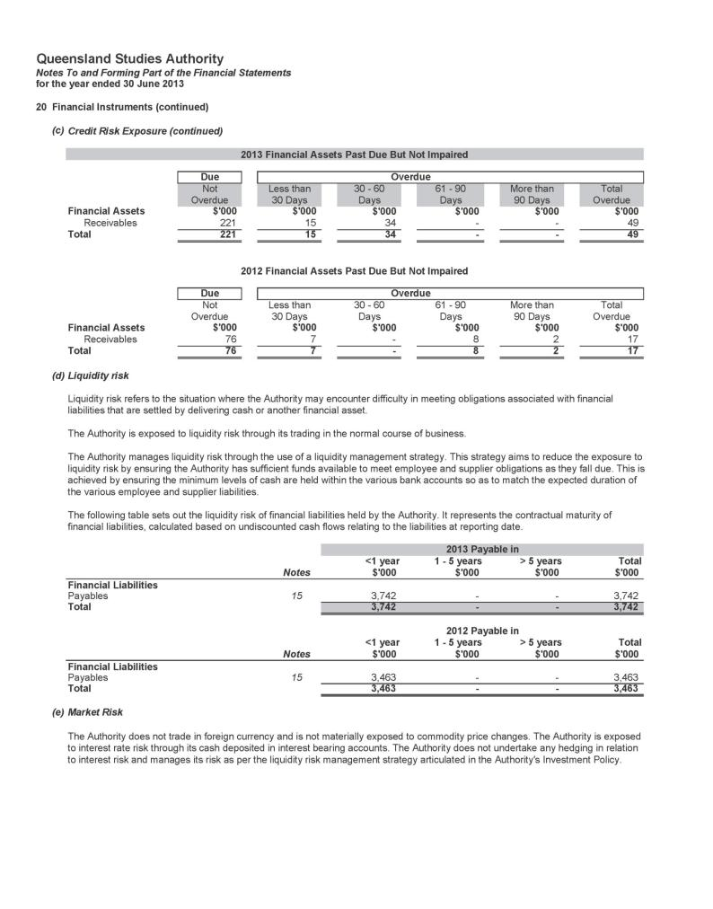
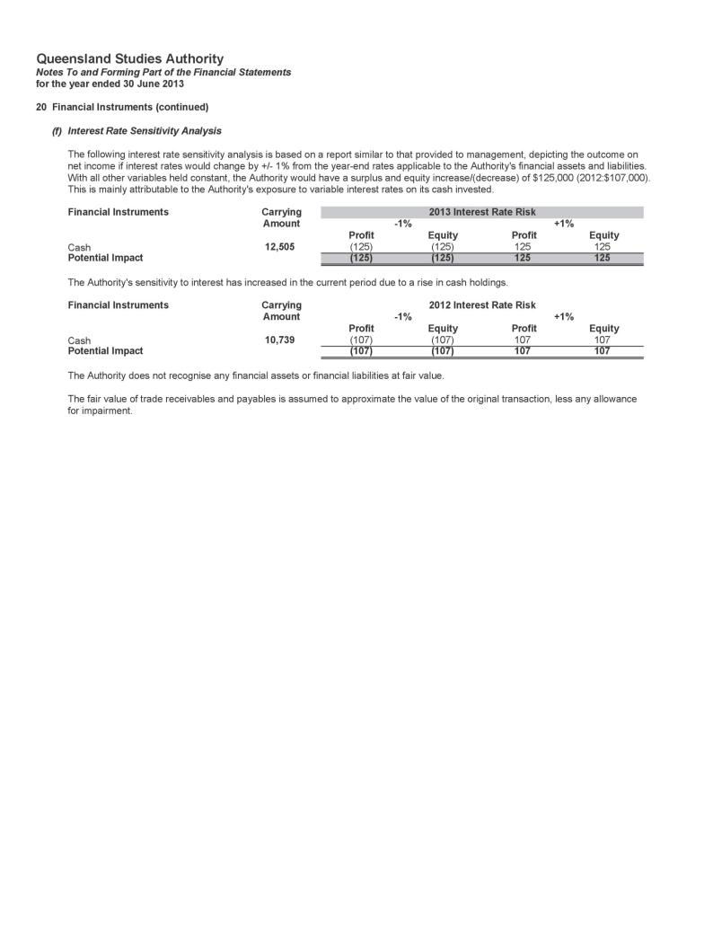
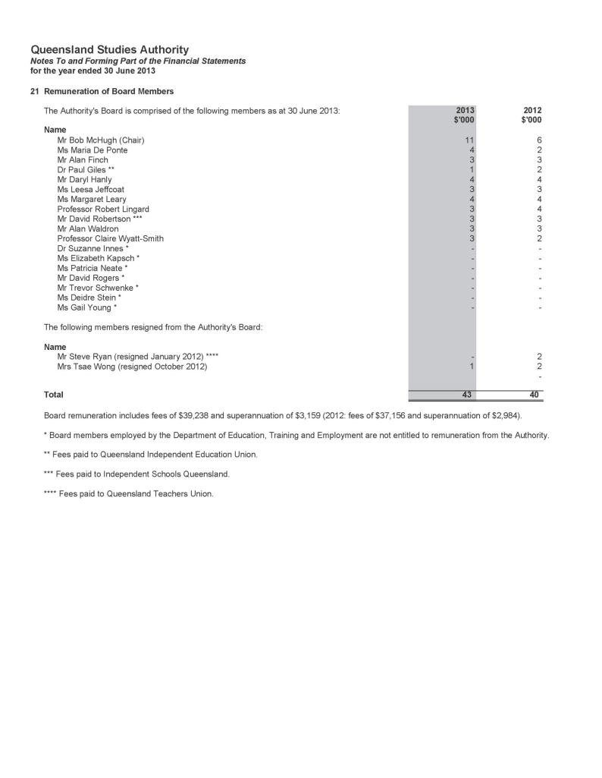

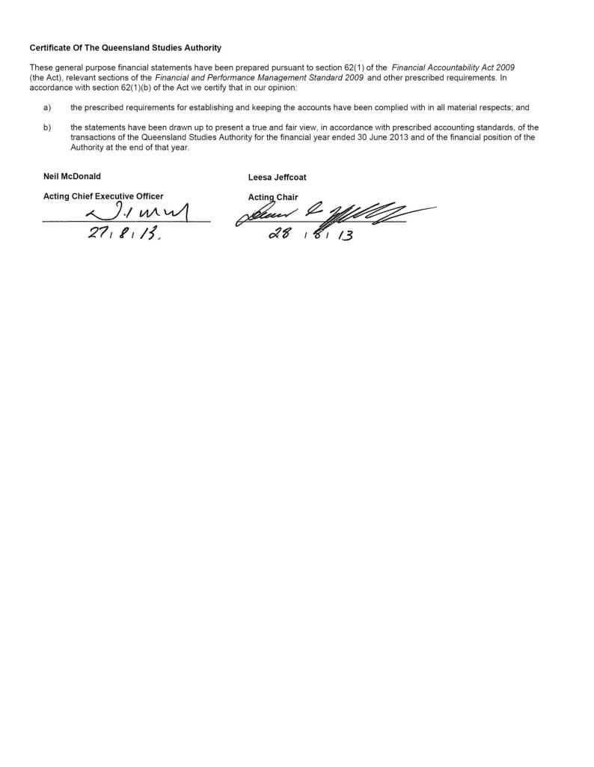
Notes to and forming part of the financial statements

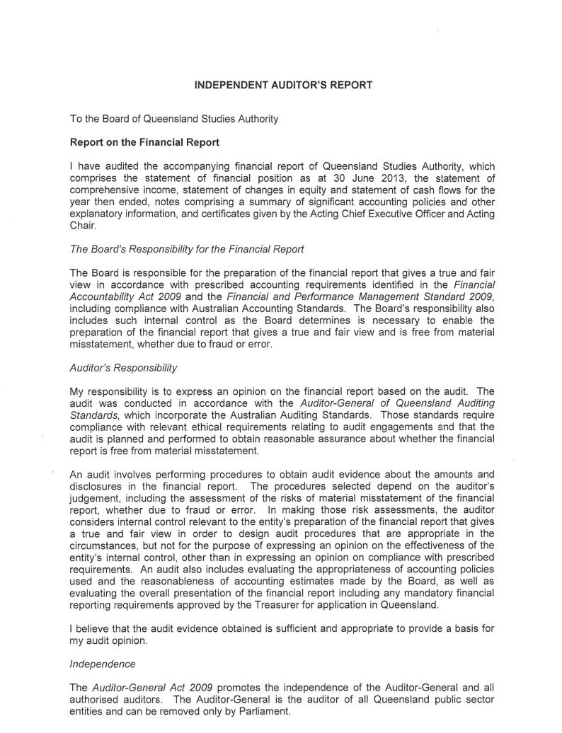
Independent auditor’s report

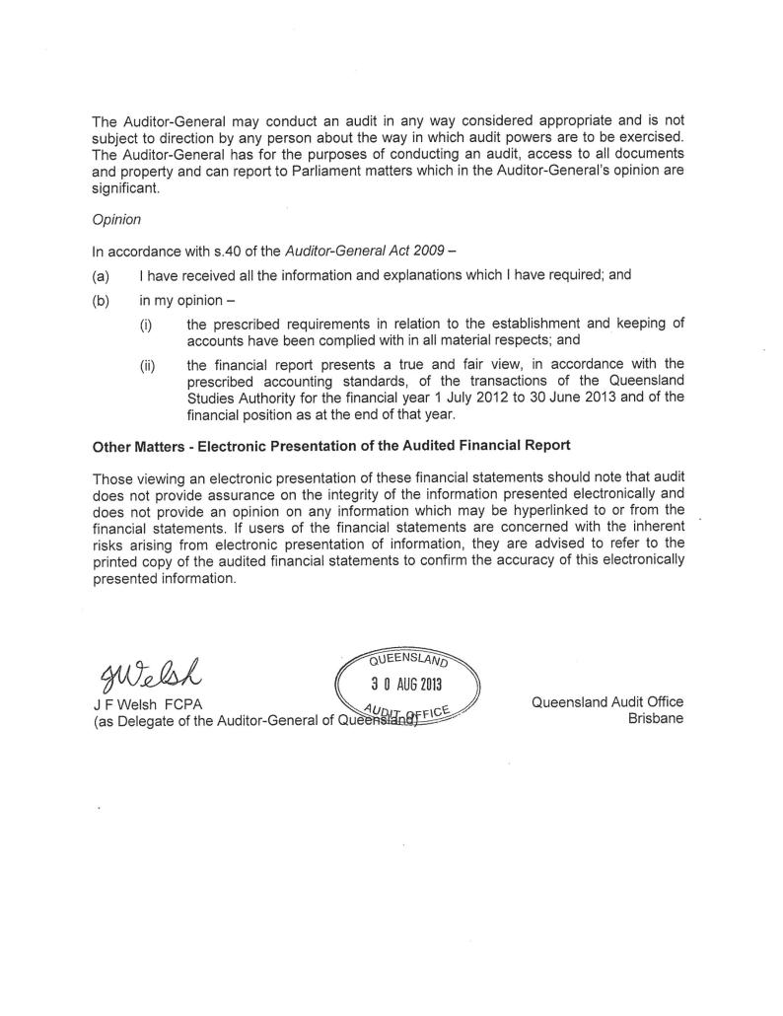

Appendixes

- Committees of the Authority
The Authority has established 10 committees to work on specific areas. Subcommittees were established as necessary to support these committees.

Aboriginal and Torres Strait Islander Education Committee
Functions are to:
- provide advice and direction to the Authority and CEO of the QSA on
  - ensuring that the QSA’s products and services meet the educational needs of Aboriginal young people and Torres Strait Islander young people
  - syllabus development, assessment, testing and reporting issues (including new QSA initiatives) as they relate to the education of young Aboriginal and Torres Strait Islander people, and education about both Aboriginal peoples and Torres Strait Islander peoples
  - ensuring Indigenous representation on Authority committees and other QSA consultative mechanisms
  - policy issues, particularly equity and social justice issues, as they relate to the education of Aboriginal young people and Torres Strait Islander young people
- be the primary mechanism for the QSA to consult with Aboriginal and Torres Strait Islander communities on QSA matters
- provide a two-way communication forum for Indigenous perspectives on QSA activities, and as a communication between the QSA and Indigenous communities.
Membership comprises:
- chair — Authority member with expertise in the education of Aboriginal young people and/or Torres Strait Islander young people
- one parent nominee
- one nominee of the Queensland Indigenous Education Consultative Committee
- one senior officer from the Department of Education, Training and Employment (DETE) — education sector
- one senior officer from DETE — training sector
- one nominee of the Queensland Catholic Education Commission
- one nominee of Independent Schools Queensland
- one nominee of Education Queensland
- one nominee of the Queensland Teachers’ Union
- one nominee of the Independent Education Union of Australia — Queensland and Northern Territory Branch
- four teachers representing each of the State, Catholic and Independent school sectors
(preferably an early years teacher, a secondary teacher, a primary teacher and a school principal)
- one nominee of the Torres Strait (Torres Strait Islander Regional Education Council)
- one representative of the Cape York education community
- one representative of the tertiary education sector
- QSA Principal Education Officer (Indigenous Education)
- one QSA senior officer
- executive officer — QSA officer.

Accreditation and Recognition Committee
Functions are to:
- oversee the accreditation process of non-QSA syllabuses and guidelines and assess applications
- oversee the recognition process of non-QSA and QSA developed courses of study, other than Authority or Authority-registered courses and assess applications
- make recommendations to the QSA Governing Body about the accreditation of non-QSA syllabuses and guidelines and recognition of non-QSA and QSA courses of study contributing towards a QCE.
Membership comprises:
- chair — Authority member
- one nominee of Education Queensland
- one nominee of the Queensland Catholic Education Commission
- one nominee of Independent Schools Queensland
- one nominee of DETE — training sector
- one nominee of the Office of Non-State Education, DETE
- one representative of the tertiary education sector
- one nominee of the Queensland Teachers’ Union
- one nominee of the Independent Education Union of Australia — Queensland and Northern Territory Branch
- one QSA senior officer
- executive officer — QSA officer.

Assessment, Moderation and Certification Committee
Functions are to:
- determine and recommend procedures for assessment, moderation and certification within the approved policies of the Authority
- provide advice and make recommendations to the Authority on assessment components of relevant documents such as QSA syllabuses and ACARA curriculum materials
- provide advice and make recommendations to the Authority on assessment information provided to teachers
- identify and advise the Authority on strategic issues relating to future developments in assessment, moderation and certification.
Membership comprises:
- chair — Authority member
- one nominee of Education Queensland
- one nominee of the Queensland Catholic Education Commission
- one nominee of Independent Schools Queensland
- one nominee of DETE — training sector
- one parent nominee
- one tertiary educator/researcher
- one district review panel chair
- one state review panel chair
- two school administrators (state and non-state)
- one primary school principal
- one nominee of the Queensland Teachers’ Union
- one QSA senior officer
- executive officer — QSA officer.

Audit Committee
Functions are to:
- provide independent assurance and assistance to the Authority and CEO of the QSA on
  - the risk control and compliance frameworks
  - the agency’s external accountability responsibilities as prescribed in Education (Queensland Studies Authority) Act 2002
- oversee internal and external audit services
- review strategic risk assessment
- monitor improvement strategies to reduce and mitigate against risk.
Membership comprises:
- chair — Authority member
David Robertson, Executive Director, Independent Schools Queensland
- external member — Authority member
David Rogers, Principal, Southport Special School
- one member who has ‘financial expertise’ as described in the Queensland Treasury publication, Audit Committee Guidelines — Improving accountability and performance 2008
Graham Smith, Deputy Director, Corporate and Information Services Division
- one member with expertise in the industry in which the agency operates
Peter Jordan, Acting Deputy Director, Assessment and Reporting Division.
The committee held four meetings in 2012–13. During this period, it:
- considered and approved the external audit strategy, and oversaw the internal and external audit processes
- considered and gave clearance to the annual financial statements
- had oversight of the process of revising the strategic risk assessment and the initiatives implemented to reduce and mitigate against the identified risks
- reviewed its charter to incorporate changes to Queensland Treasury’s Audit Committee Guidelines.
The internal and external auditors have a standing invitation to attend meetings.
The Audit Committee observed the terms of its charter and had due regard to Queensland Treasury’s Audit Committee Guidelines.

Curriculum Committee
Functions are to:
- provide advice to the Authority on the current directions in curriculum development for the early, middle and senior phases of schooling
- review submissions of syllabuses, curriculum guidelines and other materials and make recommendations to the Authority about the suitability of such materials
- provide advice on P–12 matters that the Authority may determine.
Membership comprises:
- chair — Authority member
- three Authority members from each school sector
- one nominee of Education Queensland
- one nominee of the Queensland Catholic Education Commission
- one nominee of Independent Schools Queensland
- one nominee of DETE — training sector
- one parent nominee
- one nominee of the Queensland Teachers’ Union
- one nominee of the Independent Education Union of Australia — Queensland and Northern Territory Branch
- one nominee of EQ — special education
- one nominee of EQ — rural and remote
- one nominee of QCEC — senior years
- one nominee of ISQ — middle years
- one nominee of EQ — early years
- one nominee of the Queensland Indigenous Education Consultative Committee
- two tertiary educators
- one QSA senior officer
- executive officer — QSA officer.

Equity Committee
Functions are to:
- provide expertise and advice to the Authority, and the Office of the Authority, on equity issues in education, relevant to the functions of the Authority
- liaise with other committees of the Authority as required
- represent the interests of groups at educational risk in the community.
Membership comprises:
- chair — Authority member
- one nominee of Education Queensland
- one nominee of the Queensland Catholic Education Commission
- one nominee of Independent Schools Queensland
- one nominee of DETE — training sector
- one nominee of the Queensland Indigenous Education Consultative Committee
- one nominee of the Queensland Teachers’ Union
- one nominee of the Independent Education Union of Australia — Queensland and Northern Territory Branch
- one practising teacher or school-based person with expertise in special education
- one practising teacher with expertise in distance education
- one nominee of the Queensland Association of Gifted and Talented Children
- one researcher
- one nominee of the Queensland
Anti-Discrimination Commission
- one nominee of the Queensland Guidance and Counselling Association
- one nominee of the Queensland Association of Teaching English as a Second or Other Language
- one nominee of the Ethnic Communities Council of Queensland
- two parent nominees
- one QSA senior officer
- executive officer — QSA officer.

Finance Committee
Functions are to:
- oversee the development and approval of the annual budget
- ensure that annual resource allocations are consistent with the strategic direction and operational priorities of the QSA
- provide advice on major project and capital expenditure proposals or initiatives
- monitor actual financial performance against budget and forecasts and provide advice on significant trends or variances
- review the financial performance of major strategic initiatives
- perform any other activities consistent with this charter that the Governing Body requests.
Membership comprises:
- chair — Authority member
- two nominees of the Authority
- executive officer — QSA officer.

Scaling Anomalies Committee
Functions are to:
- consider applications from schools for examination of their Queensland Core Skills (QCS) Test data where schools consider that exceptional circumstances may have resulted in lesser performance
- examine data for schools that have a significant negative mismatch between within-school achievement and QCS Test data, and recommend measures to be implemented to help schools identify the reasons for the mismatch
- confirm that special procedures, which are part of the calculation of equivalent Overall Positions (OPs), are working appropriately (such as those for visa schools)
- consider cases identified by the Office of the QSA where the normal scaling procedures for the calculation of OPs might need to be varied because they are not operating as they were intended.
Membership comprises:
- chair — Authority member
- one academic representative
- one nominee of Education Queensland
- one nominee of the Queensland Catholic Education Commission
- one nominee of Independent Schools Queensland
- Deputy Director, Assessment and Reporting Division, QSA
- Assistant Director, Analysis and Reporting Branch, QSA
- Manager, Quantitative Analysis Unit, QSA
- Manager, Qualitative Analysis Unit, QSA — executive officer.

Tertiary Entrance Committee
Functions are to:
- monitor developments on tertiary entrance matters and assist in the provision of informed advice about tertiary entrance matters
- provide advice on the management of information and secondary–tertiary link programs that maximise the capacity of potential tertiary applicants to make informed choices and pursue tertiary studies.
Membership comprises:
- chair — Authority member
- two university admissions managers
- one TAFE admissions manager
- one nominee of DETE with policy expertise relating to TAFE — university interface
- one nominee of the Office of Higher Education, DETE
- one nominee of the Queensland Tertiary Admissions Centre
- one nominee of the Australian Council of Private Education and Training
- two guidance counsellors (state and non-state)
- two student representatives
- two tertiary student representatives
- one parent nominee
- one QSA senior officer
- executive officer — QSA officer.

Vocational Education and Training Committee
Functions are to:
- provide advice to the Authority on emerging policies and issues relating to VET pathways at both the national and state levels
- provide strategic advice to the Authority on the implementation of legislation in relation to VET at both the national and state levels
- provide information to the Authority on issues relating to the implementation of VET in Queensland schools.
Membership comprises:
- chair — Authority member
- two nominees of DETE — training sector, one to include a TAFE practitioner
- one nominee of the Australian Council for Private Education and Training
- one nominee of industry
- one nominee of Education Queensland
- one nominee of the Queensland Catholic Education Commission
- one nominee of Independent Schools Queensland
- two parents nominees
- three practitioners (state, non-state and TAFE) with responsibility for VET
- two principals/administrators (state and non-state) with responsibility for VET
- one QSA senior officer
- executive officer — QSA officer.
- Fees paid to Board members
A total of $41 633 was payable to Authority members in 2012–13. This amount does not include associated meeting and travel costs of $23 854.
Further information relating to QSA’s expenditure on consultancies and overseas travel, and compliance with information systems and recordkeeping legislation can be found through the Queensland Government’s Open data website: www.qld.gov.au/data.
- Early retirement, redundancy and retrenchment
A program of redundancies was implemented during 2012–13. During the period, 12 employees received redundancy packages at a cost of $1 770 377. There were no early retirement or retrenchment packages.
- Key corporate governance committee of the QSA

Strategic Directions Group
Paul Herschell, Deputy Director, Curriculum Services Division
Peter Jordan, Acting Deputy Director, Assessment and Reporting Division
Peter Luxton, Acting Director (until December 2012)
John McGuire, Assistant Director, Policy Coordination Branch
Graham Smith, Deputy Director, Corporate and Information Services Division
Patrea Walton, Chief Executive Officer
(from January 2013)
- QSA district offices

Brisbane Central
Helen Best
Phone: (07) 3359 6131 Fax: (07) 3359 6387
Email: BrisbaneCentralOffice@qsa.qld.edu.au
Suite G1, 449 Gympie Rd, Kedron Qld 4031

Brisbane North
Judy Beadle
Phone: (07) 3859 6132 Fax: (07) 3359 6387
Email: UBrisbaneNorthOffice@qsa.qld.edu.au
Suite G1, 449 Gympie Rd, Kedron Qld 4031

Brisbane East
Elisabeth Case
Phone: (07) 3324 1072 Fax: (07) 3397 2955
Email: UBrisbaneEastOffice@qsa.qld.edu.au
Suite 6.01, 433 Logan Rd,
Stones Corner Qld 4120
PO Box 686, Stones Corner Qld 4120

Brisbane South
Sally Dwyer
Phone: (07) 3397 3955 Fax: (07) 3397 2955
Email: UBrisbaneSouthOffice@qsa.qld.edu.au
Suite 6.01, 433 Logan Rd
Stones Corner, Qld 4120
PO Box 686, Stones Corner Qld 4120

Brisbane Ipswich
Andrew Sycz
Phone: (07) 3202 3325 Fax: (07) 3202 3347
Email: UBrisbaneIpswichOffice@qsa.qld.edu.au
Unit 2/56 Cascade St, Raceview Qld 4305
PO Box 860, Booval Qld 4304

Cairns
Carol Mcllwain
Phone: (07) 4054 6278 Fax: (07) 4054 3943
Email: UCairnsOffice@qsa.qld.edu.au
455 Mulgrave Rd, Earlville Qld 4870
PO Box 122, Earlville 4870

Gold Coast
Sylvia Richardson
Phone: (07) 5591 4255 Fax: (07) 5591 4461
Email: UGoldCoastOffice@qsa.qld.edu.au
1/8 Short St, Southport Qld 4215
PO Box 2005, Southport Qld 4215

Mackay
Sandra Davis
Phone: (07) 4953 0977 Fax: (07) 4953 0988
Email: UMackayOffice@qsa.qld.edu.au
Mercury House
38 Wellington St, Mackay Qld 4740
PO Box 8163, Mt Pleasant Qld 4740

Rockhampton
Keren Chillingworth & Dian Hamilton
Phone: (07) 4927 7279 Fax: (07) 4922 6574
Email: URockhamptonOffice@qsa.qld.edu.au
Room 8, North Street Annex
Cnr North & West Sts
Rockhampton Qld 4700
PO Box 919, Rockhampton Qld 4700

Sunshine Coast
Amanda Poeppmann
Phone: (07) 5493 9452 Fax: (07) 5493 9451
Email: USunshineCoastOffice@qsa.qld.edu.au
Shop 3A, 710 Nicklin Way (Cnr Erang St)
Currimundi Qld 4551
PO Box 44, Wurtulla Qld 4575

Toowoomba
Marion Goebel
Phone: (07) 4638 3699 Fax: (07) 4638 5390
Email: UToowoombaOffice@qsa.qld.edu.au
D Block, Toowoomba State High School
Via Peter St, Toowoomba Qld 4350
PO Box 572, Toowoomba 4350

Townsville
Nola Popowycz
Phone: (07) 4728 8485 Fax: (07) 4728 8486
Email: UTownsvilleOffice@qsa.qld.edu.au
F Block, Heatley Secondary College
Hanlon St, Heatley Qld 4814
PO Box 207, Aitkenvale Qld 4814

Wide Bay
Diane Armstrong
Phone: (07) 4123 1612 Fax: (07) 4121 6811
Email: UWideBayOffice@qsa.qld.edu.au
Maryborough State High School
Block Z, Rooms 814–817,
Sussex St, Maryborough Qld 4650
PO Box 452, Maryborough Qld 4650

- Reader evaluation of the Annual Report 2012–13
Please take some time to answer the following questions, to help the QSA communicate effectively with you.
To indicate your response, please circle the appropriate number for each question as follows:
0 = Unable to respond | 1 = Very poor | 2 = Poor | 3 = Acceptable | 4 = Very good | 5 = Excellent

Did the Annual Report achieve its communication objectives? (see page 2)
0 1 2 3 4 5
What did you think of the content?
Value of information
0 1 2 3 4 5
Presentation
0 1 2 3 4 5
Did the design of the report make it easy to read?
Layout of information
0 1 2 3 4 5
Type and colour
0 1 2 3 4 5
Overall, how would you rate the report?
0 1 2 3 4 5

Please return to:
Policy Coordination Branch
Queensland Studies Authority
Reply Paid 307, Spring Hill QLD 4004
Fax: (07) 3864 0406
What client group do you come from?
(Please tick appropriate box)
School staff
State
Catholic
Independent
Student
Secondary
Tertiary
Education authority
State
Catholic
Independent
Parent
State
Catholic
Independent
Tertiary institution
University
TAFE
Union
Employer
Queensland Government

Other comments

Abbreviations and acronyms

ACACA Australasian Curriculum, Assessment and Certification Authorities
ACARA Australian Curriculum, Assessment and Reporting Authority
ASQA Australian Skills Quality Authority
CCAFL Collaborative Curriculum and Assessment Framework for Languages
DETE Department of Education, Training and Employment
EQ Education Queensland
ESL English as a Second Language
F Foundation
FP Field Position
ICT Information and communications technology
IEUA–QNT Independent Education Union of Australia — Queensland and Northern Territory Branch
ISQ Independent Schools Queensland
K Kindergarten
NAPLAN National Assessment Program — Literacy and Numeracy
OP Overall Position
P, Prep Preparatory Year
QCAT Queensland Comparable Assessment Task
QCE Queensland Certificate of Education
QCEC Queensland Catholic Education Commission
QCIA Queensland Certificate of Individual Achievement
QCS Queensland Core Skills (Test)
QKLG Queensland kindergarten learning guideline
QSA Queensland Studies Authority
LASDs Learning area standards descriptors
RTO registered training organisation
SDCS Student Data Capture System
SEP Senior Education Profile
SLIMS Senior Learning Information Management System
TAFE Technical and Further Education
TSXPO Tertiary Studies Expo
VET vocational education and training

Queensland Studies Authority
154 Melbourne Street, South Brisbane
PO Box 307 Spring Hill
QLD 4004 Australia
T +61 7 3864 0299
F +61 7 3221 2553
www.qsa.qld.edu.au

