2011–12

Annual Report
Queensland Studies Authority

Published September 2012
© Queensland Studies Authority 2012
ISSN 2201-0580
154 Melbourne Street, South Brisbane
PO Box 307 Spring Hill Queensland 4004 Australia
Phone: +61 7 3864 0299
Fax: +61 7 3221 2553
Email: office@qsa.qld.edu.au
Website: www.qsa.qld.edu.au

Contents
Letter of compliance 1
Communication objectives 2
Highlights of 2011–12 3
Chair’s introduction 4
Financial snapshot 2011–12 5
Constitution, functions & powers 6
Corporate profile 6
Authority members 6
Executive committee 7
Authority committee functions 7
Authority committees 8
Organisational structure 9
Strategic Plan 2011–15 10
Planning and objectives 10
Performance against objectives 10
Challenges and future priorities 10
Program review 11
Syllabus development and implementation 11
Testing and assessment 15
Certification and tertiary entrance 17
Corporate support and communication 20
Financial report 2011–12 25
Statement of comprehensive income 26
Statement of financial position 27
Statement of changes in equity 28
Statement of cash flows 29
Notes to and forming part of the financial statements 30
Certificate of the Queensland Studies Authority 46
Independent auditor’s report 47
Appendixes 49
1. Fees paid to Board members 49
2. Voluntary Separation Program (VSP) 49
3. Key corporate governance committee of the QSA 49
4. Committees of the Authority 50
5. QSA district offices 54
6. Reader evaluation of the Annual Report 2011–12 55
Abbreviations and acronyms inside back cover

Letter of compliance
30 August 2012
The Honourable John-Paul Langbroek MP
Minister for Education, Training and Employment
PO Box 15033, CITY EAST QLD 4002
Dear Minister
I am pleased to present the Annual Report 2011–12 for the Queensland Studies Authority.
I certify that this annual report complies with:
- the prescribed requirements of the Financial Accountability Act 2009 and the Financial and Performance Management Standard 2009, and
- the detailed requirements set out in the Annual report requirements for Queensland Government agencies.
A checklist outlining the annual reporting requirements can be accessed at: www.qsa.qld.edu.au/624.html.
Yours sincerely
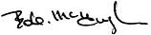
Bob McHugh
Chair
Queensland Studies Authority

Communication objectives
The Queensland Studies Authority (QSA) was established in 2002 and is responsible for a range of functions including developing and accrediting Kindergarten to Year 12 syllabuses and guidelines, testing, assessment, moderation, certification, vocational education and training, and tertiary entrance.
This annual report shows the ways in which the QSA is fulfilling its role as prescribed by the
Education (Queensland Studies Authority) Act 2002. The report is aimed, in particular, at:
- school staff
- parents
- tertiary institutions
- unions
- employers
- the Queensland Government.

Report access
Access to this report is provided through the QSA’s website or by contacting the QSA.

Interpreter Service Statement
The Queensland Government is committed to providing accessible services to Queenslanders from all culturally and linguistically diverse backgrounds. If you have difficulty in understanding the annual report, you can contact the QSA on (07) 3864 0299 and we will arrange an interpreter to effectively communicate the report to you.

Highlights of 2011–12
Senior Education Profiles  issued to 47 200  Year 12 students | QSA’s K–12 conference,  Shaping teaching and learning:  The assessment factor | Delivery of workshops for  more than 4000 educators to support implementation of the  Australian Curriculum
Queensland Certificates of Education awarded to  39 500 students | Administration of  2012 NAPLAN | Moderation of 110 000 senior student assessment folios
Public release of 2011  NAPLAN and  Year 12 outcomes reports | Administration of 2011 and development of 2012  QCATs and QCS Test | 200 new P–10 assessment resources aligned to the Australian Curriculum and added to the Assessment Bank

Chair’s introduction
The QSA’s vision is to provide quality, innovative and future-focused education products and services to all schools in Queensland. Within our resources, I believe we have managed to do that well over the past year.
We know that teacher quality can be the most significant influence on student learning. Supporting teachers in their work, therefore, remains central to the QSA’s objectives. In 2012, our conference, Shaping teaching and learning: The assessment factor, was about recognising the power of assessment, its role in the teaching and learning process, and as a vital element of teachers’ professional practice.
It was one of more than 250 face-to-face workshops and events the QSA delivered during the past year throughout Queensland on a range of topics from Kindergarten to Year 12.
Additionally, the organisation published hundreds of curriculum and assessment resources for many subject areas and year levels. In particular, we produced a considerable body of work to support Queensland schools in their transition to the Australian Curriculum, which began in earnest in 2012 with the introduction of English, Mathematics and Science for Prep to Year 10. We are committed to maintaining a similar output and quality in coming years as further Australian Curriculum learning areas are implemented. Meanwhile we will continue to participate in the Australian Curriculum, Assessment and Reporting Authority’s curriculum development and consultation activities to promote Queensland’s position and ensure the delivery of a world-class national curriculum.
In the senior phase of learning, our partnership with schools remains fundamental to the success of Queensland’s internationally regarded system of externally moderated school-based assessment.
It is a system with many benefits, but above all it promotes authentic pedagogy and confirms the role of teachers as professionals. In 2011–12, more than 4500 teachers participated in moderation panels to quality assure more than 110 000 student assessment folios. The system relies on their dedication and professionalism to ensure educational standards are comparable across the State.
I thank them all for their continued support. It is pleasing to note that these teachers have provided positive feedback on the QSA’s recently launched online senior assessment hub, which was developed as part of our commitment to maintain and improve Years 11 and 12 school-based assessment and moderation practices.
Partnerships like this one — indeed stakeholder engagement in general — are the foundation on which QSA’s work can prosper. They create the conditions that allow us to support all schools to provide the best education and training for students. In this endeavour, the QSA relies on the policy direction, guidance and advice of its Governing Body. With representatives from the State, Catholic, and Independent school sectors, as well as teachers, parents, unions, higher education and employment groups, its advice and collective wisdom is invaluable. Our thanks must also go to the hundreds of educators whose work on QSA committees ensures our products and services meet the needs of schools.
Change in education has been a constant for the past two decades and there are no signs that this will cease. This is a challenge. But I am of the view, that with ongoing professional dialogue and close collaboration among the education sectors, we can continue to do what is right for all students and schools in Queensland.
Bob McHugh
Chair
Queensland Studies Authority

Financial snapshot 2011–12
In 2011–12, the QSA received $41.223 million in grant revenue from the Department of Education, Training and Employment (DETE) and raised $3.259 million from the curriculum and professional development products and services it delivered to approximately 1800 state and non-state schools.
Table 1: Summary of QSA finances 2011–12
 | 2011–12 | 2010–11 | 2009–10 | 2008–09 | 2007–08
 | $(000) | $(000) | $(000) | $(000) | $(000)
Revenue
Grant revenue | 41 223 | 41 423 | 38 276 | 37 425 | 40 184
Other revenue | 3 259 | 3 963 | 3 653 | 3 707 | 3 745
Expenses
Employee expenses | 29 033 | 28 804 | 26 636 | 24 786 | 22 724
Other expenses | 14 924 | 16 579 | 16 182 | 15 003 | 18 622
Operating surplus/(deficit) | 525 | 3 | (889) | 1 343 | 2 583
Capital outlays
Plant and equipment | 107 | 297 | 211 | 445 | 473
Software | 182 | 0 | 839 | 2 227 | 4 023
Total assets | 17 919 | 17 068 | 17 823 | 18 215 | 18 788
Total liabilities | 5 855 | 5 529 | 6 287 | 5 790 | 7 706
Net assets/(liabilities) | 12 064 | 11 539 | 11 536 | 12 425 | 11 082
Table 2: QSA employees 2011–12
 | 2011–12 | 2010–11 | 2009–10 | 2008–09 | 2007–08
Number of employees  at 30 June 2012  (full-time equivalent) | 247.2 | 248.5 | 239.8 | 235.5 | 231.9
A comprehensive set of financial statements covering all aspects of the QSA’s activities starts at page 25 of this report.

Constitution, functions & powers
The QSA is a statutory body established under the provisions of the Education (Queensland Studies Authority) Act 2002.

The main functions of the QSA are to:
- develop and implement syllabuses and guidelines from Kindergarten to Year 12, and accredit syllabuses and guidelines prepared outside of the QSA
- undertake assessment and testing programs that help students demonstrate and improve their learning achievements and plan for their future, and that benchmark Queensland students against national standards and support school improvement processes
- determine procedures for and quality assure Queensland's system of continuous school-based assessment in the senior phase of learning
- manage certification and reporting processes that reflect student learning across the range of their school experiences, capture student achievement in their various endeavours, and provide personalised, up-to-date information to students and parents
- register schools as registered training organisations (RTOs), and accredit and recognise vocational education and training courses
- develop tertiary entrance procedures, issue tertiary entrance statements and provide information to the public about tertiary entrance procedures and requirements
- undertake research in relation to the aforementioned functions.
In performing its functions, the QSA also provides the three schooling sectors with a range of professional development activities to support:
- implementation of syllabuses, associated materials and processes
- QSA business processes of assessment, moderation, certification and accreditation.

Corporate profile

Authority members
The constitution of the Authority is specified in Section 25 of the Act. It comprises representatives of primary and secondary schools, special and tertiary education sectors (including practising teachers), the vocational education sector, parent groups, unions and industry.
The Authority held eight meetings during the 2011–12 financial year. Its membership for 2011–12 is outlined below:

- one nominee of the Minister for Education, Training and Employment (chair):
Bob McHugh (appointed until June 2013)
- the chief executive (Director-General) of the education department, whose nominee is:
Dr Suzanne Innes
- the chief executive (Director-General) of the vocational education and training department, whose nominee is:
Trevor Schwenke
- one nominee of Independent Schools Queensland (ISQ):
David Robertson (appointed until June 2013)
- one nominee of the Queensland Catholic Education Commission (QCEC):
Leesa Jeffcoat (appointed until June 2013)
- two nominees of the Higher Education Forum
(at least one of whom must have expertise relating to tertiary entrance):
Professor Bob Lingard (appointed until June 2013)
Alan Finch (appointed until June 2013)
- two persons who, at the time of appointment, are parents or guardians of students enrolled at a school, of whom:
  - one is to be nominated jointly by the Federation of Parents and Friends Associations of Catholic Schools, Qld, and the Queensland Independent Schools Parents Council
  - one is to be nominated by the Queensland Council of Parents’ and Citizens’ Associations Incorporated
Machus de Ponte (appointed until June 2013)
Margaret Leary (appointed until June 2013)
- one primary school principal and one secondary school principal, of whom:
  - one is to be nominated by the chief executive
  - one is to be nominated jointly by ISQ and QCEC
Patricia Neate (appointed until June 2013)
Daryl Hanly (appointed until June 2013)
- one teacher of primary education and one teacher of secondary education, neither of whom is a school principal, of whom:
  - one is to be nominated by the chief executive
  - one is to be nominated jointly by ISQ and QCEC
Gail Young (appointed until June 2013)
Tsae Wong (appointed until June 2013)
- one nominee of the Queensland Teachers’ Union:
Vacant
- one nominee of the Independent Education Union of Australia — Queensland and Northern Territory Branch (IEUA–QNT):
Dr Paul Giles (appointed until June 2013)
- one nominee of the Minister administering the vocational education and training department:
Deidre Stein (appointed until June 2013)
- three nominees of the Minister for Education, Training and Employment, of whom:
  - one is to have expertise in the provision of special education
  - one is to have expertise in the education of Aboriginal peoples or Torres Strait Islander peoples
  - one is to be representative of industry
David Rogers (appointed until June 2013)
Elizabeth King (appointed until June 2013)
Alan Waldron (appointed until June 2013)
- one other person who may be nominated by the Minister for Education, Training and Employment:
Professor Claire Wyatt-Smith
(appointed until June 2013).

Executive committee
In accordance with Section 45 of the Act, an executive committee meets before each Authority meeting to set the agenda. The executive committee comprises:
- chair
- one nominee of the chief executive (Director-General) of education
- one nominee of the chief executive (Director-General) of vocational education and training
- one nominee of the Queensland Catholic Education Commission
- one nominee of Independent Schools Queensland.
The Director of the QSA also participates in executive committee meetings as outlined in Section 46 of the Act, but has no voting rights.
The executive committee also performs any other functions conferred on it by the Authority and reports to the Authority as required.

Authority committee functions
A number of committees of the Authority have been established, as set out in Section 47 of Act, to:
- develop policy proposals (for referral to the Authority)
- identify issues that require policy development by the committee
- provide advice to the Authority on matters referred to the committee by the Authority
- provide advice to the Authority on matters identified by the committee as warranting such advice
- keep the Authority informed about current and expected issues requiring its attention
- consider and approve plans and procedures that provide mechanisms for the implementation and endorsement of Authority policy
- establish (or recommend establishment of) subcommittees and task groups to provide specialist advice and develop policy proposals
- consider specialist advice and policy proposals from subcommittees and task groups
- advise and assist the Office of the Authority in policy implementation
- consider advice from the Office of the Authority on relevant issues
- maintain and strengthen communication links between the Authority and its stakeholders.
Details of the functions and membership of each committee are given in Appendix 4.

Authority committees
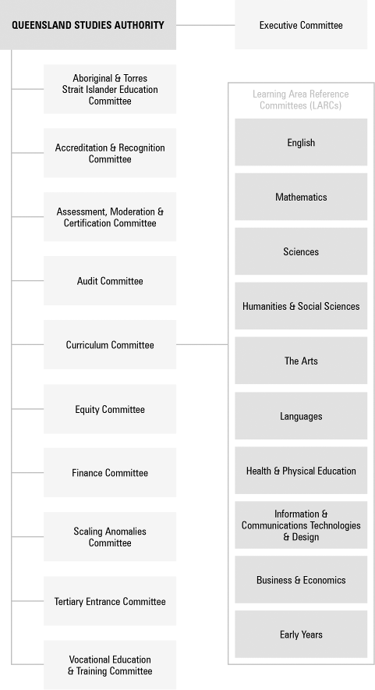

Organisational structure
The organisational structure of the QSA, as at June 2012, is shown below. Members of the key corporate governance committee of the QSA are listed in Appendix 3.
QSA’s central office is located at 154 Melbourne Street, South Brisbane. The QSA had 247.2 full-time equivalent staff as at June 2012, based mostly at the central office. The remainder work in 13 district offices across Queensland (district office contact details are listed in Appendix 5). Positions are filled through a mix of permanent and temporary appointments, and secondments. Staff are employed directly by the Authority as part of the Education, Training and Employment portfolio.
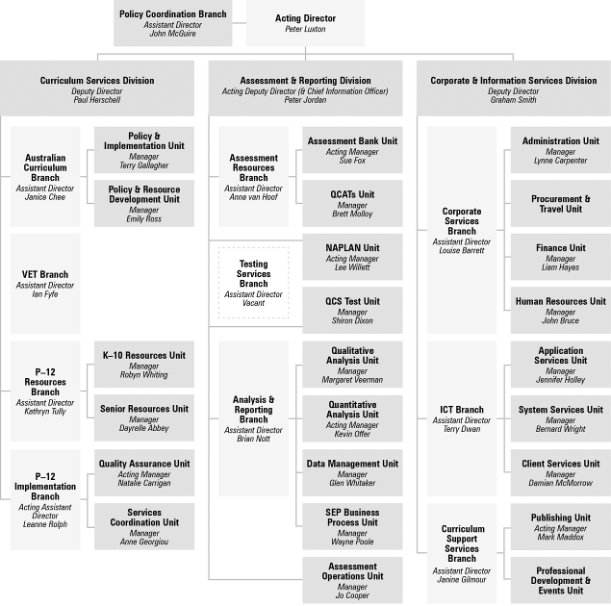

Strategic Plan 2011–15

Planning and objectives
The Strategic Plan 2011–15 refined the objectives and strategies of the Strategic Plan 2010–14, taking into account the strategic direction and policy focus of the government and progress achieved against current strategies. The plan will guide the work of the QSA and provide the framework for its operational planning in a context of significant state and national developments in education.
QSA’s work supports the Queensland Government’s objective to revitalise front line services for families by assisting teachers to develop high quality curriculum for the classroom. To support this, our strategic objectives focus on providing:
- innovative syllabuses and supporting products that assist schools to prepare young people for life and work in the 21st century
- assessments and other resources that enable students to demonstrate achievement and provide useful information for teachers, parents and other stakeholders
- efficient and effective delivery of our products and services.

Performance against objectives
A summary of achievements is presented on page 3. Performance against priorities identified in the plan is detailed throughout the report.

Challenges and future priorities
QSA’s main challenge is to continue to adapt its products and services in line with education policy changes, in Queensland and nationally.
QSA has identified priorities to assist teachers and school communities to deliver the best educational outcomes for students. These include:
- working closely with our education partners to ensure the transition to the Australian Curriculum continues to progress smoothly
- continuing to provide schools with resources and support to enable teachers to confidently implement the Australian Curriculum
- providing resources and support to assist implementation of the Queensland kindergarten learning guideline in childcare centres
- implementing the recommendations of the Queensland Certificate of Education and the Queensland Core Skills Test periodic reviews
- assisting more students to become eligible for a Queensland Certificate of Education
- increasing Year 12 completion rates
- collaborating with the Australian Skills Quality Authority (ASQA) and schools to successfully transition to the new national regulatory arrangements for vocational education and training
- contributing to the review of QSA legislation and operations to better position the organisation for the future.

Program review

Syllabus development and implementation
During 2011–12, the QSA continued to develop its vision of an innovative and future-focused Kindergarten (K)–12 education framework based on:
- syllabus design principles and elements that create the conditions for teachers to shape a curriculum that meets the needs of their students
- phases of learning with a specific developmental focus
- syllabus content that focuses on the expected learning and sets the parameters for the intended curriculum
- assessment, standards and consistency that show how standards-based, school-based assessment is integral to the teaching and learning process.
A survey of education stakeholders showed that 93% were satisfied with the syllabuses and support materials that the QSA developed in 2011–12. This is a 7% increase on 2010–11 and a 10% increase on 2009–10.

Transition to the Australian Curriculum

The QSA is working with its education partners to ensure a smooth transition to the Australian Curriculum and promote the best interests of Queensland schools.
QSA’s partnership with the school sectors is coordinated through the Transition to Australian Curriculum Steering Committee, which provides a structure for ensuring Queensland schools receive consistent and timely information about the new curriculum. As an activity of the committee, the QSA developed an agreed implementation plan and Prep (P)–12 work plan that addresses:
- guidelines and advice
- resource development
- professional development
- communication
- ICT infrastructure.

Curriculum development
QSA’s key curriculum development activities have included:
- providing advice about P–12 curriculum content, achievement standards, assessment and implementation strategies to inform Queensland’s position at national and state meetings
- developing coordinated Queensland responses to
  - draft initial and final shape papers for general capabilities, cross-curriculum priorities, Health and Physical Education, Technology, Civics and Citizenship and Business and Economics
  - draft curriculum materials for Geography, The Arts, the general capabilities, cross-curriculum priorities and students with disability
- coordinating participation of Queensland teachers and curriculum specialists in national forums, national panels and Australian Curriculum, Assessment and Reporting Authority (ACARA) advisory committees
- coordinating Queensland participation in ACARA projects including:
  - the national work samples project
  - the intensive engagement with senior secondary Australian Curriculum
  - trial school engagement with The Arts and curriculum materials for students with disability
- coordinating a Queensland response to 14 senior secondary subject drafts.

Queensland’s position
Guidelines and advice have been developed to give an agreed Queensland position on:
- P–2 curriculum, assessment and reporting
- implementation of History
- the position of Studies of Society and Environment
- Year 7 in 2012 and 2013
- entitlement P–10 and advice to support curriculum planning in Year 10.
Consultation papers have been published on:
- reporting student achievement and progress
in P–10
- assessment advice and guidelines in P–10
- learning area standards descriptors (LASDs) to support assessment and reporting on English, Mathematics, Science and History, including audiovisual professional development materials to assist teachers to use the LASDs
- planning with the general capabilities and cross-curriculum priorities
- activities to embed Aboriginal and Torres Strait Islander history and cultures as a cross-curriculum priority.

Resource development
Resources have been developed with the school sectors and classroom teachers, and published on the QSA website, including:
- year level and unit overview planning templates for History
- exemplars for P–10 History to demonstrate the application of the templates
- exemplars for multiple year level planning for
P–7 Science
- detailed mapping of the Australian and Queensland curriculums for History
- P–10 Literacy and Numeracy indicators aligned to the Australian Curriculum general capabilities
- Year 1 Checkpoints assessments and associated resources
- example literacy and numeracy short assessments for Years 2–7
- Agricultural Education Course Advice and Elaborations for Year 7–10 Science
- information statements and templates to support catering for diversity.

Professional development
Professional development activities included:
- delivering 106 workshops for more than 2500 teachers
- providing sessions by invitation from professional associations, school clusters and administrator’s groups
- developing online modules
- facilitating Queensland forums and workshops with stakeholders to support ACARA consultation;
in July 2011, a two-day workshop assisted ACARA with its revision of the F–10 achievement standards.

Communication
Communication activities included maintaining an online discussion forum, and publishing a regular e-newsletter.

OUTLOOK FOR 2012–13:
Transition to the Australian Curriculum
The QSA will:
- continue to provide strategic advice to inform Queensland’s position on the development and finalisation of the P–12 Australian Curriculum content and achievement standards
- develop and revise guidelines and advice to reflect Australian Curriculum learning areas as they are approved including:
  - Studies of Society and Environment (SOSE) and Geography
  - senior secondary position paper
  - P–2 planning for teaching and learning, assessment and reporting for 2013
  - Year 7
  - assessment advice and guidelines in P–10
  - reporting student achievement and progress
in P–10
  - working with the general capabilities
- develop resources including:
  - exemplars for other Australian Curriculum learning areas as they are approved
  - multiple year level exemplars for History and other learning areas as they are approved
  - mapping Australian Curriculum to Queensland curriculum in learning areas as they are approved
  - revising assessment resources that support the application of the Australian Curriculum achievement standards in classroom practice following the validation process
- provide professional development including:
  - workshops for teachers focusing on disciplinary learning and assessment
  - online modules
- provide timely, consistent and accurate information to a range of stakeholders including:
  - maintaining the Australian Curriculum latest
e-newsletter
  - maintaining the online discussion forum
  - providing stakeholder forums.

Kindergarten — Year 10 resources

Queensland kindergarten learning guideline (QKLG)
The QSA has continued to develop online professional development resources and delivered 26 training workshops to support implementation of the QKLG in kindergartens and childcare centres.

Lower Secondary Subject Area Guidelines
The Lower Secondary Subject Area Guidelines provide practical planning advice for schools developing courses of study for Years 8–10 using the Essential Learnings and the Year 10 Guidelines learning statements. Guidelines were finalised for:
- Business
- Home Economics
- Design and Technology.

OUTLOOK FOR 2012–13:
Kindergarten — Year 10 resources
The QSA will:
- develop further resources to assist schools implementing the Australian Curriculum
- continue to develop online professional development resources and deliver teacher professional development workshops supporting the QKLG
- develop further resources to support literacy and numeracy learning in K–10.

Aboriginal and Torres Strait Islander perspectives

The QSA is working to increase awareness of Indigenous perspectives and improve outcomes for Indigenous students in Queensland schools. Embedding Indigenous perspectives into our organisational environment, products and services is the key to achieving these aims.
The QSA has developed a suite of resources to support the implementation of the P–10 Aboriginal and Torres Strait Islander Languages Syllabus. The resources support teachers and community members in the maintenance, revival and development of Aboriginal and Torres Strait Islander languages and build respect for local histories and culture.
The QSA has sought expressions of interest from schools to trial the Aboriginal and Torres Strait Islander Languages Senior Syllabus from 2013. The syllabus will enable students to study the languages associated with their own communities and locations.

OUTLOOK FOR 2012–13: Aboriginal and Torres Strait Islander perspectives
The QSA will:
- continue to support school communities wishing to implement the P–10 Aboriginal and Torres Strait Islander Languages syllabus
- support the trial of the Aboriginal and Torres Strait Islander Languages syllabus for Years 11–12
- embed Aboriginal and Torres Strait Islander perspectives in QSA products and services.

Senior curriculum resources

Senior syllabuses
Quality assurance processes continue to be developed and refined for the periodic revision of senior syllabuses. These processes provide schools with quality senior syllabuses and support resources, and improve consistency across syllabuses. Recent refinements include:
- a consistent format for design briefs that describe the scope of syllabus revisions
- expanded consultation processes, such as focus groups at two key points in the revision process
- a revised syllabus template that more closely reflects the principles of informed prescription and informed professionalism.

Current periodic revisions of
senior syllabuses
Queensland’s senior syllabuses are revised on a six-year cycle to ensure currency and relevance. Eight syllabuses for Authority subjects are currently being revised:
- Agricultural Science
- Business Organisation and Management
- Drama
- Graphics
- Legal Studies
- Marine Studies
- Music
- Technology Studies.
English for ESL Learners Senior Syllabus continues in extended trial, as a similar course is being developed as part of the Australian Curriculum.

Syllabus revisions completed
Eight syllabus revisions were completed. This included the publication of syllabuses and support resources and delivery of workshops to support implementation.
Seven syllabuses for Authority subjects were revised:
- Aerospace Studies
- Business Communication and Technologies
- Chinese Extension
- English Extension
- Hospitality Studies
- Information and Technology Systems
- Study of Society.
One Authority-registered subject syllabus was revised:
- Science in Practice (previously named Science Study Area Specification).
The average cost for each syllabus revision in
2011–12 was $93 181.

OUTLOOK FOR 2012–13:
Senior curriculum resources
The QSA will:
- continue revision of the senior syllabuses in Agricultural Science, Business Organisation and Management, Drama, Graphics, Legal Studies, Marine Studies, Music and Technology Studies
- plan the redevelopment of the suite of Study Area Specifications
- commence the revisions of Study Area Specifications
- develop and implement a Punjabi language syllabus.

Testing and assessment
The QSA works in partnership with school communities to support assessment practices across Prep to Year 12.
QSA also works with students, principals, teachers and parents to build greater understanding of test results and their use in improving student performance.

Prep–Year 10

Year 1 Literacy and Numeracy Checkpoints Assessments
Year 1 Literacy and Numeracy Checkpoints Assessments have been developed by QSA to provide teachers with assessment resources for monitoring children’s progress and making judgments about their achievement of targeted P–3 literacy and numeracy indicators. These assessments have been aligned to the Australian Curriculum and added to the Assessment Bank as a resource for teachers.

Literacy and Numeracy Indicators
Literacy and Numeracy Indicators describe expected learning in literacy and numeracy for students from Prep to Year 10. They support planning for teaching, learning, assessment and monitoring across all key learning areas.
The indicators have been aligned to the Australian Curriculum and a range of short literacy and numeracy assessment resources for Years 8 and 9 have been developed in response to feedback from principals.
The 18 short assessments developed focus on specific literacy and numeracy skills within learning areas, and provide practical resources and example strategies to embed the monitoring and assessment of literacy and numeracy skills across the curriculum.

National Assessment Program — Literacy and Numeracy (NAPLAN)
The NAPLAN tests are designed to assess the skills of Australian students in literacy and numeracy by:
- collecting data from the population of Years 3, 5, 7 and 9 students for reporting to parents/carers and schools and for systemic reporting
- assessing students against national minimum standards.
The 2012 NAPLAN tests were held in May for all students in Australia in Years 3, 5, 7 and 9.
The QSA successfully coordinated the administration, marking and reporting of NAPLAN for more than 218 000 students in Queensland within the agreed time frames.
This is 12 000 fewer students than in 2011 as there was only a half-cohort intake of Prep students in 2007.
In a survey of school principals, 94% rated QSA’s communication materials for NAPLAN as “good” or “very good”.
The average cost of developing and issuing the NAPLAN report was $35 per student.

Queensland Comparable Assessment Tasks (QCATs)
The QCATs provide evidence of what students know, understand and can do in relation to a selection of Australian Curriculum content and achievement standards for English, Mathematics and Science in Years 4, 6 and 9.
Three QCATs were implemented by schools in 2011. These tasks were developed by the QSA with common requirements and parameters and were marked according to a common guide for making judgments.
The 2012 QCATs were specifically developed to align with Australian Curriculum exemplars produced by the QSA. Queensland teachers were involved in the quality assurance processes and trialling of the 2012 QCATs.

Assessment Bank
The Assessment Bank is an online collection of assessments and resources linked to the current curriculum. About 35 800 educators are registered users — an increase of about 5700 on 2010–11.
The Assessment Bank was launched in 2008 with 560 assessment and resource items covering all Years 1–9 key learning areas (KLAs). It now has more than 1200 items.
Over the past year, assessment packages have been developed for English, Mathematics and Science to support the implementation of the Australian Curriculum in these subjects. History packages are currently being created to support the implementation of the History Australian Curriculum in Queensland schools in 2013.
Teachers across Queensland and from all school sectors have worked with the QSA to develop and quality assure these assessment packages.

Years 11–12

Queensland Core Skills (QCS) Test
The QCS Test assesses candidates in the common curriculum elements of Authority subjects and contributes scaling data for the calculation of Overall Positions (OPs) and Field Positions (FPs) for tertiary entrance.
Table 3 shows a breakdown of candidates who sat the 2011 QCS Test. Table 4 shows the distribution of grades awarded, both by gender and overall.
Table 3: 2011 QCS Test candidates
Total | 29258
OP-eligible | 25444
OP-ineligible | 2882
Equivalent eligible | 859
Equivalent ineligible | 33
Sat but not certificated | 40
Table 4: 2011 QCS Test grades
Grade | Overall | Female | Male
Total # | 29218 | 16239 | 12979
A | 15.89% | 12.72% | 19.86%
B | 27.63% | 25.39% | 30.43%
C | 34.49% | 37.48% | 30.76%
D | 20.71% | 23.24% | 17.54%
E | 1.28% | 1.16% | 1.42%
Total % | 100.00% | 55.58% | 44.42%

Senior External Examination
The QSA conducts a series of senior subject examinations at locations across Queensland in October and November each year. These examinations are for people who are not senior students in Queensland secondary schools or for Year 12 students unable to access particular subjects at their school.
Twenty-one subjects were offered at the 2011 Senior External Examination, with seven language subject examinations borrowed from interstate curriculum authorities under the Collaborative Curriculum and Assessment Framework for Languages (CCAFL) arrangements. In total, 1181 candidates nominated and 1005 sat the examinations.

Externally moderated school-based assessment
Queensland’s system of externally moderated school-based assessment in Years 11 and 12 is a highly regarded model for the quality assurance of educational standards. Senior students are taught and assessed by their teachers in accordance with the requirements of Years 11–12 syllabuses. The QSA works in partnership with schools to maintain and improve this system. Our achievements in 2011–12 include:
- hosting the annual moderation conference for approximately 700 state review panellists and district review panel chairs
- training review panels
- conducting random sampling of student exit folios
- moderating over 110 000 student assessment folios
- coordinating moderation meetings for Authority-registered subjects.

OUTLOOK FOR 2012–13: Testing and assessment
The QSA will:  - work with DETE to provide feedback to the national testing authority about potential test items, test protocols and test administration issues relating to NAPLAN tests  - administer NAPLAN tests to all Queensland students in Years 3, 5, 7 and 9  - provide an in-depth analysis of NAPLAN test items to assist teachers to interpret data from NAPLAN results  - develop and administer the QCS Test for eligible Year 12 students  - develop and administer senior external examinations for non-school candidates and school students who are unable to access those subjects in their school  - continue to develop assessment items in the Assessment Bank, aligned with the content descriptors and achievement standards in the Australian Curriculum  - continue to provide a facility for data analysis of NAPLAN, the QCS Test, OPs and FPs and  Year 12 outcomes | - evaluate and refine all processes involved in NAPLAN tests and the QCS Test  - check Subject Achievement Indicators allocated by schools for Authority subjects in Year 12  - promote statewide standards of learning and assessment through online assessment materials for Authority and Authority-registered subjects  - provide strategic direction on standards-based assessment and external moderation of school-based assessment through the online assessment hub for Authority subjects  - maintain high quality moderation processes for Authority subjects by revising panel training packages and developing a school moderator package to assist teachers in performing their role in the moderation system  - refine procedures and support materials for quality assurance of Authority-registered subjects  - facilitate initiatives to improve the quality of advice for schools on standards of learning and assessment through the training of review panels at the annual moderation conference.

Certification and tertiary entrance

Senior Education Profile (SEP)
In 2011, the QSA issued Senior Education Profiles (SEPs) and Senior Statements to 47 209 students who completed Year 12. A total of 39 582 students were awarded a Queensland Certificate of Education (QCE), about 2350 more than in 2010. Of these students, 26 815 received a Tertiary Entrance Statement. This was achieved within the agreed government time frames, as has been the case each year since the QSA assumed responsibility for certification in Queensland in 2002.
The quality of QSA’s certification processes is evident from these statistics:
- the QCE-eligibility status of only 0.4% of all learners changed following requests for verification or review of results
- only three OPs (or 0.01%) were required to be changed following official appeals by students, down from six the previous year.
The average cost of developing and issuing SEPs was $254 per student.
The average cost of providing tertiary entrance and pathways information programs (which included the Queensland Core Skills Test, calculation of Subject Achievement Indicators and career advice) was $8 per student.

Queensland Certificate of Education (QCE)
The QCE is Queensland’s senior schooling certificate. It is awarded to eligible students when they complete the senior phase of learning, usually at the end of Year 12.
The QCE provides pathways to work, further education and training by recognising a broad range of learning options and offering flexibility in what is learnt, as well as where and when that learning occurs. Learning options can include senior school subjects, vocational education and training, workplace and community learning, and university subjects undertaken while at school.

Learning accounts
The QSA continues to work with learning providers to promote the online student learning account as a useful tool for students to personally monitor their progress towards the QCE. The learning account records what, where and when a student learns, and the results achieved.

Student Connect

www.studentconnect.qsa.qld.edu.au
The Student Connect website gives senior students access to their learning account and results, as well as information and links for exploring post-school education, training and career pathways.

Queensland Certificate of Individual Achievement (QCIA)
The QCIA recognises and reports the individualised learning achievements of students with special needs who have completed at least 12 years of schooling. The QCIA ensures that the educational achievement of all students can be recorded.
In 2011, the QSA issued 660 QCIAs to students from 179 schools.

Equivalency of non-Queensland qualifications
The QSA provides Education Statements for school qualifications that have been awarded by recognised interstate or overseas institutions. The statements give the Queensland secondary school level equivalent of submitted qualifications.
In 2011–12, the QSA received and processed 111 equivalency applications for qualifications from 33 countries. Equivalency assessments are provided for employment and recruitment purposes.

2011 Year 12 outcomes report
On behalf of the Queensland Government, the QSA publicly reported a range of Year 12 student outcomes data. For each school, the report includes:
- information on the number of students awarded certificates and qualifications
- the proportion of Queensland Tertiary Admissions Centre applicants receiving a tertiary offer
- the number of students who received OPs in bands 1–5, 6–10, 11–15, 16–20 and 21–25
- the number of students receiving VET certificates at various levels.
The QSA worked closely with schools to ensure the accuracy of the data, and to communicate the implications of the data to school communities.

OUTLOOK FOR 2012–13:
Senior Education Profile
The QSA will:
- continue to implement the approved recommendations of the periodic review of the QCE
- continue to promote the QCE and work with stakeholders to maximise learning opportunities for students
- develop resources to support schools to make optimum use of Student Connect
- evaluate all processes involved in providing Tertiary Entrance Statements
- provide ongoing support for the implementation of the QCIA by training QCIA advisors in policies and protocols
- continue to provide a facility for data analysis of Year 12 outcomes.

Vocational education and training (VET)

The QSA registers schools as registered training organisations (RTOs) to Australian Qualifications Framework Certificate IV level (except declared Apprenticeship Certificates III). This registration function is performed under delegation 39 from the Training and Employment Recognition Council.
The QSA also provides advice to schools on becoming an RTO and implementing selected qualifications from National Training Packages. This advice is provided through a range of modes, including workshops, memos, newsletters and telephone calls.
Strong VET participation by schools is contributing to the achievement of the Queensland Government’s target to reduce unemployment in Queensland to 4% over the next 6 years.

School audits
As part of the registration process, schools are audited by QSA for compliance with the Australian Quality Training Framework Essential Conditions and Standards.
In the past year, the QSA has conducted 72 site audits (including three combined audits with DETE staff and 18 desk audits) and 111 document reviews.

Registration activity
In the past year, the QSA processed 1483 registration activities for the 370 schools registered as RTOs. This fourfold increase in registration activities was due to implementation of new training packages and accredited courses.

VET and the QCE
The QSA continued to work with the State Training Agency Clearinghouse to ensure accurate banking of VET achievements from non-school RTOs. The QSA also banked student VET achievements gained at schools in other states.

VET data quality
The QSA conducted workshops with school RTOs to assist them in improving their reporting of student VET achievement.

National collaboration
The QSA and fellow members of the Australasian Curriculum, Assessment and Certification Authorities (ACACA) continued working together on a range of common issues relating to VET in schools.

National VET regulator
In April 2011, the National Vocational Education and Training Regulator Act 2011 established the Australian Skills Quality Authority (ASQA).
ASQA will take over certain state and territory VET registration and accreditation functions from those states and territories that refer their powers to the Commonwealth.
Legislation was passed by the Queensland Government on 21 June 2012 referring its VET registration powers to ASQA from 1 July 2012.
The QSA has worked with DETE and ASQA to facilitate a smooth transition to the new arrangements.

OUTLOOK FOR 2012–13: VET
The QSA will:
- secure a delegation from ASQA to register schools as RTOs
- monitor the impact of ASQA on the QSA and Queensland school RTOs
- continue to guide schools that are RTOs or seeking to become RTOs in complying with the
VET Quality Framework
- work according to the VET Quality Framework to:
  - register schools as RTOs, including those seeking to add to their scope of registration
  - renew registration of schools that are RTOs
- work with DETE staff to improve the quality of VET data reported by RTOs
- work with school RTOs to improve the quality of their VET data
- work with other states and territories through ACACA on issues of common interest
- work with school sectors on the implementation
of National Trade Cadetships.

Corporate support and communication
Corporate support functions have a key role in developing the governance framework of the QSA and leading the development and implementation of effective resource management and capability development strategies.
Effective communication and partnerships with schools, industry, academia and the community ensure that the QSA’s products and services meet the needs of stakeholders.
The QSA continues to develop its consultative structures and uses a range of approaches to build partnerships and share information with these groups.

Shaping teaching and learning: The assessment factor
The QSA held its annual conference in Brisbane on
26–27 April 2012. Over 1500 delegates attended, representing more than 700 organisations including about 400 Queensland schools. The conference theme focused on assessment, its role in the teaching and learning process, and as a vital element of teachers’ professional practice. The conference remains the only event of its type in the country for educators across
K–12. Its aim is to create a stimulating environment where teachers, principals, national and international education experts and sector administrators come together to focus on enhancing educational practice.

Leadership in Education Forum
The Leadership in Education Forum, co-hosted by QSA and the Queensland Education Leadership Institute (QELi), comprised part of the QSA annual conference.
The forum explored the concept of a learning society and challenged school leaders to draw innovation from across society and apply it in schools. More than 300 principals and deputy principals heard presentations from education experts and researchers and shared ideas with their peers.

Consultation mechanisms
Ten committees provide advice to the QSA Governing Body to ensure its decision making is well informed. These committees are an important part of the consultation framework that assists the QSA to develop high quality products and services for all Queensland teachers and students.
Reference groups of principals from special needs, primary, P–12 and secondary schools provided a formal structure for sharing information and perspectives on key initiatives and emerging issues. Typically, these groups meet twice each year. The meetings focused on the Australian Curriculum, and support required by schools to ensure teachers can confidently implement the new curriculum.
The QSA held focus group meetings with principals in 15 locations across the state to provide an opportunity to discuss key education issues. These discussions also allowed the QSA to seek feedback on ways to improve its products and services and to help schools improve learning outcomes.

Professional development workshops
During 2011–12, the QSA delivered more than 260 workshops to about 7000 teachers and school and curriculum leaders to support the introduction and implementation of curriculum, assessment and reporting initiatives across K–12. Participants at workshops received certification appropriate for registration renewal based on the standards of the Queensland College of Teachers’ Continuing Professional Development Framework.
The QSA organised 56 presentations in response to requests for professional development services from clusters of schools and professional associations. Topics included Australian Curriculum, assessment, literacy and numeracy, VET and a range of subject areas.
We continued to support DETE’s professional development program by providing presentations on connecting curriculum and assessment using the literacy and numeracy indicators.
Annually more than 90% of participants express satisfaction with QSA’s workshop program.

Briefing for education academics
The QSA hosted its annual briefing for more than 50 academics involved in teaching pre-service education students. The briefing encouraged professional conversations and information sharing about the implementation of Australian Curriculum standards and assessment, and QSA products and services.

Careers markets
The QSA provided advice for students, parents, and prospective tertiary applicants at the Tertiary Studies Expo (TSXPO) careers fair in Brisbane.

Enquiry service
The QSA maintained its toll-free Student Connect service for students, parents/carers and school staff.
During the 2011 release of the Senior Education Profile (SEP) and the 2011–12 tertiary admissions offer round, the QSA operated its SEP Hotline to assist with student certification queries.
Between 19 December 2011 and 9 January 2012, the QSA received about 890 enquiries relating to certification and post-school options. This was significantly fewer than in previous years, as students are now able to access their results and other information in their online learning account, and the QSA has been proactive in communication with students prior to the release of the SEP.

Publications
Regular publications produced by the QSA for stakeholders include:
- QSA Connect, a fortnightly email newsletter that updates more than 12 500 subscribers about QSA initiatives, professional development activities and events
- QSA Focus, an email bulletin for Queensland teachers. It shares relevant and timely information about key education issues and is distributed periodically. With only one article per issue, QSA Focus provides detailed information and resources designed to add value to teachers’ everyday work
- NAPLAN, a monthly online bulletin keeping schools informed about processes and procedures for the National Assessment Program — Literacy and Numeracy tests
- Australian Curriculum latest, an online bulletin providing information and advice to all Queensland schools about the transition to the Australian Curriculum
- Student Connect (formerly Exit Lines), a magazine published twice a year, providing Year 12 students with news, study tips and information about their studies and further education, training and career pathways
- VET Update, a quarterly update about practical aspects of VET in schools for VET coordinators
and principals
- memos, timely online advice to schools about important QSA information.

Information and communications technology (ICT)
Efficient ICT systems are essential to ensure the delivery of the QSA’s strategic initiatives and to support the delivery of accurate and timely data to schools, teachers, students and other stakeholders, particularly for testing and senior certification programs.

Senior Learning Information Management System (SLIMS)
Consolidation work continued on the SLIMS application, which registers young people working towards the QCE and records information about their enrolments and results.

Event Management System
An Event Management System was developed during 2011–12 to streamline the planning and delivery of QSA events including workshops, seminars and professional development sessions for teachers.

ICT governance
The QSA’s ICT Strategic Plan guides development, investment and maintenance decisions relating to QSA’s ICT systems.

OUTLOOK FOR 2012–13: ICT
The QSA will:
- support and advise schools about student enrolment rules and regulations for senior certification
- redevelop the Student Data Capture System (SDCS) subject to funding approval
- develop and implement enhancements to SLIMS
- replace ageing computer hardware associated with the delivery of the QCE
- support and maintain all QSA corporate application systems
- assist QSA business units to identify, scope and implement system improvements
- support the development and maintenance of the QSA website.

Workforce planning, attraction and retention
In 2011–12, the QSA was staffed by 247.2 full-time equivalent staff. The permanent retention rate during this period was 92.5% and the permanent separation rate was 7.5%.
The QSA Workforce Planning Framework provides an overarching structure for strategic human resources initiatives. It outlines a series of ongoing strategies designed to ensure the organisation recruits, develops and retains high performing, responsive and engaged staff. Key initiatives include:
- continuing the QSA’s flexible workplaces opportunities
- continuing to implement the Professional Development Strategy to provide learning, development and career opportunities for staff
- implementing enhanced recruitment and selection processes
- providing quality corporate and local induction programs
- supporting current and aspiring leaders
- supporting performance management and employee engagement through the Engaged Workplaces program.

Governance achievements
The QSA has undertaken a range of initiatives aimed at ensuring its sustainability and compliance with legislative requirements. These include:
- maintaining and promoting the Corporate Governance Framework to support the effectiveness of QSA’s corporate governance activities
- engaging the Department of Education, Training and Employment (DETE) to provide internal audit services (financial compliance and performance audits)
- continuing to review the strategic risk assessment and ensuring risk minimisation or mitigation actions are in place
- developing the 2011–12 operating and capital budgets to support strategic priorities and accountabilities
- continuing to improve internal reporting systems
- implementing the QSA Corporate Procurement Plan in accordance with State Procurement Policy requirements to strengthen purchasing in the QSA
- monitoring and reviewing the Financial Management Improvement Framework to articulate explicit links between improvement initiatives and operational activities
- continuing to conduct business process review exercises to ensure the currency, accuracy and relevance of procedures and to identify opportunities for process improvement
- aligning business units to deliver QSA strategic priorities and projects
- monitoring QSA corporate and management performance against branch operational plans and performance accountabilities for managers and branch budgets.

Advice and compliance
During 2011–12, the QSA provided advice on administrative, financial, human resource, service improvement and publishing issues that influenced the performance of the organisation. This included reviewing, developing, improving and implementing policies and procedures to ensure that the QSA’s corporate service-related activities complied with whole-of-government legislation, policies and directives.
Every year the QSA is audited internally and externally. The internal audit was performed by DETE’s Internal Audit Unit, and the external audit was performed by Prosperity Advisers Pty Ltd, a contractor of the Queensland Audit Office. There were no significant issues arising from either the internal or external audits in 2011–12.
The QSA also engaged DETE’s Internal Audit Unit to undertake an independent examination of all activity associated with the calculation and reconciliation of costs involved in the QSA’s administration of the NAPLAN tests. Internal Audit found QSA’s processes to be sound.

Audit and risk management
The QSA has an Audit Committee, whose charter is consistent with the Queensland Treasury Audit Committee Guidelines. Its membership, duties and responsibilities are listed in Appendix 4.
The QSA’s internal audit plan was informed by its strategic plan, operational plan, and strategic risk assessment.

Delegations
During 2011–12, the QSA reviewed and endorsed all financial, procurement, and human resource management activities in accordance with their delegations. These were subject to the Financial Accountability Act 2009 and Financial and Performance Management Standard 2009.

Workplace ethics
The Public Sector Ethics Act 2004 has been amended by the Public Sector Ethics Regulation 2010. The Code of Conduct is now shaped around the four key ethical principles contained in the amended Act to guide ethical decision-making and behaviour. The ethical principles are:
- integrity and impartiality
- promoting the public good
- commitment to the system of government
- accountability and transparency.
The Code of Conduct is published on the QSA website. All QSA employees undergo education and training about the Code of Conduct — which includes the application of ethics principles and obligations of public officials — at induction and annually throughout their employment.

Information
Information provision is undertaken by the QSA in accordance with Sections 13–15 and 17 of the Education (Queensland Studies Authority) Act.

Copies of certificates
As outlined in Part 7 of the Education (Queensland Studies Authority) Regulation 2002, certified copies of certificates issued by the QSA were provided on request to those who had previously been awarded a Junior Certificate, Senior Certificate, Queensland Certificate of Individual Achievement, Queensland Certificate of Education and/or Tertiary Entrance Statement.

Right to Information
The QSA received no applications under Right to Information provisions but processed 11 applications under the Information Privacy Act 2009.

OUTLOOK FOR 2012–13:
Corporate support and communication
The QSA will:
- monitor the strategic risk assessment and risk management plan
- improve the quality management systems that support delivery of core products and services,
and coordinate the development of quality plans for new products and services
- implement financial resources for strategic and operational products and services
- monitor the Financial Management Practice
Manual to support consistent business practice and ensure compliance with the Financial Accountability Act 2009 and subordinate legislation
- continue to review and implement the Financial Management Improvement Framework
- continue to build staff capability to develop and deliver high quality educational products and services
- monitor the Engaged Workplaces initiative to ensure it continues to foster a productive and engaged environment and promotes effective performance management
- conduct mandatory annual ethics training for staff
- continue to refine recruitment and selection processes
- continue to review corporate services policies to support quality corporate governance
- conduct further business process improvement exercises to identify areas for improvement and ensure efficiency of procedures
- continue to improve the quality of records-management practices across the QSA through electronic record keeping
- continue to conduct training for new and existing QSA managers to ensure familiarity and compliance with corporate policies
- monitor implementation of the Professional Development Strategy.

Financial report 2011–12

Contents
Statement of comprehensive income 26
Statement of financial position 27
Statement of changes in equity 28
Statement of cash flows 29
Notes to and forming part of the financial statements 30
Certificate of the Queensland Studies Authority 46
Independent auditor’s report 47

General information
This financial report covers the QSA.
The QSA is a statutory body established under the Education (Queensland Studies Authority) Act.
The QSA is controlled by the State of Queensland, which is the ultimate parent.
The QSA’s central office and principal place of business is:
154 Melbourne Street
South Brisbane QLD 4101
A description of the nature of the QSA’s operations and its principal activities is included in the notes to the financial statements.
For information in relation to the QSA’s financial report, please call (07) 3864 0222, email finance@qsa.qld.edu.au or visit the QSA website: www.qsa.qld.edu.au.
Amounts shown in this financial report may not add to the correct subtotals or totals due to rounding.

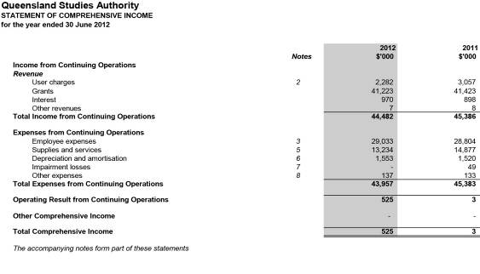

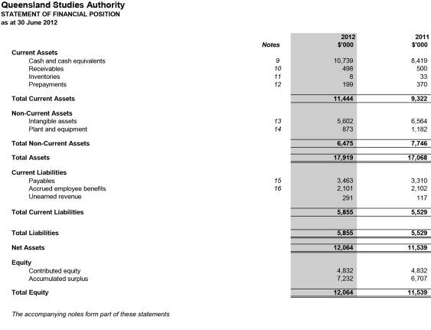

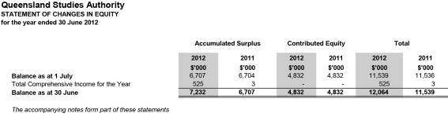

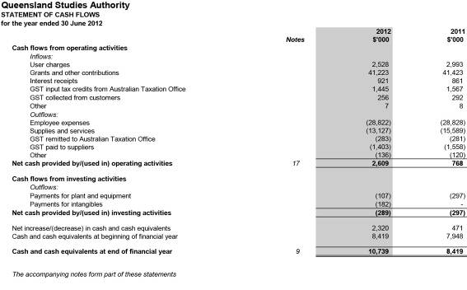

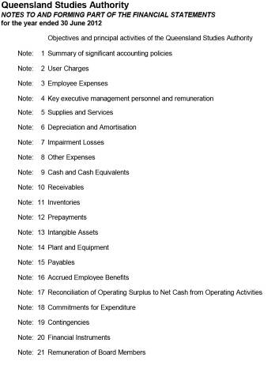

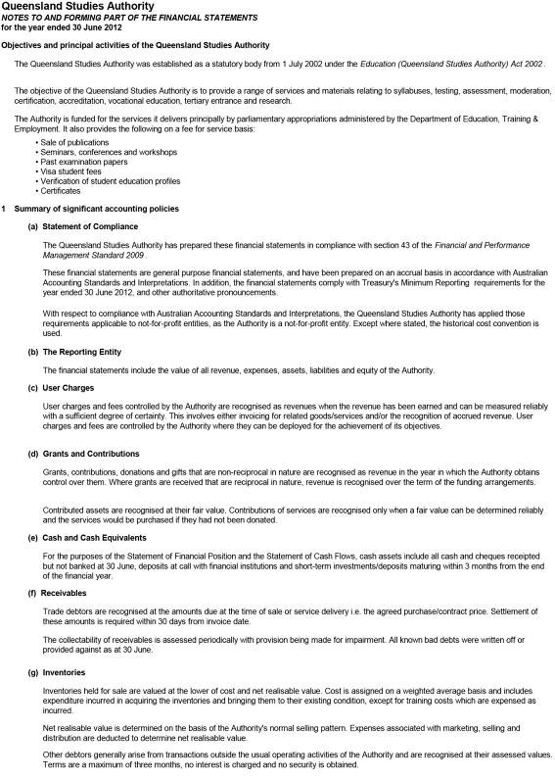

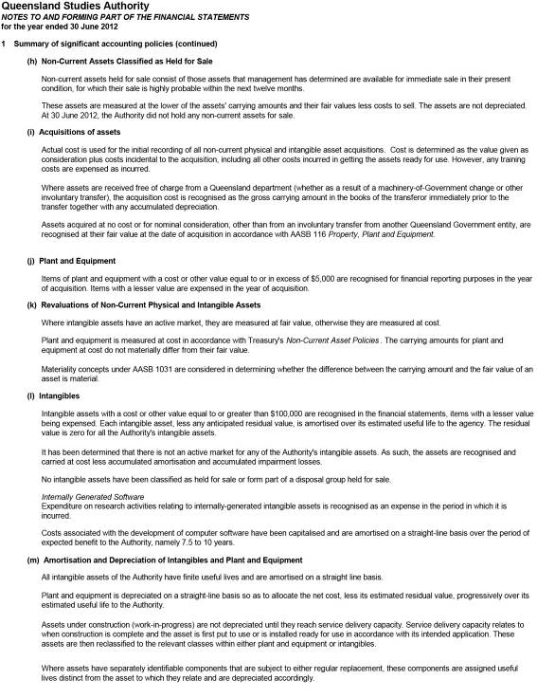

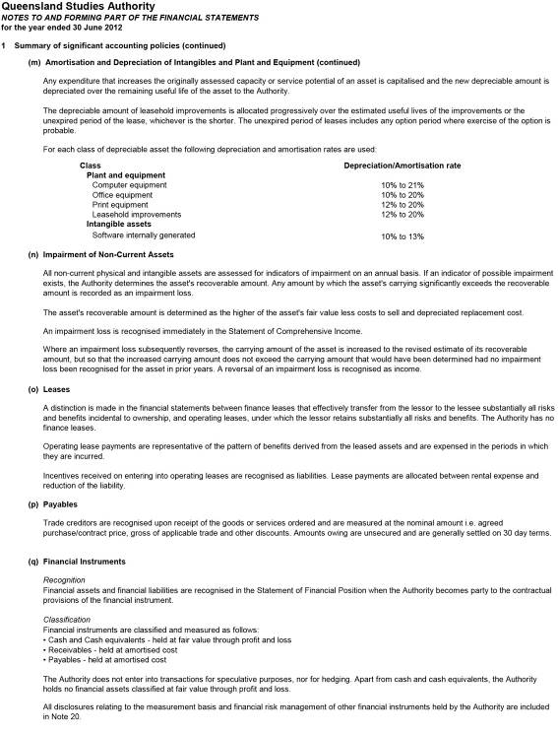

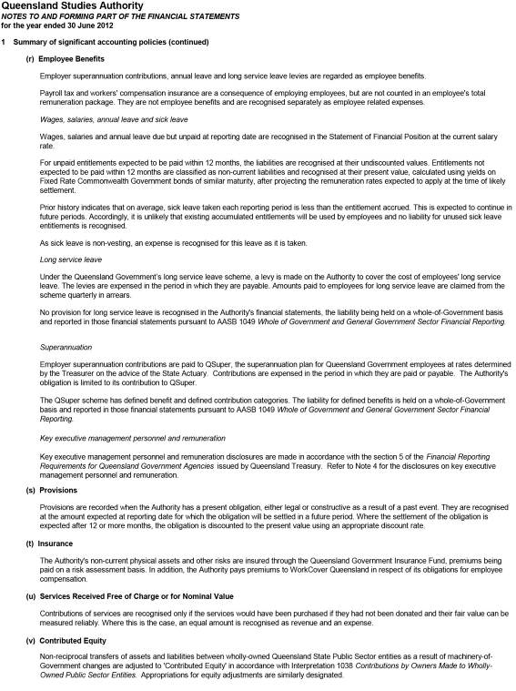

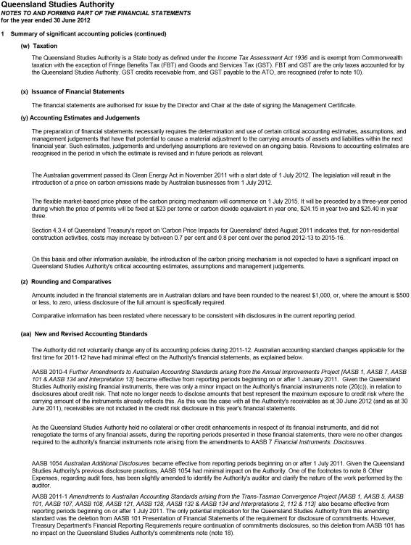

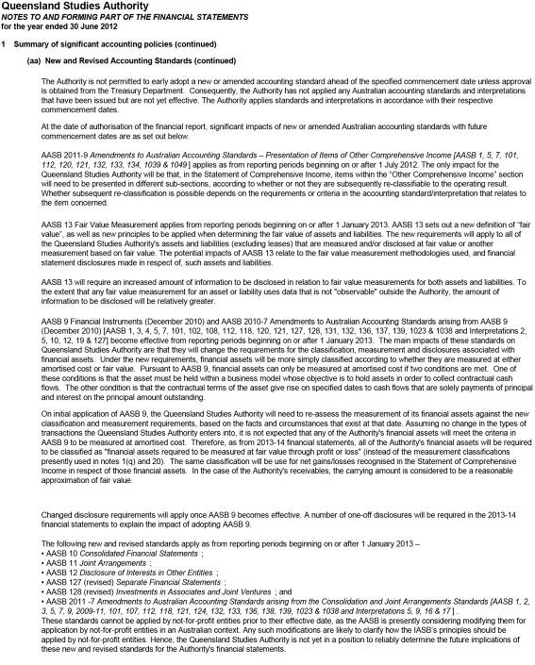

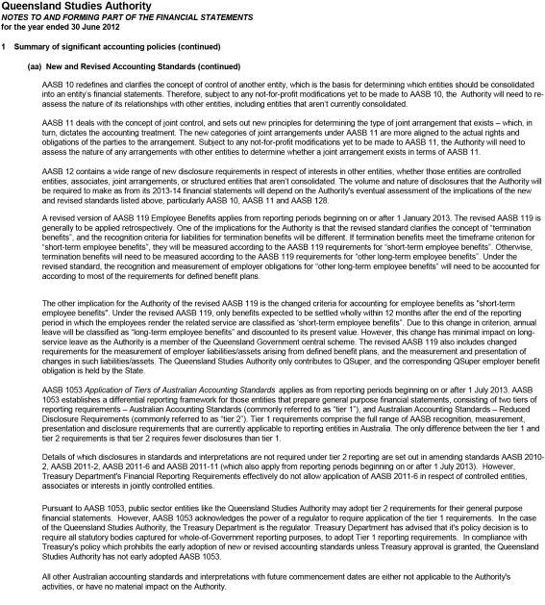

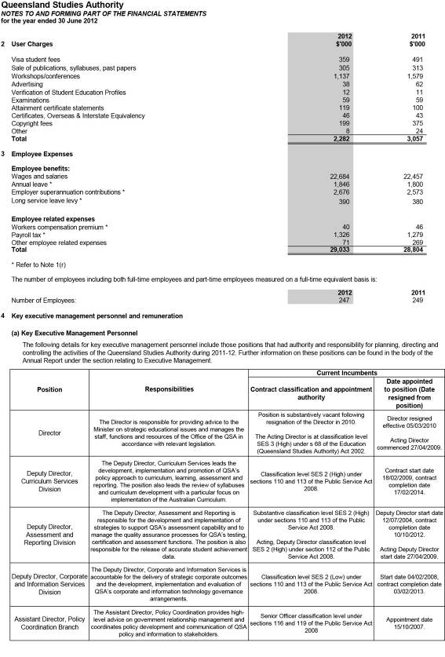

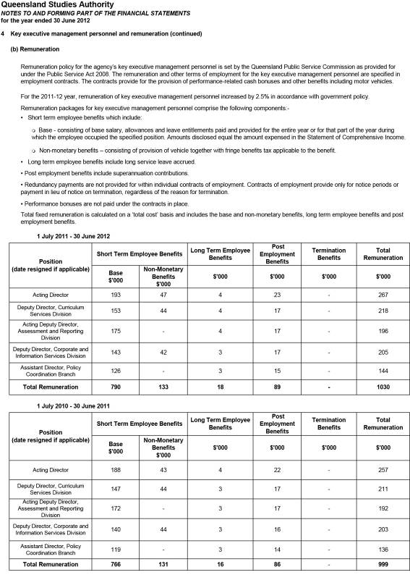

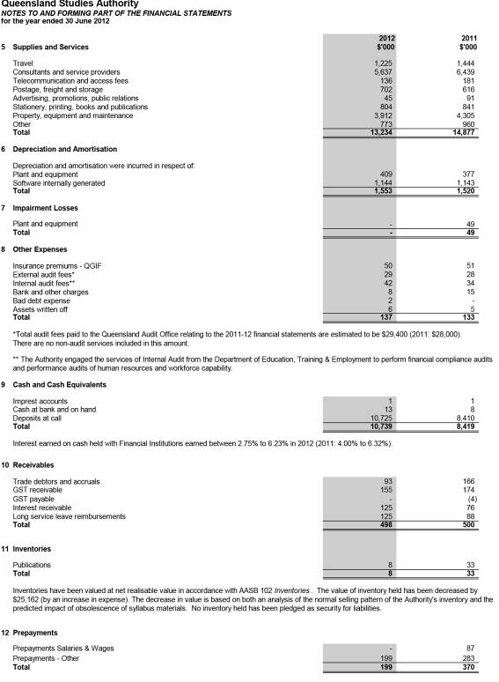

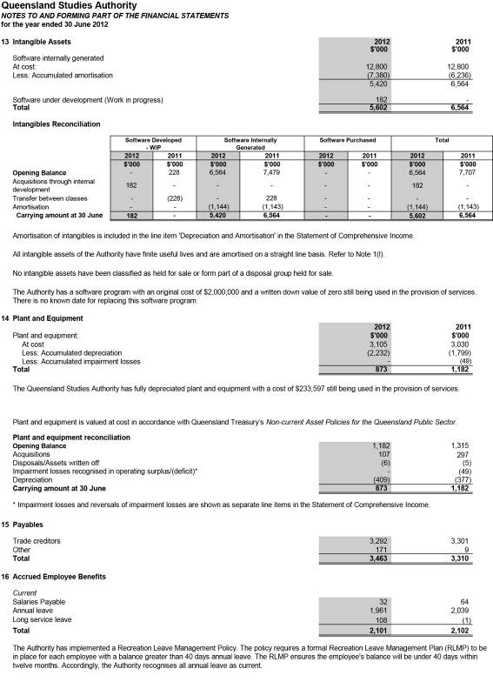

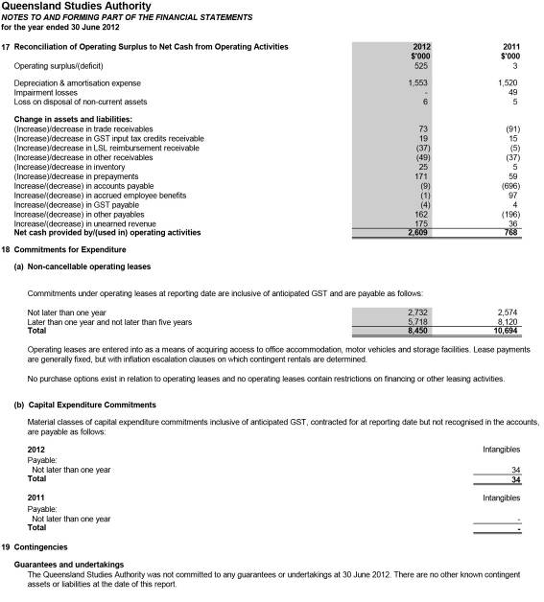

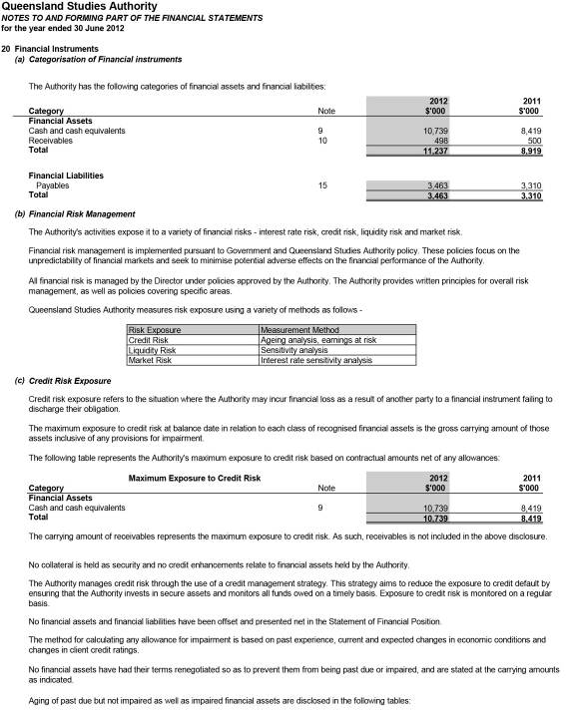

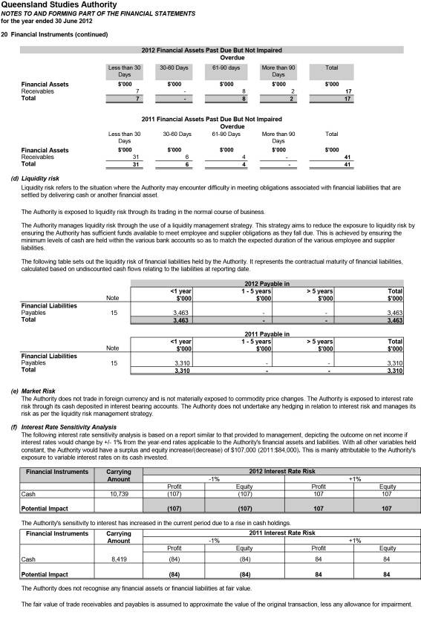

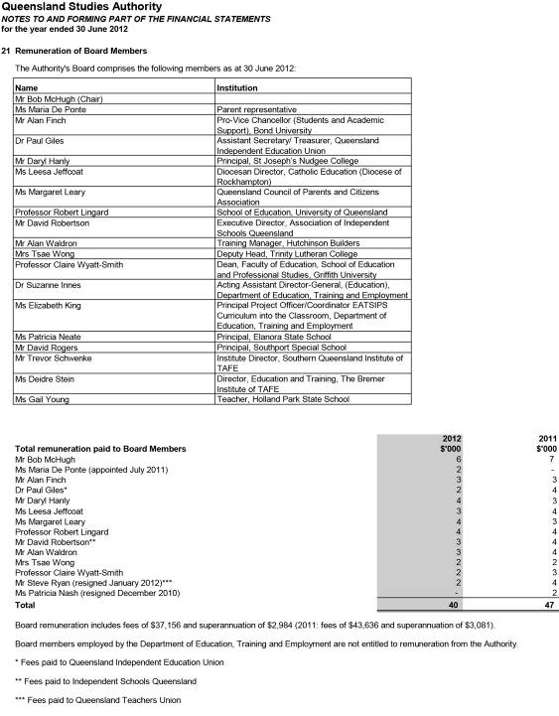

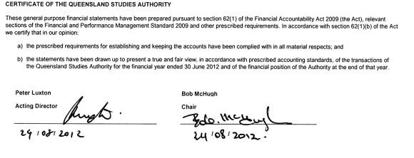
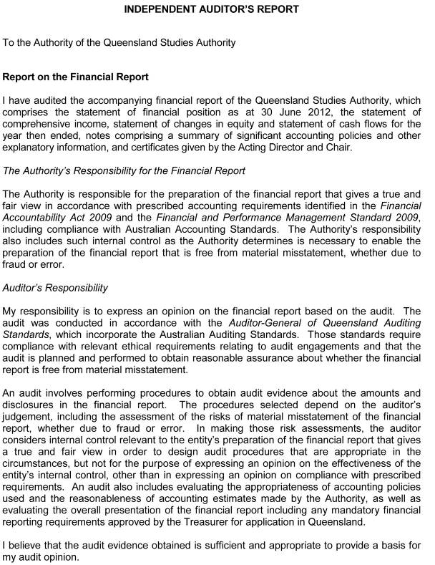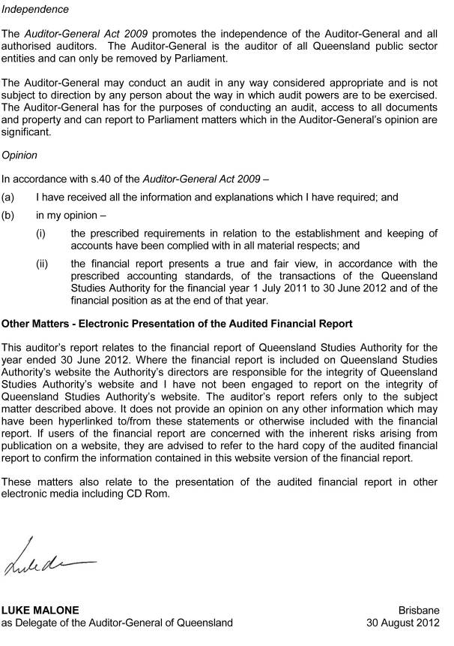

Appendixes
- Fees paid to Board members
A total of $40 140 was payable to Authority members in 2011–12. This amount does not include associated meeting and travel costs of $10 721.
Further information relating to QSA’s expenditure on consultancies and overseas travel, and compliance with information systems and recordkeeping legislation can be found in the document “Annual Report 2011–12: Disclosure of additional information”, available on the QSA website: www.qsa.qld.edu.au/624.html.
- Voluntary Separation Program (VSP)
A Voluntary Separation Program was introduced as part of the Mid-Year Fiscal and Economic Review in January 2011. This program was one of a number of measures designed to deliver additional savings and reprioritise spending.
The program was targeted primarily at non-frontline areas, as a service reprioritisation strategy to ensure continued growth in frontline areas. The QSA sought expressions of interest from all permanent staff across the agency.
In 2011–12 one employee accepted an offer of a voluntary separation package at a cost of $212 728.
- Key corporate governance committee of the QSA

Strategic Directions Group
Peter Luxton, Acting Director
Paul Herschell, Deputy Director, Curriculum Services Division
Peter Jordan, Acting Deputy Director, Assessment and Reporting Division
Graham Smith, Deputy Director, Corporate and Information Services Division
John McGuire, Assistant Director, Policy Coordination Branch

- Committees of the Authority
The Authority has established 10 committees to work on specific areas. Subcommittees were established as necessary to support these committees.

Aboriginal and Torres Strait Islander Education Committee
Functions are to:
- provide advice and direction to the Authority and Director of the QSA on
  - ensuring that the QSA’s products and services meet the educational needs of Aboriginal young people and Torres Strait Islander young people
  - syllabus development, assessment, testing and reporting issues (including new QSA initiatives) as they relate to the education of young Aboriginal and Torres Strait Islander people, and education about both Aboriginal peoples and Torres Strait Islander peoples
  - ensuring Indigenous representation on Authority committees and other QSA consultative mechanisms
  - policy issues, particularly equity and social justice issues, as they relate to the education of Aboriginal young people and Torres Strait Islander young people
- be the primary mechanism for the QSA to consult with Aboriginal and Torres Strait Islander communities on QSA matters
- provide a two-way communication forum for Indigenous perspectives on QSA activities, and as a communication between the QSA and Indigenous communities.
Membership comprises:
- chair — Authority member with expertise in the education of Aboriginal young people and/or
Torres Strait Islander young people
- one parent nominee
- one nominee of the Queensland Indigenous Education Consultative Committee
- one senior officer from the Department of Education, Training and Employment (DETE) — education sector
- one senior officer from DETE — training sector
- one nominee of the Queensland Catholic Education Commission
- one nominee of Independent Schools Queensland
- one nominee of Education Queensland
- one nominee of the Queensland Teachers’ Union
- one nominee of the Independent Education Union of Australia — Queensland and Northern Territory Branch
- four teachers representing each of the State, Catholic and Independent school sectors
(preferably an early years teacher, a secondary teacher, a primary teacher and a school principal)
- one nominee of the Torres Strait (Torres Strait Islander Regional Education Council)
- one representative of the Cape York education community
- one representative of the tertiary education sector
- QSA Principal Education Officer (Indigenous Education)
- one QSA senior officer
- executive officer — QSA officer.

Accreditation and Recognition Committee
Functions are to:
- oversee the accreditation process of non-QSA syllabuses and guidelines and assess applications
- oversee the recognition process of non-QSA and QSA developed courses of study, other than Authority or Authority-registered courses and assess applications
- make recommendations to the QSA Governing Body about the accreditation of non-QSA syllabuses and guidelines and recognition of non-QSA and QSA courses of study contributing towards a QCE.
Membership comprises:
- chair — Authority member
- one nominee of Education Queensland
- one nominee of the Queensland Catholic Education Commission
- one nominee of Independent Schools Queensland
- one nominee of DETE — training sector
- one nominee of the Office of Non-State Education, DETE
- one representative of the tertiary education sector
- one nominee of the Queensland Teachers’ Union
- one nominee of the Independent Education Union of Australia — Queensland and Northern Territory Branch
- one QSA senior officer
- executive officer — QSA officer.

Assessment, Moderation and Certification Committee
Functions are to:
- determine and recommend procedures for assessment, moderation and certification within the approved policies of the Authority
- provide advice and make recommendations to the Authority on assessment components of relevant documents such as QSA syllabuses and ACARA curriculum materials
- provide advice and make recommendations to the Authority on assessment information provided to teachers
- identify and advise the Authority on strategic issues relating to future developments in assessment, moderation and certification.
Membership comprises:
- chair — Authority member
- one nominee of Education Queensland
- one nominee of the Queensland Catholic Education Commission
- one nominee of Independent Schools Queensland
- one nominee of DETE — training sector
- one parent nominee
- one tertiary educator/researcher
- one district review panel chair
- one state review panel chair
- two school administrators (state and non-state)
- one primary school principal
- one nominee of the Queensland Teachers’ Union
- one QSA senior officer
- executive officer — QSA officer.

Audit Committee
Functions are to:
- provide independent assurance and assistance to the Authority and Director of the QSA on:
  - the risk control and compliance frameworks
  - the agency’s external accountability responsibilities as prescribed in Education (Queensland Studies Authority) Act
- oversee internal and external audit services
- review strategic risk assessment
- monitor improvement strategies to reduce and mitigate against risk.
Membership comprises:
- chair — Authority member
- external member — Authority member
- one member who has “financial expertise” as described in the Queensland Treasury publication, Audit Committee Guidelines — Improving accountability and performance 2008
- one member with expertise in the industry in which the agency operates.

Curriculum Committee
Functions are to:
- provide advice to the Authority on the current directions in curriculum development for the early, middle and senior phases of schooling
- review submissions of syllabuses, curriculum guidelines and other materials and make recommendations to the Authority about the suitability of such materials
- provide advice on P–12 matters that the Authority may determine.
Membership comprises:
- chair — Authority member
- three Authority members from each school sector
- one nominee of Education Queensland (EQ)
- one nominee of the Queensland Catholic Education Commission (QCEC)
- one nominee of Independent Schools Queensland (ISQ)
- one nominee of DETE — training sector
- one parent nominee
- one nominee of the Queensland Teachers’ Union
- one nominee of the Independent Education Union of Australia — Queensland and Northern Territory Branch
- one nominee of EQ — special education
- one nominee of EQ — rural and remote
- one nominee of QCEC — senior years
- one nominee of ISQ — middle years
- one nominee of EQ — early years
- one nominee of the Queensland Indigenous Education Consultative Committee
- two tertiary educators
- one QSA senior officer
- executive officer — QSA officer.

Equity Committee
Functions are to:
- provide expertise and advice to the Authority, and the Office of the Authority, on equity issues in education, relevant to the functions of the Authority
- liaise with other committees of the Authority as required
- represent the interests of groups at educational risk in the community.
Membership comprises:
- chair — Authority member
- one nominee of Education Queensland
- one nominee of the Queensland Catholic Education Commission
- one nominee of Independent Schools Queensland
- one nominee of DETE — training sector
- one nominee of the Queensland Indigenous Education Consultative Committee
- one nominee of the Queensland Teachers’ Union
- one nominee of the Independent Education Union of Australia — Queensland and Northern Territory Branch
- one practising teacher or school-based person with expertise in special education
- one practising teacher with expertise in distance education
- one nominee of the Queensland Association of Gifted and Talented Children
- one researcher
- one nominee of the Queensland Anti-Discrimination Commission
- one nominee of the Queensland Guidance and Counselling Association
- one nominee of the Queensland Association of Teaching English as a Second or Other Language
- one nominee of the Ethnic Communities Council of Queensland
- two parent nominees
- one QSA senior officer
- executive officer — QSA officer.

Finance Committee
Functions are to:
- oversee the development and approval of the annual budget
- ensure that annual resource allocations are consistent with the strategic direction and operational priorities of the QSA
- provide advice on major project and capital expenditure proposals or initiatives
- monitor actual financial performance against budget and forecasts and provide advice on significant trends or variances
- review the financial performance of major strategic initiatives
- perform any other activities consistent with this charter that the Governing Body requests.
Membership comprises:
- chair — Authority member
- two nominees of the Authority
- executive officer — QSA officer.

Scaling Anomalies Committee
Functions are to:
- consider applications from schools for examination of their Queensland Core Skills (QCS) Test data where schools consider that exceptional circumstances may have resulted in lesser performance
- examine data for schools that have a significant negative mismatch between within-school achievement and QCS Test data, and recommend measures to be implemented to help schools identify the reasons for the mismatch
- confirm that special procedures, which are part of the calculation of equivalent Overall Positions (OPs), are working appropriately (such as those for visa schools)
- consider cases identified by the Office of the QSA where the normal scaling procedures for the calculation of OPs might need to be varied because they are not operating as they were intended.
Membership comprises:
- chair — Authority member
- one academic representative
- one nominee of Education Queensland
- one nominee of the Queensland Catholic Education Commission
- one nominee of Independent Schools Queensland
- Deputy Director, Assessment and Reporting Division, QSA
- Assistant Director, Analysis and Reporting Branch, QSA
- Manager, Quantitative Analysis Unit, QSA
- Manager, Qualitative Analysis Unit, QSA — executive officer.

Tertiary Entrance Committee
Functions are to:
- monitor developments on tertiary entrance matters and assist in the provision of informed advice about tertiary entrance matters
- provide advice on the management of information and secondary–tertiary link programs that maximise the capacity of potential tertiary applicants to make informed choices and pursue tertiary studies.
Membership comprises:
- chair — Authority member
- two university admissions managers
- one TAFE admissions manager
- one nominee of DETE with policy expertise relating to TAFE — university interface
- one nominee of the Office of Higher Education, DETE
- one nominee of the Queensland Tertiary Admissions Centre
- one nominee of the Australian Council of Private Education and Training
- two guidance counsellors (state and non-state)
- two student representatives
- two tertiary student representatives
- one parent nominee
- one QSA senior officer
- executive officer — QSA officer.

Vocational Education and Training Committee
Functions are to:
- provide advice to the Authority on emerging policies and issues relating to VET pathways at both the national and state levels
- provide strategic advice to the Authority on the implementation of legislation in relation to VET at both the national and state levels
- provide information to the Authority on issues relating to the implementation of VET in Queensland schools.
Membership comprises:
- chair — Authority member
- two nominees of DETE — training sector, one to include a TAFE practitioner
- one nominee of the Australian Council for Private Education and Training
- one nominee of industry
- one nominee of Education Queensland
- one nominee of the Queensland Catholic Education Commission
- one nominee of Independent Schools Queensland
- two parents nominees
- three practitioners (state, non-state and TAFE) with responsibility for VET
- two principals/administrators (state and non-state) with responsibility for VET
- one QSA senior officer
- executive officer — QSA officer.

- QSA district offices

Brisbane Central
Helen Best
Phone: (07) 3359 6131 Fax: (07) 3359 6387
Email: BrisbaneCentralOffice@qsa.qld.edu.au
Suite G1, 449 Gympie Rd, Kedron Qld 4031

Brisbane North
Judy Beadle
Phone: (07) 3859 6132 Fax: (07) 3359 6387
Email: UBrisbaneNorthOffice@qsa.qld.edu.au
Suite G1, 449 Gympie Rd, Kedron Qld 4031

Brisbane East
Elisabeth Case
Phone: (07) 3324 1072 Fax: (07) 3397 2955
Email: UBrisbaneEastOffice@qsa.qld.edu.au
Suite 6.01, 433 Logan Rd,
Stones Corner Qld 4120
PO Box 686, Stones Corner Qld 4120

Brisbane South
Sally Dwyer
Phone: (07) 3397 3955 Fax: (07) 3397 2955
Email: UBrisbaneSouthOffice@qsa.qld.edu.au
Suite 6.01, 433 Logan Rd
Stones Corner, Qld 4120
PO Box 686, Stones Corner Qld 4120

Brisbane Ipswich
Andrew Sycz
Phone: (07) 3202 3325 Fax: (07) 3202 3347
Email: UBrisbaneIpswichOffice@qsa.qld.edu.au
Unit 2/56 Cascade St, Raceview Qld 4305
PO Box 860, Booval Qld 4304

Cairns
Carol Mcllwain
Phone: (07) 4054 6278 Fax: (07) 4054 3943
Email: UCairnsOffice@qsa.qld.edu.au
455 Mulgrave Rd, Earlville Qld 4870
PO Box 122, Earlville 4870

Gold Coast
Sylvia Richardson
Phone: (07) 5591 4255 Fax: (07) 5591 4461
Email: UGoldCoastOffice@qsa.qld.edu.au
1/8 Short St, Southport Qld 4215
PO Box 2005, Southport Qld 4215

Mackay
Sandra Cain
Phone: (07) 4953 0977 Fax: (07) 4953 0988
Email: UMackayOffice@qsa.qld.edu.au
Mercury House
38 Wellington St, Mackay Qld 4740
PO Box 8163, Mt Pleasant Qld 4740

Rockhampton
Keren Chillingworth & Dian Hamilton
Phone: (07) 4927 7279 Fax: (07) 4922 6574
Email: UMackayOffice@qsa.qld.edu.au
Room 8, North Street Annex
Cnr North & West Sts
Rockhampton Qld 4700
PO Box 919, Rockhampton Qld 4700

Sunshine Coast
Amanda Poeppmann
Phone: (07) 5493 9452 Fax: (07) 5493 9451
Email: USunshineCoastOffice@qsa.qld.edu.au
Shop 3A, 710 Nicklin Way (Cnr Erang St)
Currimundi Qld 4551
PO Box 44, Wurtulla Qld 4575

Toowoomba
Peter Wedgwood
Phone: (07) 4638 3699 Fax: (07) 4638 5390
Email: UToowoombaOffice@qsa.qld.edu.au
B Block, Toowoomba North State School
Mort & Taylor Sts, Toowoomba Qld 4350

Townsville
Nola Popowycz
Phone: (07) 4728 8485 Fax: (07) 4728 8486
Email: UTownsvilleOffice@qsa.qld.edu.au
F Block, Heatley Secondary College
Hanlon St, Heatley Qld 4814
PO Box 207, Aitkenvale Qld 4814

Wide Bay
Diane Armstrong
Phone: (07) 4123 1612 Fax: (07) 4121 6811
Email: UWideBayOffice@qsa.qld.edu.au
Maryborough State High School
Block Z, Rooms 814–817,
Sussex St, Maryborough Qld 4650
PO Box 452, Maryborough Qld 4650

- Reader evaluation of the Annual Report 2011–12
Please take some time to answer the following questions, to help the QSA communicate effectively with you.
To indicate your response, please circle the appropriate number for each question as follows:
0 = Unable to respond | 1 = Very poor | 2 = Poor | 3 = Acceptable | 4 = Very good | 5 = Excellent

Did the Annual Report achieve its communication objectives? (see page 2)
0 1 2 3 4 5
What did you think of the content?
Value of information
0 1 2 3 4 5
Presentation
0 1 2 3 4 5
Did the design of the report make it easy to read?
Layout of information
0 1 2 3 4 5
Type and colour
0 1 2 3 4 5
Overall, how would you rate the report?
0 1 2 3 4 5

Please return to:
Policy Coordination
Queensland Studies Authority
Reply Paid 307, Spring Hill QLD 4004
Fax: (07) 3864 0318
What client group do you come from?
(Please tick appropriate box)
School staff
State
Catholic
Independent
Student
Secondary
Tertiary
Education authority
State
Catholic
Independent
Parent
State
Catholic
Independent
Tertiary institution
University
TAFE
Union
Employer
Queensland Government

Other comments

Abbreviations and acronyms

ACACA Australasian Curriculum, Assessment and Certification Authorities
ACARA Australian Curriculum, Assessment and Reporting Authority
ASQA Australian Skills Quality Authority
CCAFL Collaborative Curriculum and Assessment Framework for Languages
DETE Department of Education, Training and Employment
EQ Education Queensland
ESL English as a Second Language
F Foundation
FP Field Position
ICT Information and communications technology
IEUA–QNT Independent Education Union of Australia — Queensland and Northern Territory Branch
ISQ Independent Schools Queensland
K Kindergarten
KLA key learning area
NAPLAN National Assessment Program — Literacy and Numeracy
OP Overall Position
P, Prep Preparatory Year
QCAT Queensland Comparable Assessment Task
QCE Queensland Certificate of Education
QCEC Queensland Catholic Education Commission
QCIA Queensland Certificate of Individual Achievement
QCS Queensland Core Skills (Test)
QELi Queensland Education Leadership Institute
QKLG Queensland kindergarten learning guideline
QSA Queensland Studies Authority
QTAC Queensland Tertiary Admissions Centre Ltd
RTO registered training organisation
SDCS Student Data Capture System
SEP Senior Education Profile
SLIMS Senior Learning Information Management System
SOSE Studies of Society and Environment
TAFE Technical and Further Education
TSXPO Tertiary Studies Expo
VET vocational education and training
VSP Voluntary Separation Program

Queensland Studies Authority
Annual Report 2011–12
www.qsa.qld.edu.au

