Annual Report 2010–11
Queensland Studies Authority

Contents
Letter of compliance 1
Communication objectives 2
Highlights of 2010–11 3
Chair’s introduction 4
Financial snapshot 2010–11 2
Constitution, functions & powers 3
Corporate profile 4
Authority members 4
Executive committee 6
Authority committee functions 6
Authority committees 7
Organisational structure 8
Strategic Plan 2010–14 9
Plan development 9
Performance against objectives 9
Challenges during plan implementation 10
Program review 11
Syllabus development and implementation 11
Testing and assessment 16
Certification and tertiary entrance 20
Corporate support and communication 24
Financial report 2010–11 31
Appendixes 54
1. Schedule of consultancies 54
2. Schedule of overseas travel 54
3. Fees paid to Board members 54
4. Voluntary Early Retirement (VER) 55
5. Committees of the Authority 55
6. Key corporate governance committee of the QSA 61
7. QSA district offices 62
8. Reader evaluation of the QSA Annual Report 2010–11 64
Abbreviations and acronyms 65

Letter of compliance
31 August 2011
The Honourable Cameron Dick MP
Minister for Education and Industrial Relations
Parliament House
Brisbane Qld 4000
Dear Minister
I am pleased to present the Annual Report 2010–11 for the Queensland Studies Authority.
I certify that this annual report complies with:
- the prescribed requirements of the Financial Accountability Act 2009 and the Financial and Performance Management Standard 2009, and
- the detailed requirements set out in the Annual Reporting Guidelines for Queensland Government Agencies.
A checklist outlining the annual reporting requirements can be accessed at <www.premiers.qld.gov.au/publications/categories/guides/annual-report-guidelines.aspx>.
Yours sincerely
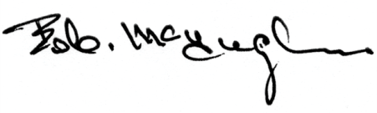
Bob McHugh
Chair
Queensland Studies Authority

Communication objectives
The Queensland Studies Authority (QSA) was established in 2002 and is responsible for a range of functions including developing and accrediting Kindergarten to Year 12 syllabuses and guidelines, testing, assessment, moderation, certification, vocational education and training, and tertiary entrance.
In addition to fulfilling the statutory obligations of the Financial Accountability Act 2009, this annual report shows the ways in which the QSA is fulfilling its role as prescribed by the Education (Queensland Studies Authority) Act 2002. The report is aimed, in particular, at:
- school staff
- parents
- tertiary institutions
- unions
- employers
- Queensland Government.

Report access
Access to this report is provided through the QSA’s website or by contacting the QSA.

Interpreter Service Statement
The Queensland Government is committed to providing accessible services to Queenslanders from all culturally and linguistically diverse backgrounds. If you have difficulty in understanding the annual report, you can contact the QSA on (07) 3864 0299 and we will arrange an interpreter to effectively communicate the report to you.

Highlights of 2010–11
Development of more than 150 online resources to support schools as they implement the Australian Curriculum | QSA’s K–12 conference,  Vision to Reality: Queensland’s new education landscape | Publication of the Queensland kindergarten learning guideline and Continua of learning and development
100 new Science Assessment Bank items | Administration of  2011 NAPLAN | Launch of Student Connect website for senior students
Public release of 2010  NAPLAN and Year 12 outcomes reports | Administration of 2010 and development of 2011 QCATs and QCS Test | Implementation of the P–10 Aboriginal and Torres Strait Islander Languages syllabus

Chair’s introduction

The past 12 months have seen the QSA preparing for impending changes to the state and national education landscape while continuing to deliver its core products and services in the areas of curriculum, assessment, reporting and certification. Our achievements span the early years of learning to Year 12 and are designed to assist schools throughout Queensland.
The QSA completed development of the Queensland kindergarten learning guideline for the Department of Education and Training. The guideline supports kindergarten teachers’ professional practice, and is based on the Australian Government’s Early Years Learning Framework for Australia. It embraces the inclusive vision that all children experience learning that is engaging and builds success for life.
The QSA continues to work with its education partners to help Queensland schools make a smooth transition to the Australian Curriculum from 2012. Already we have produced more than 150 online resources for all Queensland teachers in addition to delivering a comprehensive and statewide program of face-to-face workshops.
In June, the Queensland Government announced that from 2013, a new education standards authority will assume the functions of the Queensland Studies Authority and the Non-State Schools Accreditation Board. The new independent authority will perform curriculum, assessment and reporting functions and accredit all schools. The QSA will continue to perform its current functions for at least the next 18 months, while working with the government to establish the new authority.
This year, the QSA honoured its commitments under the Queensland Education Performance Review by delivering a further 100 Assessment Bank items to help teachers assess Science more effectively across Years 1–9. We will now be concentrating on aligning Assessment Bank items to the Australian Curriculum.
For some time, the QSA has been embedding Australian Indigenous perspectives in its curriculum and assessment materials for schools. One of our recent achievements was the implementation of the P–10 Aboriginal and Torres Strait Islander Languages syllabus. A strength of the syllabus is its capacity to forge connections between schools and communities. It is intended that students will study the languages associated with their own communities and localities, and in the process build respect for local culture and traditions. A syllabus for Years 11 and 12 will follow next year.
Supporting professional development for teachers remains central to the QSA’s role. Our 2011 conference, Vision to Reality: Queensland’s new education landscape, attracted over 1800 participants from more than 550 schools. From the enthusiastic response, I believe this year’s three-day event firmly established the QSA conference as a key annual networking and professional development opportunity for teachers and educators in Queensland.
Finally, I thank QSA Governing Body members for their guidance and informed advice. With representatives from the State, Catholic and Independent school sectors, as well as teachers, parents, unions and higher education groups, the Governing Body is an inclusive group. It exemplifies the stakeholder collaboration and engagement processes that are essential in making the QSA’s work effective.
Bob McHugh
Chair
Queensland Studies Authority
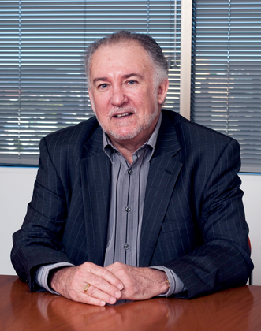

Financial snapshot 2010–11
In 2010–11, the QSA received $41.423 million in grant revenue from the Department of Education and Training (DET) and raised $3.963 million from its curriculum and professional development products and services. The QSA delivered its education products and services to approximately 1800 state and non-state schools.
Table 1: Summary of QSA finances 2010–11
 | 2010–11 | 2009–10 | 2008–09 | 2007–08 | 2006–07
 | $(000) | $(000) | $(000) | $(000) | $(000)
Revenue
Grant revenue | 41 423 | 38 276 | 37 425 | 40 184 | 33 849
Other revenue | 3 963 | 3 653 | 3 707 | 3 745 | 3 084
Expenses
Employee expenses | 28 804 | 26 636 | 24 786 | 22 724 | 20 207
Other expenses | 16 579 | 16 182 | 15 003 | 18 622 | 13 345
Operating surplus/(deficit) | 3 | (889) | 1 343 | 2 583 | 3 381
Capital outlays
Plant and equipment | 297 | 211 | 445 | 473 | 272
Software | 0 | 839 | 2 227 | 4 023 | 1 462
Total assets | 17 068 | 17 823 | 18 215 | 18 788 | 13 100
Total liabilities | 5 529 | 6 287 | 5 790 | 7 706 | 4 593
Net assets/(liabilities) | 11 539 | 11 536 | 12 425 | 11 082 | 8 507
Table 2: QSA employees 2010–11
 | 2010–11 | 2009–10 | 2008–09 | 2007–08 | 2006–07
Number of employees at 30 June 2011  (full-time equivalent) | 248.5 | 233.5 | 235.5 | 231.9 | 230.1
A comprehensive set of financial statements covering all aspects of the QSA’s activities starts at page 31 of this report.

Constitution, functions & powers
The QSA is a statutory body established by an Act of Parliament under the provisions of the Education (Queensland Studies Authority) Act 2002.
The main functions of the QSA are to:
- develop and implement syllabuses and guidelines from Kindergarten to Year 12, and accredit syllabuses and guidelines prepared outside of the QSA
- undertake assessment and testing programs that help students demonstrate and improve their learning achievements and plan for their future, and that benchmark Queensland students against national standards and support school improvement processes
- determine procedures and implement quality assurance for Queensland's system of continuous school-based assessment in the senior phase of learning
- manage certification and reporting processes that reflect student learning across the range of their school experiences, capture student achievement in their various endeavours, and provide personalised, up-to-date information to students and parents
- register schools as Registered Training Organisations (RTOs), and accredit and recognise vocational education and training courses
- develop tertiary entrance procedures, issue tertiary statements and provide information to the public about tertiary entrance procedures and requirements
- undertake research in relation to the aforementioned functions.
In performing its functions, the QSA also provides the three schooling sectors with a range of professional development activities to support:
- implementation of syllabuses, associated materials and processes
- QSA business processes of assessment, moderation, certification and accreditation.

Corporate profile

Authority members
The constitution of the Authority is specified in Section 25 of the Education (Queensland Studies Authority) Act 2002. It comprises representatives of education across the primary, secondary, special and tertiary sectors (including practising teachers), vocational education, parents, unions and industry.
The membership of the Authority supports the Queensland Government’s Women on Boards strategy with almost 50 per cent of the positions held by women. This is particularly important in the education sector where women are well represented in the workforce.
Bob McHugh | Yvana Jones | David Roberston | Leesa Jeffcoat | Bob Lingard | Alan Finch
Trish Nash | Margaret Leary | Patricia Neate | Daryl Hanly | Gail Young | Tsae Wong
Steve Ryan | Dr Paul Giles | Tim Maloney | David Rogers | Penny Taylor | Claire Wyatt-Smith

The Authority held eight meetings during the 2010–11 financial year. Its membership for 2010–11 is outlined below.
- One nominee of the Minister for Education and Training (Chair):
Bob McHugh (appointed until June 2012)
- The chief executive (Director-General) of the education department, whose nominee is:
Yvana Jones
- The chief executive (Director-General) of the vocational education and training department, whose nominee is:
Vacant
- One nominee of Independent Schools Queensland (ISQ):
David Robertson (appointed until June 2012)
- One nominee of the Queensland Catholic Education Commission (QCEC):
Leesa Jeffcoat (appointed until June 2012)
- Two nominees of the Higher Education Forum (at least one of whom must have expertise relating to tertiary entrance):
Professor Bob Lingard (appointed until December 2011)
Alan Finch (appointed until December 2011)
- Two persons who, at the time of appointment, are parents or guardians of students enrolled at a school, of whom:
- one is to be nominated jointly by the Federation of Parents and Friends Associations of Catholic Schools, Queensland, and the Queensland Independent Schools Parents Council; and
- one is to be nominated by the Queensland Council of Parents’ and Citizens’ Associations Incorporated
Trish Nash (to December 2010)
Margaret Leary (appointed until December 2011)
- One primary school principal and one secondary school principal, of whom:
- one is to be nominated by the chief executive; and
- one is to be nominated jointly by ISQ and QCEC
Patricia Neate (appointed until June 2012)
Daryl Hanly (appointed until June 2012)
- One teacher of primary education and one teacher of secondary education, neither of whom is a school principal, of whom:
- one is to be nominated by the chief executive; and
- one is to be nominated jointly by ISQ and QCEC
Gail Young (appointed until December 2011)
Tsae Wong (appointed until June 2012)
- One nominee of the Queensland Teachers’ Union (QTU):
Steve Ryan (appointed until June 2012)
- One nominee of the Queensland Independent Education Union (QIEU):
Dr Paul Giles (appointed until June 2012)
- One nominee of the Minister administering the vocational education and training department:
Tim Maloney (appointed until December 2011)
- Three nominees of the Minister for Education and Training, of whom:
- one is to have expertise in the provision of special education; and
- one is to have expertise in the education of Aboriginal peoples or Torres Strait Islander peoples
- one is to be representative of industry
David Rogers (appointed until December 2011)
Penny Taylor (appointed until December 2011)
Alan Waldron (appointed until December 2011)
- One other person who may be nominated by the Minister for Education and Training:
Professor Claire Wyatt-Smith (appointed until June 2012)

Executive committee
In accordance with Section 45 of the Education (Queensland Studies Authority) Act 2002, an executive committee meets before each Authority meeting to set the agenda. The executive committee comprises:
- the Chair
- the nominee of the chief executive (Director-General) of education
- the nominee of the chief executive (Director-General) of vocational education and training
- the nominee of the Queensland Catholic Education Commission
- the nominee of Independent Schools Queensland.
The Director of the QSA also participates in executive committee meetings as outlined in Section 46 of the Act, but has no voting rights.
The executive committee also performs any other functions conferred on it by the Authority and reports to the Authority as required.

Authority committee functions
A number of committees of the Authority have been established, as set out in Section 47 of the Education (Queensland Studies Authority) Act 2002, to:
- develop policy proposals (for referral to the Authority)
- identify issues that require policy development by the committee
- provide advice to the Authority on matters referred to the committee by the Authority
- provide advice to the Authority on matters identified by the committee as warranting such advice
- keep the Authority informed about current and expected issues requiring its attention
- consider and approve plans and procedures that provide mechanisms for the implementation and endorsement of Authority policy
- establish (or recommend establishment of) subcommittees and task groups to provide specialist advice and develop policy proposals
- consider specialist advice and policy proposals from subcommittees and task groups
- advise and assist the Office of the Authority in policy implementation
- consider advice from the Office of the Authority on relevant issues
- maintain and strengthen communication links between the Authority and its stakeholders.
Details of the functions and membership of each committee are given in Appendix 6.

Authority committees
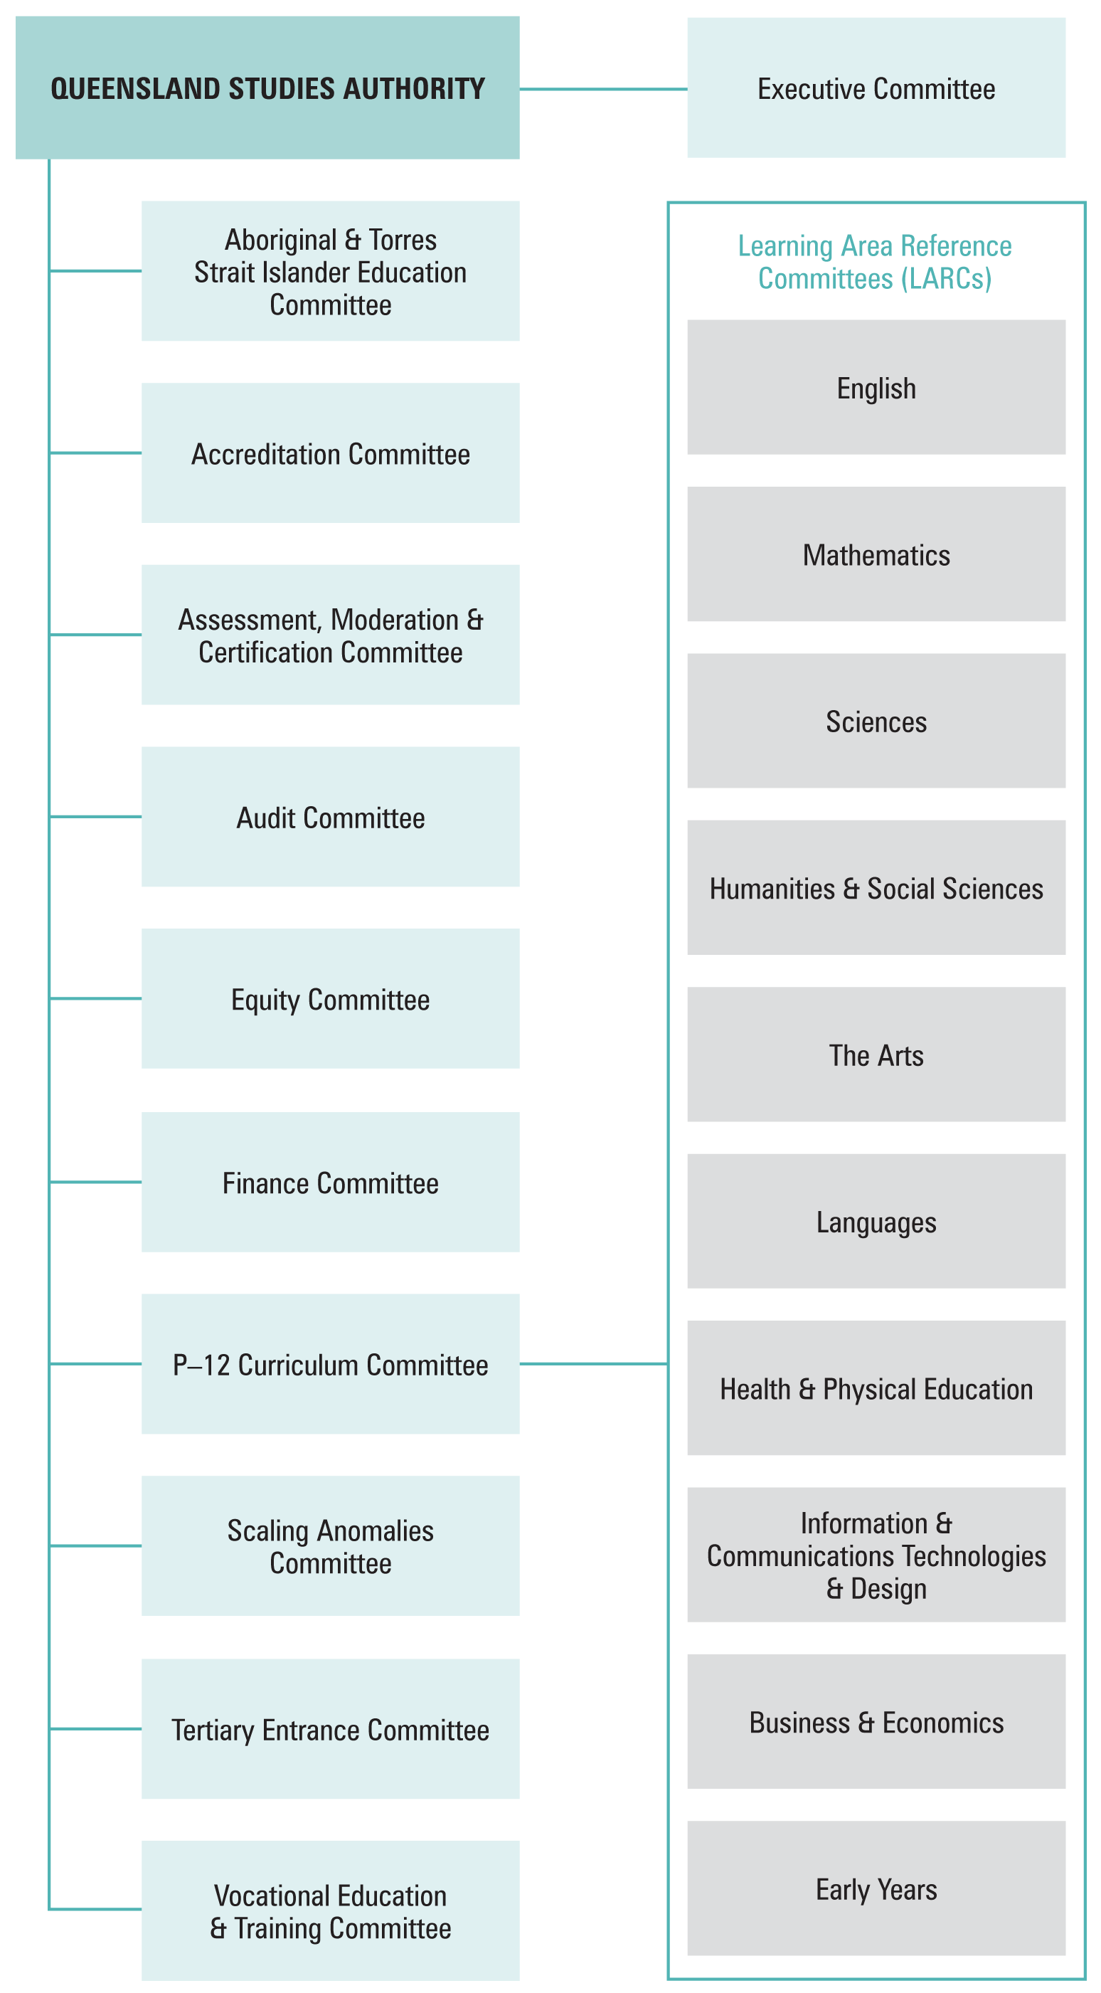

Organisational structure
The organisational structure of the QSA, as at June 2011, is shown below. Members of the key corporate governance committee of the QSA are listed in Appendix 6.
QSA’s central office is located at 154 Melbourne Street, South Brisbane. The QSA had 248.5 full-time equivalent staff as at June 2011, mostly based at the central office. The remainder work in 13 district offices across Queensland (district office contact details are listed in Appendix 7). Positions are filled through a mix of permanent and temporary appointments, and secondments. Staff are employed directly by the Authority as part of the Education and Training portfolio.
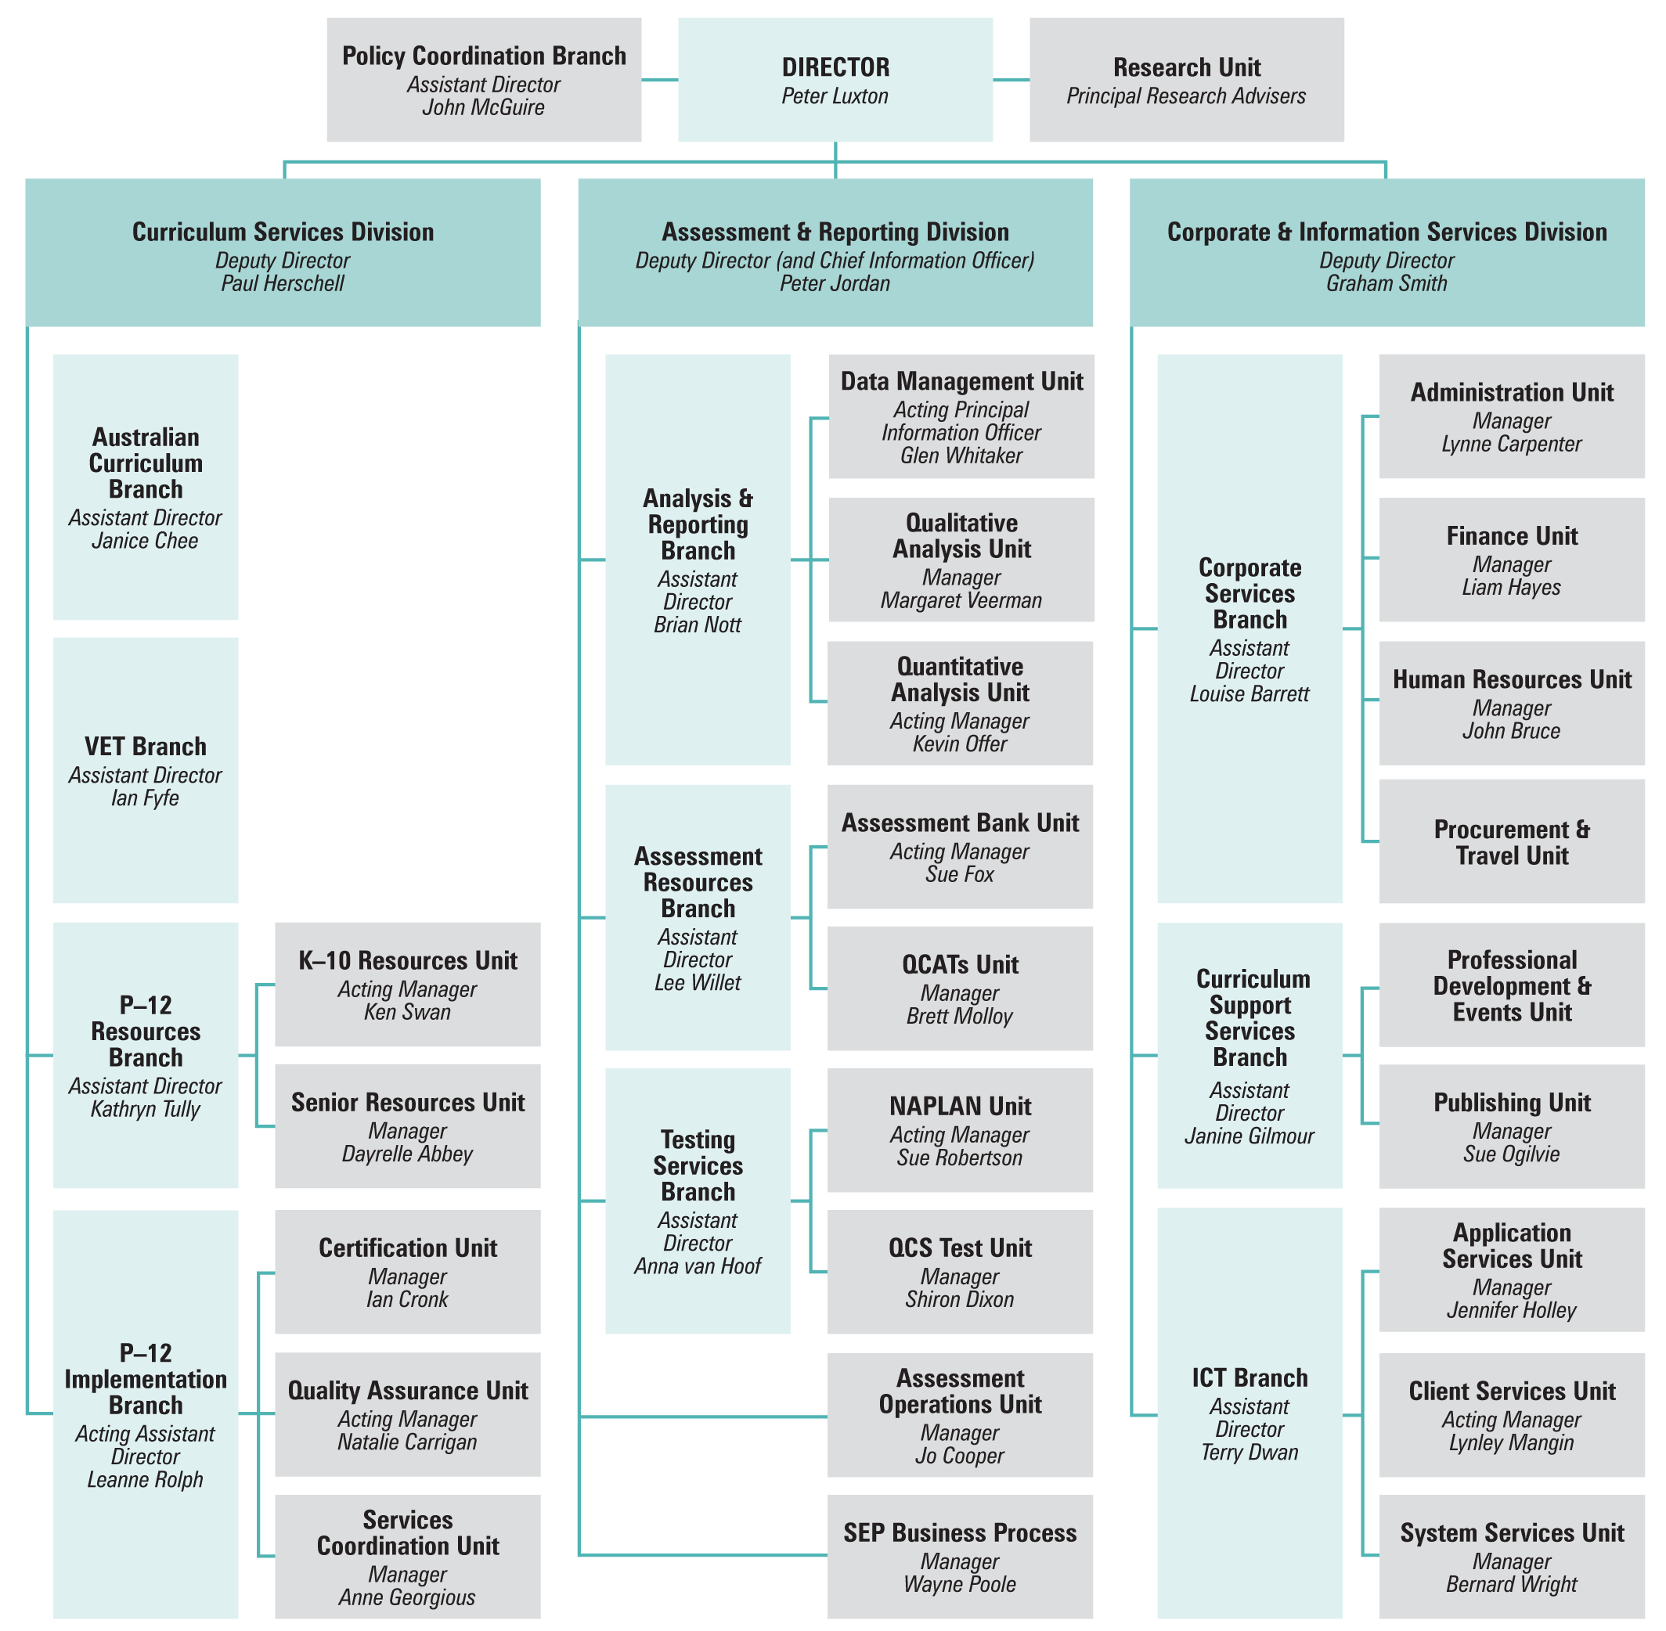

Strategic Plan 2010–14

Plan development
The Strategic Plan 2010–14 was approved by the QSA Governing Body on 7 May 2010. It refined the objectives and strategies of the previous Strategic Plan 2009–13, taking into account recent government initiatives, changes in government requirements and progress achieved against the current strategies.
Strategies on how it will provide quality, innovative and future-focused products and services to assist all Queensland educational communities are outlined in the plan under two key strategic objectives.
- Leadership and partnerships:
informed leadership through the implementation of evidence-based reforms and initiatives
strong partnerships with stakeholders through collaboration, communication and consultation
- Capability and governance:
expert capability through workforce planning, professional development and a supportive work environment
effective governance through refinement and improvement of processes.

Performance against objectives
A summary of achievements against the priority areas in the plan follows:

1. Leadership and partnerships
- In collaboration with the State, Catholic and Independent school sectors, developed a detailed plan for the implementation of the Australian Curriculum in Queensland schools.
- Developed a range of resources to support schools to implement the Australian Curriculum.
- Commenced aligning QSA products and services to the Australian Curriculum.
- Developed the Queensland kindergarten learning guideline and professional development material and resources to support the implementation of the guideline.
- Developed the P–12 Aboriginal and Torres Strait Islander Languages syllabuses to promote the value of Australian Indigenous languages.
- Worked with the wider school community to increase learning options contributing towards the Queensland Certificate of Education (QCE) to enable more students to become eligible for the QCE and increase Year 12 completion rates.
- Developed the 2010 Queensland Comparable Assessment Tasks (QCATs).
- Developed resources to implement recommendations of the Queensland Education Performance Review.
- Coordinated the administration, marking and reporting of the National Assessment Program — Literacy and Numeracy for Queensland.
- Continued to involve QSA committees and education stakeholders in the development of QSA products and services.
- Launched the new Student Connect website, which gives students access to their learning account and results.

2. Capability and governance
- Continued implementing Future Connect and Engaged Workplaces initiatives to improve staff capability and capacity to meet the challenges of the changing education environment.
- Implemented enhanced recruitment and professional development programs to attract, retain and develop highly capable and skilled staff.
- Implemented a Business Continuity Plan that ensured QSA’s core business and critical work proceeded during a period affected by natural disasters.
- Provided high quality and timely support and advice to the Governing Body to enable informed decision-making.

Challenges during plan implementation
While the QSA made significant progress in meeting the priorities and milestones in the Strategic Plan 2010–14, there are specific areas that will require attention in the Strategic Plan 2011–15. These areas are:
- working closely with our education partners to ensure the transition to the Australian Curriculum continues to progress smoothly
- continuing to provide schools with resources and support to enable teachers to confidently implement the Australian Curriculum
- continuing to align QSA products and services to the Australian Curriculum
- implementing the recommendations of the Queensland Certificate of Education and the Queensland Core Skills Test periodic reviews
- introducing innovative technologies to improve QSA products and services, and their delivery
- working collaboratively with government to transition to the new independent standards authority and achieve the reforms outlined in the education white paper: A Flying Start for Queensland Children.

Program review

Syllabus development and implementation
During 2010–11, the QSA continued to develop its vision of an innovative and future-focused Kindergarten(K)–12 education framework based on:
- syllabus design principles and elements that create the conditions for teachers to shape a curriculum that meets the needs of their students
- phases of learning with a specific developmental focus
- syllabus content that focuses on the expected learning and sets the parameters for the intended curriculum
- assessment, standards and consistency that show how standards-based, school-based assessment is integral to the teaching and learning process.
A survey of education stakeholders showed that 86% were satisfied with the syllabuses and support materials that the QSA developed in 2010–11. This is a 3% increase on
2009–10 and a 4% increase on 2008–09.
- Transition to the Australian Curriculum
The QSA is working with its education partners to ensure a smooth transition to the Australian Curriculum and promote the best interests of Queensland schools.
QSA’s partnership with the school sectors is coordinated through the Transition to Australian Curriculum Steering Committee, which provides a structure for ensuring Queensland schools receive consistent and timely information about the new curriculum. As an activity of the committee, the QSA developed an agreed implementation plan and
P–12 work plan that addresses:
- guidelines and advice
- resource development
- professional development
- communication
- ICT infrastructure.
QSA’s key curriculum development activities have included:
- providing strategic advice to inform Queensland’s position on the development and finalisation of the Foundation(F)–12 Australian Curriculum content and achievement standards for English, mathematics, science and history
- developing coordinated Queensland responses to the draft shape papers for Geography, The Arts and Languages
- coordinating participation of Queensland teachers and curriculum specialists in national forums and Australian Curriculum, Assessment and Reporting Authority (ACARA) advisory committees
- providing advice to inform ACARA’s international benchmarking activities including detailed mapping of the Australian Curriculum to Queensland and other states’ curriculums.
Advice and guidelines have included developing an agreed Queensland position on:
- resources required to support assessment, standards and reporting P–10
- time allocations and entitlement to support the implementation of the Australian Curriculum.
Resources have been developed in collaboration with the school sectors and classroom teachers, and published on the QSA website, including:
- whole school, year level, multiple year level and unit overview planning templates
- exemplars for P–10 English, mathematics and science to demonstrate the application of the templates
- exemplars for multiple year level planning for P–7 English and mathematics to demonstrate the application of the templates
- audit tools for English, mathematics, science and history
- detailed mapping of the Australian and Queensland curriculums.
Communication has included:
- providing two stakeholder forums to build familiarity and understanding of the Australian Curriculum and Queensland’s implementation strategy
- publishing a regular e-newsletter.
Professional development has included:
- developing and delivering professional development workshops to support the introduction of the Australian Curriculum in Queensland schools. From February to June 2011, the QSA conducted 43 workshops for teachers and school administrators across all QSA districts that were attended by 3848 educators
- providing professional development sessions by invitation from professional associations, school clusters and administrators’ groups. From January to June 2011, QSA delivered 16 sessions with approximately 1600 participants in total
- facilitating Queensland forums and workshops with stakeholders to support ACARA consultation. In February 2011, a two-day workshop was held to build a shared understanding of the Commonwealth and state priorities for implementation and to consult on QSA activities to support implementation. Approximately 100 State, Catholic and Independent school teachers participated
- developing online professional development modules.
OUTLOOK FOR 2011–12: Australian Curriculum resources
The QSA will:
- continue to provide strategic advice to inform Queensland’s position on the development and finalisation of the F–12 Australian Curriculum content and achievement standards
- develop guidelines and advice including:
- Prep to Year 2 planning for teaching and learning, assessment and reporting
- Year 7
- Year 10, including mapping the Australian Curriculum to Queensland senior syllabuses
- working with the general capabilities and cross-curriculum priorities
- special education
- Study of Society and Environment (SOSE) and history
- develop resources including:
- revising the draft templates and exemplars after final approval by Ministers in October 2011
- developing exemplars for P–10 History and other learning areas as they are approved
- developing multiple year level exemplars for Years 8–10 English and mathematics and P–10 Science
- mapping Australian Curriculum to Queensland curriculum in history and other learning areas as they are approved
- developing assessment resources and supporting the application of the Australian Curriculum Achievement Standards in classroom practice
- provide professional development including:
- delivering workshops to teachers focusing on disciplinary learning and assessment
- continuing to develop online modules to support professional development
- provide timely, consistent and accurate information to a range of stakeholders including:
- maintaining the e-newsletter, Australian curriculum latest
- developing an online discussion forum
- providing stakeholder forums.
- Kindergarten–Year 9 resources

Queensland kindergarten learning guideline
The QSA continues to work to support the Queensland Government’s target for all children to have access to quality early childhood education so that they are ready for school.
In November 2010, the QSA finalised the Queensland kindergarten learning guideline (QKLG) for DET’s Office for Early Childhood Education and Care (OECEC). The guideline supports planning for teaching and learning, and assessment of children aged between three-and-a-half and four-and-a-half years in a range of contexts across Queensland. It is based on the Early Years Learning Framework for Australia.
The QSA has also provided a companion resource to the QKLG. The Continua of learning and development: Queensland kindergarten learning guideline companion helps teachers assess and reflect on evidence of children's learning progress and plan ways to promote continuity of children's learning and development.
To assist implementation of the QKLG in childcare centres, the QSA has developed a comprehensive suite of online resources and delivered training sessions for stakeholders.
OUTLOOK FOR 2011–12: K–9
The QSA will:
- develop further resources to assist schools implementing the Australian Curriculum
- provide further resources and professional development supporting the QKLG
- align its suite of literacy and numeracy resources to the Australian Curriculum.

Aboriginal and Torres Strait Islander perspectives
The QSA is working to increase awareness of Indigenous perspectives and improve outcomes for Indigenous students in Queensland schools. Embedding Indigenous perspectives into our organisational environment, products and services is the key to achieving these aims.
An important project has been the development of Aboriginal and Torres Strait Islander Languages syllabuses. Through syllabuses for P–10 and Years 11–12, the QSA aims to support the maintenance, revival and development of Aboriginal and Torres Strait Islander languages and build respect for local histories and culture. The expectation is that students will be able to study the languages associated with their own communities and locations. The P–10 syllabus is available for implementation now with the senior syllabus to be trialled in 2012. Support is ongoing for communities wishing to follow the syllabuses.
The QSA engaged Aboriginal and Torres Strait Islander community artists to design culturally significant images for the cover of the Senior syllabus. The original artworks will be on public display at the QSA’s central office.
OUTLOOK FOR 2011–12: Aboriginal and Torres Strait Islander perspectives
The QSA will:
- continue to provide guided support to school communities wishing to implement the P–10 Aboriginal and Torres Strait Islander Languages syllabus
- support the trial of the Aboriginal and Torres Strait Islander Languages syllabus for Years 11–12
- develop resources to support P–12 Aboriginal and Torres Strait Islander languages.
- Year 10 resources
The Lower Secondary Subject Area Guidelines provide practical planning advice for schools developing courses of study for Years 8–10 using the Essential Learnings and the Year 10 Guidelines learning statements. Revisions of the guidelines continued for the following subjects:
- Business
- Home Economics
- Design Technology
- Information Communication Technology
- Agricultural Studies.
- Senior curriculum resources

Periodic revision of senior syllabuses
Queensland’s senior syllabuses are revised on a six-year cycle to ensure currency and relevance. Business Communication and Technologies, Information Technology Systems and Hospitality Studies are currently being revised.
The average cost for each syllabus revision in 2010–11 was $106 676.

Senior syllabuses under development
Work on five syllabuses for new or revised Authority subjects continued in 2010–11. More than 130 schools across Queensland are involved in their implementation and evaluation. Table 3 shows the status of the syllabuses under development:
Table 3: Status of syllabuses under development in 2010–11
Syllabus | 2010 | 2011 | No. of schools
Aerospace Studies | Pilot | Pilot | 25
Tourism | Pilot | Pilot | 18
Chinese Extension | Developed | Trial | 4
English Extension | Developed | Trial | 47
English for ESL learners | Trial | Trial | 38
As 2011 was the final year of the Aerospace Studies pilot, the syllabus was revised and approved for general implementation in 2012.
Tourism will not proceed to general implementation and has been offered for the final time with Year 12 students only in 2011 as a result of the evaluation of its implementation.
The trial of Chinese Extension with Year 12 students is being undertaken with DET as part of the National Asian Languages and Studies in Schools Program (NALSSP) strategy.
English Extension for students in Year 12 is studied concurrently with the 2010 English senior syllabus, giving students an opportunity to specialise in the theorised study of literature.
English for ESL Learners continues in extended trial, as a similar course is being developed by ACARA for release in 2015.

Study area specifications
Syllabuses for Authority-registered subjects take the form of study area specifications (SASs). Schools may offer industry certificates and/or strands covering a range of practical approaches within the study area.
The Science SAS continued in open trial with 88 schools.
OUTLOOK FOR 2011–12: Senior curriculum resources
The QSA will:
- monitor the development of Australian Curriculum courses and analyse their impact on Queensland courses
- provide strategic advice to inform and support the development of the Australian Curriculum, and ensure clear communication to schools
- implement the senior syllabuses in Aerospace Studies, Chinese Extension and English Extension
- commence the periodic revisions of eight syllabuses
- plan the redevelopment of the suite of SASs
- develop a Punjabi language syllabus

Testing and assessment
The QSA works in partnership with school communities to support assessment practices across Years 1–12. QSA also works with students, principals, teachers and parents to build greater understanding of test results and their use in improving student performance.
- Assessment in Years 1–9

Year 1 Literacy and Numeracy Checkpoint Assessments
Year 1 Literacy and Numeracy Checkpoints Assessments are being developed by QSA to provide teachers with assessment resources for monitoring children’s progress and making judgments about their achievement of targeted P–3 literacy and numeracy indicators.
A trial of the assessments was completed in December 2010 with 225 schools. Based on feedback from the trial and recommendations in the independent evaluator’s report, QSA is now refining the assessments. Finalised assessments will be aligned to the Australian Curriculum and added to the Assessment Bank as a resource for teachers.

Literacy and Numeracy Indicators
Literacy and Numeracy Indicators describe expected learning in literacy and numeracy for students from Prep to Year 9. They provide teachers with a resource to support planning for teaching, learning, assessment and monitoring across all key learning areas.
To aid use of the indicators, the QSA has developed Years 8 and 9 Literacy and Numeracy Monitoring Maps with targeted indicators informed by data from the National Assessment Program — Literacy and Numeracy.
A range of short literacy and numeracy assessment resources for Years 8 and 9 were also developed in response to feedback from principals. The 18 short assessments:
- focus on specific literacy and numeracy skills within learning areas
- where appropriate, have been aligned to the Australian Curriculum
- provide practical resources and example strategies to embed the monitoring and assessment of the literacy and numeracy skills across the curriculum.

National Assessment Program — Literacy and Numeracy (NAPLAN)
The NAPLAN tests are designed to assess the skills of Australian students in literacy and numeracy. The specific purposes are to:
- collect data from the population of Year 3, 5, 7 and 9 students for reporting to parents/carers and schools, and for systemic reporting
- assess students against national minimum standards.
The 2011 NAPLAN tests were held in May for all students in Australia in Years 3, 5, 7 and 9.
The QSA successfully coordinated the administration, marking and reporting of NAPLAN for more than 230 000 students in Queensland within the agreed time frames. This is 15 000 fewer students than in 2010 as there was only a half-cohort intake of Preparatory Year students in 2006.
In a survey of school principals, 86% rated QSA’s communication and test preparation materials for NAPLAN as “good” or “very good”.
The average cost of developing and issuing the NAPLAN report was $32 per student.

Queensland Comparable Assessment Tasks (QCATs)
The QCATs provide evidence of what students know, understand and can do in relation to a selection of Essential Learnings for English, Mathematics and Science in Years 4, 6 and 9.
Three centrally-devised QCATs were implemented by schools in 2010. These tasks were developed by the QSA with common requirements and parameters and were marked according to a common guide for making judgments.
In response to recommendations of the Queensland Education Performance Review (QEPR), the 2010 QCATs were enhanced to provide rigorous common assessment for Queensland students and build a strong assessment culture among teachers.

Assessment Bank
The Assessment Bank is an online collection of assessments and resources linked to the Essential Learnings and Standards. About 30 000 educators are registered users — an increase of about 5400 on 2009–10.
The Assessment Bank was launched in July 2008 with 560 assessment and resource items covering all Years 1–9 key learning areas (KLAs). It now has more than 1000 items.
Following QEPR advice aimed at supporting quality teaching in Science, 100 new Science assessment items have been published on the Assessment Bank over the past 12 months. Teachers from across Queensland and from all school sectors helped to develop these items.
- Testing in Year 12

Queensland Core Skills (QCS) Test
The QCS Test assesses candidates in the common elements of the Queensland senior curriculum and contributes information for the calculation of Overall Positions (OPs) and Field Positions (FPs) for tertiary entrance.
Table 4 shows a breakdown of candidates who sat the 2010 QCS test.
Table 4: 2010 QCS Test candidates
Total | 29 377
OP-eligible | 25 251
OP-ineligible | 3 169
Equivalent eligible | 845
Equivalent ineligible | 47
Sat but not certified | 65
Table 5 shows the distribution of grades awarded for females, males and overall.
Table 5: 2010 QCS Test grades
Grade | Overall | Females | Males
Total # | 29 312 | 16 332 | 12 980
A | 15.59% | 12.88% | 19.01%
B | 27.91% | 26.48% | 29.70%
C | 34.84% | 37.42% | 31.59%
D | 20.87% | 22.62% | 18.66%
E | 0.79% | 0.60% | 1.04%
Total % | 100.00% | 55.70% | 44.30%

Senior External Examination
The QSA conducts a series of senior subject examinations at locations across Queensland in October and November each year. These examinations are for people who are not senior students in Queensland secondary schools or for senior students unable to access particular subjects at their school.
Twenty-two subjects were offered at the 2010 Senior External Examination, with seven language subject examinations borrowed from interstate curriculum authorities under the Collaborative Curriculum and Assessment Framework for Languages (CCAFL) arrangements. In total, 1214 candidates nominated and 1053 sat the examinations. In the 2010 Senior External Examination, an additional language subject, Arabic, was offered.
The review and assessment of the quality of examination papers and processes continued, focusing particularly on the development of the internal scrutiny process that supplements the work of the external examining teams.

Externally moderated school-based assessment
Queensland’s system of externally moderated school-based assessment in Years 11 and 12 is a highly regarded model for the quality assurance of educational standards. Senior students are taught and assessed by their teachers in accordance with the requirements of Years 11–12 syllabuses. The QSA works in partnership with schools to maintain and improve this system. Our achievements in 2010–11 include:
- hosting the annual moderation conference for approximately 700 state review panellists and district review panel chairs
- training review panels
- conducting random sampling of student exit folios
- moderating 110 000 student assessment folios
- coordinating moderation meetings of Authority-registered subjects throughout Queensland.
OUTLOOK FOR 2011–12: Testing and assessment
The QSA will:
- work with DET to provide feedback to the national testing authority about potential test items, test protocols and test administration issues relating to the NAPLAN tests
- administer the NAPLAN tests to all Queensland students in Years 3, 5, 7 and 9
- provide an in-depth analysis of the NAPLAN test items to assist teachers to interpret data from the NAPLAN tests
- develop and administer the QCS Test for eligible Year 12 students
- develop and administer a small number of senior external examinations for non-school candidates and school students who are unable to access those subjects in school
- continue to develop assessment items in the Assessment Bank aligned with the content descriptors and achievement standards in the Australian Curriculum
- develop QCATs in English, mathematics and science
- continue to provide a facility for data analysis for NAPLAN, the QCS Test, OPs and FPs and Year 12 outcomes
- check Subject Achievement Indicators allocated by schools in Authority subjects in Year 12
- evaluate all processes involved in the NAPLAN tests, the QCS Test and the Tertiary Entrance Statement
- promote statewide standards of learning and assessment through online assessment materials for Authority and Authority-registered subjects
- provide strategic direction on standards-based assessment and external moderation of school-based assessment through the development of a guide to all moderation policies and protocols and a moderation handbook for Authority subjects
- maintain high quality moderation processes for current senior Authority subjects by revising panel training packages and developing a school moderators’ package to assist schools in performing their role in the moderation system
- develop and maintain quality-assurance procedures for Authority-registered subjects by revising the training package for teachers to highlight the use of syllabus standards
- facilitate initiatives to improve the quality of advice for schools on standards of learning and assessment through the training of review panels at the annual moderation conference.

Certification and tertiary entrance

Senior Education Profile (SEP)
In 2010, the QSA issued Senior Education Profiles (SEPs) and Senior Statements to 45 733 students who completed Year 12. A total of 37 228 students were awarded a Queensland Certificate of Education (QCE), about 2500 more than in 2009. Of these students, 26 566 received a Tertiary Entrance Statement. This was achieved within the agreed government time frames, as has been the case each year since the QSA assumed responsibility for certification in Queensland in 2002.
The quality of QSA’s certification processes is shown by the fact that the QCE-eligibility status of only 0.2% of all learners changed following requests for verification or review of results. Also, only six OPs were required to be changed following official appeals by students.
The average cost of developing and issuing SEPs was $253 per student.
The average cost of providing tertiary entrance and pathways information programs (including the Queensland Core Skills Test, calculation of Subject Achievement Indicators and career advice) was $8 per student.

Queensland Certificate of Education (QCE)
The QCE is Queensland’s senior schooling certificate. It is awarded to eligible students when they complete the senior phase of learning, usually at the end of Year 12.
QCE pathways provide clear benefits to senior students, recognising a broad range of learning options and offering flexibility in what is learnt, as well as where and when that learning occurs. With more learning options to engage students in senior schooling, the QSA is supporting a range of pathways to work, further education and training. This flexibility is contributing to the achievement of the Queensland Government’s Toward Q2: Tomorrow’s Queensland Smart education target — that three out of four Queenslanders will hold trade, training or tertiary qualifications by 2020.

Learning accounts
The QSA continues to work with learning providers to promote the online student learning account as a useful tool for students to personally monitor their progress towards the QCE. The learning account records what, where and when a student learns, and the results achieved.

Student Connect
www.studentconnect.qsa.qld.edu.au
The Student Connect website gives students access to their learning account and results, as well as information and links for exploring post-school education, training and career pathways. This new student-friendly website replaced the Career Information Service website.

Queensland Certificate of Individual Achievement (QCIA)
The QCIA recognises and reports the individualised learning achievements of students with special needs who have completed at least 12 years of schooling. The QCIA adds to the suite of certificates that the QSA issues and ensures that the educational achievement of all students can be recorded.
The QSA issued 548 QCIAs to students from 157 schools in 2010.
OUTLOOK FOR 2011–12: Certification and tertiary entrance
The QSA will:
- implement the approved recommendations of the periodic review of the QCE
- continue to promote the QCE and work with stakeholders to maximise learning opportunities for students
- develop resources to support schools to make optimum use of Student Connect
- evaluate all processes involved in providing Tertiary Entrance Statements
- provide ongoing support for the implementation of the QCIA by training QCIA advisors in policies and protocols
- continue to provide a facility for data analysis of Year 12 outcomes.

Equivalency of non-Queensland qualifications
The QSA provides Education Statements for school qualifications that have been awarded by recognised interstate or overseas institutions. The statements give the Queensland secondary school level equivalent of submitted qualifications.
In 2010–11, the QSA received and processed 106 equivalency applications for qualifications from 41 countries. Equivalency assessments are provided for employment and recruitment purposes.

Year 12 outcomes 2010
On behalf of the Queensland Government, the QSA publicly released a range of Year 12 student outcomes data. For each school, the report includes:
- information on the number of students awarded certificates and qualifications
- the proportion of OP-eligible students with OPs 1 to 15
- the proportion of Queensland Tertiary Admissions Centre applicants receiving a tertiary offer
- the number of students who received OPs in bands 1–5, 6–10, 11–15, 16–20 and 21–25
- the number of students receiving VET certificates at various levels.
The report was published in metropolitan and regional newspapers and on the QSA website. The QSA worked closely with schools to ensure the accuracy of the data being published, and to communicate the implications of the data to school communities.
- Vocational education and training (VET)
The QSA registers schools as registered training organisations (RTOs) to Australian Qualifications Framework (AQF) Certificate II (Certificate III in Information Technology).
It also provides advice to schools on becoming an RTO and implementing selected qualifications from National Training Packages. This advice is provided through a range of modes, including workshops, memos, newsletters and telephone calls.
Strong VET participation by schools is contributing to the achievement of the Queensland Government’s Toward Q2: Tomorrow’s Queensland Smart education target — that three out of four Queenslanders will hold trade, training or tertiary qualifications by 2020.

New delegation
From April 2011 the Training and Employment Recognition Council (TERC) extended QSA’s delegation to register schools as RTOs and to deliver and assess vocational education and training and issue qualifications and statements of attainment up to Australian Qualifications Framework (AQF) Certificates IV level for students in years 10, 11 and 12, excluding where the qualification has been declared as an apprenticeship in Queensland.

School audits
Schools registered as RTOs are required to comply with the Australian Quality Training Framework (AQTF) Essential Conditions and Standards. As part of the registration process, schools are audited by QSA for compliance with the AQTF.
In the past year, the QSA has conducted 107 AQTF site audits, including six combined audits with DET staff, and seven AQTF desk audits. Fifty-three document reviews were conducted.
The average cost of external audit as an RTO in 2010–11 was $9 872 per school.

Registration activity
In the past year, the QSA processed 334 registration activities for the 371 schools registered as RTOs.

VET and the QCE
The QSA worked with the State Training Agency Clearinghouse to ensure accurate banking of VET achievements from non-school RTOs. The QSA also banked student VET achievements gained at schools in other states.

External audit
The QSA was audited for compliance with the AQTF Standards for State and Territory Registering Bodies and Guidelines, the Vocational Education, Training and Employment (VETE) Act and Delegation 39.

National collaboration
The QSA and fellow members of the Australasian Curriculum, Assessment and Certification Authorities (ACACA) continued working together on a range of common issues relating to VET in schools.
Each year the ACACA VET Group produces the ACACA VET Report: <http://acaca.bos.nsw.edu.au/go/acaca-documents>, which shows the contribution by boards of studies to the reporting of VET in senior secondary certificates of education.

National VET regulator
In April 2011 the National Vocational Education and Training Regulator Act 2011 was proclaimed. This Commonwealth legislation established the Australian Skills Quality Authority (ASQA). It is intended that ASQA take over certain state and territory VET registration and accreditation functions from those states/territories that refer their powers to the Commonwealth.
OUTLOOK FOR 2011–12: VET
The QSA will:
- continue to guide schools that are RTOs or seeking to become RTOs in complying with AQTF Essential Conditions and Standards for Initial Registration and AQTF Essential Conditions and Standards for Continuing Registration
- register schools as RTOs in accordance with the AQTF Essential Conditions and Standards for Initial Registration
- renew registration of schools which are RTOs in accordance with the AQTF Essential Conditions and Standards for Continuing Registration
- register schools seeking to add to their scope of registration
- maintain compliance with the AQTF Standards for State and Territory Registering Bodies and AQTF National Guidelines for a Registering Body
- work with DET staff to improve the quality of VET data reported by schools
- work with other states and territories through ACACA on issues of common interest
- work with school sectors on the implementation of National Trade Cadetships
- monitor the impact of ASQA on the QSA and Queensland school RTOs.

Corporate support and communication
Corporate support functions have a key role in developing the governance framework of the QSA and leading the development and implementation of effective resource management and capability development strategies.
Effective communication and partnerships with schools, industry, academia and the community ensure that the QSA’s products and services meet the needs of stakeholders.
The QSA continues to develop its consultative structures and uses a range of communication tools to build and share information with these groups.

Vision to Reality: Queensland’s new education landscape
The QSA held its annual conference in Brisbane on 27–29 April 2011. Over 1800 delegates registered for the conference, representing more than 550 Queensland schools. They explored topics from the early childhood years to post-school pathways. Themes included the implementation of the Australian Curriculum, assessment literacy, quality teaching and school leadership. Highly respected international, national and local speakers including academics, school sector representatives and teachers addressed the conference each day, sharing their expertise, knowledge and insights.

Leadership in Education Forum
A highly successful Leadership in Education Forum comprised part of the QSA’s Vision to Reality conference. Approximately 400 principals and deputy principals heard presentations from education experts and practitioners and discussed the opportunities and challenges presented by the Australian Curriculum. Discussion focused on how school leaders can motivate and support teachers to improve their curriculum development skills and approaches to pedagogy.
- Consultation mechanisms
Ten committees continued to broaden the scope of consultation and improve the quality of advice to the QSA Governing Body on key business issues.
Reference groups of principals from special needs, primary, P–12 and secondary schools provided a formal structure for sharing information and perspectives on key initiatives and emerging issues. These groups meet three times each year. A combined meeting of the QSA’s Principals Reference Groups was held in Brisbane in June 2010 to discuss the development and implementation of the Australian Curriculum and seek feedback on QSA’s initiatives.
The QSA held principals forums in 17 locations across the state, with over 800 principals attending. The main focus of the forums was preparing schools for the implementation of the Australian Curriculum.
- Professional development workshops
Feedback about QSA’s professional development workshops indicates that teachers, and curriculum and school leaders find them informative and relevant to their work. Over 90% of respondents reported satisfaction with proceedings. This figure has been consistent for several years.
During 2010–11, the QSA delivered more than 330 workshops to about 7600 teachers and school and curriculum leaders to support the introduction and implementation of curriculum, assessment and reporting initiatives across K–12. Participants at workshops received certification appropriate for registration renewal based on the standards of the Queensland College of Teachers’ Continuing Professional Development Framework.
The QSA organised 50 presentations in response to requests for professional development services from clusters of schools and professional associations. Topics included assessment, moderation, literacy and numeracy, interpreting and using test data, the Australian Curriculum and a range of subject areas.
QSA also supported DET’s professional development program by providing presentations on connecting curriculum and assessment using the literacy and numeracy indicators.
- Briefing for education academics
The QSA hosted a two-day briefing for more than 50 academics involved in teaching pre-service education students. The briefing encouraged professional conversations and information sharing about QSA products and services.
- Careers markets
The QSA provided advice for students, parents, and prospective tertiary applicants at careers expos held in Brisbane, Cairns, Gold Coast, Mackay, Rockhampton, Toowoomba, Townsville and the Sunshine Coast.
- Enquiry service
The QSA maintained its toll-free Career Information Service (now Student Connect) to improve access to information for callers from outside the metropolitan area.
During the 2010 release of the Senior Education Profile (SEP) and the 2010–11 tertiary admissions offer round, the QSA operated its SEP Hotline to assist with student certification queries.
Between 20 December 2010 and 10 January 2011, the QSA received about 1600 enquiries relating to certification and post-school options. This was significantly fewer than in previous years owing to students now being able to access their results and other information in their online learning account.
- Publications
Regular publications produced by the QSA for stakeholders include:
- QSA Connect, a fortnightly email newsletter that updates more than 12 500 subscribers about QSA initiatives, professional development activities and events
- QSA Focus, an email bulletin for Queensland teachers. It shares relevant and timely information about key education issues and is distributed periodically. With only one article per issue, QSA Focus provides detailed information and resources designed to add value to teachers’ everyday work
- NAPLAN, a monthly online bulletin keeping schools informed about processes and procedures for the National Assessment Program — Literacy and Numeracy tests
- Australian curriculum latest, an online bulletin providing information and advice to all Queensland schools about the transition to the Australian Curriculum
- Exit Lines, a magazine published two times a year, providing Year 12 students with news, study tips and information about OPs and further education and training pathways
- VET Update, a twice-yearly update about VET in schools for VET coordinators and principals
- QCIA Update, a quarterly publication on the QSA website that assists schools offering the QCIA to meet their compliance obligations
- Memos, online advice to schools about important compliance information.
- Information and communications technology (ICT)
Efficient ICT systems are essential to ensure the delivery of the QSA’s strategic initiatives and to support the delivery of accurate and timely data to Queensland school students and other stakeholders, particularly for the testing and senior certification programs.

Senior Learning Information Management System (SLIMS)
Development work continued during the year on the SLIMS application, which registers young people working towards the QCE and records information about their enrolments and results.
The QSA will continue to identify and develop enhancements to SLIMS over the next 12 months.

ICT governance
The QSA’s ICT Strategic Plan guides development, investment and maintenance decisions relating to QSA’s ICT systems.

Desktop environment
During 2010–11, all QSA desktops were migrated to Windows 7 and Office 2010. Additionally, asset management and Help Desk management applications were implemented.
OUTLOOK FOR 2011–12: ICT
The QSA will continue to:
- support and advise schools about student enrolment rules and regulations for senior certification
- develop and enhance the QSA data warehouse
- support and maintain all QSA corporate application systems
- assist business units of the QSA to identify, scope and implement system improvements
- support the development and maintenance of the QSA website.
- Workforce planning, attraction and retention
In 2010–11, the QSA was staffed by 248.5 full-time equivalent staff. The permanent retention rate during this period was 93.9% and the permanent separation rate was 6.1%.
The draft QSA Workforce Planning Framework articulates initiatives being undertaken to ensure the organisation continues to attract, select, develop and retain high performing, responsive and engaged staff. Key initiatives include:
- continuing the QSA’s flexible workplaces opportunities
- implementing the Professional Development Strategy to provide learning, development and career opportunities for QSA staff
- enhancing recruitment and selection processes
- continuing to implement quality induction processes
- establishing the QSA Leadership Network to support current and aspiring leaders
- continuing to implement the Engaged Workplaces initiative to promote employee engagement.

Carers (Recognition) Act 2008
QSA employees have been made aware of their responsibilities and entitlements under the Carers (Recognition) Act 2008. A range of the QSA’s human resources policies and procedures, including flexible working arrangements, leave provisions and complaints resolution processes, are relevant to and support the needs of staff who are carers and the persons they care for. Information about these policies and procedures is accessible via the Human Resources Unit, staff induction process and QSA intranet.
- Governance achievements
The QSA has undertaken a range of initiatives aimed at ensuring its sustainability and compliance with legislative requirements. These include:
- maintaining and promoting the Corporate Governance Framework to support the effectiveness of QSA’s corporate governance activities
- engaging DET to provide internal audit services (financial compliance and performance audits)
- continuing to review the strategic risk assessment and ensuring risk minimisation or mitigation actions are in place
- developing the 2010–11 operating and capital budgets to support strategic priorities and accountabilities
- continuing to improve internal reporting systems
- implementing the QSA Corporate Procurement Plan in accordance with State Procurement Policy requirements to strengthen purchasing in the QSA
- monitoring and reviewing the Financial Management Improvement Framework to articulate explicit links between improvement initiatives and operational activities
- implementing the revised Financial Management Practice Manual to ensure high quality financial systems and processes and compliance with legislation
- implementing improved records management procedures and processes to ensure the QSA’s compliance with the Public Records Act 2002
- continuing to conduct business process review exercises to ensure the currency, accuracy and relevance of procedures and to identify opportunities for process improvement
- aligning business units to deliver QSA strategic priorities and projects
- monitoring QSA corporate and management performance against branch operational plans and performance accountabilities for managers and branch budgets
- revising the Disaster Recovery and Business Continuity Plan.
- Advice and compliance
During 2010–11, the QSA provided advice on administrative, financial, human resource, service improvement and publishing issues that influenced the performance of the organisation. This included reviewing, developing, improving and implementing policies and procedures to ensure that the QSA’s corporate service-related activities complied with whole-of-government legislation, policies and directives.
Every year the QSA is audited internally and externally. The internal audit was performed by Internal Audit, DET. The external audit was performed by Prosperity Advisers Pty Ltd, a contractor of the Queensland Audit Office. There were no significant issues arising from either the internal or external audits of 2010–11.
The QSA also engaged DET’s Internal Audit Unit to undertake an independent examination of all activity associated with the calculation and reconciliation of costs involved in the QSA’s administration of the NAPLAN tests. Internal Audit found QSA’s processes to be sound.

Delegations
During 2010–11, the QSA reviewed and endorsed all financial, procurement, and human resource management activities in accordance with their delegations. These were subject to the Financial Accountability Act 2009 and Financial and Performance Management Standard 2009.

Workplace ethics
Until 31 December 2010, the QSA had its own Code of Conduct, applicable to all employees and published on the QSA intranet. All new employees were educated about the code, including the application of ethics principles and obligations of public officials.
The code underpinned the QSA’s administrative procedures and management practices. Copies were available to external parties upon request although no requests were received.
The Public Sector Ethics Regulation was made by the Governor in Council on 9 December 2010 and gazetted on 10 December 2010. The regulation included the QSA in the definition of “public service agency” under the Public Sector Ethics Act 1994, which meant the Code of Conduct for the Queensland Public Service applied to QSA employees from 1 January 2011.
The QSA has not adopted a specific standard of practice applying to the agency. However, the Code of Conduct for the Queensland Public Service was published on the QSA intranet. In addition, all new employees were educated about the Code of Conduct, including instruction in the application of ethics principles and obligations of public officials.
An education and training program was developed for QSA employees, including public sector ethics and the Code of Conduct. The education and training program will be provided annually.
OUTLOOK FOR 2011–12: Corporate services and governance
The QSA will:
- monitor the strategic risk assessment and risk management plan
- improve the quality management systems that support delivery of core products and services, and coordinate the development of quality plans for new products and services
- implement financial resources for strategic and operational products and services
- monitor the Financial Management Practice Manual to support consistent business practice and ensure compliance with the Financial Accountability Act 2009 and subordinate legislation
- continue to review and implement the Financial Management Improvement Framework
- progress the Future Connect recommendations to build staff capability to develop and deliver high quality educational products and services
- monitor the Engaged Workplaces initiative to ensure it continues to foster a productive and engaged environment
- conduct mandatory annual ethics training for staff
- facilitate training for all staff on the revised QSA Code of Conduct and other important corporate policies
- continue to refine recruitment and selection processes
- continue to review corporate services policies to support quality corporate governance
- conduct further business process improvement exercises to identify areas for improvement and ensure efficiency of procedures
- continue to improve the quality of records-management practices across the QSA through electronic recordkeeping, which will include increasing the number of TRIM users across the QSA
- continue to conduct training for new and existing QSA managers to ensure familiarity and compliance with corporate policies
- monitor the revised QSA Disaster Recovery and Business Continuity Plan
- monitor implementation of the Professional Development Strategy.
- Information
Information provision is undertaken by the QSA in accordance with Sections 13 to 15 and 17 of the Education (Queensland Studies Authority) Act 2002.

Copies of certificates
As outlined in Part 7 of the Education (Queensland Studies Authority) Regulation 2002, certified copies of certificates issued by the QSA were provided on request to those who had previously been awarded a Junior Certificate, Senior Certificate and/or Tertiary Entrance Statement.

Annual report completed and tabled
The QSA annual report was prepared in accordance with the Act (Sections 23, 24, 49, 74 and 76) and tabled on 30 September 2010. In addition to meeting the requirements of the Financial Accountability Act 2009 and the Financial and Performance Management Standard 2009, the annual report provided interested groups with details of the QSA’s achievements in 2009–10. The audit report of the QSA for the 2009–10 financial year was unqualified.

Fulfilment of requirements of other legislation

Right to Information
The QSA received three applications under Right to Information provisions. Our responses to the applications were completed within the required timelines of the Right to Information Act 2009. The QSA also processed eight applications under the Information Privacy Act.

Disclosures
The QSA did not receive any disclosures under the Whistleblowers Protection Act 1994 during 2010.
With the repeal of the Whistleblowers Protection Act and the introduction of the Public Interest Disclosure Act 2010 (PID Act) on 1 January 2011, the way in which public interest disclosures are to be reported has changed. From 1 January 2011, agencies are no longer required to report public interest disclosures in annual reports.
Under section 61 of the PID Act, the Public Service Commission is now responsible for the oversight of public interest disclosures and preparing an annual report on the operation of the PID Act. From 1 January 2011, agencies are required to report information about public interest disclosures to the commission. The commission will prepare an annual report on the operations of the PID Act and the information provided by agencies. The annual report will be made publicly available after the end of each financial year.

Financial report 2010–11
Contents
Statement of comprehensive income 32
Statement of financial position 33
Statement of changes in equity 34
Statement of cash flows 35
Notes to and forming part of the financial statements 36
Certificate of Queensland Studies Authority 51
Independent auditor’s report 52
General information
This financial report covers the QSA.
The QSA is a statutory body established under the Education (Queensland Studies Authority) Act 2002.
The QSA is controlled by the State of Queensland, which is the ultimate parent.
The QSA’s central office and principal place of business is:
154 Melbourne Street
South Brisbane QLD 4101
A description of the nature of the QSA’s operations and its principal activities is included in the notes to the financial statements.
For information in relation to the QSA’s financial report, please call (07) 3864 0222, email finance@qsa.qld.edu.au or visit the QSA website: www.qsa.qld.edu.au.
Amounts shown in this financial report may not add to the correct subtotals or totals due to rounding.

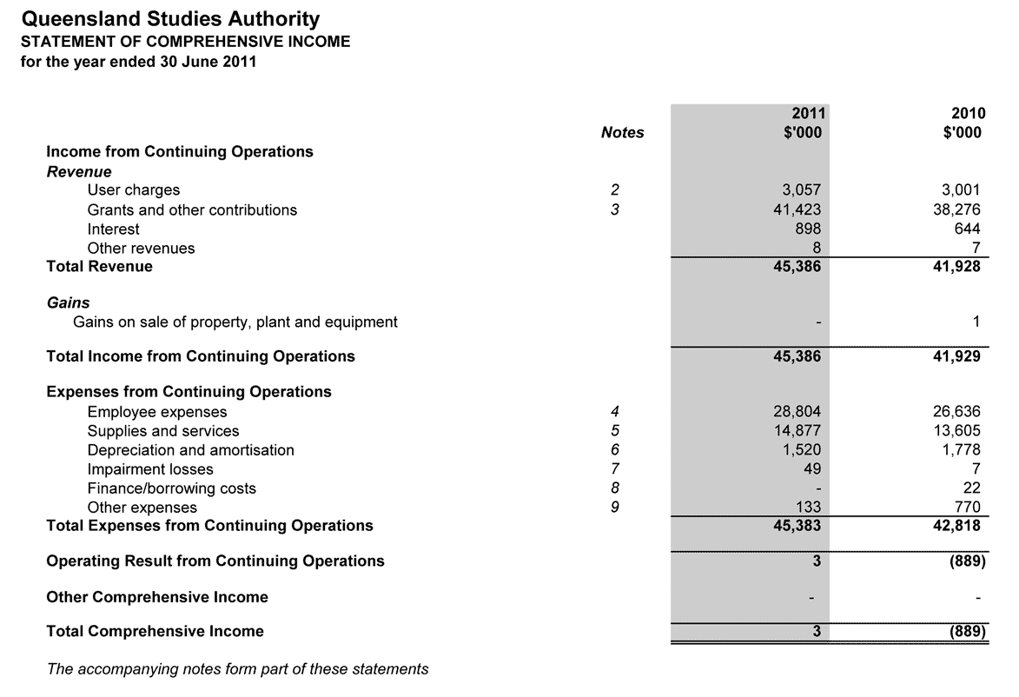

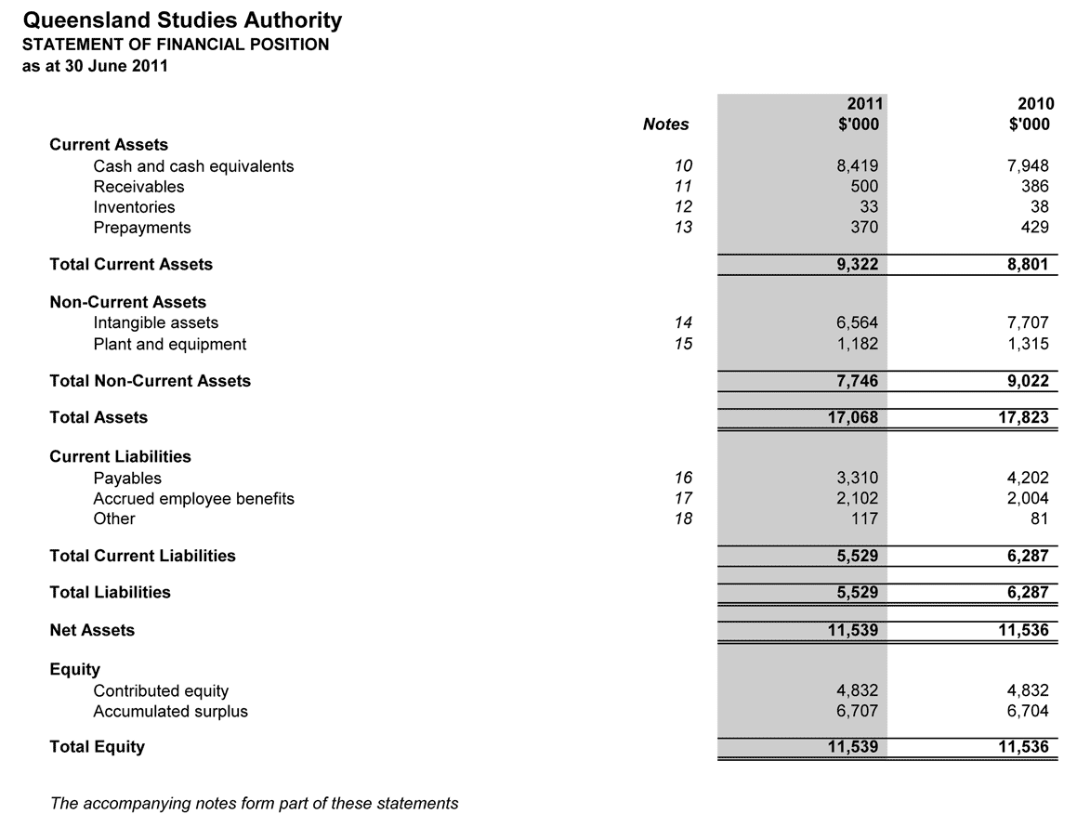

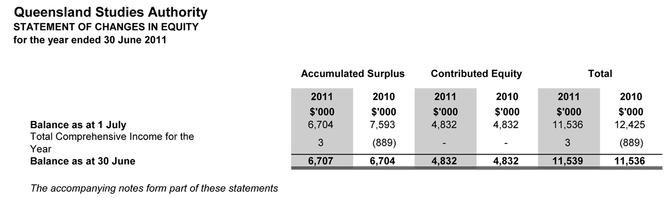

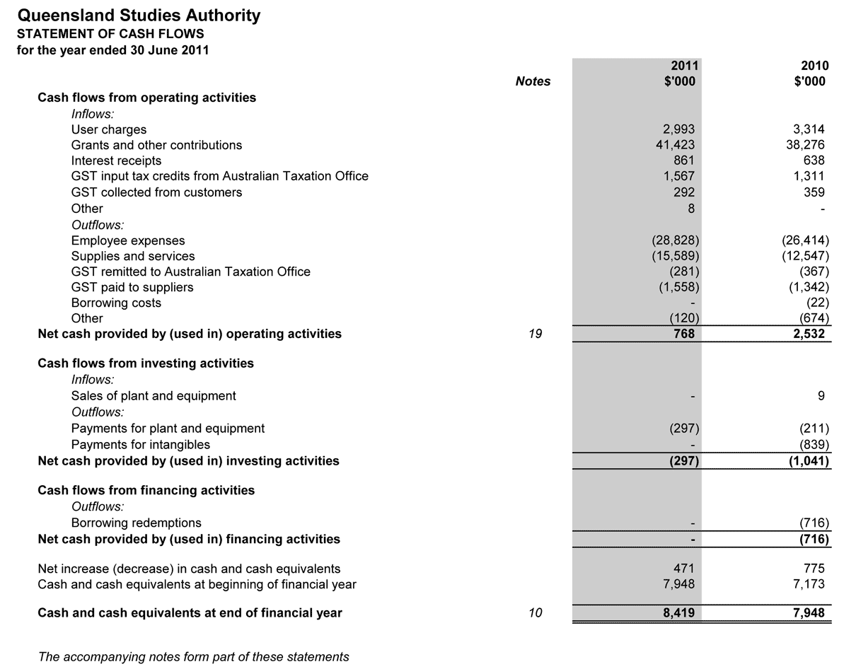

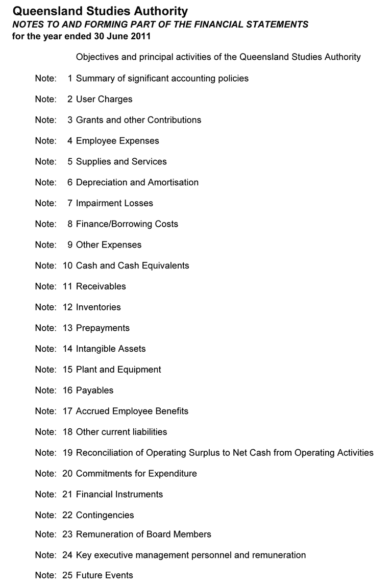

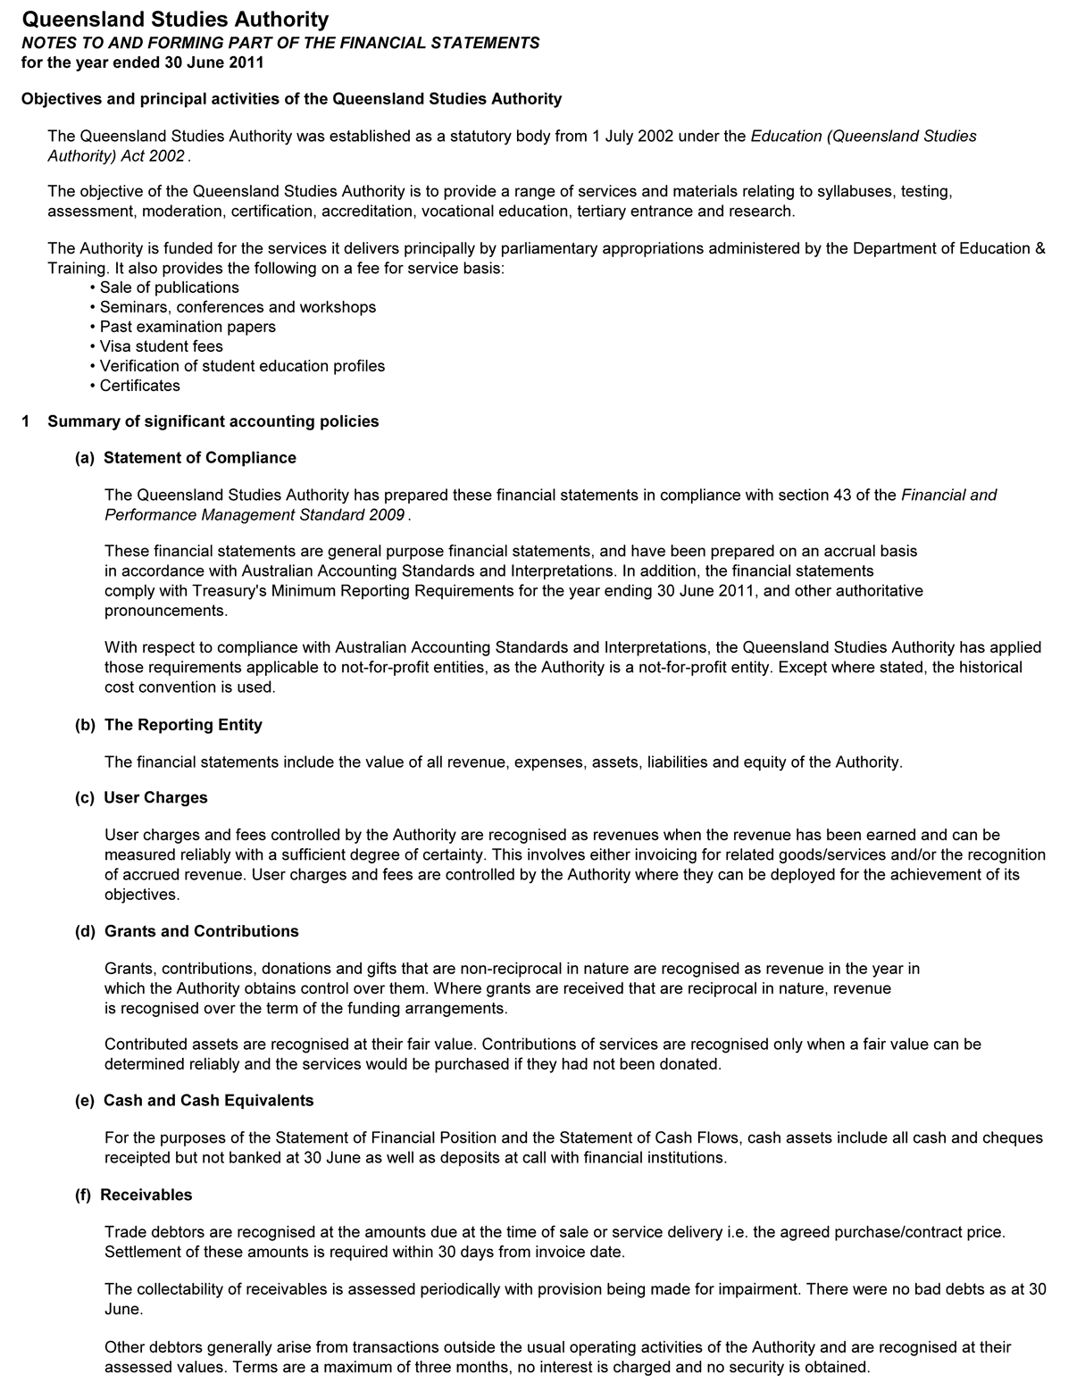

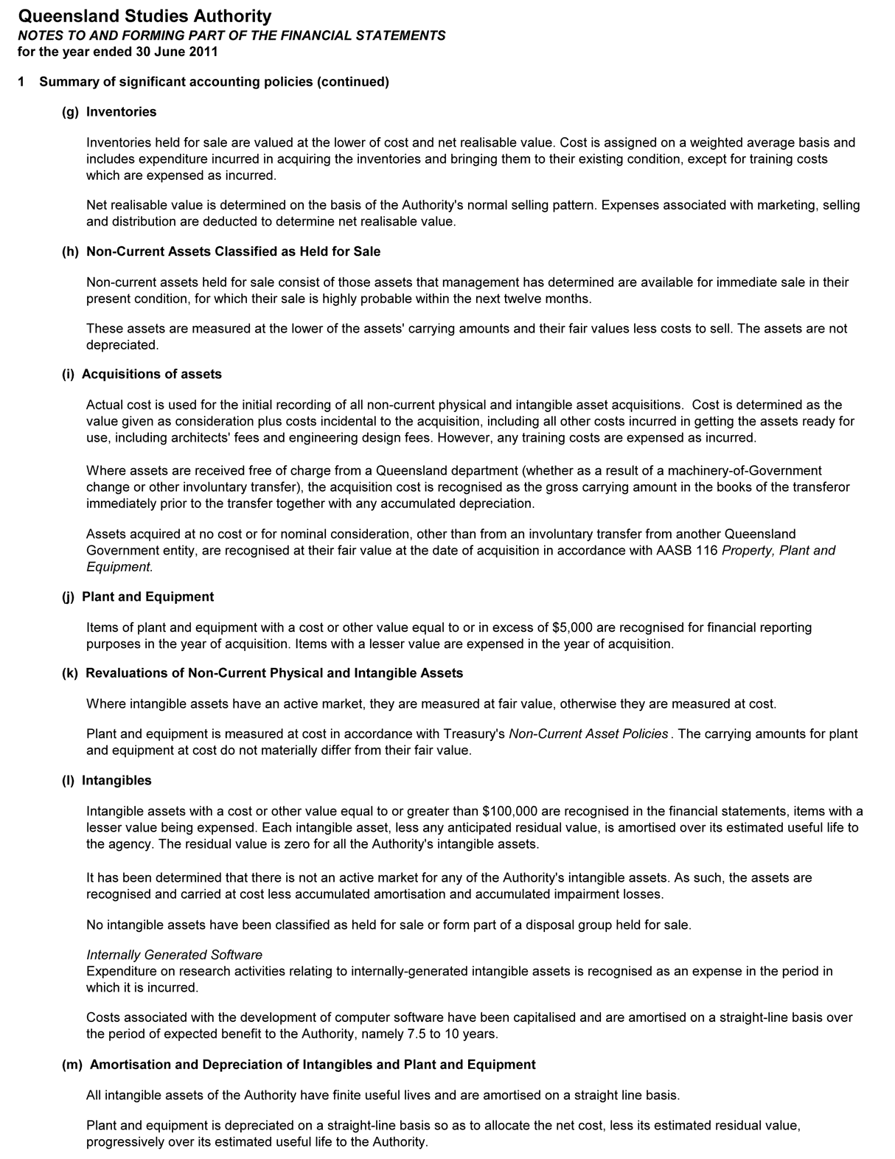

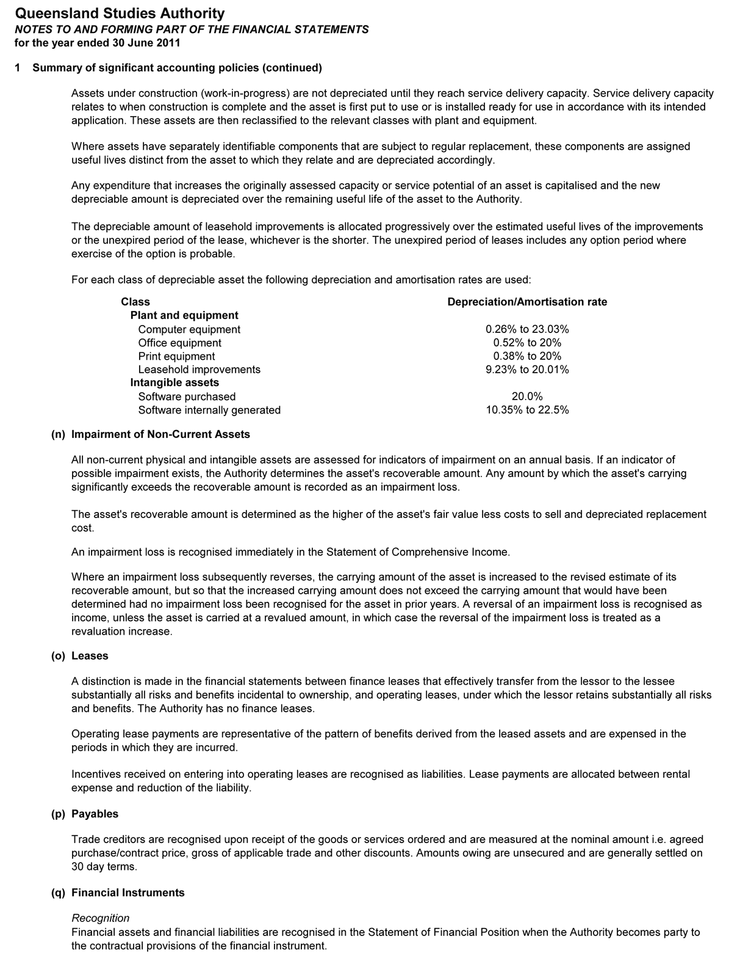

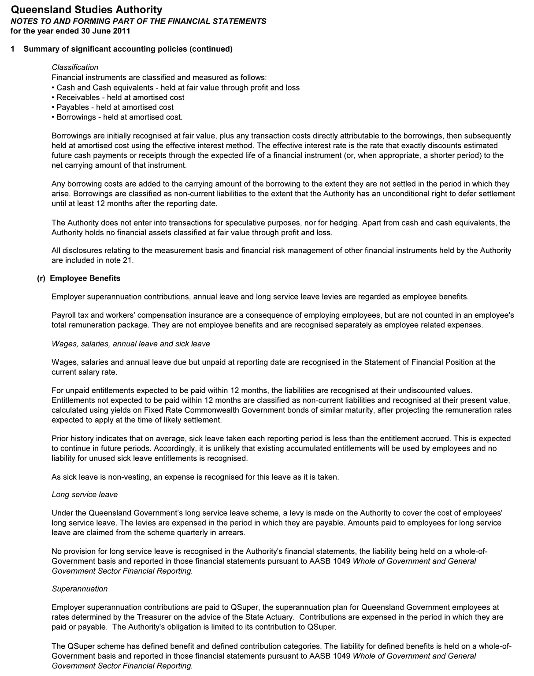

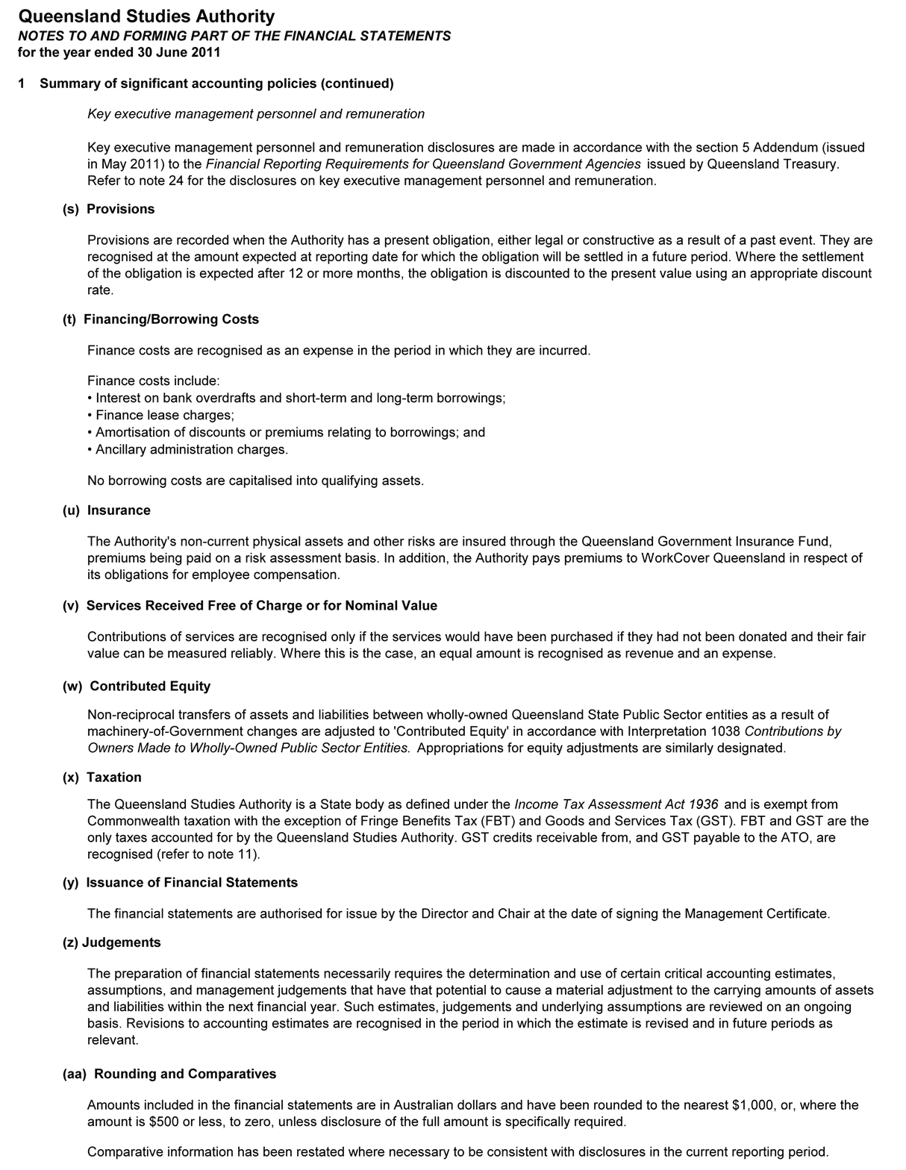

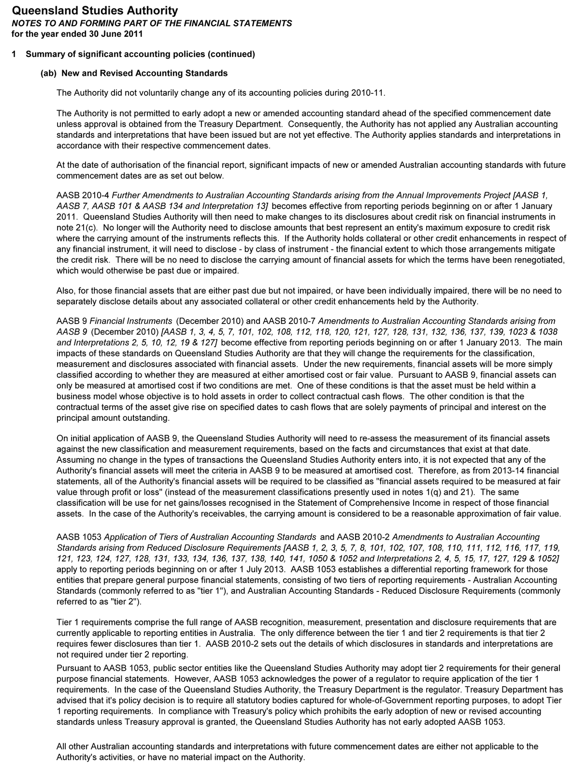

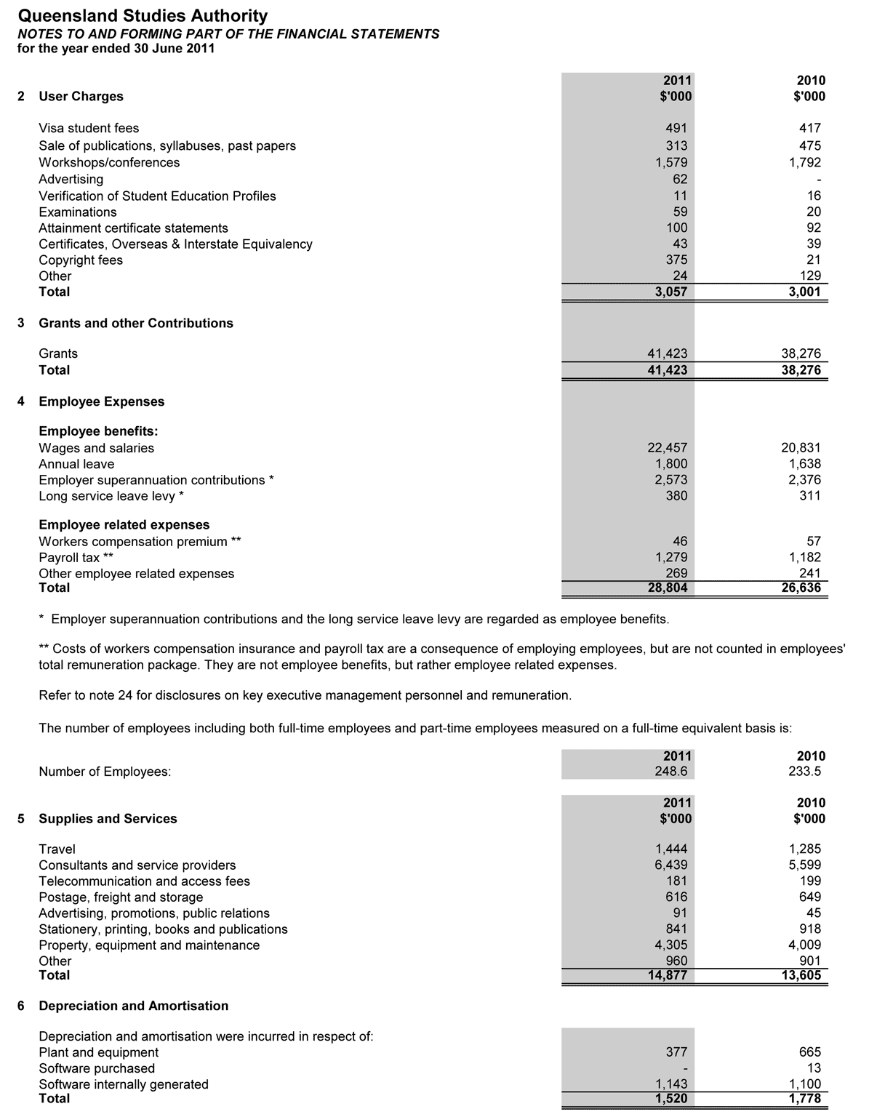

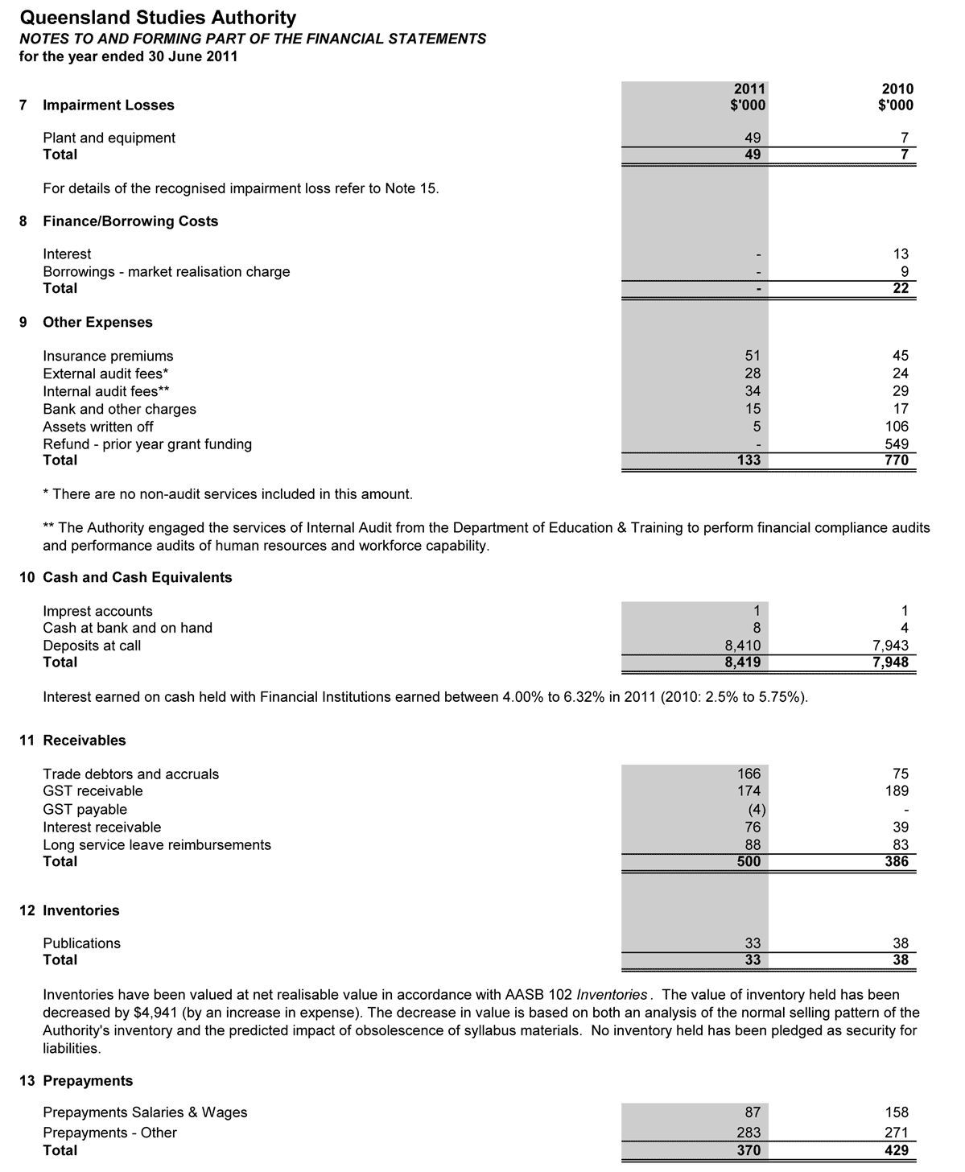

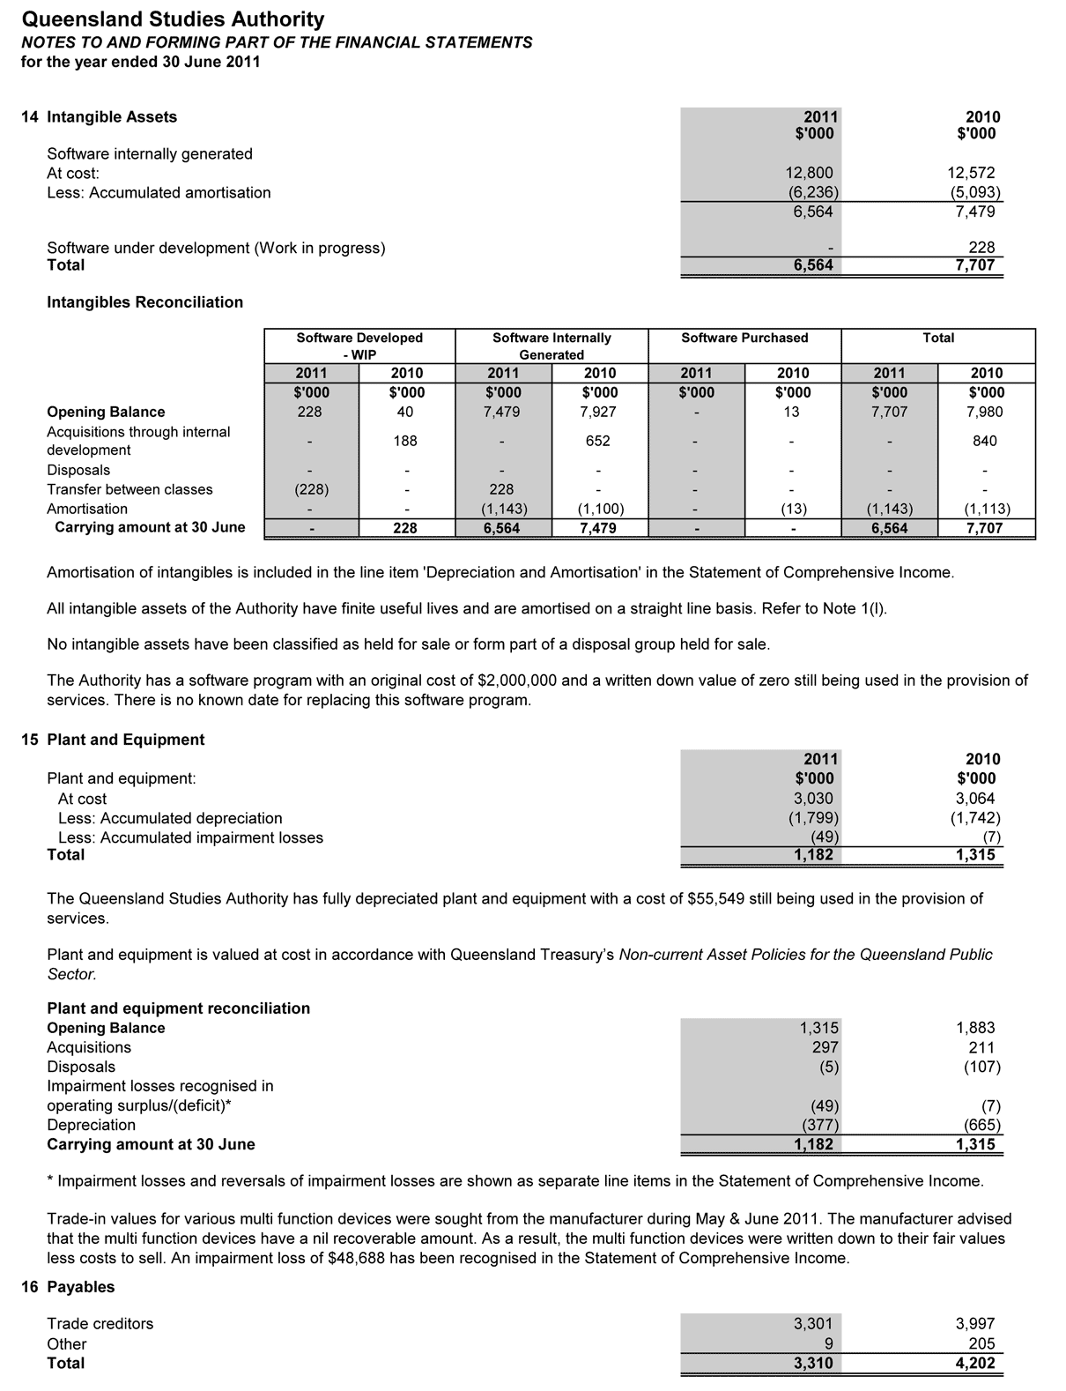

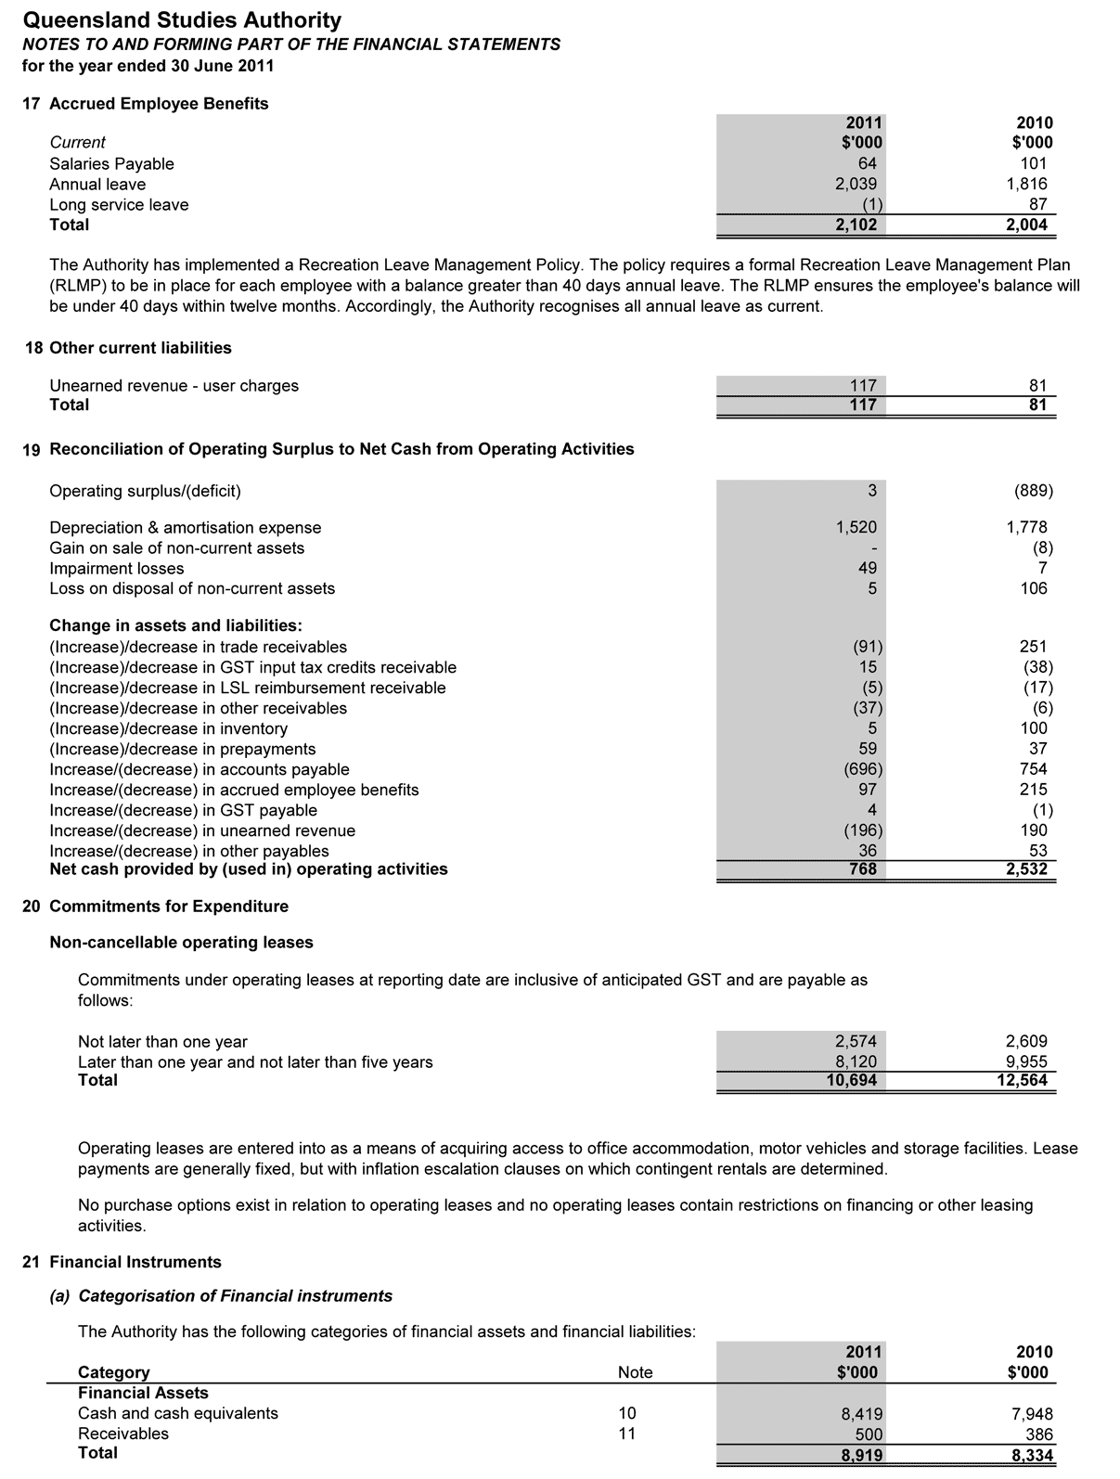

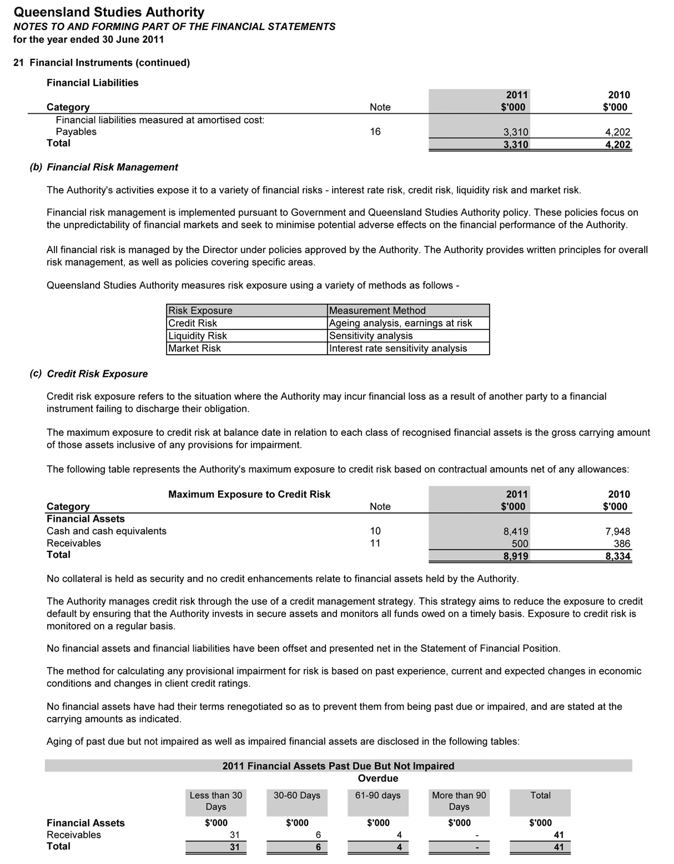

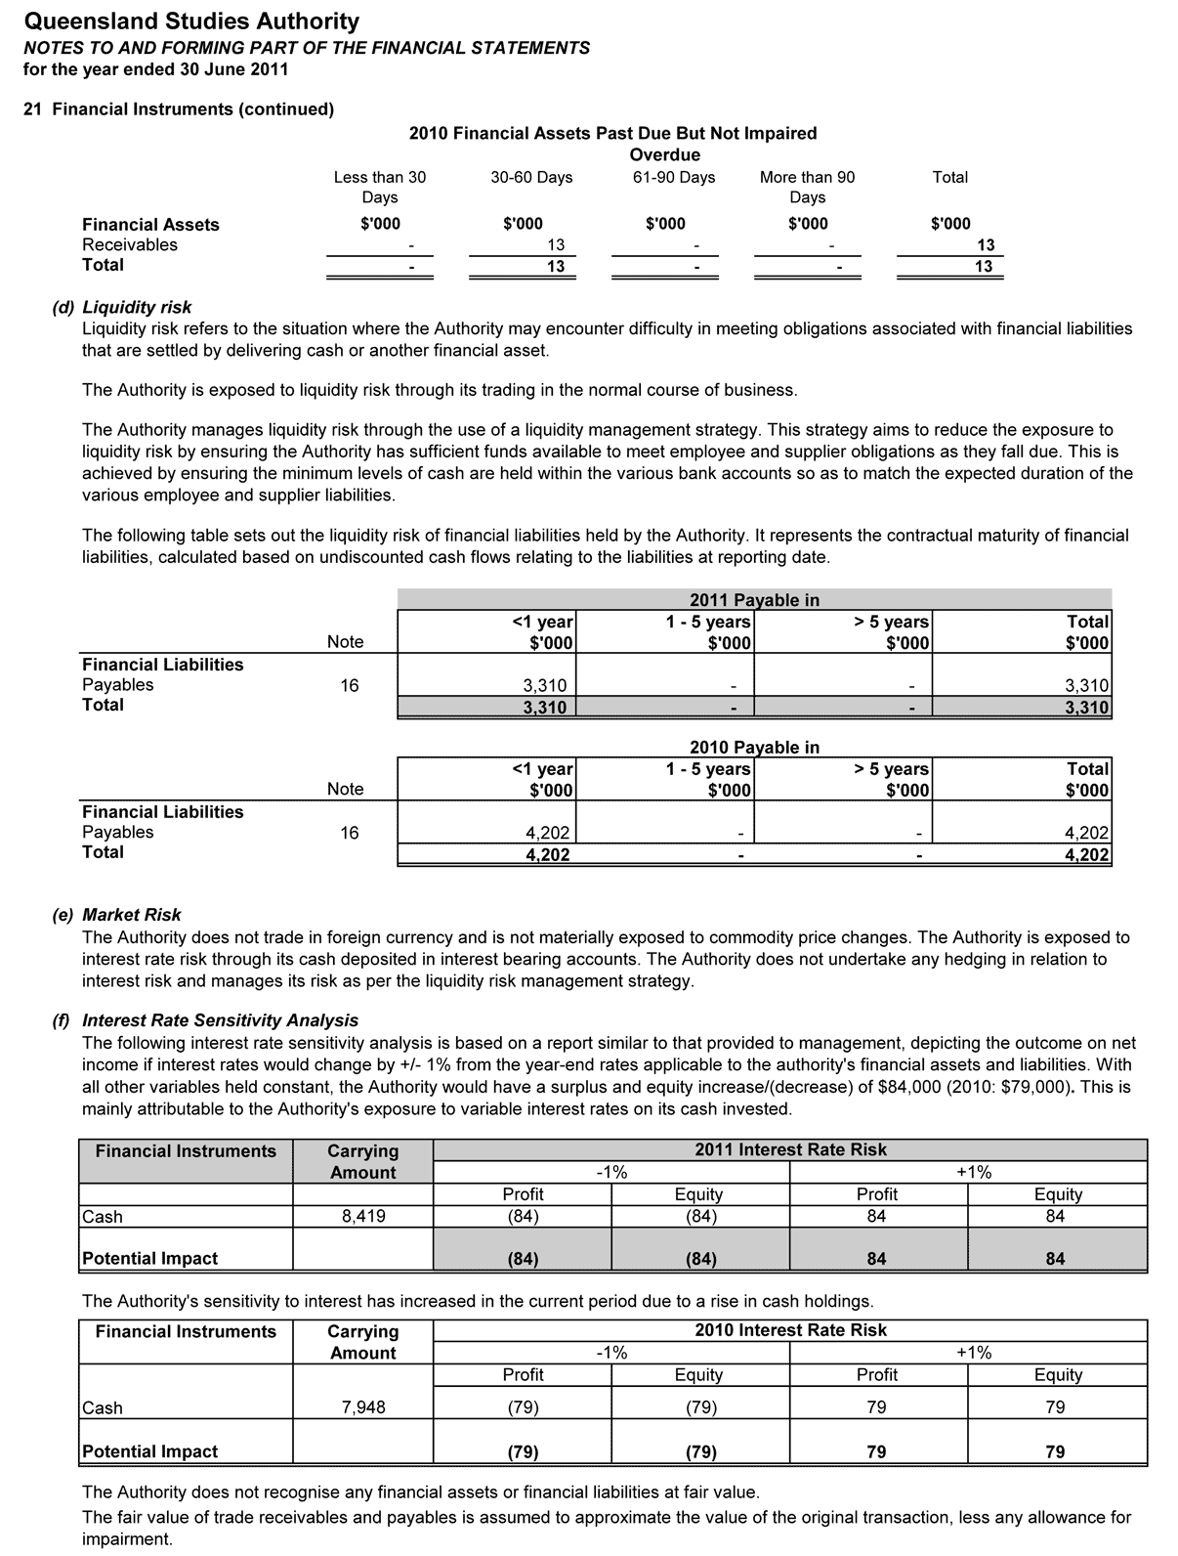

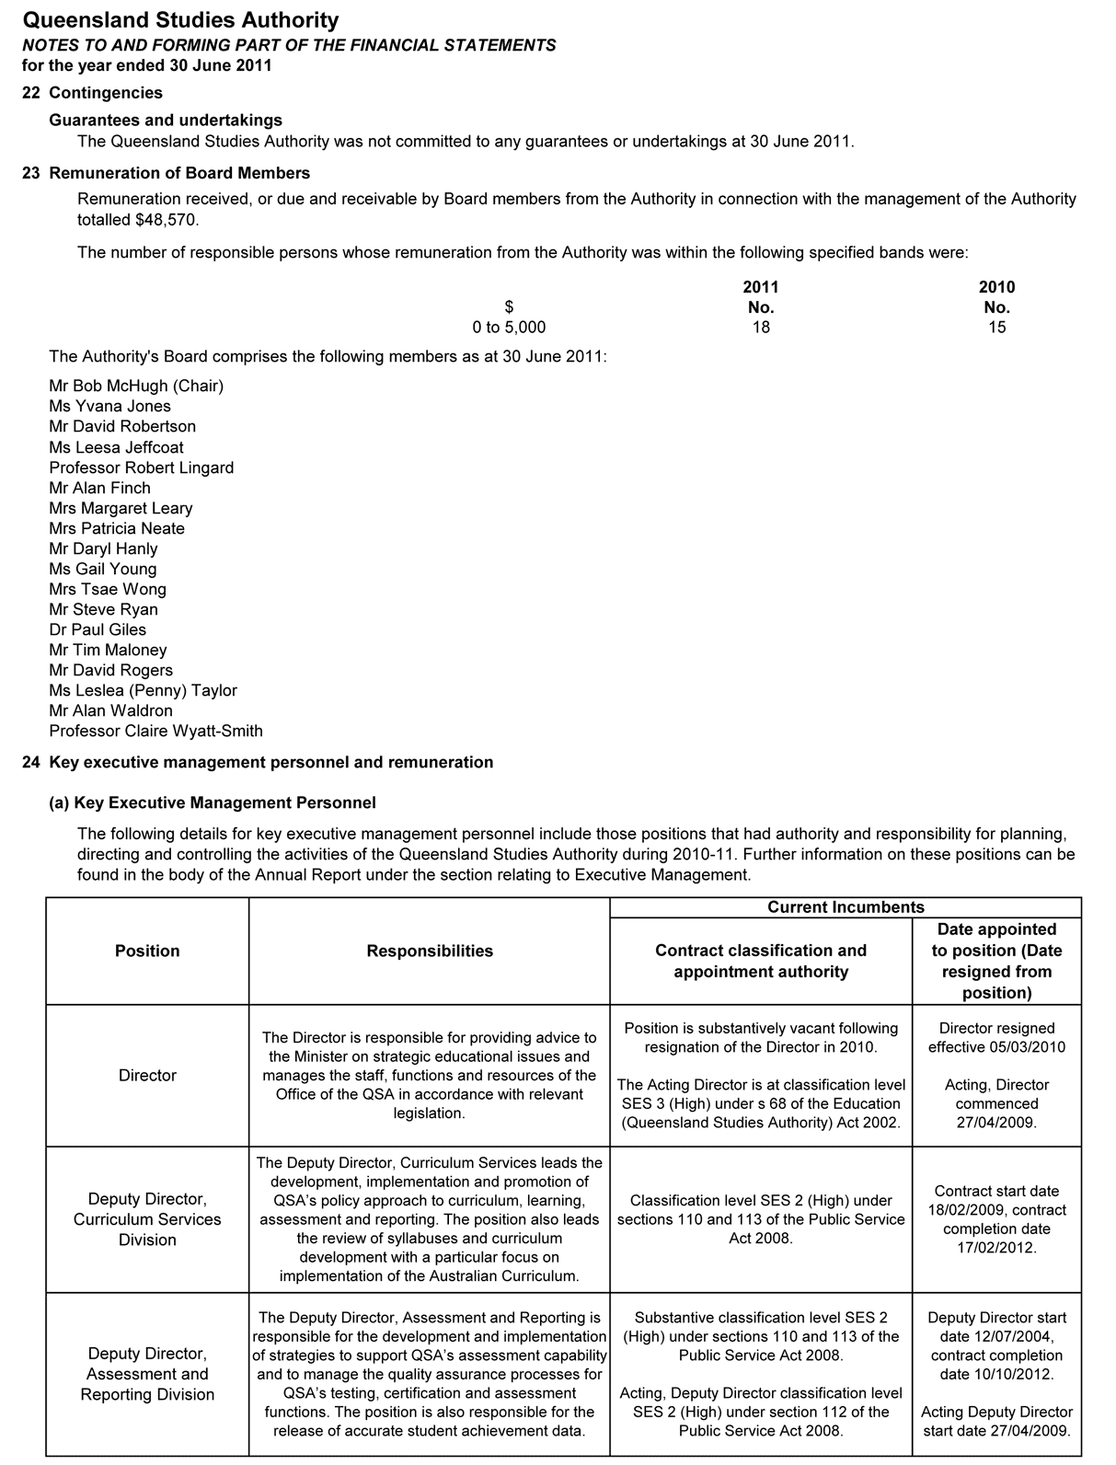

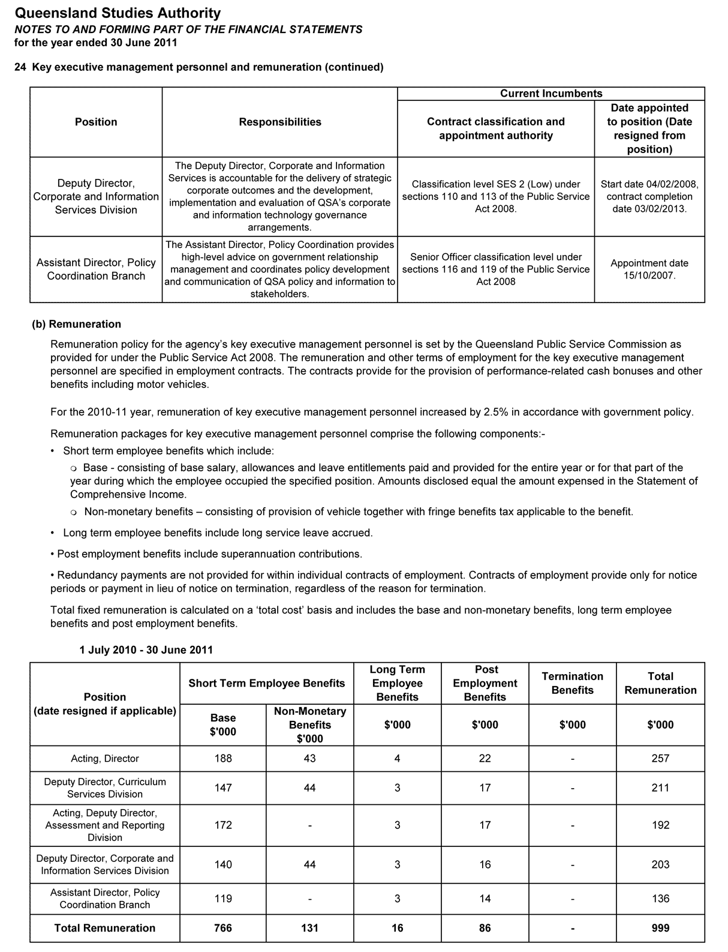

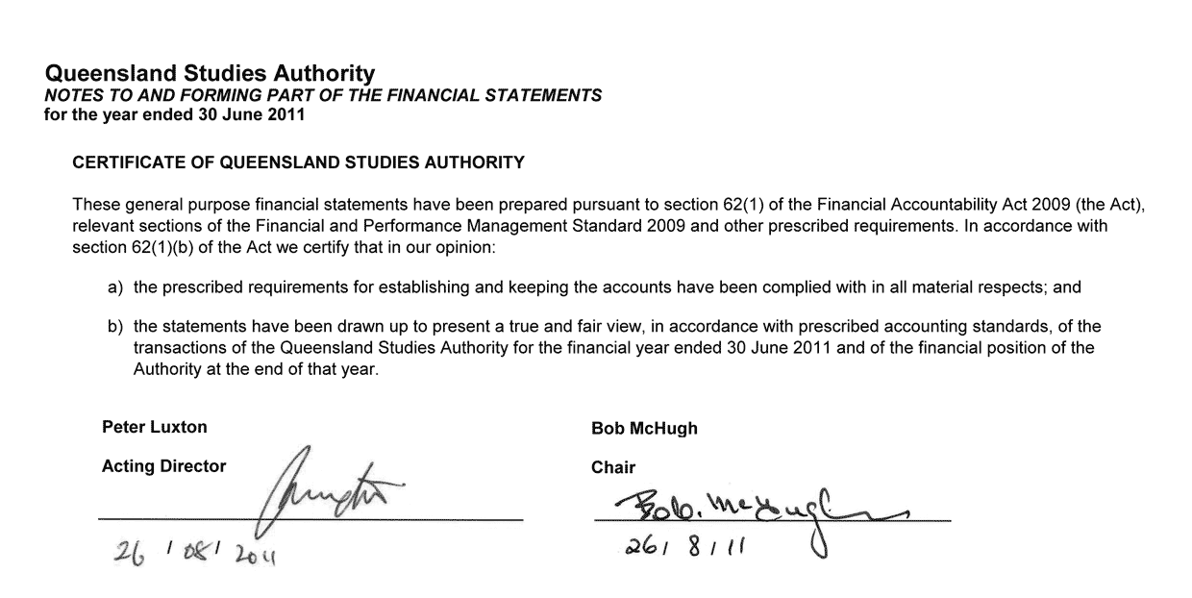

Matters relating to the electronic presentation of the audited financial report
The audit report relates to the financial report of Queensland Studies Authority (QSA) for the financial year ended 30 June 2011 included on QSA’s web site. The QSA is responsible for the integrity of the QSA’s web site. We have not been engaged to report on the integrity of the QSA web site. The audit report refers only to the statements named below. It does not provide an opinion on any other information which may have been hyperlinked to/from these statements. If users of the financial report are concerned with the inherent risks arising from electronic data communications they are advised to refer to the hard copy of the audited financial report, available from QSA, to confirm the information included in the audited financial report presented on this website.

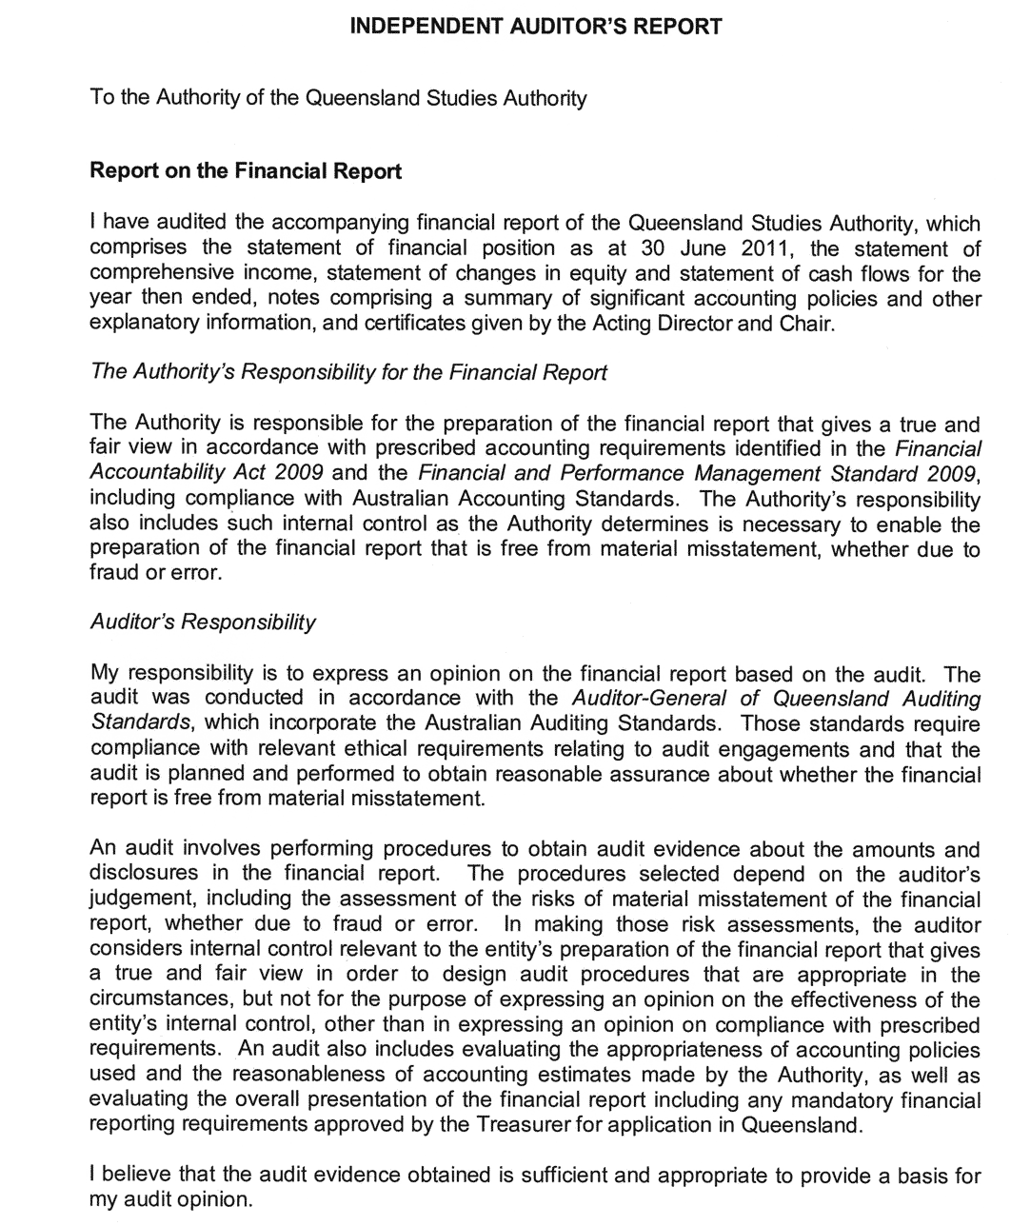
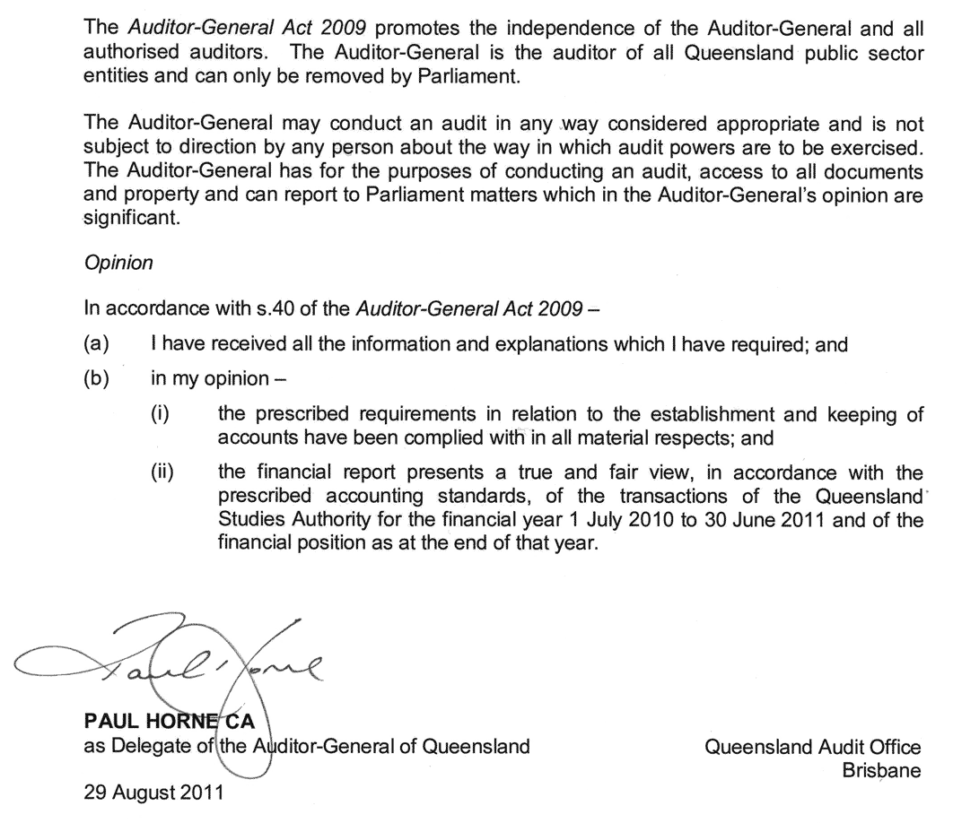

Appendixes

Schedule of consultancies
Consultancies during 2010–11 included:
Category | Expenditure
Curriculum, assessment and certification | $140 259
Review of event management ICT system | $6 200
Total consultancy expenditure | $146 459

Schedule of overseas travel
Name of officer and position | Destination | Purpose | Cost to QSA | Contribution from other agency
Andrew Edwards, Project Officer and Gary Jorgensen, Administration Officer, QCS Test Unit | Singapore | Took part in QCS Test equating undertaken annually as part of the quality assurance process to collect data from a non-Queensland based student population. | $6 208 | Nil
Paul Herschell, Deputy Director, Curriculum Services Division and Leanne Rolph, Assistant Director, P–12 Implementation Branch | Thailand | Presented papers on externally moderated standards-based assessment policy at the 2010 International Association for Educational Assessment conference. | $7 451 | Nil
Peter Luxton, Acting Director | South Korea | Presented a paper on Emerging Schooling Issues for 21st Century Demands at the 2010 Global HR Forum. | $1 218 | $6 343  Korean Ministry of Education, Science and Technology
Shauna Bouel, Senior Education Officer, Quality Assurance Unit | South Korea | Participated in the 2010 Korean Studies Workshop Program. | $2 355 | $12 500  Korean Foundation

Fees paid to Board members
A total of $48 570 was payable to Authority members in 2010–11. This amount does not include associated meeting and travel costs of $14 469.

Voluntary Early Retirement (VER)
No QSA employees were offered a Voluntary Early Retirement package during the
2010–11 financial year.

Committees of the Authority
The Authority has established ten committees to work on specific areas. Subcommittees were established as necessary to support these committees.
- Aboriginal and Torres Strait Islander Education Committee
Functions are to:
- provide advice and direction to the Authority and Director of the QSA on:
- ensuring that the QSA’s products and services meet the educational needs of Aboriginal young people and Torres Strait Islander young people
- syllabus development, assessment, testing and reporting issues (including new QSA initiatives) as they relate to the education of young Aboriginal and Torres Strait Islander people, and education about both Aboriginal peoples and Torres Strait Islander peoples
- ensuring Indigenous representation on Authority committees and other QSA consultative mechanisms
- policy issues, particularly equity and social justice issues, as they relate to the education of Aboriginal young people and Torres Strait Islander young people
- be the primary mechanism for the QSA to consult with Aboriginal and Torres Strait Islander communities on QSA matters
- provide a two-way communication forum for Indigenous perspectives on QSA activities, and as a communication between the QSA and Indigenous communities.
Membership comprises:
- chair — Authority member with expertise in the education of Aboriginal young people and/or Torres Strait Islander young people
- one nominee of the joint parent body
- one nominee of the Queensland Indigenous Education Consultative Committee (QIECC)
- one senior officer from the Department of Education and Training (education)
- one senior officer from the Department of Education and Training (training)
- one nominee from the Queensland Catholic Education Commission (QCEC)
- one nominee from Independent Schools Queensland (ISQ)
- one nominee from Education Queensland (EQ)
- four teachers representing each of the state, Catholic and independent school sectors (preferably an early years teacher, a secondary teacher, a primary teacher and a school principal)
- one nominee of the Queensland Teachers’ Union
- one nominee of the Queensland Independent Education Union
- one nominee of the Torres Strait (Torres Strait Islander Regional Education Council)
- one representative from the Cape York education community
- one representative of the tertiary education sector
- QSA’s Principal Education Officer (Indigenous Education)
- one QSA senior officer
- executive officer — QSA officer.
- Accreditation Committee
Functions are to:
- assess applications for accreditation and re-accreditation of non-Authority syllabuses and guidelines
- provide oversight of the accreditation process for accreditation and re-accreditation of non-Authority syllabuses and guidelines
- provide recommendations to the Authority about the accreditation and re-accreditation of non-Authority syllabuses and guidelines.
Membership comprises:
- chair — Authority member
- three nominees of the education sector (one each from QCEC, ISQ and EQ)
- two union nominees
- one QSA senior officer
- executive officer — QSA officer.
- Assessment, Moderation and Certification Committee
Functions are to:
- determine and approve procedures for assessment, moderation and certification within the approved policies of the Authority
- consider matters referred to it from, and to refer matters for consideration to, its subcommittees
- identify and advise the Authority on strategic issues relating to future developments in assessment, moderation and certification.
Membership comprises:
- chair — Authority member
- three nominees from the education sectors (one each from QCEC, ISQ and EQ)
- one nominee of the employment and training sector
- two syllabus advisory committee chairs
- one state review panel chair
- one district review panel chair
- two school administrators (one state and one non-state)
- one primary school principal
- one tertiary educator/researcher
- one union nominee
- one parent nominee
- one QSA senior officer
- executive officer — QSA officer.
- Audit Committee
Functions are to:
- provide independent assurance and assistance to the Authority and Director of the QSA on:
- the risk control and compliance frameworks
- the agency’s external accountability responsibilities as prescribed in the Education (Queensland Studies Authority) Act 2002
- oversee internal and external audit services
- review strategic risk assessment
- monitor improvement strategies to reduce and mitigate against risk.
The Audit committee has observed the terms of its charter and had due regard to Queensland Treasury’s Audit Committee Guidelines.
During 2010–11, the committee was responsible for overseeing the process of revising the strategic risk assessment and the initiatives pursued to reduce and mitigate against the identified risks. The committee’s charter was reviewed in accordance with the Performance Management Standard and Queensland Treasury’s Audit Committee Guidelines.
Membership comprises:
- Chair — Authority member
- external member — Authority member
- one member who has “financial expertise” as described in the Queensland Treasury publication, Audit Committee Guidelines — Improving accountability and performance 2008
- one member with expertise in the industry in which the agency operates.
- Equity Committee
Functions are to:
- provide expertise and advice to the Authority, and the Office of the Authority, on equity issues in education, relevant to the functions of the Authority
- liaise with other committees of the Authority as required
- represent the interests of groups at educational risk in the community.
Membership comprises:
- chair — Authority member
- three nominees of the education sectors (one each from QCEC, ISQ and EQ)
- one nominee of the employment and training sector
- one nominee of the QIECC
- one practising teacher or school-based person with expertise in special education
- two parent nominees
- two union nominees
- two nominees from the higher education sector (universities)
- one nominee from the Youth Affairs Network of Queensland
- one nominee of the Queensland Anti-Discrimination Commission
- one nominee of the Queensland Guidance and Counselling Association
- one teacher of distance education
- one nominee of Queensland Association of Teachers of English to Speakers of Other Languages (QATESOL)
- one nominee of the Ethnic Communities Council of Queensland
- one QSA senior officer
- executive officer — QSA officer.
- Finance Committee
Functions are to assist the Governing Body in performing its functions by:
- overseeing the development and approval of the annual budget
- ensuring that annual resource allocations are consistent with the strategic direction and operational priorities of the QSA
- providing advice on major project and capital expenditure proposals or initiatives
- monitoring actual financial performance against budget and forecasts and providing advice on significant trends or variances
- reviewing the financial performance of major strategic initiatives
- performing any other activities consistent with this charter that the Governing Body requests.
Membership comprises:
- chair — Authority member nominated by the Chair of the Authority
- two nominees of the Authority
- executive officer — QSA officer.
- P–12 Curriculum Committee
Functions are to:
- provide advice to the Authority on the current trends in curriculum development for the early, middle and senior phases of schooling
- review syllabuses, curriculum guidelines and other materials submitted by syllabus advisory committees and make recommendations to the Authority about the suitability of such materials
- provide advice on P–12 matters that the Authority may determine.
Membership comprises:
- chair — Authority member
- three Authority members (one each from QCEC, ISQ and EQ)
- two tertiary educators
- three nominees of the education sectors (one each from QCEC, ISQ and EQ)
- one nominee of the employment and training sector
- one nominee of the Training and Employment Recognition Council
- two nominees of EQ (one each from a rural/remote area and special education)
- one nominee of parent groups
- one Indigenous education nominee
- three teacher nominees (one each from early years, middle years and senior years of schooling)
- two teacher union nominees
- one nominee of QSA
- one QSA senior officer
- executive officer — QSA officer.
- Scaling Anomalies Committee
Function: to examine mismatches between Queensland Core Skills Test data and level of achievement data provided by schools. This is part of the quality assurance processes associated with Overall Positions and tertiary entrance.
Membership comprises:
- three nominees of the education sectors (one each from EQ, QCEC and ISQ), one of which is the chair
- nominee of the tertiary sector
- three nominees of QSA
- executive officer — QSA officer.
- Tertiary Entrance Committee
Functions are to:
- monitor developments in, and assist in the provision of informed advice about, tertiary entrance matters
- provide advice on the management of information and secondary–tertiary link programs that maximise the capacity of potential tertiary applicants to make informed choices and pursue tertiary study.
Membership comprises:
- chair — Authority member
- two university admissions managers
- one TAFE admissions manager
- one guidance officer (state school sector)
- one independent school counsellor (non-state school sector)
- one nominee from the employment and training sector
- one nominee from DET’s Office of Higher Education
- one parent of a Year 11 or 12 student
- one tertiary student
- two school students (Year 11 and 12)
- one nominee from the Queensland Tertiary Admissions Centre
- one QSA senior officer
- executive officer — QSA officer.
- Vocational Education and Training Committee
Functions are to:
- provide advice to the Authority on emerging policies and issues in relation to VET in both the national and state arenas
- provide information to the Authority on issues relating to the implementation of VET in Queensland schools
- provide strategic advice to the Authority on the implementation of VET arising from the Education and Training Reforms for the Future program.
Membership comprises:
- chair — Authority member
- two nominees from the employment and training sector (to include a TAFE practitioner)
- one nominee from the Australian Council of Private Education and Training
- one industry nominee
- three nominees of the education sectors (one each from QCEC, ISQ and EQ)
- two parents with expertise in encouraging and supporting VET in schools
- three practitioners (state, non-state and TAFE) with responsibility for VET (two union representatives nominated by QTU and QIEU)
- two principals/administrators (state and non-state) with responsibility for VET
- one QSA senior officer
- executive officer — QSA officer.

Key corporate governance committee of the QSA

Strategic Directions Group
Peter Luxton, Acting Director
Paul Herschell, Deputy Director, Curriculum Services Division
Peter Jordan, Acting Deputy Director, Assessment and Reporting Division
Graham Smith, Deputy Director, Corporate and Information Services Division
John McGuire, Assistant Director, Policy Coordination Branch

QSA district offices

Brisbane Central
Helen Best
Phone: (07) 3397 3955, fax: (07) 3397 2955
433 Logan Road
Greenslopes Qld 4120
PO Box 686, Stones Corner Qld 4120

Brisbane North
Judy Beadle
Phone: (07) 3855 1672, fax: (07) 3855 1673
Everton Park SHS
Stafford Road, Everton Park Qld 4053
PO Box 642, Everton Park Qld 4053

Brisbane East
Elisabeth Case
Phone: (07) 3324 1072, fax: (07) 3397 2955
433 Logan Road
Stones Corner Qld 4120
PO Box 686, Stones Corner Qld 4120

Brisbane South
Sally Dwyer
Phone: (07) 3808 9133, fax: (07) 3208 2633
Springwood SHS
Springwood Road, Qld 4127
PO Box 2138, Logan City DC 4114

Brisbane–Ipswich
Andrew Sycz
Phone: (07) 3202 3325, fax: (07) 3202 3347
Unit 2/56 Cascade Street, Raceview Qld 4305
PO Box 860, Booval Qld 4304

Cairns
Carol Mcllwain
Phone: (07) 4054 6278, fax: (07) 4054 3943
455 Mulgrave Rd, Earlville Qld 4870
PO Box 122, Earlville 4870

Gold Coast
Sylvia Richardson
Phone: (07) 5591 4255, fax: (07) 5591 4461
1/8 Short Street, Southport Qld 4215
PO Box 2005, Southport Qld 4215

Mackay
Sandra Cain
Phone: (07) 4953 0977, fax: (07) 4953 0988
Mercury House
38 Wellington Street, Mackay Qld 4740
PO Box 8163, Mt Pleasant Qld 4740

Rockhampton
Keren Chillingworth and Dian Hamilton
Phone: (07) 4927 7279, fax: (07) 4922 6574
Room 8, North Street Annex
Cnr North and West Streets, Rockhampton Qld 4700
PO Box 919, Rockhampton Qld 4700

Sunshine Coast
Amanda Poeppmann
Phone: (07) 5493 9452, fax: (07) 5493 9451
Shop 3A
710 Nicklin Way (Cnr Erang Street), Curramundi Qld 4551
PO Box 44, Wurtulla Qld 4575

Toowoomba
Peter Wedgwood
Phone: (07) 4638 3699, fax: (07) 4638 5390
B Block, Toowoomba North SS
Mort and Taylor Streets, Toowoomba Qld 4350

Townsville
Nola Popowycz
Phone: (07) 4728 8485, fax: (07) 4728 8486
F Block, Heatley Secondary College
Hanlon Street, Heatley Qld 4814
PO Box 207, Aitkenvale Qld 4814

Wide Bay
Diane Armstrong
Phone: (07) 4123 1612, fax: (07) 4121 6811
Maryborough SHS
Block Z, Rooms 814–817
Sussex Street
Maryborough Qld 4650
PO Box 452, Maryborough Qld 4650

Reader evaluation of the QSA Annual Report 2010–11
Please take some time to answer the following questions, to help the QSA communicate effectively with you. To indicate your response, please circle the appropriate number for each question as follows:
0 = Unable to respond | 1 = Very poor | 2 = Poor | 3 = Acceptable | 4 = Very good | 5 = Excellent

Did the Annual Report achieve its communication objectives? (see page 2)
0 1 2 3 4 5
What did you think of the content?
Value of information
0 1 2 3 4 5
Presentation
0 1 2 3 4 5
Did the design of the report make it easy to read?
Layout of information
0 1 2 3 4 5
Type and colour
0 1 2 3 4 5
Overall, how would you rate the report?
0 1 2 3 4 5

Please return to:
Policy Coordination
Queensland Studies Authority
Reply Paid 307, Spring Hill QLD 4004
Fax: (07) 3864 0318
What client group do you come from?
(Please tick appropriate box)
School staff
State
Catholic
Independent
Student
Secondary
Tertiary
Education authority
Stat
Catholic
Independent
Parent
State
Catholic
Independent
Tertiary institution
University
TAFE
Union
Employer
Queensland Government

Other comments

Abbreviations and acronyms
ACACA Australasian Curriculum, Assessment and Certification Authorities
ACARA Australian Curriculum, Assessment and Reporting Authority
AEE Alliance for Excellence in Education
AQF Australian Qualifications Framework
AQTF Australian Quality Training Framework
ASQA Australian Skills Quality Authority
CCAFL Collaborative Curriculum and Assessment Framework for Languages
CIS Career Information Service
DEEWR Department of Education, Employment and Workplace Relations
DET Department of Education and Training
EQ Education Queensland
ESL English is their Second Language
F Foundation
FP Field Position
HPE Health and Physical Education
IAEA International Association for Educational Assessment
ICT Information and communications technology
IP intellectual property
ISQ Independent Schools Queensland
K Kindergarten
KLA key learning area
LARC Learning Area Reference Committee
NALSSP National Asian Languages and Studies in Schools Program
NAPLAN National Assessment Program — Literacy and Numeracy
OECEC Office of Early Childhood Education and Care
OP Overall Position
P, Prep Preparatory Year
QATESOL Queensland Association of Teachers of English to Speakers of Other Languages
QCAR Queensland Curriculum, Assessment and Reporting (project/Framework)
QCAT Queensland Comparable Assessment Task
QCE Queensland Certificate of Education
QCEC Queensland Catholic Education Commission
QCIA Queensland Certificate of Individual Achievement
QCS Queensland Core Skills (Test)
QEPR Queensland Education Performance Review
QIECC Queensland Indigenous Education Consultative Committee
QIEU Queensland Independent Education Union
QKLG Queensland kindergarten learning guideline
QSA Queensland Studies Authority
QTAC Queensland Tertiary Admissions Centre Ltd
QTU Queensland Teachers’ Union
RTO registered training organisation
SAI Subject Achievement Indicator
SAS study area specification
SCOPE Stanford Centre for Opportunity Policy in Education
SEP Senior Education Profile
SET Senior Education and Training (Plan)
SHS state high school
SLIMS Senior Learning Information Management System
TAFE Technical and Further Education
TERC Training and Employment Recognition Council
VER voluntary early retirement
VET vocational education and training

Queensland Studies Authority
154 Melbourne Street, South Brisbane
PO Box 307 Spring Hill
QLD 4004 Australia
T +61 7 3864 0299
F +61 7 3221 2553
www.qsa.qld.edu.au

Department of Education, Employment and Workplace Relations 2010, “Early Years Learning Framework”, accessed Aug 2010, www.deewr.gov.au/Earlychildhood/Policy_Agenda/Quality/Pages/EarlyYearsLearningFramework.aspx
Queensland Government 2002, Queensland the Smart State — Education and Training Reforms for the Future: A white paper, Brisbane

