Healthy food choices
Teacher guidelines
Beginner Stage Year 8 | Languages — Japanese
Students use written Japanese to describe healthy foods and healthy eating habits.
Context for assessment
This assessment targets choices made by young people about the foods they eat and develops their awareness of healthy food choices. Students describe the foods they eat and their eating habits in Japanese, then explains the differences between languages and cultures in terms of the written scripts used to describe food
(e.g. katakana for borrowed words).

© The State of Queensland (Queensland Studies Authority) and its licensors 2010

This assessment gathers evidence of learning for the following Essential Learnings:
Languages Essential Learnings by the end of the Beginner Stage
Assessable elements | Ways of working
Composing texts | Students are able to:  - construct simple spoken and written texts in familiar contexts
Intercultural competence | - notice and compare aspects of their own cultures and of the target cultures.
 | Knowledge and understanding
Knowledge and understanding | Comprehending and composing in the target language  Comprehending and composing skills are used to understand language input, to convey information and to express ideas in response to needs and interests.  - Language forms, functions, grammar and vocabulary are combined with process skills and strategies to make meaning.  Intercultural competence and language awareness  Noticing and comparing similarities and differences between languages and cultures informs intercultural communication.  - Languages and cultural practices have particular features, conventions, patterns and practices that may be similar to or different from one’s own language and culture.
Source: Queensland Studies Authority 2007, Languages Essential Learnings by the end of Beginner Stage, QSA, Brisbane.

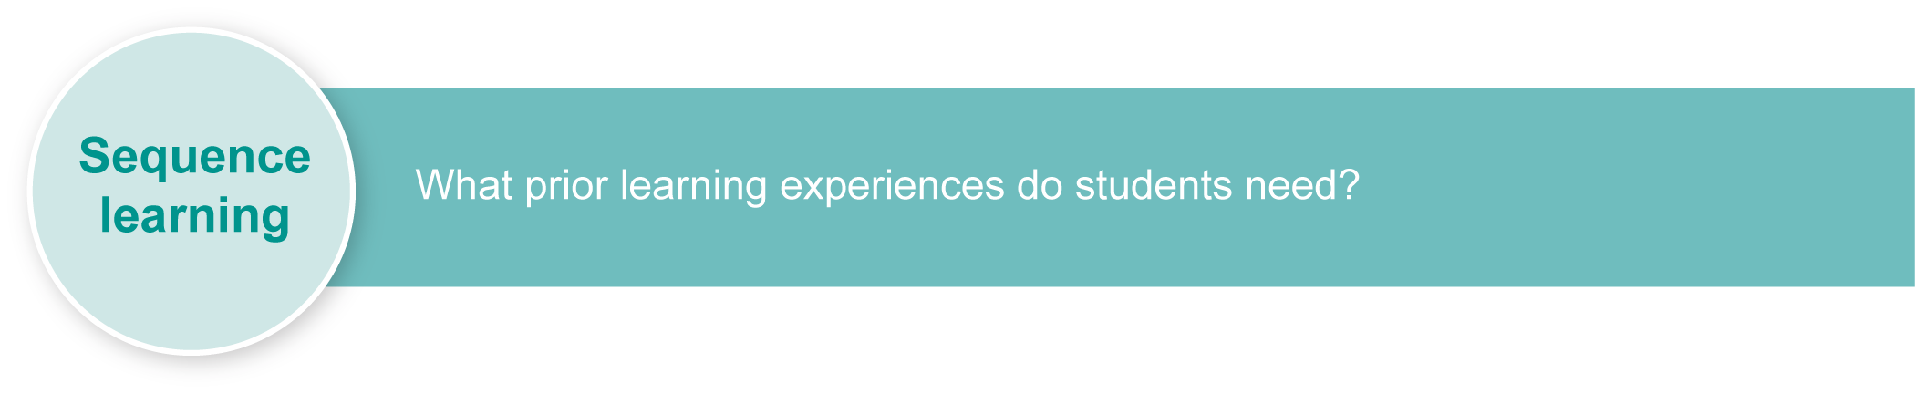
Listed here are suggested learning experiences for students before implementing this assessment.
- Listen to class members talk about what they might eat in a day. Use this information to construct a bar graph showing the number of servings of particular foods the class eats.
- Investigate types of food that should be eaten every day for good health and those that should be eaten only occasionally.
- Survey the food likes and dislikes of class members and whether their daily habits meet nutritional recommendations.
- Investigate the range of food categories available from the school’s tuckshop.
- Analyse food labels to determine the nutritional value of various foods.
- Read menus in Japanese and compare with similar English menus (e.g. McDonalds and other fast food chains).
- Keep a food habits diary for a weekend.
- Compare foods eaten in Australia and Japan. See Appendix A: Japanese web resources.
- Discuss the way menus are written and presented in Japan.
- Research foods used for special occastions in Japan and Australia.
- Research the origins of the Japanese scripts, particularly katakana.
- Identify similarities and compare differences between the language used to describe food in Japanese and English. Discuss how languages and cultural practices have specific characteristics that can be the same or different.
- Write a note to the editor of a health food magazine explaining and justifying food habits and choices. See Appendix B: Indicative language exponents and optional Assessment-related resource: Genkoo yooshi.
- Design a poster to illustrate the interrelationship of energy needs, nutrients and foods.
- Investigate special dietary requirements.
- Examine a particular lifestyle and plan a balanced menu.
- Develop a balanced menu to suit own or someone else’s lifestyle. Write a short paragraph explaining why the menu suits the lifestyle.
Ensure that all students have access to learning experiences. Consider the following inclusive strategies and make any required adjustments to teaching and learning to meet specific individual learning needs.
Inclusive strategies
Inclusive strategies enable a learner with disabilities to participate in learning experiences on the same basis as a learner without disabilities. This is achieved by making adjustments to the delivery or mode of assessment, without changing the way the assessment is judged or marked.
A teacher makes required adjustments to teaching, learning and assessment to enable a student with disabilities to demonstrate knowledge, skills or competencies (Disability Discrimination Act 1992 and Disability Standards for Education 2005 Cwlth).
Adjustments made to teaching, learning and assessment should not impact on judgments made about student achievement.
Adjustments to teaching, learning and assessment can be grouped into five broad areas:
- Timing — the amount of time allocated
- Scheduling — when assessment occurs
- Setting — where assessment is completed
- Presentation — how an assessment appears or is communicated to a student
- Response — how a student responds to the assessment.
Note: More than one inclusive strategy can be used.

Teacher resources
Appendix A Japanese web resources
Appendix B Indicative language exponents
Assessment-related resource Genkoo yooshi (optional)
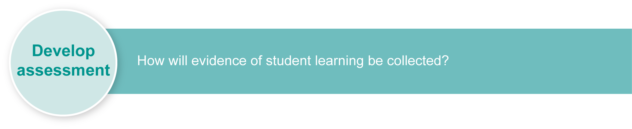
Preparing
Consider these points before implementing the assessment.
- Revise key text structures and language elements targeted for assessment. Students should have significant opportunity for practice. See Appendix B: Indicative language exponents.
- Print any relevant stimulus resources, script charts or grid paper.
- Explain each section of the assessment to the class and ensure students understand the assessment.

Resources for the assessment
Appendix B Indicative language exponents
Hiragana and katakana charts (optional)

Suggested implementation plan
Suggested time | Student activity | Teacher role
Section 1. Food habits diary
15 minutes | Review script charts — hiragana and katakana. | Distribute script charts.
1 hour | Complete the food habits diary in Japanese. | Assist as required.
Section 2. Note to the editor
1 hour | Write a 200-character note to the editor of a health food magazine. | Assist as required.
Section 3. Cultural influences
1 hour | Participate in discussion on the use of words from other languages. | Facilitate discussion.
1 hour | Complete the table and answer questions. | Assist as required.

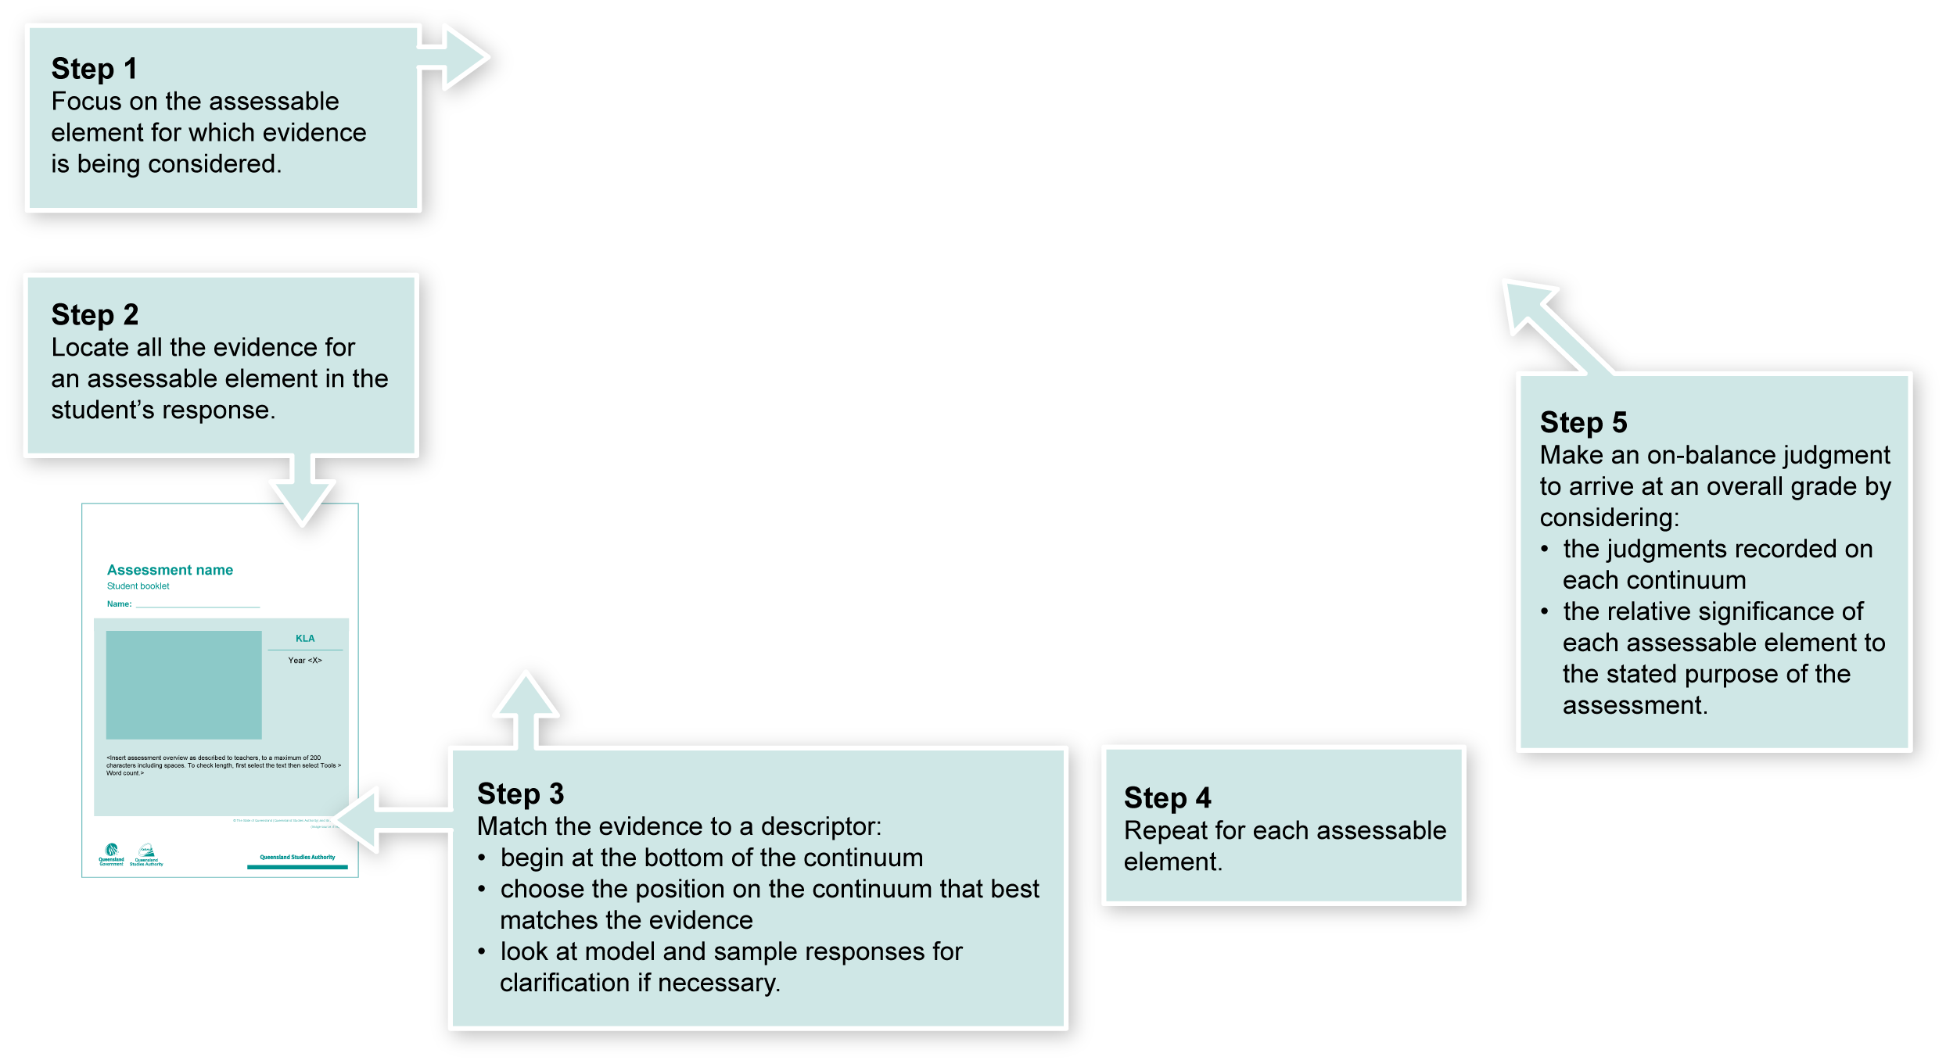
Using the Guide to making judgments (GTMJ)
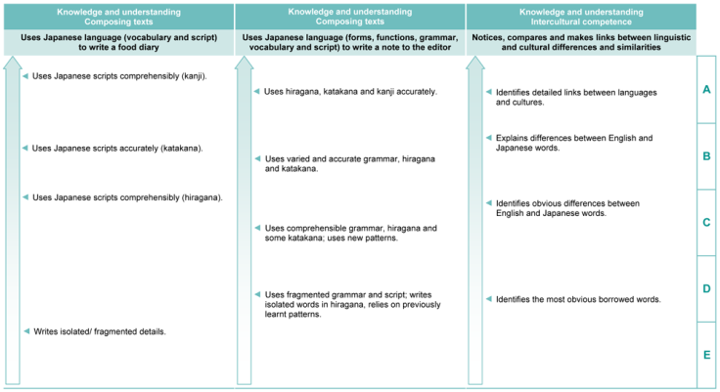

Making judgments about this assessment
In this assessment teachers have been asked to make A to E judgments around the identified Assessable elements.

Where to find the evidence
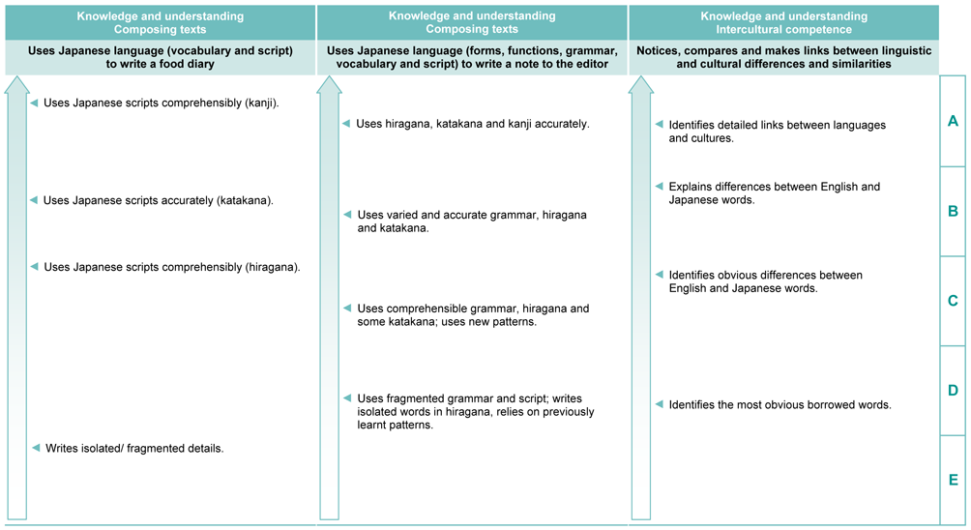
Demonstrated in Section 2 of the Student booklet.
Look for evidence of:
- composing a simple letter to the editor using all three Japanese scripts.
Demonstrated in Section 3 of the Student booklet.
Look for evidence of:
- making comparisons of cultural similarities and differences, specifically:
  - borrowed words (katakana).
Demonstrated in Section 1 of the Student booklet.
Look for evidence of:
- writing a variety of Japanese scripts including simple kanji.

Evaluate the information gathered from the assessment to inform teaching and learning strategies.
Involve students in the feedback process. Give students opportunities to ask follow-up questions and share their learning observations or experiences.
Focus feedback on the student’s personal progress. Emphasise continuous progress relative to their previous achievement and to the learning expectations — avoid comparing a student with their classmates.

Giving feedback about this assessment
Teachers may choose to give individual feedback to students or whole class comments as needed.
More information about providing feedback to students is contained in a series of professional development packages entitled Assessment for learning, available in the resources section of the Assessment Bank.
See <www.qsa.qld.edu.au> Prep–Year 9 > Assessment Bank.

Japanese web resources
Teachers should always check websites before recommending them to students. These websites were accessed in August and September 2008.
Japanese culture
- Search for images of Japan on Flickr photosharing website: <www.flickr.com>.
- Japan zone — travel guide, information and culture:
<www.japan-zone.com/culture/dishes.shtml>.
- Japan guide — Japan living and travel guide: <www.japan-guide.com/e/e2035.html>.
- About.com — Japanese language and culture: <http://japanese.about.com>.
- Earthy Family — Culture of Japan: <www.earthyfamily.com/J-Culture.htm>.
- Japan Culture Club, online catalogue of Japanese cultural items: <http://japan-cc.com>.
- At home in Japan — Japanese home-stay tutorial: <http://athome.nime.ac.jp>.
- Web Japan — sponsored by Japanese Ministry of Foreign Affairs (MOFA):
<http://web-japan.org>.
- Kids Web Japan — cultural information, quizzes, legends and folk tales:
<http://web-japan.org/kidsweb>.
- Japan Foundation resources: <http://momiji.jpf.go.jp/kyozai/English/index.php>.
- Culture at work — Japanese culture: <www.culture-at-work.com/jpnlinks.html>.
- Japan National Tourist Organisation: <www.jnto.go.jp/eng>.
- YesJapan.com Culture Centre: <www.yesjapan.com/culture/culture2.mv>.
- Asahi guide to Japanese culture: <www.asahi-net.or.jp/~py3y-knd/culture.html>.
- Traditional Japanese Culture and Modern Japan: <www.japanlink.co.jp/ka/home.html>.
- Japanese holidays and cultural events: http://web.mit.edu/jpnet/holidays.
- The Japan Web Guide's FAQ of Japan — Japanese festivals and celebrations: <www.thejapanfaq.com/celebrations.html>.

Japanese food
- Fast food in Japan: <www.nihongomemo.com/resources/fast-food-in-japan-webquest.htm>.
- Wikipedia on Japanese festivals: <http://en.wikipedia.org/wiki/Japanese_festivals>.
- Darkchilde's Sanctuary on the Web — Japanese food: <www.bookmice.net/darkchilde/japan/jfood.html>.
- AsiaRecipe.com — history of Japanese cuisine: <www.asiarecipe.com/japeathistory.html>.

Japanese web resources (cont.)

Language resources
- Real Kana — learn and practice hiragana and katakana <www.realkana.com>.
- Easyjapanese.org — hiragana quiz, katakana quiz, phrases, grammar, kanji flashcards: <www.easyjapanese.org>.
- Tofugu — free Japanese lessons online: <www.tofugu.com>.
- Access Japanese — interactive games for hiragana, listening, kanji and vocabulary: <www.accessjapanese.com/game.html>.
- Learning the Japanese is fun! — Year 8–12 grammar, vocabulary and games: <www.lumen.wa.edu.au/home/sumuram>.
- Quia — activities, calendar, games, webpage creation, quizzes: <www.quia.com/shared/japanese>.
- Hiragana and Katakana practice: <www.gyford.com/japanese>.
- Genki Japan!net — hiragana and katakana games, numbers, pen-pals, tutor and songs: <http://genkienglish.net/genkijapan/japanese.htm>.
- Online Language Resources for the Middle Years with students living all around Japan: <http://studio.qantm.com.au/onlinelanguageresources/main.htm>
- elanguages school — learn to speak Japanese: <http://learnjapanese.elanguageschool.net>.
- Kanji step — make a postcard in kanji: <www.kanjistep.com>.
- Curriculum Corporation — Japanese language resources: <http://studio.qantm.com.au/onlinelanguageresources/main.htm>.
- Shunko Muroya, Japanese Advisor for Alberta Education, Canada — Information and Resources for Teachers of Japanese Language: <www.nihongomemo.com>.
- Japanese picture dictionary: <www.plala.or.jp/y-naka/jiten.html>.
- Japanese language resources for teachers:
<http://loquela-education.net/course/view.php?id=21#section-3>.
- NSW Department of Education and Training Japanese Language Unit: <http://www1.curriculum.edu.au/nalsas/explorers/japanese/index.html>.

Language exponents | Example
Adjectives of description including negatives | おいしくない ですが けんこうに いい です。  まずい です けど けんこうに いい です。  やすくない です。でも、けんこうに いい です。  たかい ですが おいしい です。  おいしいですが けんこうに わるいです。
Adjective joiners | やすくて、けんこうにいいです。  べんりで、いいです。
Giving reasons | オメガ３だから けんこうに いい です。  けんこうに いい です から 食べてください。
Within sentence joiners | たかい ですが おいしい です。  まずい です けど けんこうに いい です。
Please do~ | 食べてください
Frequency | よく・ときどき・毎日・あまり・
Particles | も
Superlative | 一番いい

