Health advertisement critique
Year 9 | Health & Physical Education (HPE)
Students analyse a health advertisement that targets young people’s use of harmful substances and write a critique that includes further actions to increase the advertisement’s effectiveness.
Time allocation | This assessment will take approximately 3 hours of class time, across several sessions, to complete.
Student roles | Students may work individually or with others to:  - choose a health advertisement  - analyse and evaluate the health advertisement.  Students will work individually to:  - propose recommendations  - write their critique in report format.
Context for assessment
This assessment is designed to complement a unit of work that requires students to investigate how community health campaigns are developed to promote healthy lifestyle behaviours, and how they are used to intervene in health issues.
Research indicates that a range of factors influence the effectiveness of health campaigns, including the nature and range of strategies used, and how well they are tailored to the target group and sub-groups.
This assessment gathers evidence of learning for the following Essential Learnings:
HPE Essential Learnings by the end of Year 9
Ways of working  Students are able to:  - research, analyse and evaluate data, information and evidence  - propose, justify, implement and monitor plans or actions to achieve goals, address inequities and promote health and wellbeing, movement capacities and personal development. | Knowledge and understanding  Health  Health is multidimensional and dynamic, and influenced by actions and environments.  - Individual, group and community action, that enables people to adopt health promotion strategies, can address inequities and promote health and wellbeing, including safety.

Assessable elements
- Knowledge and understanding
- Investigating
- Planning
Source: Queensland Studies Authority 2007, HPE Essential Learnings by the end of Year 9, QSA, Brisbane.

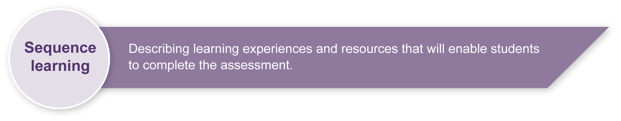
Listed here are suggested learning experiences for students before attempting this assessment.
- Research the incidence of and effects of substance use (e.g. alcohol, tobacco, other drugs) among young people.
- Analyse how personal (e.g. knowledge, beliefs, values, habits), social (e.g. peers, laws, education, campaigns), cultural (e.g. family values) and environmental (e.g. availability, social atmosphere) factors can influence use, including abstinence.
- Draw concept maps to illustrate the relationships between substance use, influencing factors and potential health outcomes.
- Identify and evaluate a range of interventions, including advertisements.
- Research the effects of various campaigns/advertisements used to influence young people and to improve health outcomes.
- Propose criteria for “what makes a good health intervention?”
- Investigate strategies used in advertisements.
- Examine structures and guidelines for developing and writing health advertisement critiques.

Preparing
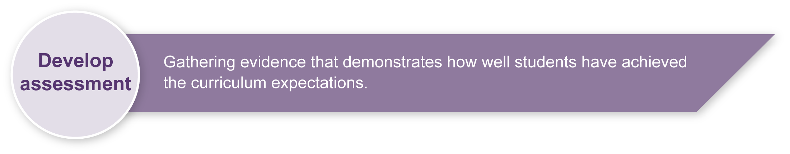
School policies
Teachers need to be aware of and observe school authority policies that may be relevant to this assessment, in particular those policies relating to sensitive issues such as substance use.

Implementation
- Read and discuss the assessment with your class.
- Support students by referring them to, and/or providing, relevant resources — for example, recordings of health advertisements that target substance use among young people, and research on the impact of advertising campaigns on people’s use of substances (refer to the Resources in these Teacher guidelines).
- Discuss the structure for developing a health advertisement critique (refer to the Guide to writing health advertisement critiques in the Student booklet).
- Insist that students do not base their critique on the advertisement used in class learning experiences.

Resources for the assessment
The references below provide links to advertisements such as television and radio commercials and posters, and other articles that can support student completion of the assessment.
- Australian Government, Department of Health and Ageing, Australian National Tobacco Strategy 2004–2009, accessed 14 Feb 2008, <www.health.gov.au/internet/wcms/publishing.nsf/Content/phd-pub-tobacco-tobccstrat2-cnt.htm>.
- Australian Government, Department of Health and Ageing, National Alcohol Campaign, accessed 14 Feb 2008, <www.alcohol.gov.au>.
- Australian Government, Department of Health and Ageing, National Drugs Campaign [home page], accessed 14 Feb 2008, <www.drugs.health.gov.au/internet/drugs/publishing.nsf/Content/home >. (This home page provides links to information about the National Drugs Campaign strategy, research and campaign resources for young people.)
- Australian Government, Department of Health and Ageing, Where’s your head at? National Drugs Campaign, accessed 14 Feb 2008, <www.drugs.health.gov.au/internet/drugs/publishing.nsf/Content/youth-home>.
- Australian Government 2006, National Tobacco Youth Campaign [home page], accessed 14 Feb 2008, <www.quitnow.info.au/internet/quitnow/publishing.nsf/content/youth-lp >. (This home page provides links to the background to the campaign, advertising materials including television commercials, radio advertising, campaign posters and other sources.)
- Center for the Advancement of Health 2004, Science Blog, “Health promotion: Can scare tactics work?”, accessed 14 Feb 2008, <www.scienceblog.com/community/older/1998/A/199800824.html>.
- Center for Disease Control and Prevention, Community Preventive Services 2003, Effectiveness of mass media campaigns to reduce initiation of tobacco use and increase cessation, accessed 14 Feb 2008, <www.thecommunityguide.org/tobacco/>. (Search for “Effectiveness of mass media”. This short article reveals that mass media campaigns are effective when combined with other actions.)
- Drug and Alcohol Services South Australia [home page], accessed 14 Feb 2008, <www.dassa.sa.gov.au>. (Select “Publications”, then “Alcohol” to access a range of alcohol publications.)
- The National Clearinghouse for Alcohol and Drug Information (NCADI) [home page], accessed 14 Feb 2008, <www.druginfo.adf.org.au>. (Select “Alcohol and drug info”, then “Free resources” to access a range of fact sheets, pamphlets and reports.)
- NSW Health, Save A Mate Campaign, accessed 14 Feb 2008, <www.saveamate.org.au>.
- Queensland Government, Alcohol Tobacco and Other Drugs Branch, Queensland Drug Strategy 2006–2010, accessed 14 Feb 2008, <www.health.qld.gov.au/atods>.
- Queensland Government, Alcohol Tobacco and Other Drugs Branch, Young Women and Alcohol Campaign, accessed 14 Feb 2008, <http://www.health.qld.gov.au/atods/programs/alcohol.asp>.
During the learning process, you and your students should have developed a shared understanding of the curriculum expectations identified as part of the planning process.
After students have completed the assessment, identify, gather and interpret the information provided in student responses. Use only the evidence in student responses to make your judgment about the quality of the student learning. Refer to the following documents to assist you in making standards-referenced judgments:
- Guide to making judgments
- Indicative A response
- Sample responses (where available).
For further information, refer to the resource Using a Guide to making judgments, available in the Resources section of the Assessment Bank website.
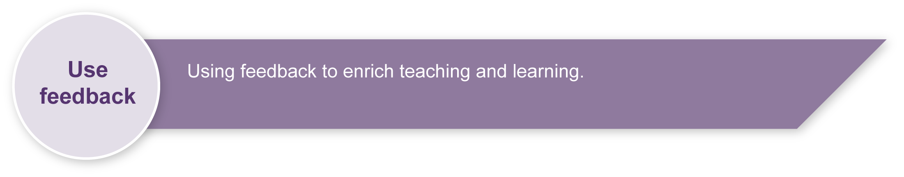
Evaluate the information gathered from the assessment to inform teaching and learning strategies.
Involve students in the feedback process. Give students opportunities to ask follow-up questions and share their learning observations or experiences.
Focus feedback on the student’s personal progress. Emphasise continuous progress relative to their previous achievement and to the learning expectations — avoid comparing a student with their classmates.
For further information, refer to the resource Using feedback, available in the Resources section of the Assessment Bank website.

