Languages — Beginner stage
Planning and auditing template

About this template  This resource is intended to help you plan teaching, learning and assessment of the Essential Learnings across the curriculum. It can be used to:  - audit existing units  - plan new units of work.  The purpose of this template is to provide information for Languages — Beginner stage focusing on:  - Ways of working  - Knowledge and understandings (conceptual statements only)  - Assessable elements.  Using the form features  This template is a protected MS Word form document — it allows you to enter unit titles in the shaded areas and check and uncheck boxes by clicking on them.  To make any other changes to the template, turn off the MS Word protection feature:  - Open the document in MS Word.  - Display the Forms toolbar: from the top menu, select View > Toolbars > Forms.  - On the Forms toolbar, click on the Protect forms icon (padlock).  Reactivate protection by clicking on padlock when needed. | Five processes that guide planning  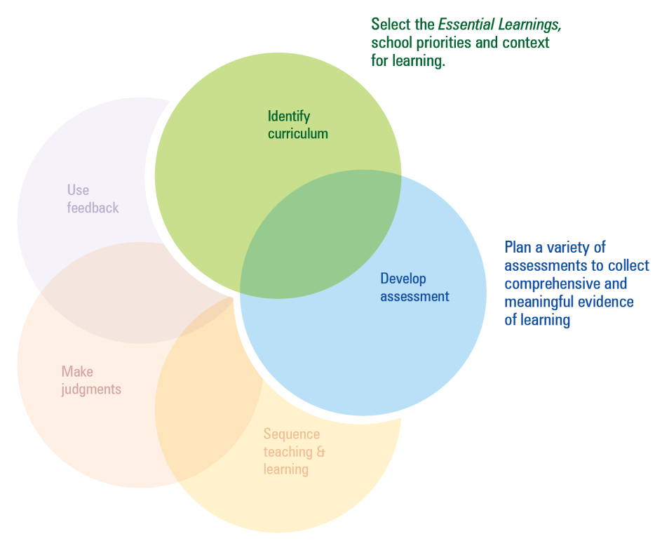  This template can be used to identify curriculum and develop assessment.  Additional planning and auditing resources  APEL is a QSA developed software application to help teachers audit their curriculum and plan units of work using the Essential Learnings. Available from the QSA website <www.qsa.qld.edu.au>.

Time allocation | Unit title | Assessment focus | Assessment techniques | Functions | Grammar | Key vocabulary/topics | Miscellaneous
e.g. 7 weeks | Getting to know you | Comprehending - listening  Composing - speaking  Intercultural competence | Listening to a conversation  Role play - meeting someone  Presentation - cultural protocol | e.g. introducing yourself, greetings, etc. | Konnichiwa mina san (Japanese) | Interest, hobbies, age, family | script

Languages — Beginner stage
Ways of working |  | Units of work
 |  | Semester 1 |  |  |  | Semester 2 |  |  |  | Semester 1 |  |  |  | Semester 2
Key: Teaching and learning  Assessment | Unit title
Students are able to:
- identify the purpose or main topic in simple spoken and written texts, using visual and verbal language
- respond to familiar statements and questions in simple conversations and discussions, using key words, phrases and memorised material
- identify and use non-verbal communication strategies in familiar contexts
- construct simple spoken and written texts in familiar contexts
- notice and compare aspects of the target language and English and/or other familiar languages
- reflect on and evaluate the suitability of language choices in familiar contexts
- reflect on learning to identify new understandings and future applications.

Languages — Beginner stage
Knowledge and understanding |  | Units of work
 |  | Semester 1 |  |  |  | Semester 2 |  |  |  |  |  | Semester 1 |  |  |  |  | Semester 2
Key: Teaching and learning  Assessment | Unit title
Comprehending and composing in the target language: Comprehending and composing skills are used to understand
language input, to convey information and to express ideas in response to needs and interests.
- Verbal language and non-verbal language are used in simple, routine exchanges to negotiate meaning.
- Language forms, functions, grammar and vocabulary are combined with process skills and strategies to make meaning.
- Listening for and locating key words and phrases, and using memorised material helps to make meaning.
- Manipulating known language helps to make meaning in different contexts
Intercultural competence and language awareness: Noticing and comparing similarities and differences between
languages and cultures informs intercultural.
- Learning languages provides insights into one’s own languages and the target language, and how concepts are expressed across languages.
- Ways of using language provide information about cultures.
- Languages and cultural practices have particular features, conventions, patterns and practices that may be similar to or different from one’s own language and culture.

Languages — Beginner stage
 |  | Units of work
 |  | Semester 1 |  |  |  | Semester 2 |  |  |  | Semester 1 |  |  |  | Semester 2
Assessable elements | Unit title
Students demonstrate evidence of their learning over time in relation to the following assessable elements:
Knowledge and understanding
Comprehending texts
Composing texts
Intercultural competence
Reflecting

Queensland Studies Authority
295 Ann Street, Brisbane
PO Box 307 Spring Hill
QLD 4004 Australia
T +61 3864 0299
F +61 3221 2553
www.qsa.qld.edu.au

