|  |  |
| --- | --- |
|  | Thinking like an assessor vs activity designer |

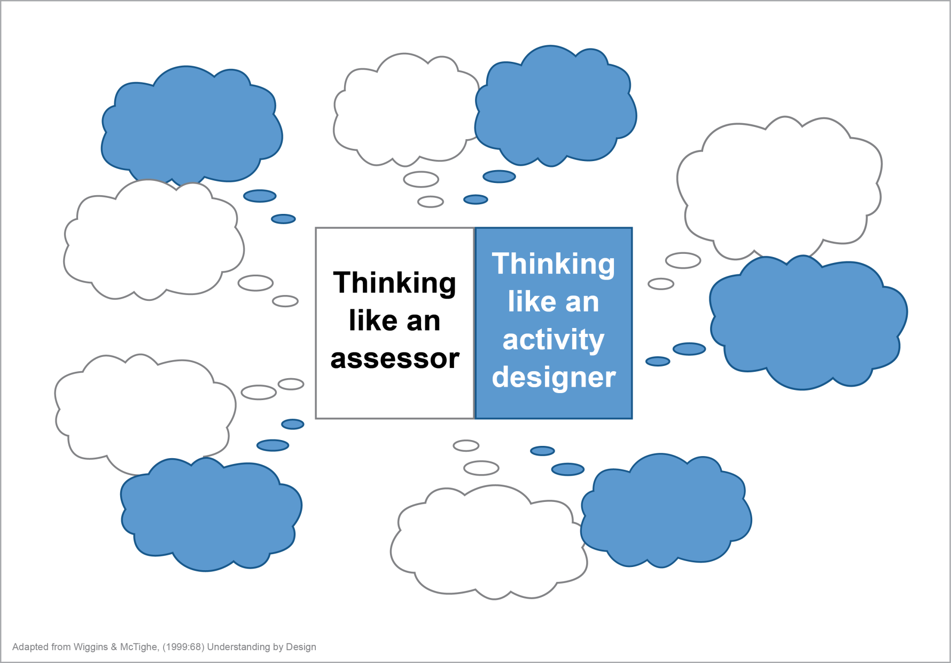

How will I be able to distinguish between those who really understand and those who don’t (though they may seem to)?

Did the activities work? Why or why not?

What misunderstandings are likely? How will I check for those?

What performance tasks must anchor the unit and focus the instructional work?

What would be sufficient and revealing evidence of understanding?

How will I give students a grade (and justify it to their parents)?

Against what criteria will I judge the work?

What resources and materials are available on this topic?

What will students be doing in and out of class?

What assignments will be given?

What would be interesting and engaging activities on this topic?